
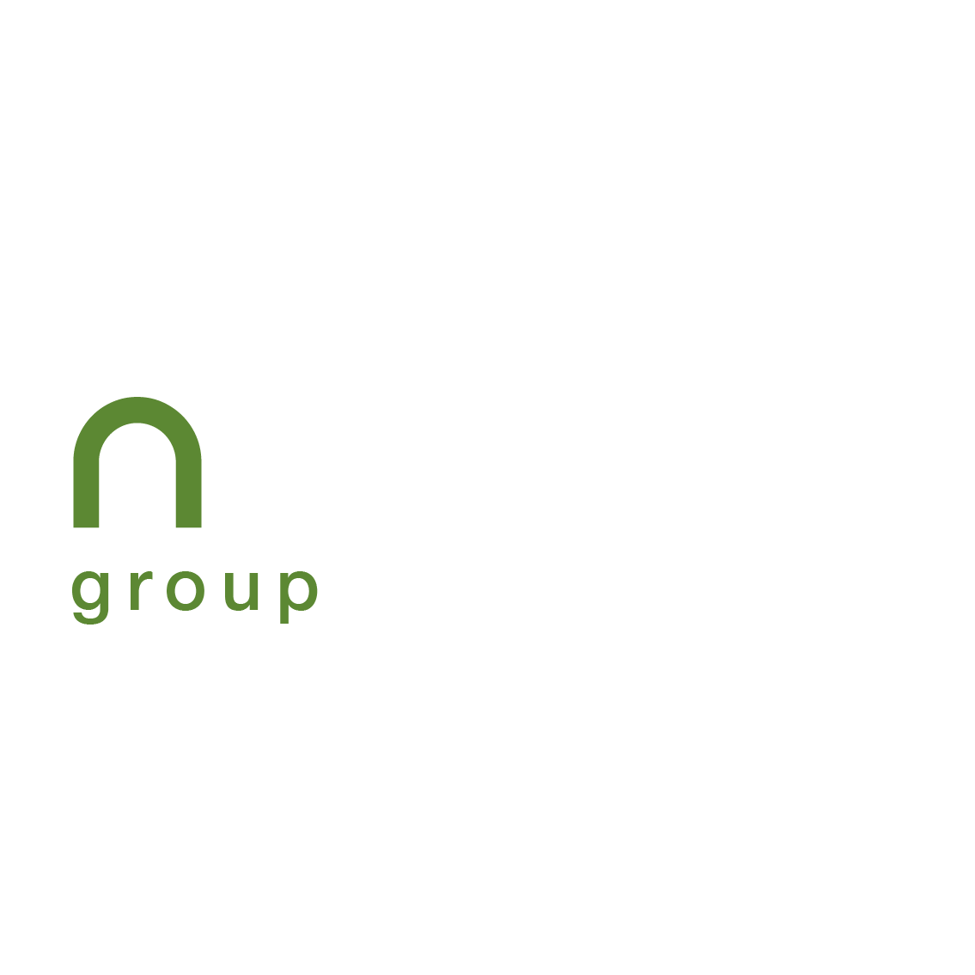

JOINT MEDIA RELEASE FROM NEWLYN GROUP & ABSA CIB
8 July 2026
Newlyn concludes R5-billion of financing with Absa CIB to execute logistics development pipeline
Newlyn Group, a leading South African ports logistics and infrastructure developer, has concluded a R5-billion integrated financing solution with Absa CIB, which will power its national development pipeline enabling growth at scale.
The finance solution will fund Newlyn Groups’ delivery of infrastructure assets across key logistics corridors in South Africa.
Rajendra Balmakhun, Founder and CEO of Newlyn Group, comments, “We are pleased to announce that Absa CIB has developed a bespoke real estate solution at favourable terms for Newlyn Group, unlocking liquidity to enable our growth at scale, while, at the same time, supporting our ongoing balance sheet strength.”
Somaya Joshua, Managing Executive: Real Estate at Absa Corporate and Investment Banking says, “This innovative transaction with Newlyn Group reflects our ability to structure complex solutions and demonstrates the strength of Absa CIB’s partnerships with key clients across the real estate sector.”
Since 1996, Newlyn Group has established a three-decade track record of proven investment and development expertise in South Africa’s specialist port logistics sector. Its national portfolio of large-scale logistics parks and properties spans 32 assets and more than 1.3-million sqm of gross lettable area (GLA) and includes a 2.0-million sqm landbank as well as 200,000 sqm of developments currently under construction.
Newlyn Group is committed to a development pipeline of strategically located, high-performance facilities at South Africa's key coastal and inland logistics hubs. Its bespoke bulk cargo terminal developments are engineered to raise efficiency across the bulk logistics sector and are set to transform the country's port logistics landscape.
Balmakhun adds, “By combining deep industry insight with responsible, solution-driven development, and harnessing the power of key partnerships, Newlyn Group will continue to create tailored infrastructure that supports the long-term commercial success of our partners and of South Africa.”

…/ends

RELEASED BY CATCHWORDS FOR:
Newlyn Group
Rashida Abrahams
Senior Marketing Manager

For more information or to book an interview, kindly contact Angie Di Giovampaolo at 083 453 6668 or angie@catchwords.co.za.

