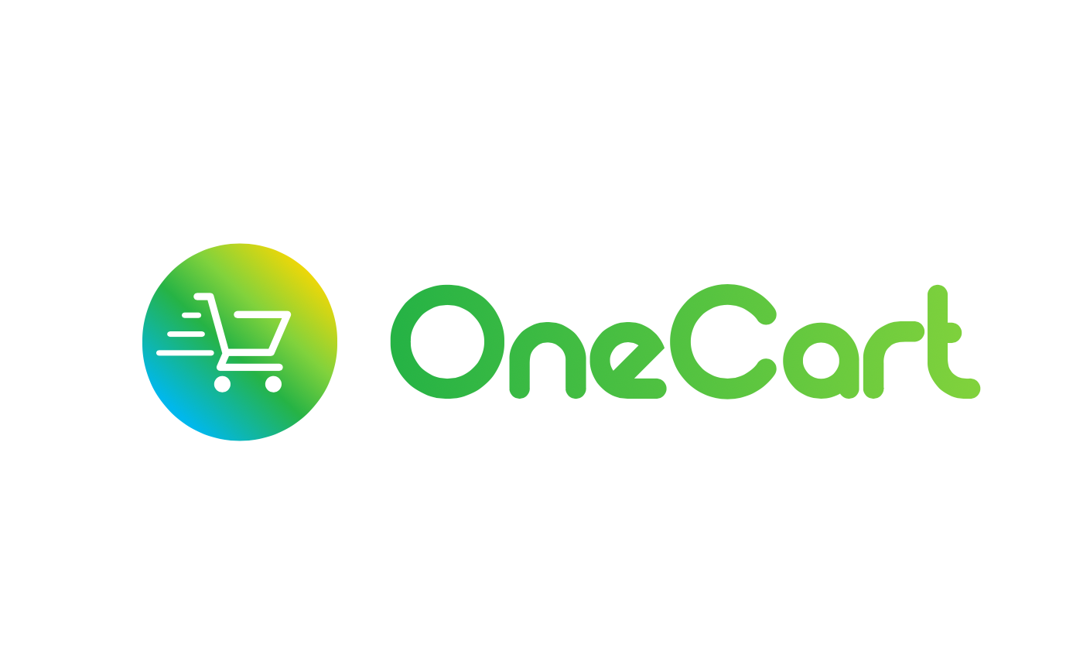
OneCart (PTY) LTD
Reg: 2016/262246/07
Second Floor West Wing, Norwich Place,
Norwich Lane, Sandton, 2196

PRESS RELEASE FROM ONECART – OneCart.co.za

12 November 2020

HP Store and Exclusive Books partner with OneCart

OneCart, SA’s premier on-demand delivery service, is expanding beyond groceries into new product ranges and has launched partnerships with HP Store and Exclusive Books.

You can now add inks and toners from the HP Store and the full range of books and stationery from Exclusive books to your OneCart basket, as well as food, beverages, and other household goods.

“We are delighted to partner with leading retailers Exclusive Books and the HP Store, and bring even more variety and value right to the doorsteps of OneCart users with the ultimate convenience and flexibility of same-day delivery,” says OneCart COO Ariel Navarro.

OneCart offers personalised shopping from multiple stores on one platform with two-hour delivery, one delivery fee and a single transaction. It partners with malls and retailers, big and small, for convenient and flexible same-day deliveries. Until now, it has focused exclusively on groceries with retailer partners including Woolworths, Pick n Pay and Pick n Pay Liquor, Food Lovers’ Market, Dis-Chem, Clicks, Jacksons, Mr Pet, Makro and Makro Liquor.

“OneCart is excited to offer customers new product ranges. Our vision has always been to be an all-inclusive e-commerce platform. Groceries were the obvious market entry point for us. Now, having grown our market share in this area significantly, OneCart is ready to increase its range to include books from Exclusive Books and ink cartridges from HP Store, and more,” explains Navarro.

OneCart customers can expect even more products to be added in future. Navarro reports, “We are working very hard on achieving full integration with our existing retail partners’ ranges, and adding health and beauty, pets, liquor and general merchandise. We plan on becoming the premium go-to e-commerce platform in South Africa and hope to make more exciting announcements soon.”

OneCart’s focus on integration and expansion will decrease the cost of online shopping for its users, further boosting the value of being able to get hand-picked shopping while getting on with life.

Stacey le Grange, Head of Marketing at HP Store explains that by partnering with OneCart it is engaging with new customers by offering them same-day doorstep delivery of HP Ink and Toner.

“With OneCart, it’s like having your own personal assistant who can dash out for ink when you run out so that you can finish printing that work report or school learning material,” says le Grange. More and more HP Store customers are now learning and working more from home, and there is an increase in demand for ink and other supplies for the home offices and classroom. Also, customers have become more familiar with online options and some remain hesitant about in-store shopping.

“There are eight brick-and-mortar HP Stores nationwide and we have an e-commerce platform at www.hpshop.co.za. But we also wanted a mobile solution, such as OneCart, that customers could download to make shopping remotely much easier and faster, providing the ultimate convenience and flexibility in a secure manner,” says le Grange. “We felt that OneCart’s simple, easy-to-use and effective app would truly benefit our customers with a quick and easy shopping experience at their fingertips, with the added benefit of same-day delivery to their doors. What is more, they can do this at the same time as shopping for other household essentials as OneCart offers over 100,000 products from multiple retailers.”

The Exclusive Books partnership with OneCart aligns with its omnichannel retail strategy. It is the only book retailer in South Africa with a strong presence online and in bricks and mortar, and it is developing both channels simultaneously to get the best offering to readers.

“At Exclusive Books, we consider books an essential service! During the lockdown, we created and ensured five different ways for customers to get books, even if they were not able or comfortable to come into a store. These included a phone-in option, and of course, online shopping. Partnering with OneCart offers yet another convenient channel for customers to get their books,” says Batya Bricker, Marketing, Loyalty and Procurement – General Manager at Exclusive Books.

Also, restricted trading hours in response to COVID-19 means that some Exclusive Books stores are not always open when customers feel like shopping for books. “In as little as two hours, our readers can now get the book they would like, at any time,” points out Bricker. “With Exclusive Books as part of the one-stop-shop mix that OneCart offers, seamlessly adding books to your grocery list or regular shopping is easy and doable. We love books to be a staple in every household!”

The SA e-commerce sector has overcome the initial inertia of slow adoption after being forced to adapt to this new way of shopping during the COVID-19 lockdown.

“OneCart experienced a surge in order volumes during the early months of the lockdown, which eased slightly with the loosening of the lockdown, the reopening of restaurants and entertainment, and more players entering the market. Nonetheless, OneCart has built an amazing customer base that values our service and wants even more from us. While some people have returned to several of their old shopping habits, online shopping is still taking place at higher levels than ever before, and we believe this is the right time to respond to the clear consumer demand,” says Navarro.

Besides delivering more than groceries, OneCart continues to expand its delivery areas across SA, most recently adding the V&A Waterfront in Cape Town, and Cradlestone Mall and Cedar Square in Johannesburg. And, there’s more on the cards. Its impressive growth trajectory also means that it is hiring more shoppers and drivers to serve the new areas and malls from which it shops.

Of course, an obsession with customer service means that OneCart is continually working on improving through market research, statistical analysis and reviews. “The app will be faster and more user friendly, while the service will be more efficient from world-class customer excellence to delivery. Our users inspire everything that we do, and we are thrilled to be making their lives easier with our new, bigger range of hassle-free, fast, and personalised shopping delivery,” says Navarro.

Find out more at OneCart https://www.onecart.co.za or download the OneCart App for iOS on the Apple App Store or for Android on Google Play.

/ends

For more information or to book an interview, please contact Mahlatse Bojanyane on 083 453 6668, Mahlatse@marketingconcepts.co.za or Angela Di Giovampaolo on 072 777 9329, Angela@catchwords.co.za.

Released by: COntent BY:
OneCart – www.onecart.co.za Catchwords
Ariel Navarro Bronwen Noble
www.oncecart.co.za bronwen@catchwords.co.za

