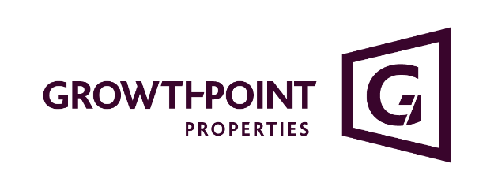
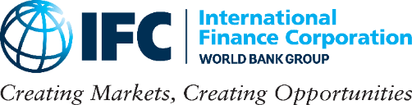

For IFC:
Hlazo Mkandawire
Phone: +27 83 795 0338
E-mail: hmkandawire@ifc.org

For Growthpoint:
Nadine Briers
Phone: +27 (0) 11 944 6251
E-mail: nbriers@growthpoint.co.za

IFC Partners with Growthpoint Properties Ltd. to Support Green Buildings in South Africa

Johannesburg, South Africa, December 14, 2022—To promote more sustainable and resource efficient buildings in South Africa, IFC today announced an investment in a green bond issued by Growthpoint Properties Limited that will help the company finance energy and water efficiency improvements in its existing commercial properties.

IFC will invest 1 billion South African rand (about $54 million) in the green bond, which will fund green improvements across Growthpoint’s office, industrial and retail spaces across South Africa. The retrofitting improvements are expected to reduce CO₂ emissions from the company’s portfolio by more than 18,000 tons annually.

The bond will also help Growthpoint, South Africa’s largest primary Johannesburg Stock Exchange (JSE) listed real estate investment trust (REIT), refinance its green office building located at 144 Oxford in Rosebank, Johannesburg. The building has a Green Star 5 category certification, as defined by the Green Building Council of South Africa (GBCSA).

“Growthpoint is committed to creating space to thrive with innovative and sustainable property solutions in environmentally friendly buildings while improving the social and material wellbeing of individuals and communities. This green bond supports our ESG strategy and renewable energy goals and furthers the diversification of our funding,” said Gerald Völkel, Growthpoint Group Financial Director.

“IFC is committed to accelerating access to green and sustainable buildings in South Africa to address climate change, protect the environment and support economic activity,” said Adamou Labara, IFC Country Manager for South Africa. “The green bond investment will contribute to greater climate change resilience in the country by supporting climate-smart infrastructure and reduce the private sector’s carbon footprint.”

Absa Corporate and Investment Banking (CIB) acted as bond advisors for the transaction and helped Growthpoint with the private placement of the bond on the JSE.

“This deal demonstrates Absa CIB’s commitment to supporting our clients on their ESG journey and our ability to deliver tailored solutions by linking clients’ sustainable growth strategies with their financing,” said Heidi Barends, Head of Sustainable Finance at Absa CIB.

Increased funding for green buildings is vital in South Africa, which is facing increasing power and water supply shortages. Furthermore, access to green funding remains limited in the country.

The bond aligns with Growthpoint’s ambitious sustainability strategy to certify its entire portfolio of buildings as carbon neutral by 2050. The strategy includes reducing its greenhouse gas emissions by 25 percent and increasing its renewable energy use by more than five times by 2026.

The green bond ZAR1 billion issuance was issued under Growthpoint’s existing Domestic Medium-Term Note (DMTN) programme, which is registered at the Johannesburg Stock Exchange. It aligns with IFC’s strategy to green the commercial sector in South Africa by further developing capital markets, promoting climate-smart investments, and crowding in climate-relevant private capital.

About Growthpoint
Growthpoint is an international property company invested in real estate and communities in South Africa and across the African continent, Australia, the UK and Eastern Europe. We are a 50% co-owner of the V&A Waterfront in Cape Town. Growthpoint is South Africa’s largest primary JSE-listed REIT. We create space to thrive with innovative and sustainable property solutions. Growthpoint is an established leader in commercial green developments and owns and manages the biggest portfolio of green-certified buildings in Africa. Visit growthpoint.co.za for more information.
Connect with us on Facebook, Twitter, LinkedIn and YouTube.

About IFC
IFC—a member of the World Bank Group—is the largest global development institution focused on the private sector in emerging markets. We work in more than 100 countries, using our capital, expertise, and influence to create markets and opportunities in developing countries. In fiscal year 2022, IFC committed a record $32.8 billion to private companies and financial institutions in developing countries, leveraging the power of the private sector to end extreme poverty and boost shared prosperity as economies grapple with the impacts of global compounding crises. For more information, visit www.ifc.org.

Stay Connected
www.facebook.com/IFCAfrica
www.linkedin.com/showcase/ifc-africa
www.twitter.com/IFCAfrica
www.youtube.com/IFCvideocasts
www.ifc.org/SocialMediaIndex

