Press Release
February 22, 2024

Surpassing International Green Standards
smart #3 Receives European Green NCAP Five-Star Rating

(February 22, 2024, Hangzhou / Leinfelden-Echterdingen) Having previously received a Euro NCAP five-star safety rating, the smart #3 has once again earned authoritative industry recognition. After rigorous testing, the smart #3 Pro+ has been awarded the highest five-star rating by the European Green NCAP (Green New Car Assessment Programme), an organization evaluating new vehicles for environmental performance and energy efficiency. With an impressive overall score of 95%, the smart #3 has become a model example for environmental friendliness, energy saving, and carbon reduction in the new energy vehicle sector.

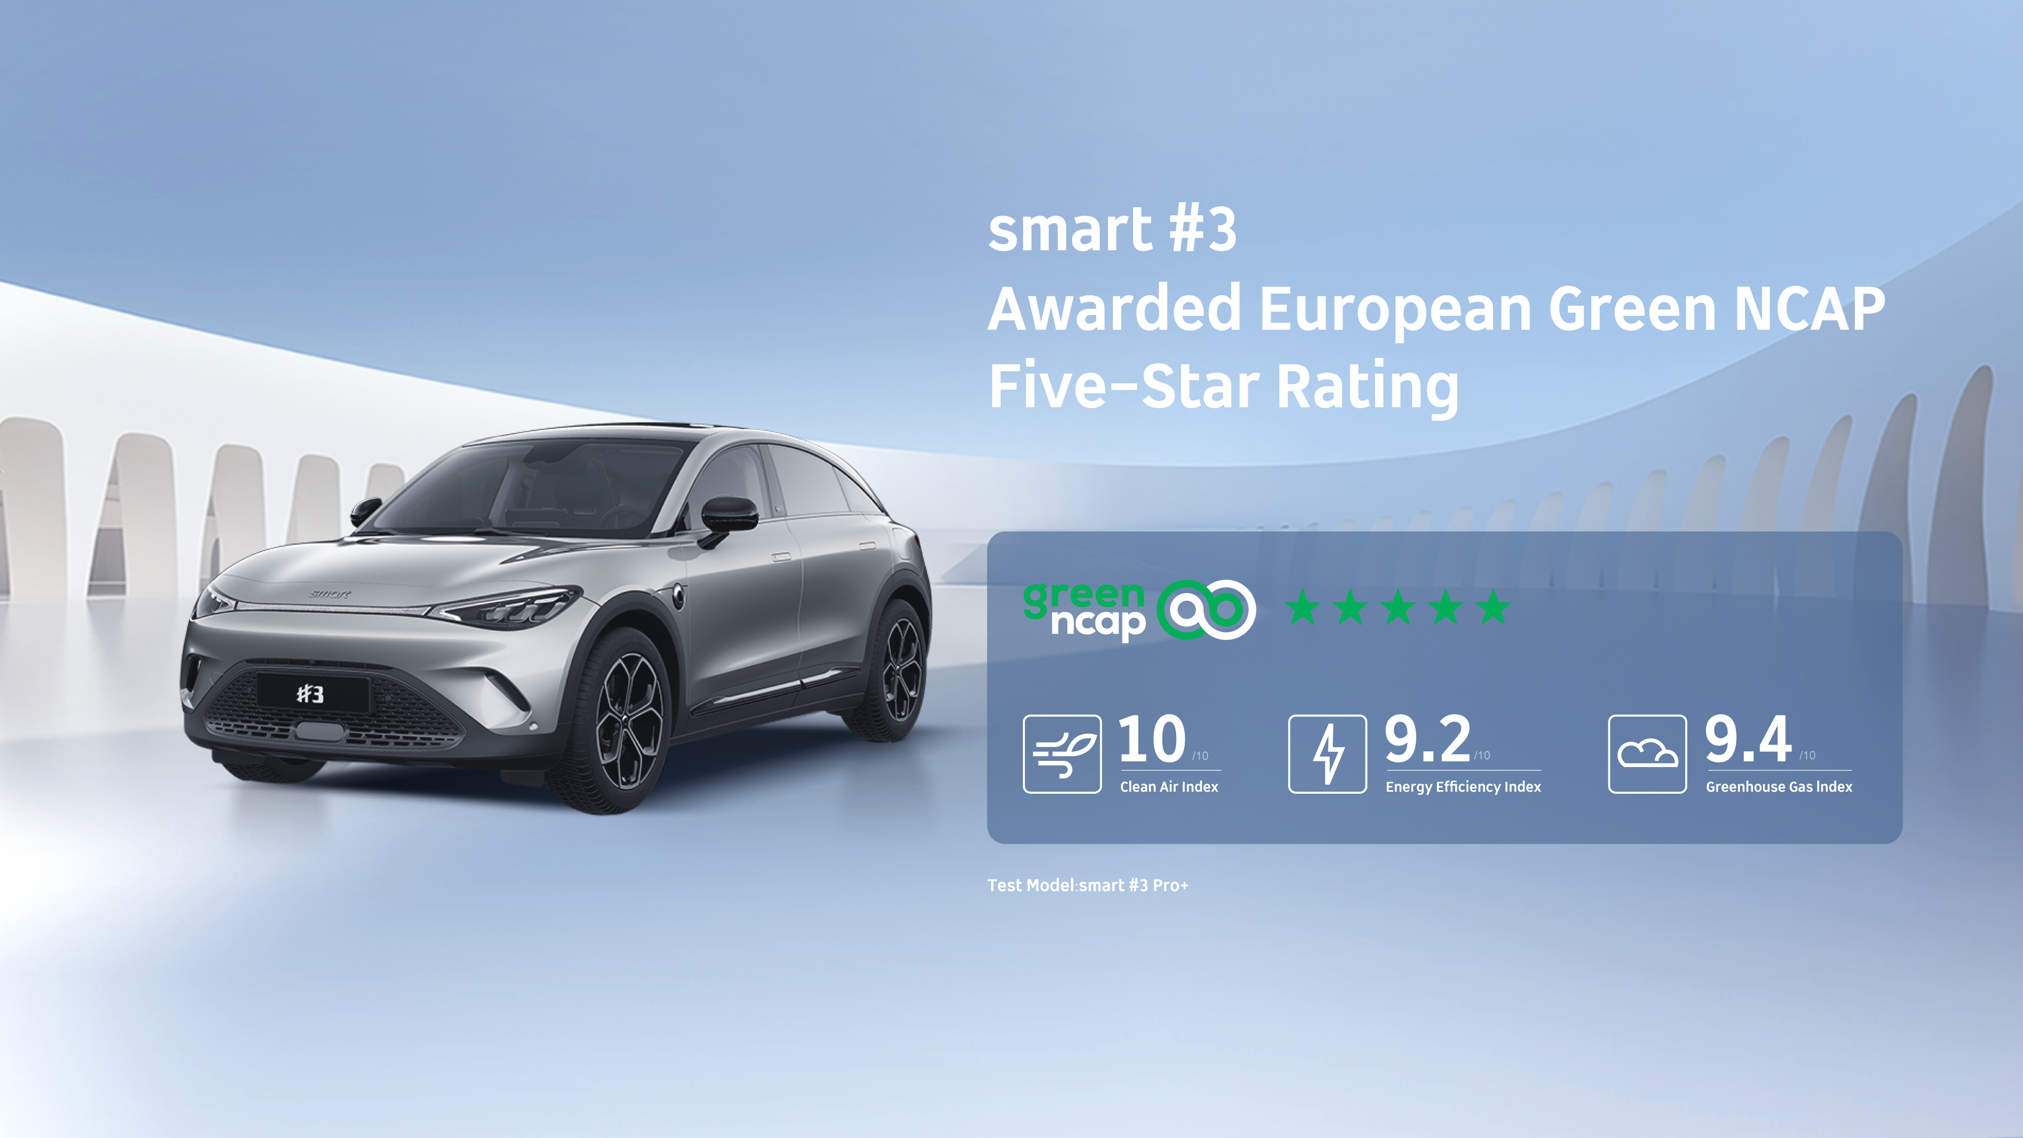
The smart #3 Pro+ awarded European Green NCAP five-star rating
An Environmental Advocate, Setting New Standards in Air Quality Systems
Green NCAP is an independent quantitative assessment conducted under Euro NCAP which evaluates vehicle performance in three areas: air quality index, energy efficiency and emissions impact. Its aim is to promote continuing progress in the automotive industry in the fields of environmental protection, energy conservation, and reduced carbon emissions, and to advocate for consumers to choose products that excel in health, safety, and environmental benefits.
The smart #3 excelled in its Green NCAP evaluation, notably achieving the maximum score of 10 in the Clean Air Index. From the laboratory to real-world roads, the smart #3’s air pollutant emissions, under a variety of different conditions, are significantly lower than testing standards, emitting “zero pollution” to the external atmosphere and allowing occupants to enjoy fresh, clean air at all times.

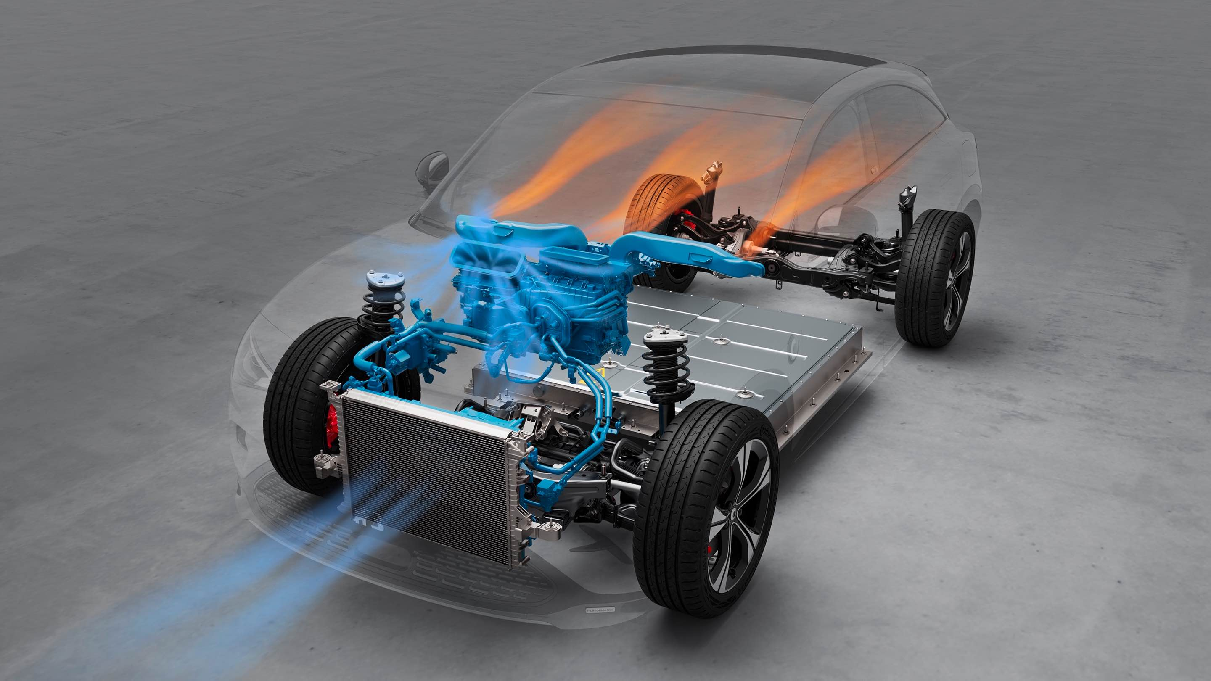
The smart #3 is equipped with an intelligent active air quality system
smart has established a rigorous air quality management system for the passenger compartment, implementing strict air quality controls from the design phase, material selection and manufacturing processes to components and procedures. In addition, the smart #3 is equipped with an intelligent active air quality system able to automatically adjust air circulation while on the move. Based on the air quality inside and outside the car, the air purification system reacts to ensure a healthier travel experience.
Confidence in Range, Advanced Battery and E-drive Technology
In the Green NCAP energy efficiency tests, the smart #3 easily handled temperature changes, performing exceptionally well in cold test environments. Its range and energy efficiency metrics scored among the top in its class, providing customers with stable driving comfort. At the same time, by adopting an active grille shutter, aerodynamically designed exterior rearview mirrors, low-drag wheel hubs and hidden door handles, the smart #3 effectively reduces the vehicle's drag coefficient to ensure outstanding performance under high-speed test conditions.

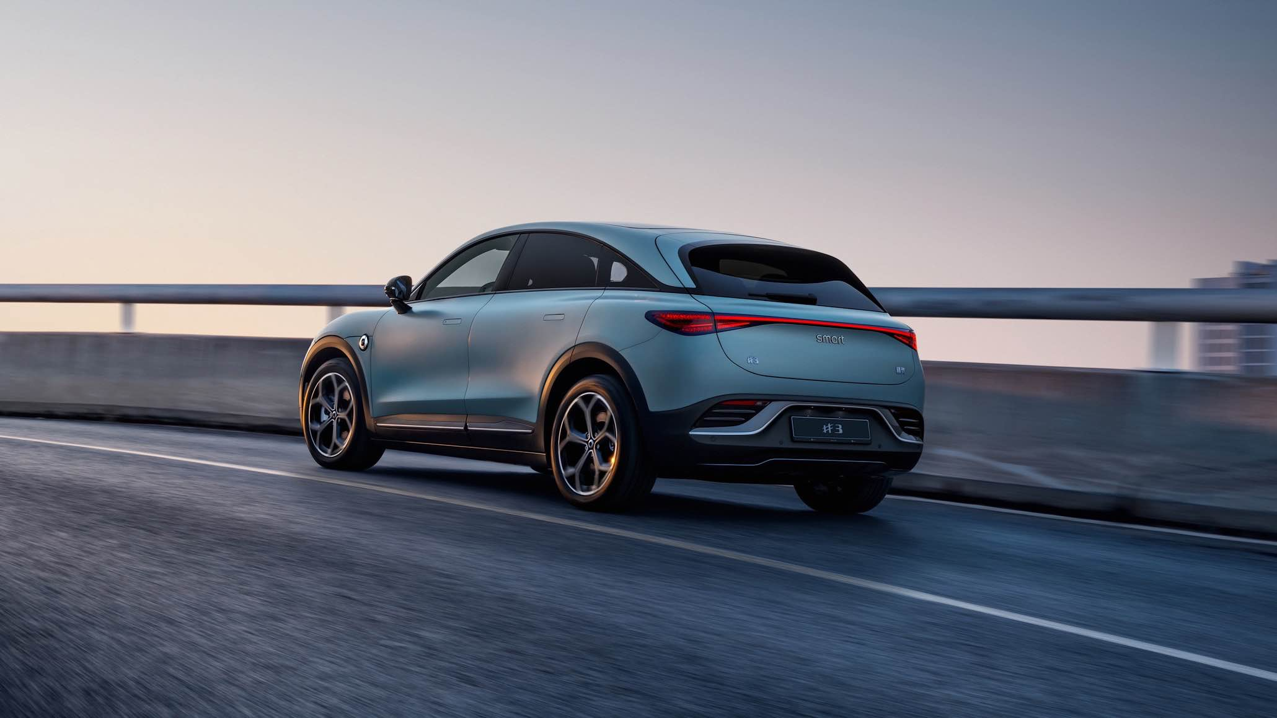
The smart #3’s range and energy efficiency metrics scored among the top in its class
The smart #3's battery and electric drive system is derived from the global leading SEA platform. The vehicle is equipped with a 66 kWh ternary lithium battery which offers a CLTC pure electric range of up to 580km. It can be charged from 10% to 80% in as little as 30 minutes and features an adjustable energy regeneration system to address range anxiety, an added safeguard for every journey.
Pioneering the Latest Sustainable Development Practices
Since its launch in 2023, the smart #3 has received authoritative industry recognition and consumer praise due to its outstanding product strengths, setting new benchmarks in various fields. On the basis of its advanced active and passive safety technology, the smart #3 has already earned a Euro NCAP five-star safety rating. Meanwhile, smart keeps a strict eye on “full-chain environmental protection”, from materials sourcing to end-user delivery. The smart #3 BRABUS performance edition also received a five-star healthy rating in 2023.

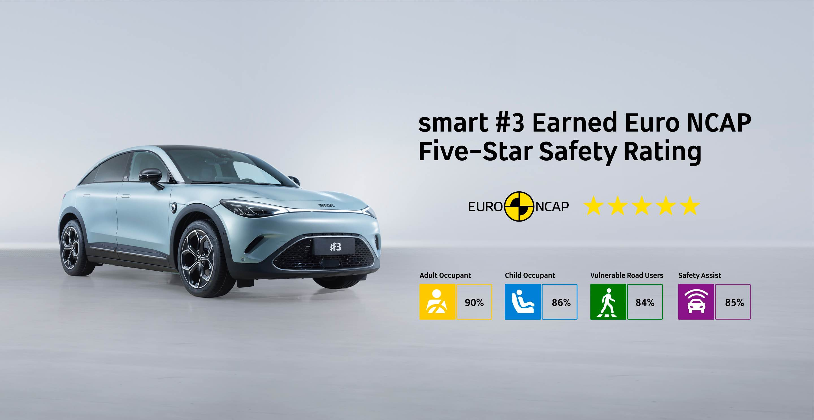
smart #3 earned Euro NCAP five-star safety rating (2023)
Now, the smart #3 has received the Green NCAP five-star rating, with the approval of a panel of judges. Green NCAP noted, “Overall, the smart #3 finishes with an Average Score of 95%, easily collects all 5 Green Stars and challenges the popular EV brands in the European market”. The smart #3 incorporates international environmental protection standards, as well as offering health and safety benefits to users, meeting the upgraded needs for high-quality mobility from customers all over the world.
As part of the global movement towards carbon neutrality, smart’s carbon management capabilities are at the core of the company’s sustainable development practice. smart has established a system to manage the whole lifecycle carbon footprint of every vehicle, incorporating collaborative carbon reduction work across the entire supply chain in cooperation with upstream and downstream industry partners.

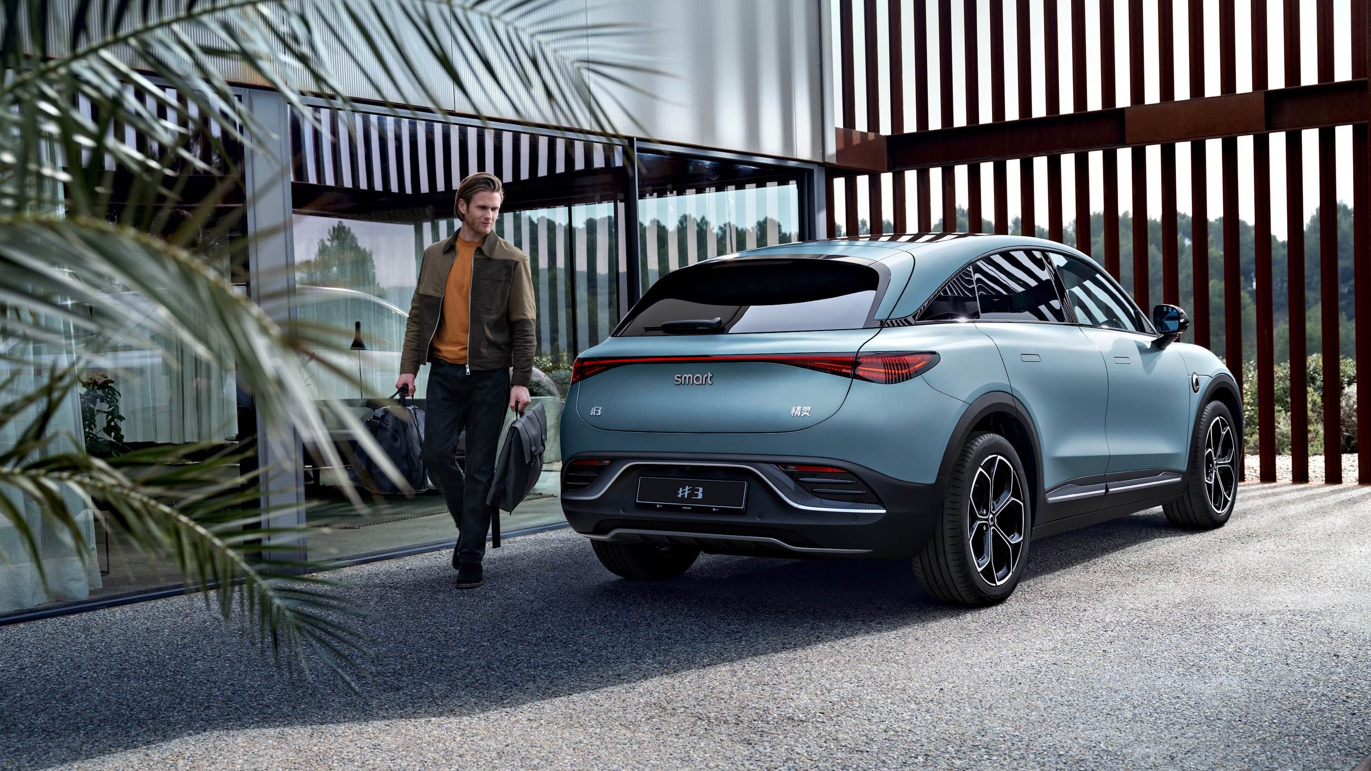
smart keeps a strict eye on full-chain environmental protection
Maintaining the vision of “exploring the best solutions for future urban mobility” has led smart to the establishment of leading practices in sustainable development, providing intelligent, environmentally friendly, safe, and healthy vehicles. smart will continue to develop sustainably, leveraging its commitment to innovation and excellence, inviting customers and fans worldwide to become part of the journey to design a smarter future together.

-End-

About smart Automobile
Since the birth of the brand in the 90s, smart has always maintained the vision of exploring the best solutions for future urban mobility. smart Automobile was officially established in 2019 with a forward-looking "China-Europe, dual home" global development strategy, and is committed to becoming a world-leading, new-premium, intelligent and all-electric auto brand.
smart has completed a comprehensive renewal of its brand, product, and business model and has entered a new era of full-speed operations, accelerating the establishment of a global product development, sales, and service management system. Engineering, research, and development for the new generation all-electric vehicle portfolio is led by the smart R&D team, with the Mercedes-Benz Global design team overseeing vehicle design. smart has now launched two all-electric SUV models, the smart #1 and smart #3, with deliveries underway across multiple markets in China and Europe and continued expansion into high-potential markets in Southeast Asia and the Middle East. From 2022 to 2025, smart will bring an all-new model to customers each year, further enriching the new generation all-electric product portfolio.

