Press Release
April 17, 2023

Chase the Thrill
The All-new smart #3 Celebrated its World Premiere in Shanghai

- The thrilling all-new SUV coupe, the smart #3, has celebrated its official world premiere in Shanghai. The model is the second to launch following smart’s renewal and comes on the 25th Anniversary of the brand.
- Sharing the same “Sensual Producty” design philosophy as the smart #1, the Mercedes-Benz global design team have imbued the all-new smart #3 with a premium, bolder and more dynamic look - both inside and out.
- The thrillingly vibrant yet elegant exterior and fastback silhouette of the all-new smart #3 create an emotionally iconic body, while the spacious interior architecture offers the most futuristically premium and excitingly sporty cabin experience in the segment.
- Matching the smart #3’s sporty and dynamic character, the model introduces a new Cheetah avatar to the signature “smart planet” UI, with additional features to seamlessly integrate customers’ digital life via the smart APP.

(April 17, 2023, Hangzhou, China/Germany) smart, the new-premium and intelligent all-electric auto brand, has officially launched its highly anticipated all-new thrilling SUV coupe, the smart #3, at an exclusive 25th Anniversary brand event in Shanghai. The smart #3’s emotionally iconic car design represents a significantly sportier and more dynamic interpretation of the” Sensual Producty” design philosophy created exclusively for the brand by Mercedes-Benz. With the launch of the smart #3 coming in a milestone year for the brand, smart remains true to its original pioneering vision of exploring the best solutions for future urban mobility.
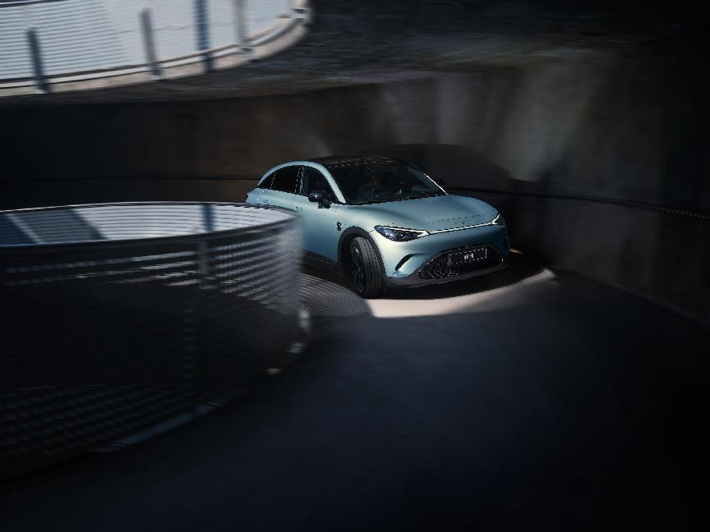
“Dynamic Urban Companion” – The all-new smart #3
Joel Baek, Head of Design China, Mercedes-Benz said, ”We are proud that the team has created an even bolder, more powerful, and more dynamic interpretation of our unique “Sensual Producty” design language for the smart #3. The emotionally confident, athletic, aerodynamic exterior design combined with the most futuristically premium and exquisite cabin in the segment make the #3 a truly thrilling masterpiece. It’s a car with the ambition to leave its mark on this world in a uniquely powerful yet elegantly unobtrusive way”
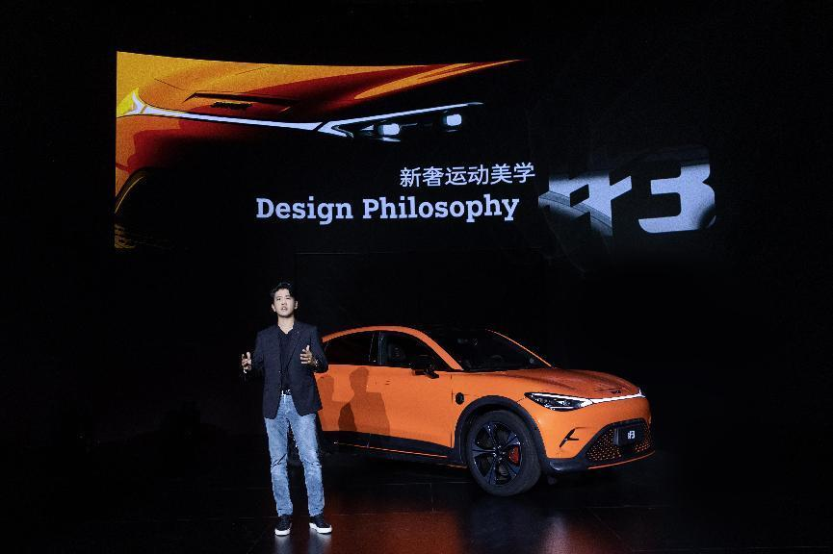
Mr. Joel Baek, Head of Mercedes-Benz China Design Center
Thrillingly from outside and in
The smart #3 features premium design thrills you both inside and out. Representing a significantly sportier interpretation of ‘sensual producty’, the truly original exterior of the smart #3 is defined by seamlessly smooth lines and beautifully athletic curves, teeming with a vibrantly muscular yet elegantly sensual energy. The body is further accentuated with numerous detailing; at the front, slimmed down LED headlights are paired with a strong ”shark nose” and A-shape wide grill. On the sides, the prominent roof meets with the smooth, continuous e-line that connects the A-pillar and C-pillar, creating an elegantly sporty fastback silhouette. The large size wheels add a powerful element, while the eye-catching rear diffuser leave no question of performance intent.
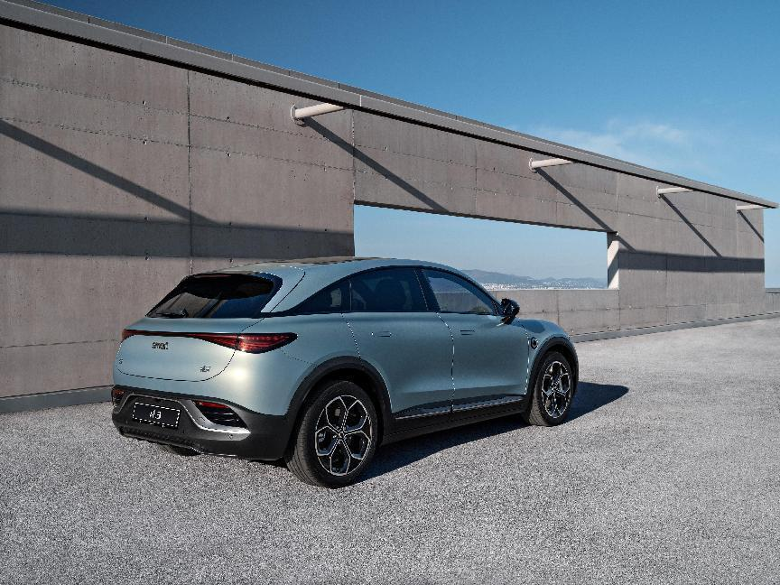
The all-new smart #3 has a length of 4,400mm and a class-leading wheelbase of 2,785mm
From the rear, the confident curvature created by the prominent spoiler, C-pillar, strong rear fender and bumper together meet the aesthetic needs of the most discerning of car connoisseurs. Imbued into this muscularity are potent elements of premium, progressively modern features, such as the taillights with pixelated elements.
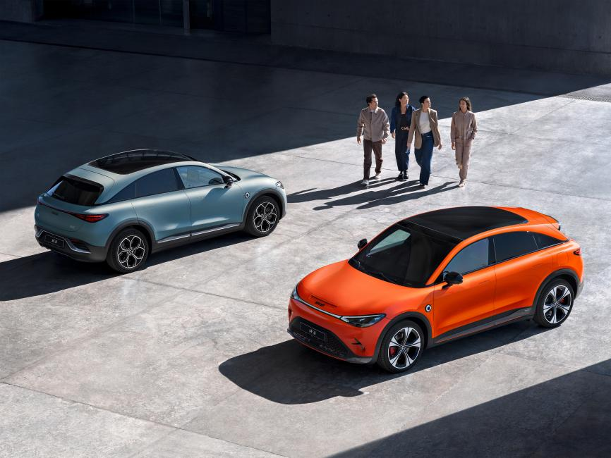
Natural fastback SUV coupe stance
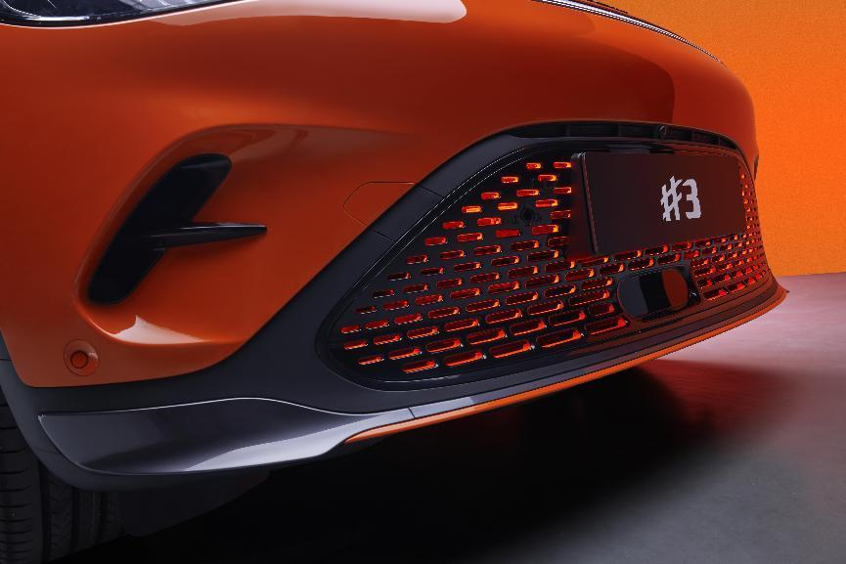
A-shape wide grille
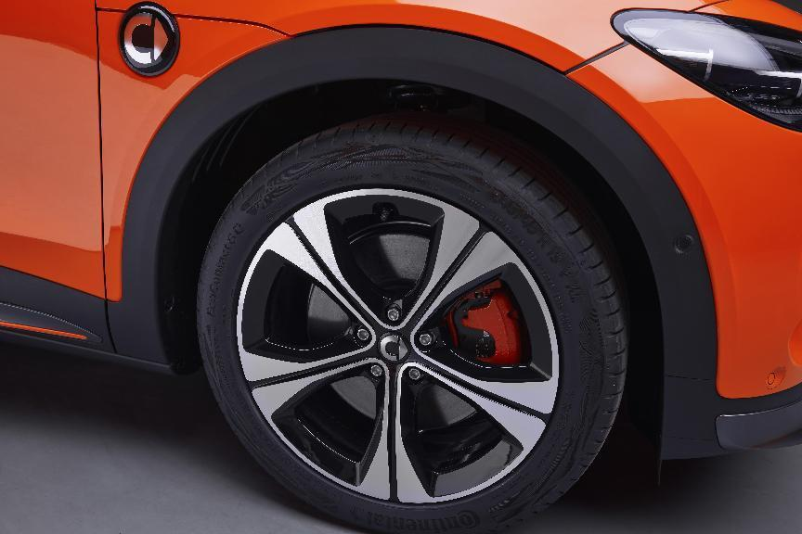
Large sized wheels
The emotionality continues naturally on the exquisite interior, with the smart #3 offering the most futuristically premium and excitingly sporty cabin experience in the segment. The cockpit infuses a premium aesthetic with the thrilling sporty energy, impressing occupants with an ultra-premium design that plays elegantly with oblong and circular shapes evocative of turbine intakes, embedding boldly voluminous elements throughout a calm and stylish architecture. The mood created feels both inspiringly futuristic and ergonomically sensual. All of the vehicle surfaces and design elements invite the human touch, while individualized colour combinations add a personal touch.
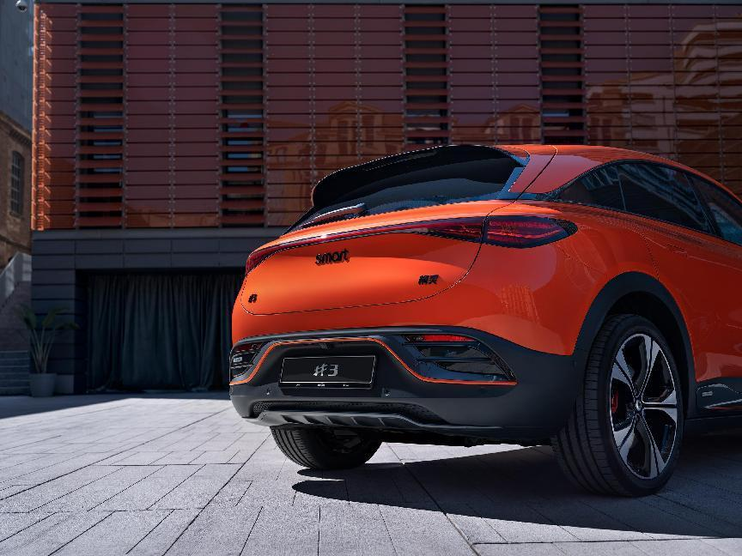
Sporty rear spoiler
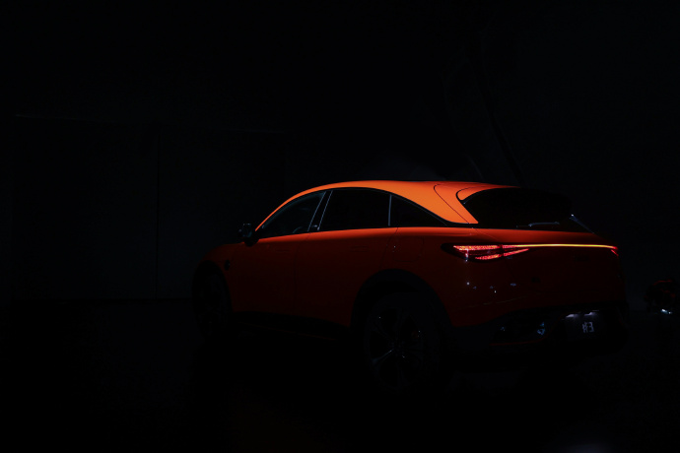
Full width LED tail lamps with new pixel elements
The perfectly sculpted dashboard flows seamlessly into a high console, housing the central art-piece of the cockpit, a prominent 12.8-inch elevated central screen. The layout creates an energizing, dynamic atmosphere, accentuated yet more by the sporty seats with integrated head rests. The driver thus feels perfectly embraced and deeply integrated into the interior
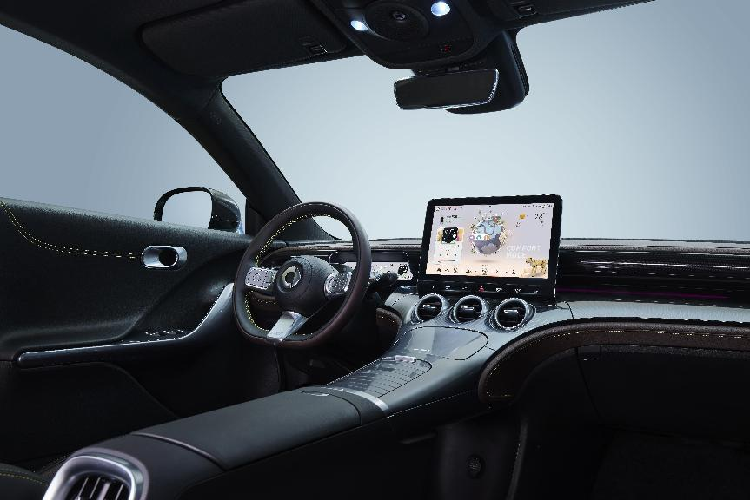
Hand-wrapped 3D Mesh soft-touch dashboard
The play of natural and artificial illumination from the large halo roof and multi-coloured ambient lighting further enhances interior atmosphere. Meanwhile, the infotainment system equipped with a 13-speaker Beats audio system rounds out the breathtaking avant-garde smart #3 cabin experience in pure sonic style.
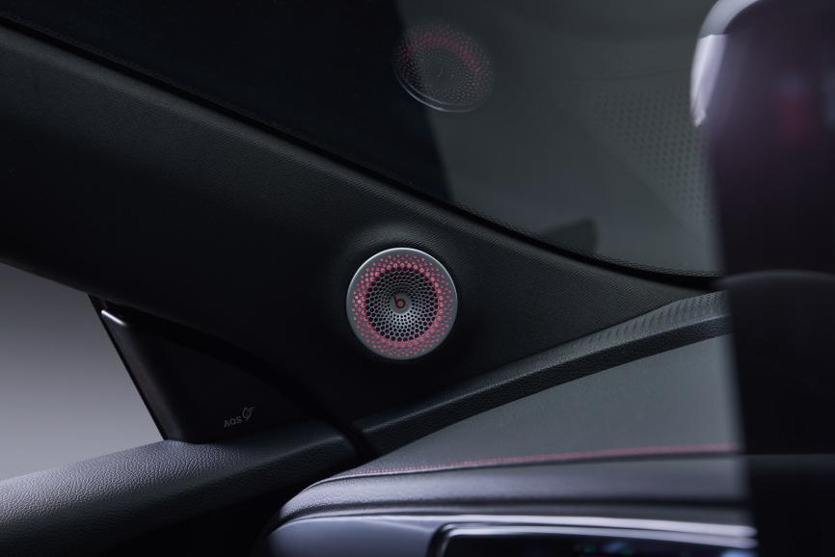
Beats 13-speaker audio system
Thrillingly Engaging with intelligent technology
Technological specifications alone are not enough, which is why the smart #3 goes to the next level to leave its mark on a discerning audience. Intelligent technology on par with segment leaders pairs with the only truly engaging UX in the car industry to offer not only efficient, advanced intelligent technology, but also to create a genuinely captivating, thrilling and personalised user experience.
The already industry-transforming signature “smart planet” UI has been further enriched to bring even more joy, excitement and a feeling of personalisation to each smart #3 owner. In keeping with the vehicle’s sporty and dynamic character, the smart #3 will introduce a new Cheetah avatar with added functions. As is true for every smart, the smart #3 will integrate seamlessly into digital life via the smart APP.
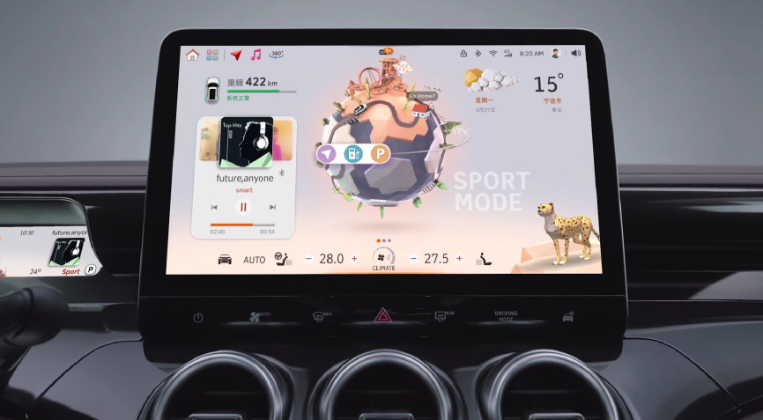
All-new Cheetah Avatar virtual assistant
With the sportiest, most exquisite avant-garde styling in the segment, along with providing an unmatched level of urban driving thrill, the smart #3 SUV coupe will be exhibited at Auto Shanghai 2023 from April 18, where further details of the all-new model will be revealed.
-End-

For the latest information, please visit
smart Global Media Centre: https://media.smart.com/
smart Automobile Website: https://www.smart.cn/

Media Inquiries
Sebastian Liu: sebastian.liu@smart.com


smart mini program

About smart Automobile
Since the birth of the brand in the 90s, smart has always maintained the vision of exploring the best solutions for future urban mobility. In 2019, smart Automobile Co., Ltd. was officially established. With a forward-looking "China-Europe dual-home" global development strategy, smart is committed to developing into a world-leading, new-premium, intelligent, and all-electric auto brand.
smart has completed a comprehensive renewal of its brand, product, and business model. The new generation all-electric product development is led by the smart R&D team, with the Mercedes-Benz global design team responsible for vehicle design, and the product portfolio now expanded into more market segments. As the renewed brand's first compact all-electric SUV, the smart #1 made its world premiere in April 2022, with initial deliveries in China followed by Europe. The second model, the thrilling new-premium smart #3 SUV coupé, made its world premiere in April 2023. Every year from 2022 to 2024, smart will bring an all-new model to customers, further enriching the new generation all-electric product portfolio.

