Press Release
August 26, 2022

The All-New smart #1 BRABUS Officially Launches in China
at the 25th Chengdu Motor Show

- On August 26, the fully renewed smart brand made its debut at the Chengdu Motor Show (H402, Hall 4). The all-new smart #1 BRABUS saw its official launch and start of sales, with pricing from RMB 279,000 (excluding new energy subsidies and paid options).
- From 2022 to 2024, smart will bring a new vehicle model to the market every year, enriching the new-generation all-electric product family and entering new market segments.
- The all-new smart #1 BRABUS officially launched at 10:30am CST on August 26. Users can log on to the smart APP or official smart mini program to place orders for a limited time.
- Customers who completed down payment for the smart #1 before August 15 can upgrade their models to the smart #1 BRABUS for a limited time from August 26, keeping the same delivery time as the original order receiving “Urban Companion BUFF” points.

(August 26, 2022, Chengdu) Today, smart, the premium all-electric automobile and technology brand, brought its all-new smart #1 BRABUS to the 25th Chengdu Motor Show (Booth H402, Hall 4, Western China International Expo City).
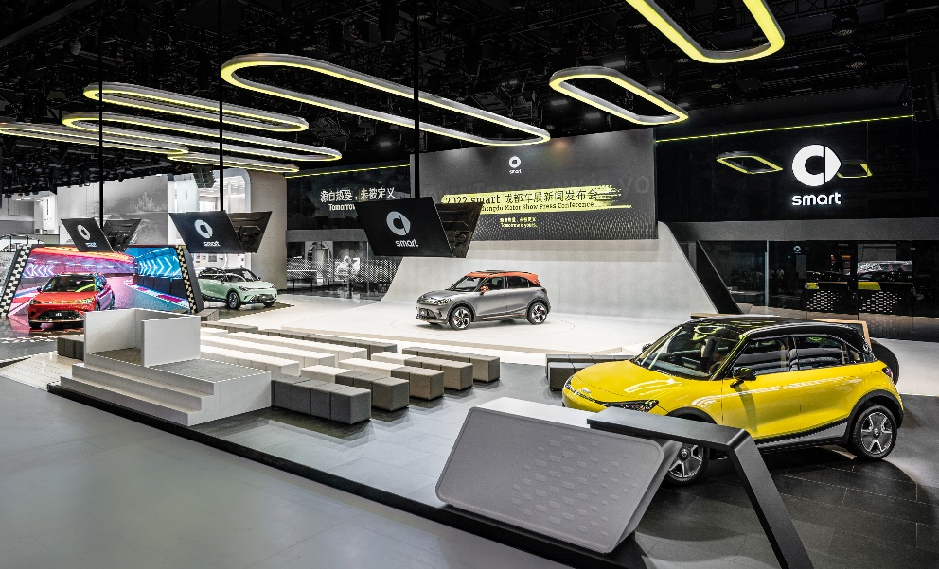
The fully renewed smart brand made its debut at the Chengdu Motor Show

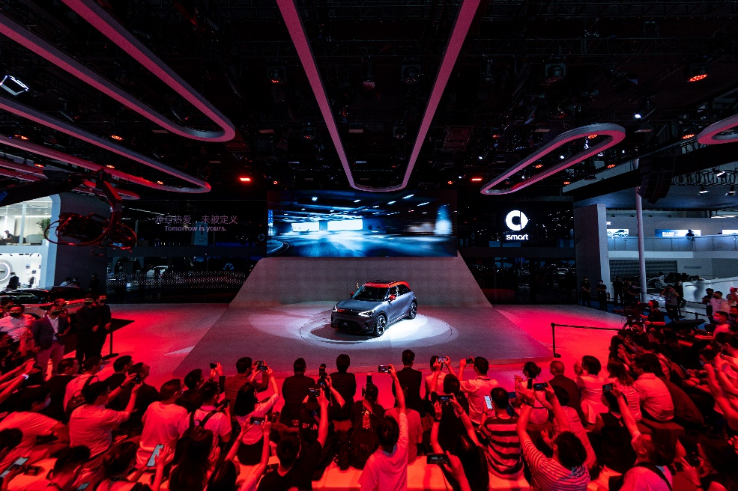
The official China launch of the all-new smart #1 BRABUS

As the first model jointly created by the comprehensively renewed smart brand and BRABUS, the all-new smart #1 BRABUS exemplifies “one-second wow” charm, redefining the exciting all-electric high-performance urban driving experience. Official pricing starts at RMB 279,000 (excluding new energy subsidies and paid options).

Mr. Tong Xiangbei, Global CEO of smart Automobile Co., Ltd. said: “In keeping with our China-Europe dual-home’ global development strategy, smart is accelerating its expansion worldwide. In addition to the Chinese and European markets, we will explore other potential new energy vehicle markets and strive to build smart into one of the world’s leading, premium, all-electric automobile and technology brands.”

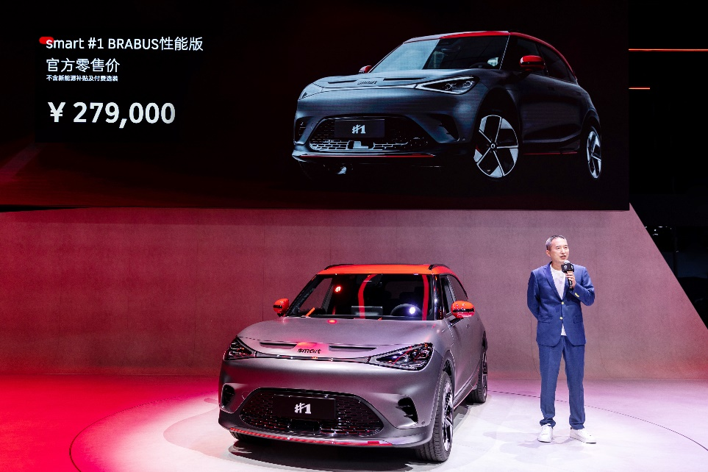
Mr. Tong Xiangbei, Global CEO of smart Automobile Co., Ltd.

Mandy Zhang, Vice President of Global Sales, Marketing and After-Sales of smart Automobile Co., Ltd. said: “2022 is a year of renewal for smart. Between now and 2024, smart will release a new model to customers each year, enriching the new-generation all-electric product family and entering new market segments. At the same time, we will continue to work with outstanding new retail partners to bring customers a brand, product and service experience that exceeds expectations.“
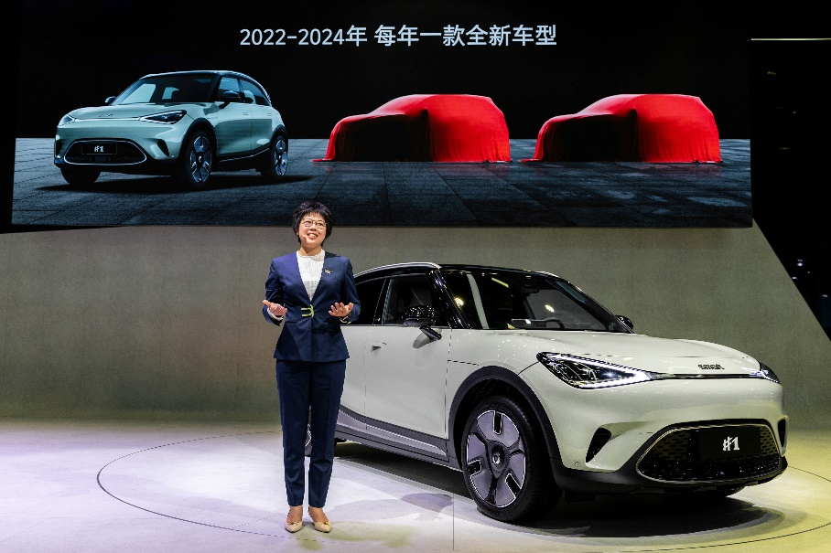
Mandy Zhang, Vice President of Global Sales, Marketing and After-Sales of smart Automobile Co., Ltd.

Embracing tomorrow, the fully renewed smart brand is developing faster than ever

After a comprehensive renewal, the smart brand has become more premium, more high-tech and more avant-garde. As a representative of the brand’s renewal, the first member of the new generation all-electric vehicle family, the smart #1 has gained widespread attention in the global market since release, and has captured the hearts of many loyal fans.

At the business level, smart’s “customer-centric, data-driven” approach leads to working with outstanding industry partners to co-create and accelerate the expansion of the sales and service network. This year, smart will have nearly 150 independent points of sales and service, covering more than 40 first-tier, new first-tier and second-tier cities. By the end of September, more than 100 offline touchpoints will have officially opened, including 30 brand-specific service centres focusing on product delivery and after-sales service. Following the grand opening of the world’s first smart brand centre in Chengdu, five additional brand centres, each with their own theme but same premium style, will open in Shanghai, Beijing, Hangzhou, Shenzhen, and Guangzhou, bringing customers the full smart brand, product and service experience.
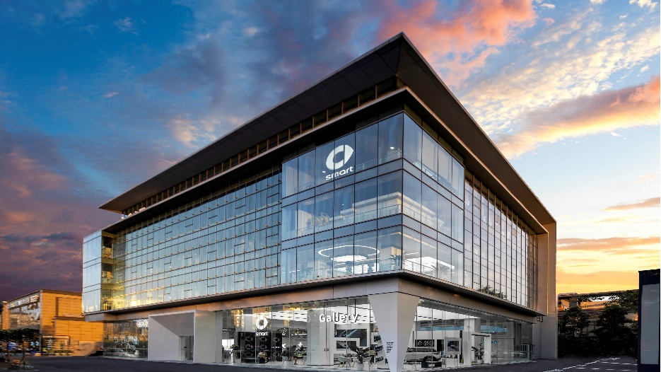
The world's first smart brand center in Chengdu

In addition, production-related work on the all-new smart #1 is progressing steadily. The first batch of products have already rolled off the line and are expected to be delivered in September.

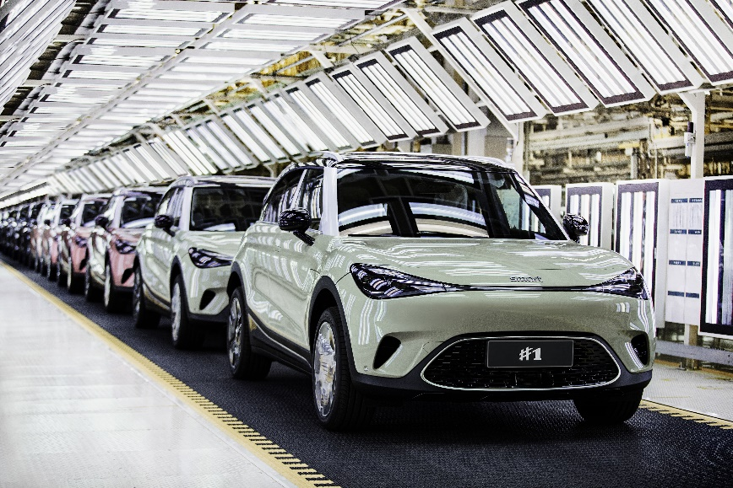
The all-new smart #1 will begin deliveries in September

One second wow – in a smart way! The all-new smart #1 BRABUS has its official launch

Stunning at a glance, premium design empowered by BRABUS. Whether it be the car’s interior or exterior, the all-new smart #1 BRABUS has many BRABUS-exclusive design elements, with every detail exuding high-performance charm. The body comes in three exterior colours - Meta Black, Laser Red, and Atom Grey-Matte, with a contrasting roof. The dynamo rims and front sporty feature show off the vehicle’s driving dynamics with strong visual contrast. The sporty hood is complemented by the bumper air curtains on both sides of the front. Meanwhile, the BRABUS designed bodywork surrounding (including front, side and rear skirts), makes the whole car exude personality and attitude from every angle. Open the door and you'll be greeted by an interior that blends high-performance aesthetics with premium design. The interior adopts the exclusive BRABUS black colour scheme, with BRABUS design headrests and the luminous BRABUS logo on the steering wheel always showcasing individuality. The Alcantara and leather stitched steering wheel create a sporty atmosphere.

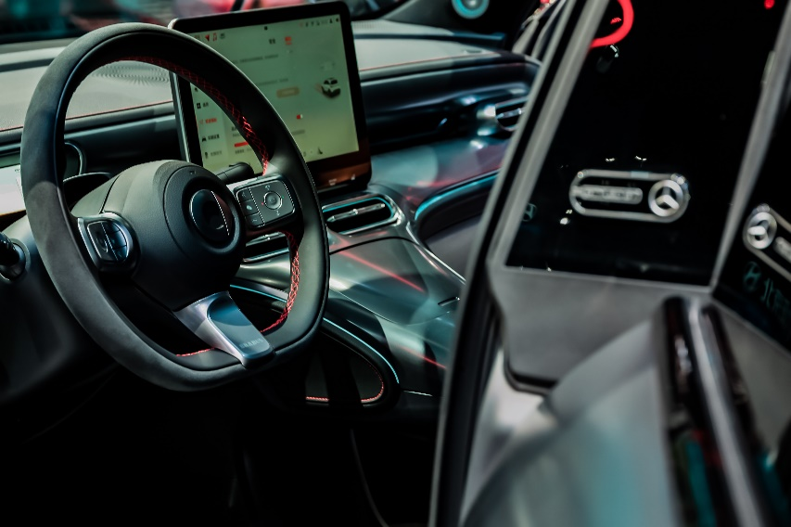
The interior features an exclusive black BRABUS colour scheme

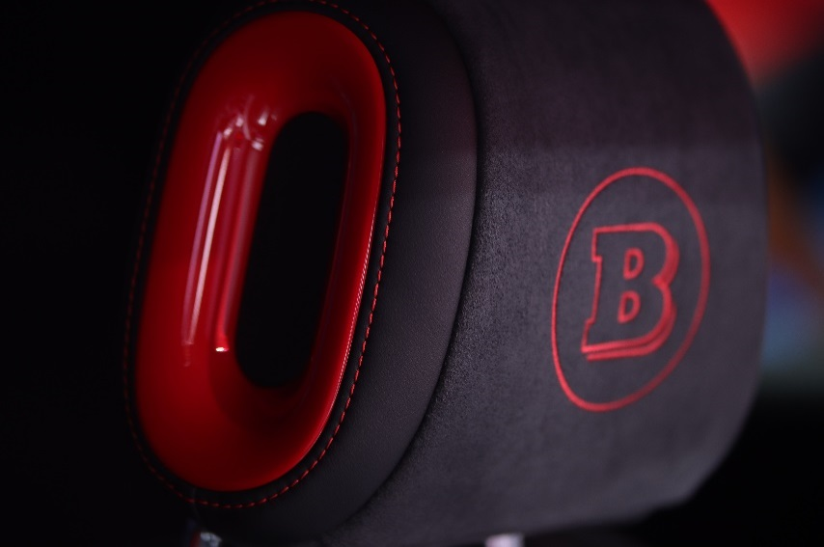
BRABUS design headrests

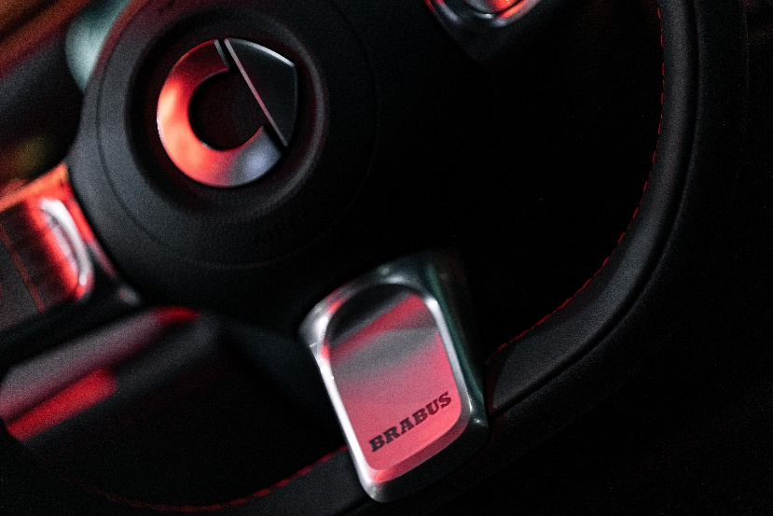
BRABUS logo on the steering wheel

In addition, the all-new smart #1 BRABUS features a translucent soft sunshade, integrating fashion with function. The visor not only effectively blocks glare but also increases vision for driving. The microfiber suede seats feature a contrasting colour scheme, with red sport stitching and red seat belts to match your driving passion. The sporty metal pedals exemplify cool and remind the driver of the vehicle’s mechanical beauty - a performance machine capable of unleashing raw power at any time.

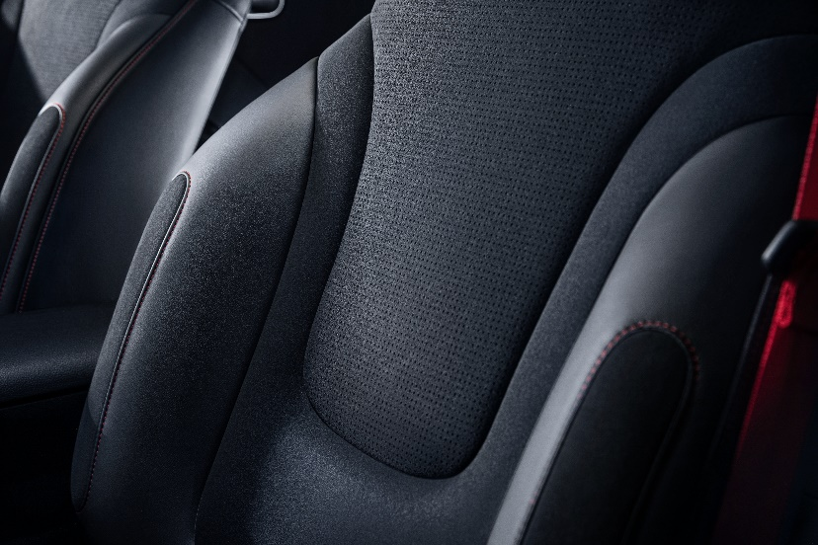
Microfiber suede seats

0 – 100 in just 3.9 seconds, easily the best in its class

The all-new smart #1 BRABUS is equipped with front and rear dual permanent magnet synchronous motors which can generate 315 kW of power and a peak torque of 543 N⋅m, giving the driver that feeling of instant, abundant power, and taking the vehicle from standstill to 100 km/h in just 3.9 seconds. As a “three second club member”, the all-new smart #1 BRABUS well deserves its nickname “high-performance urban companion” namesake.

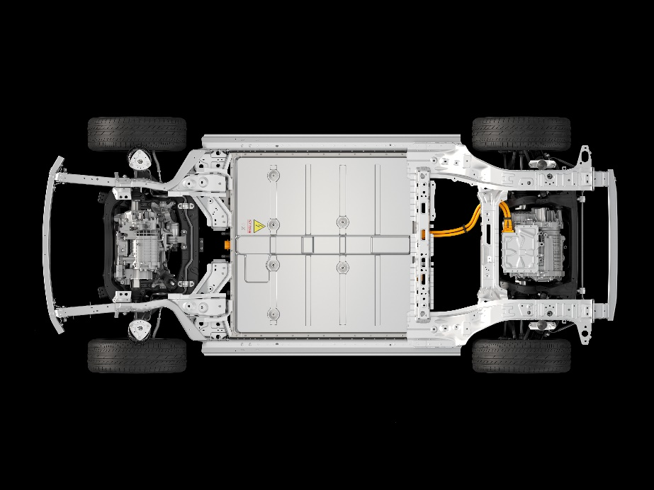
The all-new smart #1 BRABUS features front and rear dual permanent magnet synchronous motors

In addition, the car adopts front MacPherson and rear five-link independent suspension, taking into consideration both sport and comfort. By reorganising the design, the smart #1 BRABUS has a 50:50 weight distribution ratio, leading to a more agile handling experience. At the same time, the car is equipped with an intelligent four-wheel drive system with three driving modes: rear-wheel drive, part time four-wheel drive, and full-time four-wheel drive. It only takes 0.4 seconds to switch from rear to four-wheel drive, with four driving modes to choose from: Eco / Comfort / Sport / BRABUS. One car, four personalities, to meet the different needs of drivers.

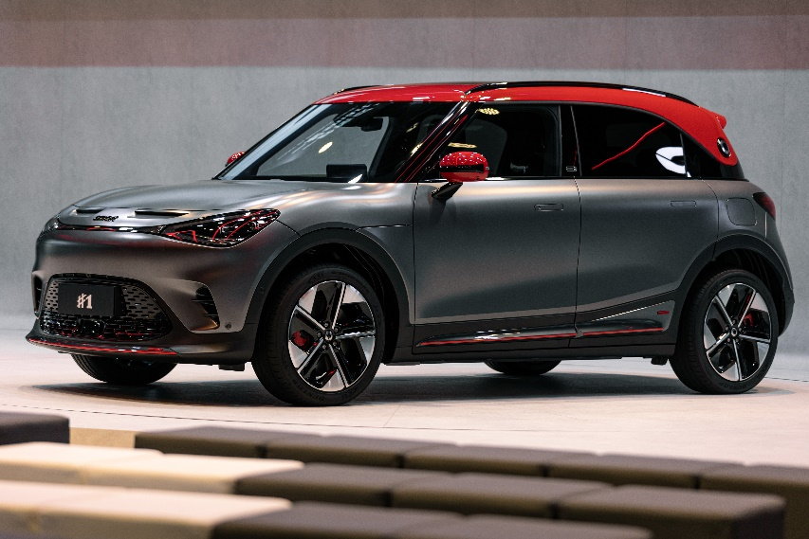
The all-new smart #1 BRABUS has a 50:50 balanced weight distribution

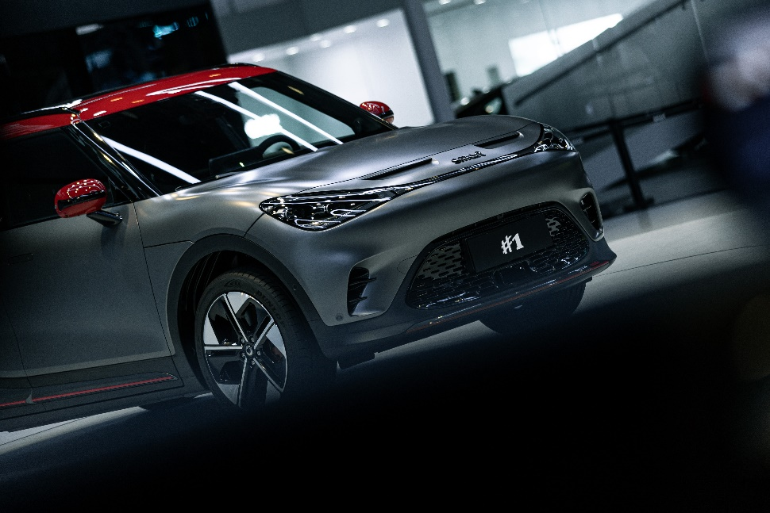
Eco / Comfort / Sport / BRABUS – Four driving modes

Eco mode uses rear-wheel drive and is suitable for normal daily urban commuting road conditions, also considering rear-drive driving fun - and the longer battery life. Comfort mode uses part time four-wheel drive, which is suitable for scenarios such as holiday travel. In Sport mode, full-time four-wheel drive is activated, with power always on call. In BRABUS mode, the front and rear motors are fully unleashed to 100% power, instantly bursting with adrenaline-pumping torque and delivering a supercar-level driving experience.

Your urban companion knows just what you need to get your driving fix

Sound is part of the symbolic personality of a performance car and one of the things most evocative of the desire to drive. The all-new smart #1 BRABUS brings 2 kinds of analog sounds, including “smart original sounds” and classic themes. Among them, the smart original sound was sampled from the previous smart BRABUS fuel version model, with the “classic” analog sound inspired by the amazingly powerful V6 engine. A light press on the throttle will activate heart pumping sounds from the 13 Beats speakers, showcasing the unique high-perfomance personality of the smart #1 BRABUS.
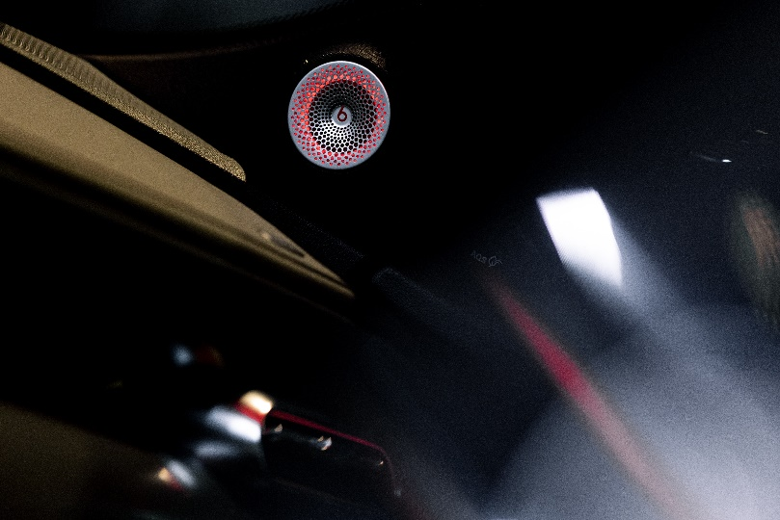
The all-new smart #1 BRABUS brings with it two analogue soundtracks

Sales of the smart #1 BRABUS officially began at 10:30 on August 26. Users can log into the smart app or the official smart mini program to enter the limited time lottery, entry closes on August 29 at 20:00. Users can qualify to enter by putting down a deposit for the smart #1 BRABUS. On August 30, the lottery winners will be announced live online; unselected entrants will automatically be refunded their deposits. Furthermore, users who have completed their deposit payment before August 15 can upgrade their models to the smart #1 BRABUS between 10:30 on August 26 and to 20:00 on August 29, keeping their original order’s estimated delivery time and receive “Companion BUFF” points.

With the continued enrichment of smart’s new-generation all-electric product family lineup and the full implementation of services to look forward to, smart will continue to bring more surprises to customers, to design a smarter future together!

-End-

For the latest information, please visit:
smart Global Media Centre: https://media.smart.com/
smart Automobile Website: https://www.smart.cn/
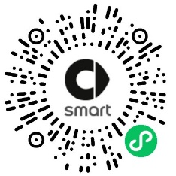
smart mini program

About smart Automobile

Since the birth of the brand in the 90s, smart has always maintained the vision of exploring the best solutions for future urban mobility. In 2019, smart Automobile Co., Ltd. was officially established. With a forward-looking “China-Europe dual-home” global development strategy, smart is committed to developing into a world-leading, premium, all-electric automobile and technology brand.

smart has recently completed a comprehensive renewal of its brand, products, and business model. New generation all-electric product development is led by the smart R&D team, with the Mercedes-Benz global design team responsible for vehicle design, and the product portfolio now expanded into more market segments. The renewed brand’s first all-new all-electric SUV, the smart #1, which premiered worldwide in April, is now on sale in China, with official deliveries from September. To further enhance its global operations, smart has established marketing and sales centres across China and Europe.

