Press Release
September 28, 2022

Driving the smart #1 –Redefining the user mobility experience

(September 28, 2022, Lisbon) Following the world premiere of the smart #1 which introduced the revolutionary model to the public for the first time, smart is excited to now hit the road with the model. Designed as a mobility companion that adapts to the user’s needs, it fits perfectly into any environment, be it a pulsating city like Lisbon or a twisting road through the coastal mountains. The smart #1 is the first of a new generation of all-electric smart cars, transforming how users will experience mobility as soon as they get into the car.

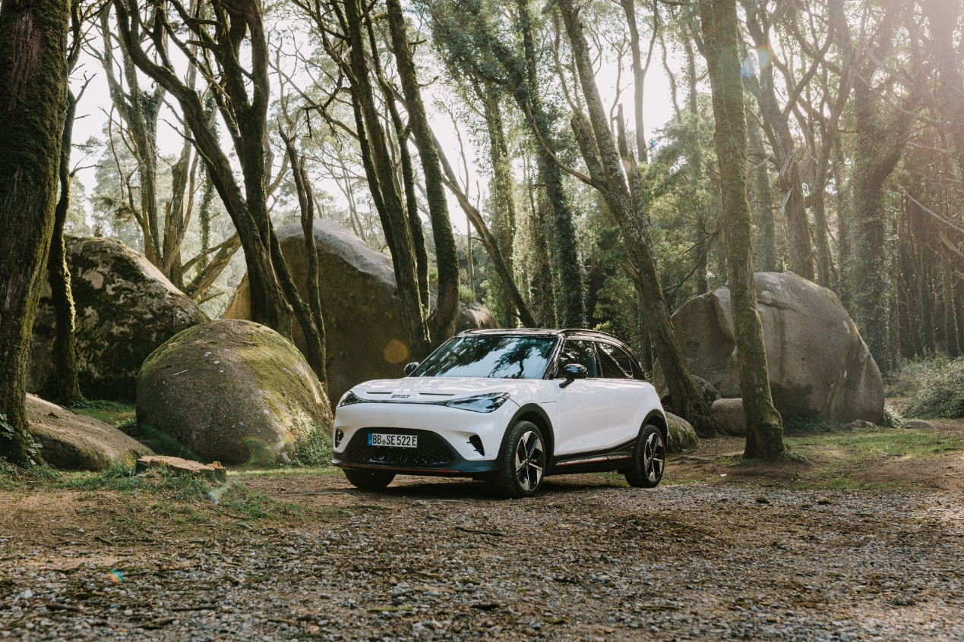

Having launched its first EV test program 15 years ago, and having been the first brand in the industry to complete the transition to all-electric vehicle in 2020, smart combines its distinct know-how in electric mobility with the pioneering premium design of Mercedes-Benz and the advanced engineering power of Geely’s SEA platform to deliver next-generation mobility today.

Ready for the Urban Environment

The smart #1 continues the smart legacy of offering exceptional space utilisation and a pioneering approach to urban mobility. At 4.27m long, it offers an outstanding amount of space and flexibility within a compact overall footprint. Perfectly suited to the urban environment it also makes long distance travel hassle-free, with a range of up to 273 miles, easy journey charging solutions and a DC charging capacity of 150kW. Combined with a high degree of connectivity, the smart #1 offers the perfect mobility solution for the modern urban customer.

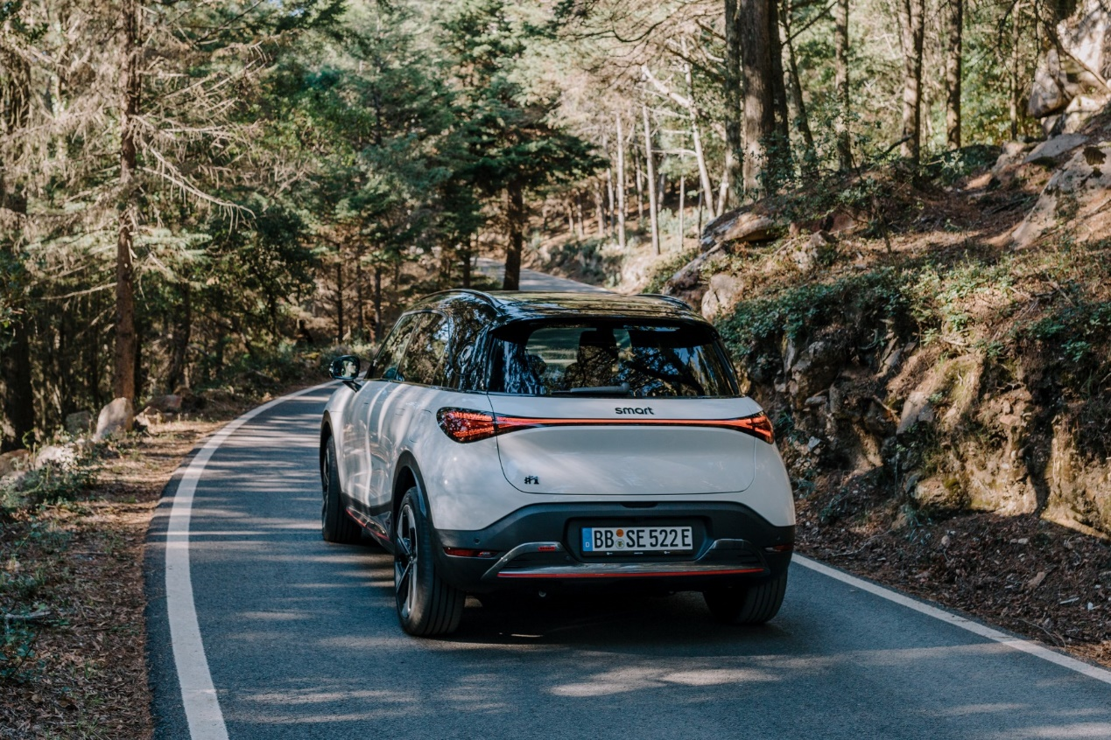

As versatile as their users - smart #1 model lines

In line with the “customer-centric, data-driven” approach, smart will offer a variety of smart #1 models to choose from, perfectly fitting the needs and lifestyles of users. Besides the well-equipped Launch Edition which was showcased at the world premiere earlier this year, the smart #1 will soon be available in several different variants: the Pro+, Premium and BRABUS.

Dirk Adelmann, CEO smart Europe: “The smart #1 finally starts its journey to become an integral part of the sustainable future mobility. With the upcoming start of pre-ordering, our direct-to-customer approach is also going live. Now our customers can select the smart #1 version that best fits their needs and define their way of owning or using it. We are really looking forward to the positive impact we can make in the industry in general and our customers’ daily lives specifically.”



Pre-order is right around the corner

Pre-ordering of left-hand drive cars for the main European markets will commence in October, with the first deliveries to customers in early 2023. For the UK, pre-orders of the Launch Edition will be available from January and are strictly limited to a volume of 100 cars. Pre-orders for the Pro+, Premium and BRABUS models will open in the second quarter of 2023, with the first customer deliveries expected in the third quarter. UK pricing will be confirmed prior to start of pre-orders.

Yifeng Tan, Head of Connected Cars and Products, smart Europe: “We are very proud of what we achieved with the smart #1. Even the entry-level car offers an extensive package of features that would normally be associated with luxury cars. With our different models, we have curated our feature list into very attractive packages that offer an exceptional standard specification and the ability for owners to tailor the car to their personal taste and lifestyle.”

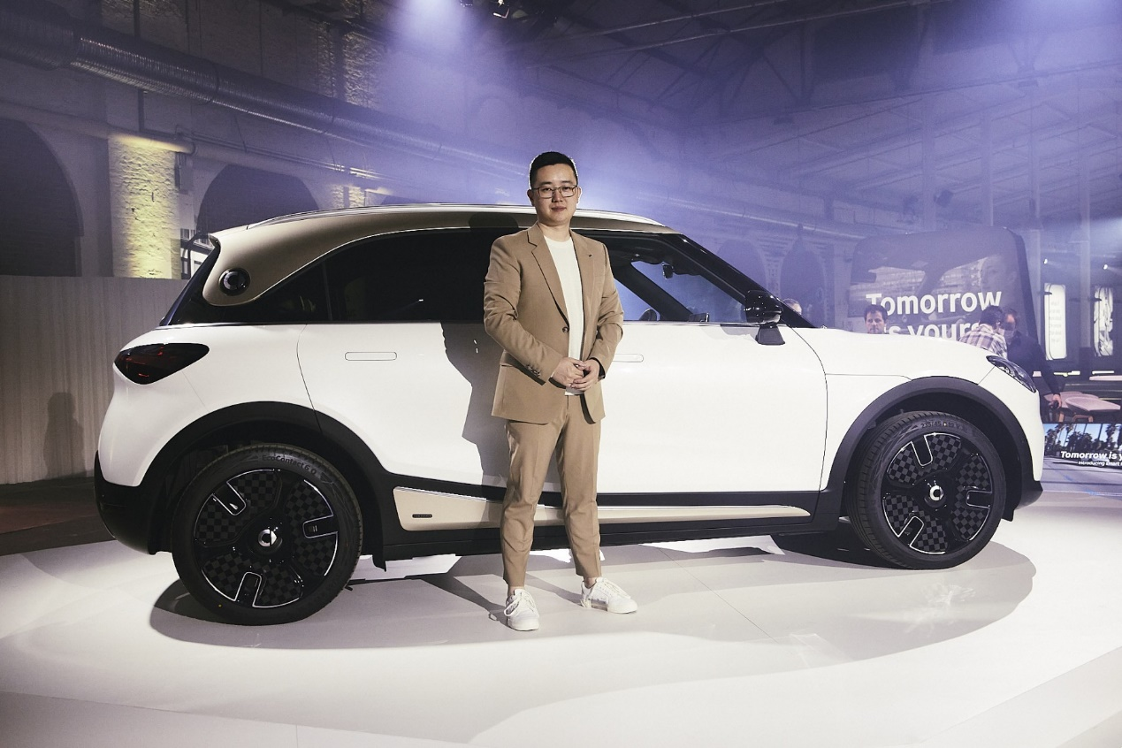

In addition to the features that are already available on the Pro+ line, such as an extensive range of driving assistance systems, a 360-degree surround camera, intelligent voice assistance, LED lights and a powered tailgate, the Premium line offers a sound system by Beats, a Head-Up Display (HUD), CyberSparks+ LED Matrix headlights and Automatic Parking Assist. The smart #1 BRABUS will step up from two-wheel drive to four-wheel drive and offer even more unique BRABUS influences around the car.

The next chapter of smart x BRABUS

The smart #1 opens a completely new chapter for smart and BRABUS, elevating their partnership to the next level. The smart #1 BRABUS marks the milestone of fully integrating the unique BRABUS touch into the smart product range at the production level, making it available to even more people.

Quite apart from its dynamic looks, the performance of the smart #1 BRABUS naturally receives an upgrade as well. The standard 200 kW of power is bumped up to 315 kW, while torque increases from 343 Nm to 543 Nm with four-wheel drive to ensure traction and aid acceleration. Paired with the specifically calibrated BRABUS driving mode, this results in an even more thrilling driving experience, unleashing the full potential of the car for incredible 0-62mph performance of just 3.9 seconds.

Kai Sieber, Head of Design smart: “The smart #1 BRABUS will seamlessly tie into the long-standing successful partnership between the two brands. The design will be clearly distinguished from other smart #1 model lines by a body kit with performance-inspired, expressive spoilers at the front and rear and specific side sills. Dedicated rims, the typical BRABUS red accents on the exterior and the specific interior line round off the car.

Constantin Buschmann, CEO BRABUS: “For us at BRABUS, partnering with smart feels completely natural, as we both keep on challenging the status quo to improve our brands and products further. For the smart #1 we keep on pushing the envelope of our partnership to integrate the essence of BRABUS into a very capable car and future-oriented mobility concept, that is accessible for a wide variety of people. We are very happy with the result and see the smart #1 as a more-than-worthy starting point for a new era of our great relationship with smart going forward.”


smart connections that happen to be a car

Connecting people, places and experiences is the essence of mobility. The smart #1 is built to achieve exactly that through an immersive and pure driving experience, which helps the driver focus on what’s really important while offering support, assistance and all the creature comforts they want and need.

Users benefit from an outstanding human-tech balance in the car, ensured by a partnership with ECARX, an expert in software and hardware integration. The powerhouse partnership is driving the transformation of vehicles into fully integrated information, communication and transportation devices. The smart #1 is the first joint project to redefine the user experience in a smooth, efficient, and enjoyable way.
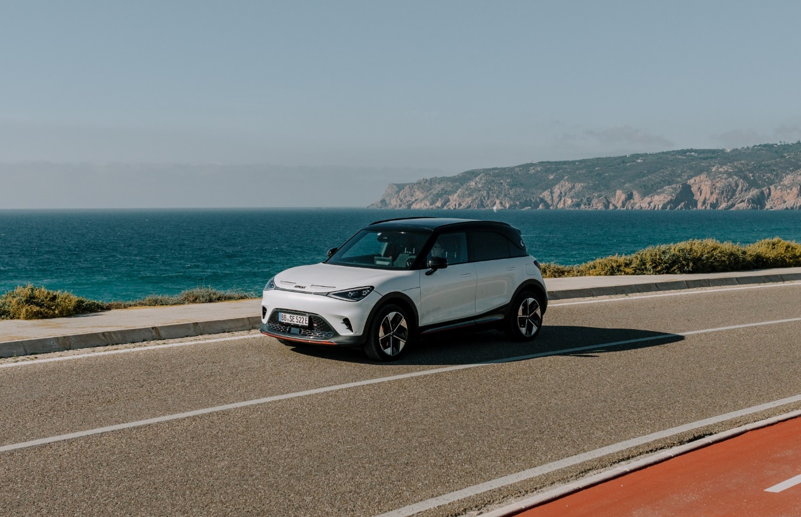

The new ease of car ownership

The introduction of the all-new smart #1 also sees smart adopt a fully integrated D2C agent-based sales model in addition to the well-organized agent dealership network. For this new digital era smart utilises the integrated financial services offering of ALD, with the payment transactions partner for European customers set to be announced shortly. The new system will keep complexity low and enable a simple ordering process for customers, allowing them to reserve, buy, or lease a smart #1 with just a few clicks and no paper contracts needed.

-END-

For the latest information, please visit:
smart Global Media Centre: https://media.smart.com/
smart Automobile Website: https://www.smart.cn/


smart mini program

About smart Automobile

Since the birth of the brand in the 90s, smart has always maintained the vision of exploring the best solutions for future urban mobility. In 2019, smart Automobile Co., Ltd. was officially established. With a forward-looking “China-Europe dual-home” global development strategy, smart is committed to developing into a world-leading, premium, all-electric automobile and technology brand.

smart has recently completed a comprehensive renewal of its brand, products, and business model. New generation all-electric product development is led by the smart R&D team, with the Mercedes-Benz global design team responsible for vehicle design, and the product portfolio now expanded into more market segments. The renewed brand’s first all-new all-electric SUV, the smart #1, which premiered worldwide in April, is now on sale in China, with official deliveries from September. To further enhance its global operations, smart has established marketing and sales centres across China and Europe.

