Press Release
March 28, 2024

Boosting Global Business Expansion
smart #1 Officially Unveiled in Singapore

- Today, smart and Cycle & Carriage, the brand’s general distributor, joined hands to officially unveil the smart #1 for the first time in Singapore.
- Sales of the smart #1 are slated to begin from April 2024 in Singapore, with a series of roving roadshows lined up before the launch of the showroom in the second half of 2024.

(March 28, Singapore/Hangzhou) After announced that Cycle & Carriage to be the general distributor in Singapore in January, smart today achieved a new milestone in the market. The first member of the brand’s new generation all-electric product portfolio, smart #1 celebrated its first unveiling in Singapore. Local sales of the model will start from the end of April 2024.
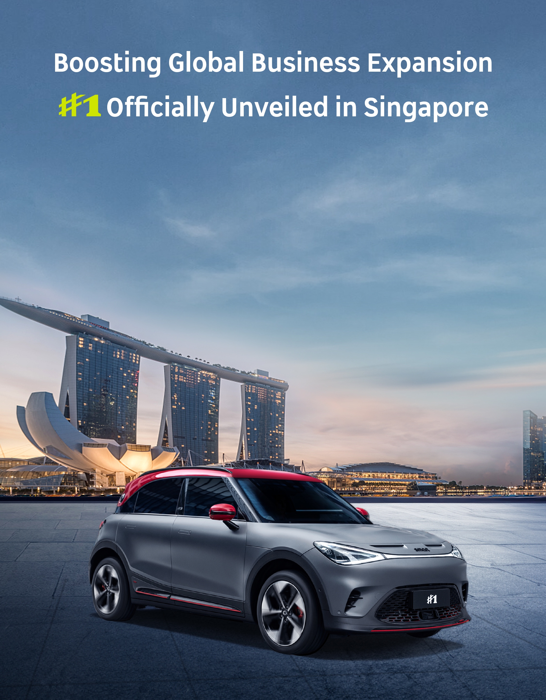
smart #1 officially unveiled in Singapore

Ms Mandy Zhang, Global CMO of smart Automobile said: “Now is the right time for smart to expand into Singapore. With Cycle and Carriage’s strong, diversified presence in Southeast Asia, and its established position as the largest automotive company in Singapore, we have found the ideal trusted partner to quickly integrate and tap into the growing wave of car owners looking to transition to EVs. This is part of our broader efforts to hold true to our vision of exploring the best solutions for future urban mobility.”
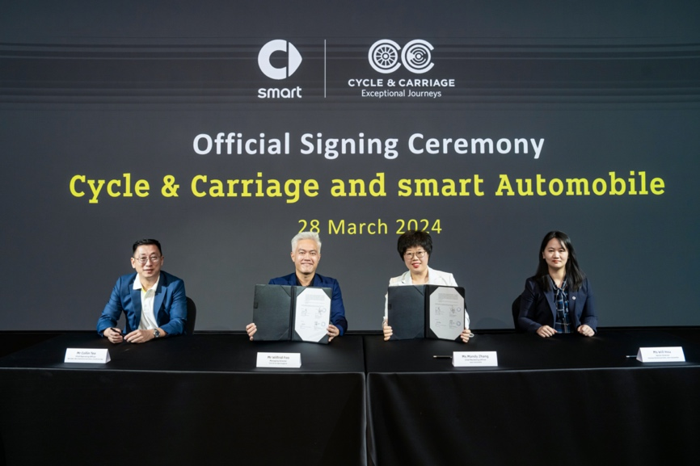
Partnering with Cycle & Carriage, smart Strengthens Its Market Presence in Singapore

The partnership with Cycle & Carriage will kick off with the introduction of smart’s all-electric line-up, beginning with the much-anticipated Singapore market entry of the smart #1 Pro+ and BRABUS edition.

Mr Wilfrid Foo, Managing Director, Cycle & Carriage Singapore, said: "We look forward to developing the EV market in Singapore together with smart, and introducing future mobility solutions that will engage and excite our community of car enthusiasts. smart’s vision of future urban mobility and sustainable development align perfectly with our focus and current trends. Together we will redefine the electric vehicle landscape in Singapore, introducing a ‘new-premium’ standard of intelligent driving experiences to our customers."
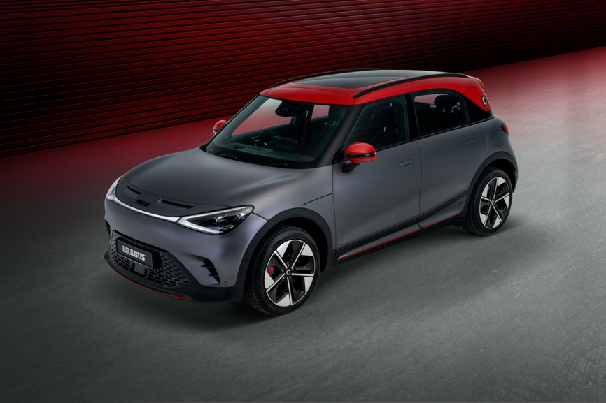
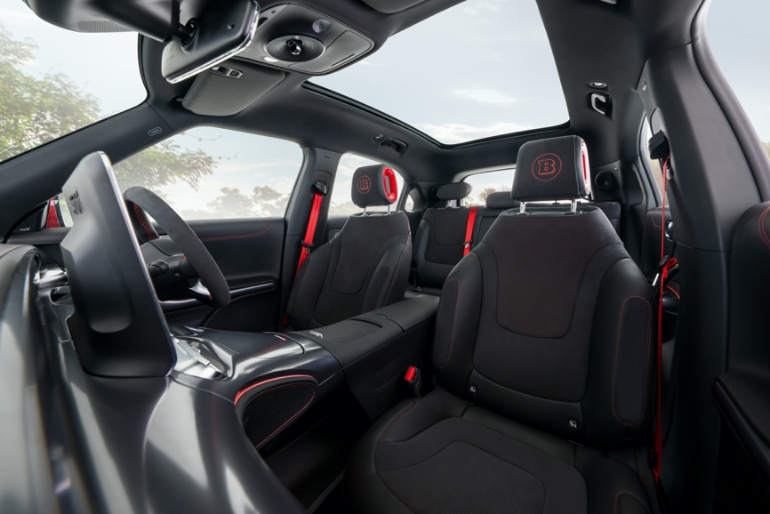
smart #1 BRABUS

In addition to establishing a strong foothold in Singapore, smart has been rapidly expanding its global business footprint. The smart #1 has entered in 22 countries and regions by this month, receiving widespread acclaim for its innovative design and eco-friendly performance. Continuing to expand its global footprint, smart remains dedicated to its mission of providing the best solutions of future urban mobility, to design a smarter future together.

-End-

