Press Release
November 16, 2022

All-new smart #1 is Awarded a Five-Star Euro NCAP Rating

(November 16, 2022, Hangzhou) Today, all new smart #1 has been awarded a five-star rating safety certificate following European New Car Assessment Program (Euro NCAP) crash test. In all safety categories covering Adult Protection, Child Protection, Vulnerable Road Users (VRU) and Safety Assist, the all new smart #1 received a five-star rating. Scores for adult protection and child protection were 96% and 89%, far exceeding the industry average.
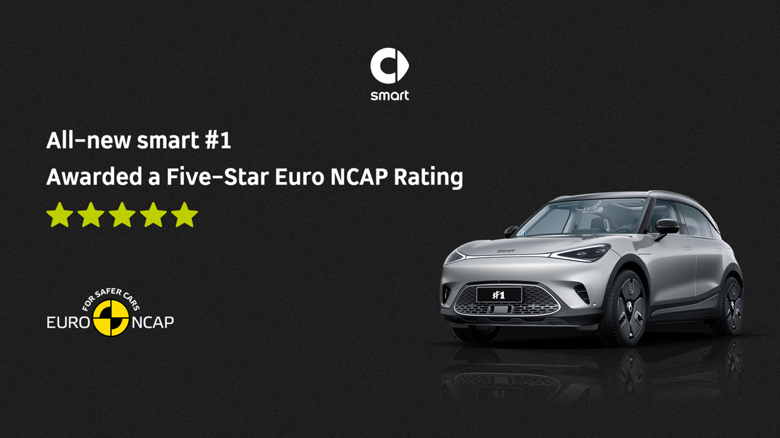
All-new smart #1 is Awarded a Five-Star Euro NCAP Rating
Intentioned R&D and design create the "five-star" safety rating
From its initial research and design stages, the overall structure of smart #1 was developed in strict accordance with the five-star safety standards of both Chinese and European markets. With a 74% usage of high strength steel and 19% press hardened steel the smart #1 creates a strong safety environment for its customers.
Meanwhile, the safety features of the vehicle are designed specifically to cover frontal collision, side collision, rear collision and roof extrusion, with ample redundancy measures to create the "five-star" safety rating.
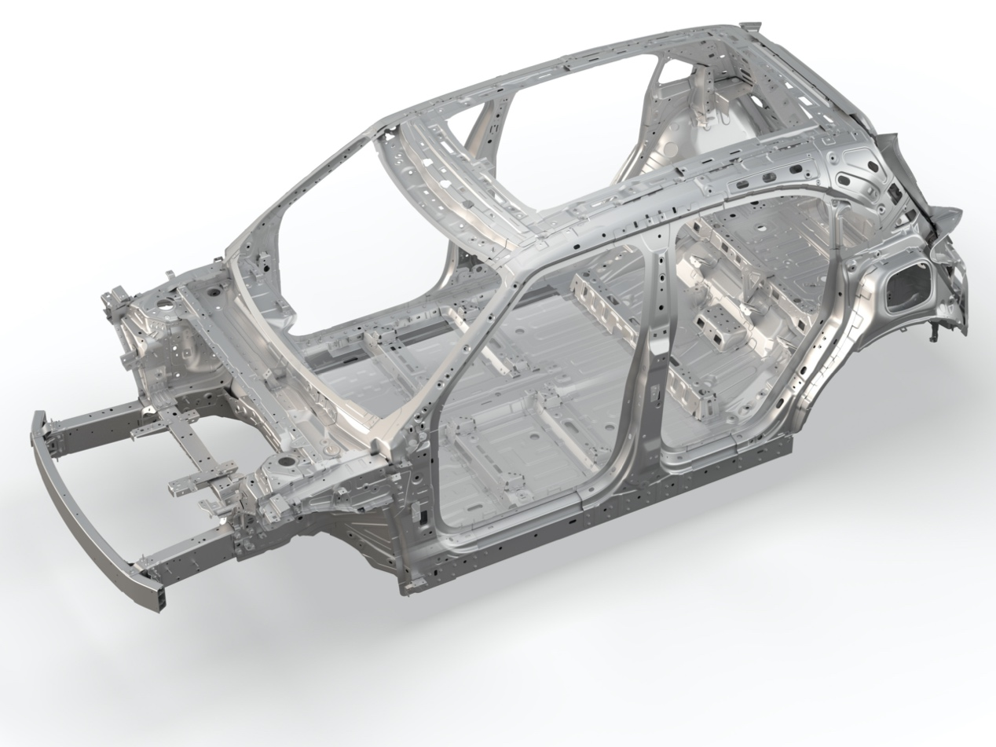
The overall structure of smart #1 was developed in strict accordance with the five-star safety standards
In addition to the top-notch safety design of the body, comprehensive safety is built into the smart vehicle batteries. smart’s batteries employ non-thermal-propagation (NTP) technology, comprehensively raising the safety profile of the entire battery pack with six additional measures: 360° prevention, automatic warning, passive heat insulation, active cooling and quick cut-off. The technology ensures that in an extreme emergency, the smart #1 battery pack will not combust within one hour, far exceeding the 10 minutes required by industry standards.
Intelligent safety for 360 degree “five-star” protection
In order to provide customers with 360 degree five-star protection, the smart #1 is equipped with numerous active safety features. The FCM front collision mitigation early warning system can apply full braking to aid the driver in collision avoidance with a forward object. When unintentionally deviating from a vehicle lane, the ELKA Plus Lane Emergency Maintenance Assist System can control the electronic power steering in time to correct the deviation.
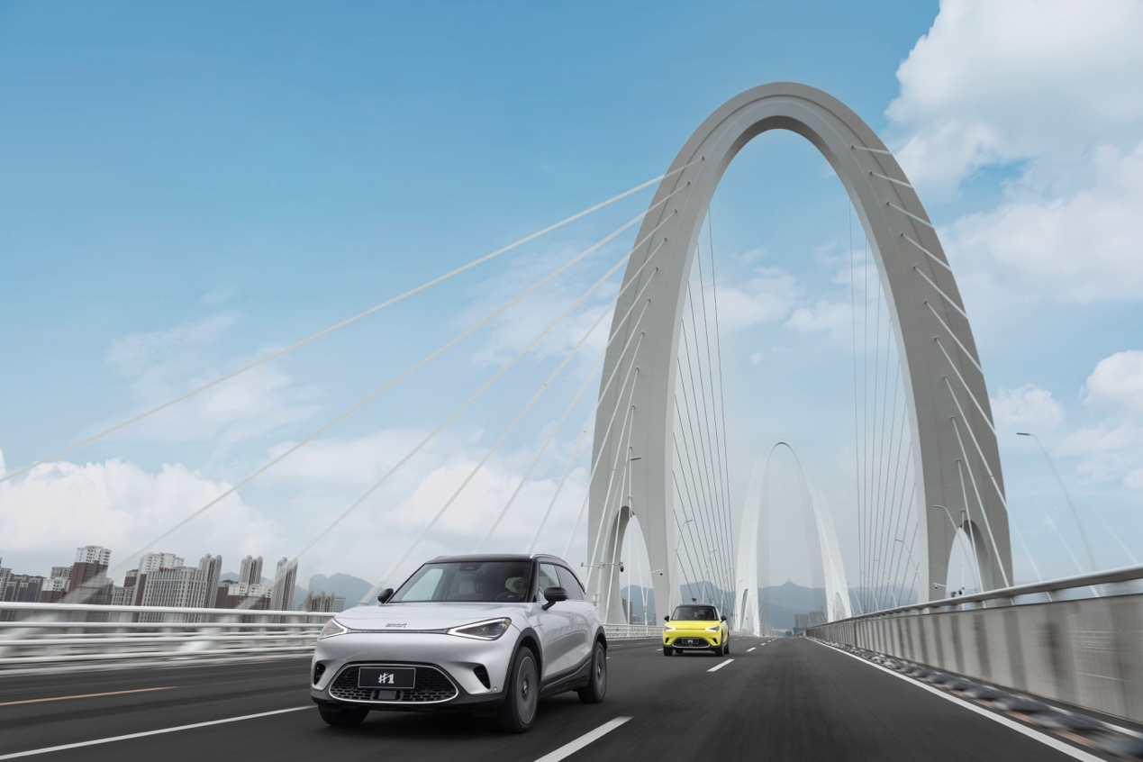
smart #1 is equipped with numerous active safety features
In addition, the smart #1 is also equipped with lane keeping assistance (LKA), parking emergency braking (PEB), door opening early warning system (DOW), emergency mobility assistance (EMA), rear collision mitigation (RCM) and other active intelligent safety features, significantly reducing the incidence of potential accidents and ensuring safer urban mobility.
Strict production and manufacturing standards create “five-star” premium quality
Euro NCAP's five-star safety rating proves not only smart #1 the outstanding level of safety, but also smart’s strict adherence to production and manufacturing standards.
The production and manufacturing process of smart include rigorous quality control and undergoes independent monitoring and auditing by a professional quality team to ensure end-to-end quality management, from raw materials and process quality to product quality. In addition, smart works together with top international suppliers like Continental, Magna, Hella and Qualcomm to establish a high-quality management system.
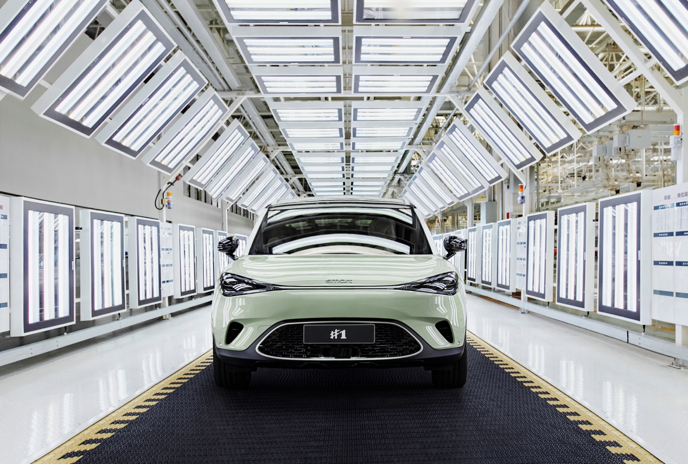
smart’s strict adherence to production and manufacturing standards
The smart #1 manufacturing facilities have achieved ISO 9001 Quality Management System certification, further demonstrating the brand’s world-class premium quality.

smart will continue to accompany customers to explore the possibilities for tomorrow’s urban mobility to design a smarter future together.

-End-

For the latest information, please visit
smart Global Media Centre: https://media.smart.com/
smart Automobile Website: https://www.smart.cn/

Media Inquiries
Sebastian Liu: sebastian.liu@smart.com


smart mini program

About smart Automobile
Since the birth of the brand in the 90s, smart has always maintained the vision of exploring the best solutions for future urban mobility. In 2019, smart Automobile Co., Ltd. was officially established. With a forward-looking “China-Europe dual-home” global development strategy, smart is committed to developing into a world-leading, premium, all-electric automobile and technology brand.
smart has recently completed a comprehensive renewal of its brand, products, and business model. New generation all-electric product development is led by the smart R&D team, with the Mercedes-Benz global design team responsible for vehicle design, and the product portfolio now expanded into more market segments. The renewed brand’s first all-new all-electric SUV, the smart #1, which premiered worldwide in April, is now on sale in China, with official deliveries from September. To further enhance its global operations, smart has established marketing and sales centres across China and Europe.

