Press Release
August 15th 2022

1 second wow, in a smart way
Stunning at a glance, the all-new smart #1 BRABUS
(August 15th, 2022, Hangzhou) After wowing the world with the first member of its new generation all-electric product family lineup, smart, the premium all-electric automotive technology brand is delivering another exciting surprise to performance car enthusiasts and smart fans around the world.

Continuing a 20-year legacy into the e-mobility era, smart and BRABUS, the world's largest independent automotive refinement specialist and exclusive supercar manufacturer, have partnered up to co-create the urban all-electric performance driving experience with an iconic edition – the all-new smart #1 BRABUS. As the first co-creation of the partnership, the all-new smart #1 BRABUS transcends the times, providing aggressive styling with BRABUS design elements, and of course the outstanding performance offered by electric drive technology for that punchy ”1 second wow”, delivered in a smart way.
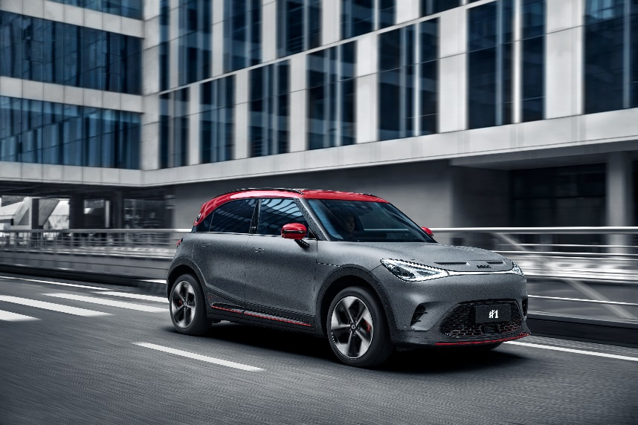
the all-new smart #1 BRABUS
Mandy Zhang, Vice President of Global Sales, Marketing and After-Sales of smart Automobile Co., Ltd. said: ”The smart #1 BRABUS reimagines the urban performance driving experience for the e-mobility age. We are rebuilding our shared vision of the urban performance car from the ground up and can’t wait to see customers’ reactions when they see the aggressive design empowered by BRABUS and feel the class-beating performance. The model is more eye-catching and sportier than ever, loaded with personality and guaranteed to wow customers and turn heads everywhere.”

Mandy Zhang, Vice President of Global Sales, Marketing and After-Sales of smart Automobile Co., Ltd.
smart & BRABUS 20-year legacy continues into the e-mobility era

First teaming up back in 2002 and now embarking on a new era of collaboration, smart and BRABUS are no strangers to one another. As the first in the industry to abandon internal combustion engines and complete the transition to an all-electric brand, smart is again pioneering the best of two worlds, harnessing the creative energy of the renewed smart brand and the freshly invigorated BRABUS to introduce new kinds of exclusivity, uncompromising intelligence and next-level power to the market.
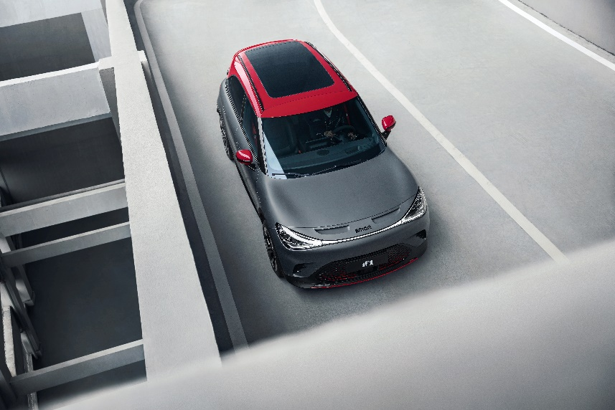
smart & BRABUS 20-year legacy continues into the e-mobility era

Mr. Constantin Buschmann, the owner & CEO of BRABUS Group said: ”Over the past 20 years, smart and BRABUS have co-created a high-performance urban legend and won the hearts of countless performance car enthusiasts. We are excited to continue our two-decade partnership with smart into the e-mobility era. At BRABUS we always push forward, more innovation, more performance, more exclusivity, more fun - but also more safety, more eco-friendliness, more sustainability. The combination of these factors makes our two brands the perfect partners.”
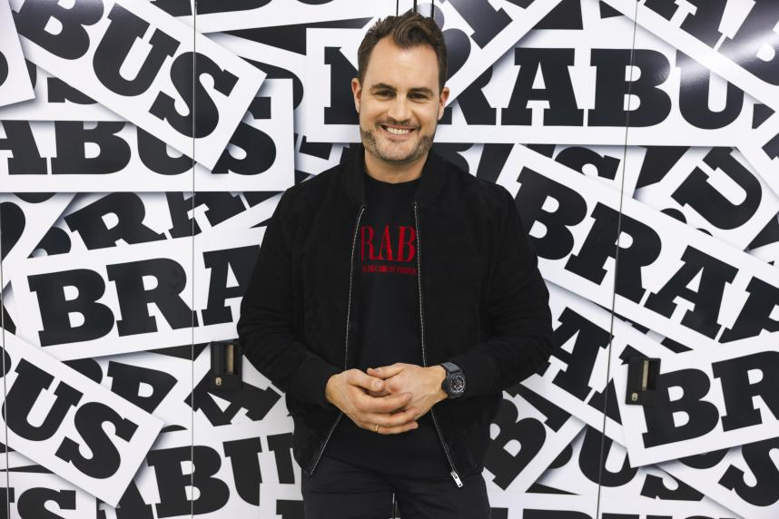
Mr. Constantin Buschmann, the owner & CEO of BRABUS Group

Stunning at a glance, premium design empowered by BRABUS

The smart #1 BRABUS promises to be the most exhilarating smart car to drive to date. The vehicle is fitted with exclusive BRABUS exterior and interior design elements and features a long list of special additions which make the model ultra-desirable. With premium performance styling, the car takes on a more aggressive look, featuring a rear spoiler, 19-inch dynamo rims and a sporty front design guaranteed to command attention, no matter how exclusive the backdrop. Accenting the front is the red grille and the unmistakable bumper air curtain, while the interior features a steering wheel covered by Alcantara and leather, microfiber suede seats and headrests with BRABUS design stitching, and red seatbelts. Translucent soft sunshades and metal pedals add to the sporty feeling of the car.
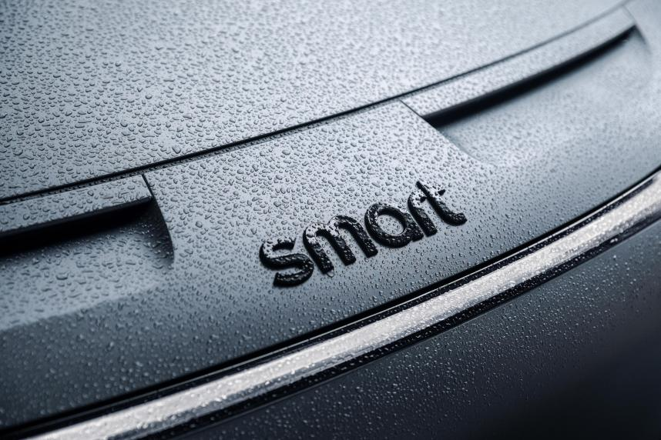
the all-new smart #1 BRABUS: a sporty front design
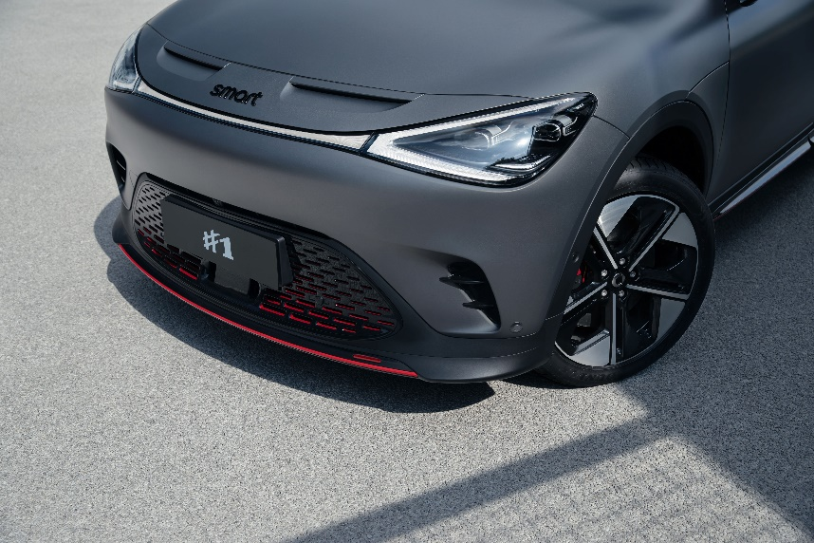
the all-new smart #1 BRABUS: bumper air curtain
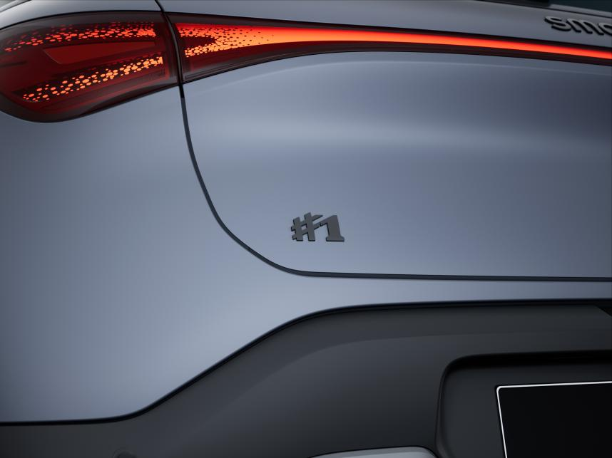
the all-new smart #1 BRABUS: black wordmark
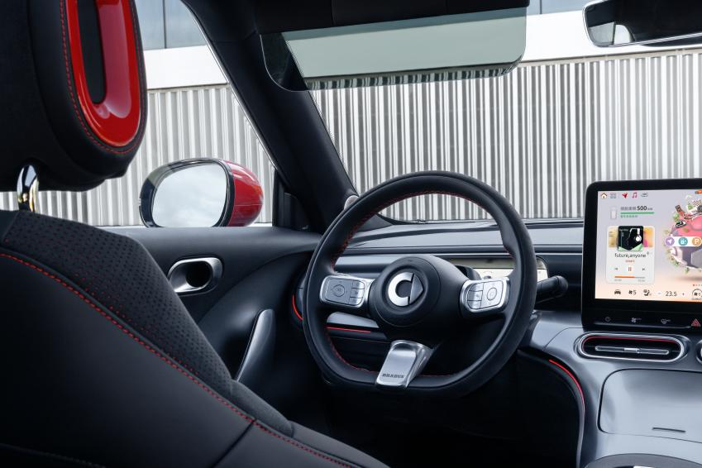
the all-new smart #1 BRABUS: translucent soft sunshades
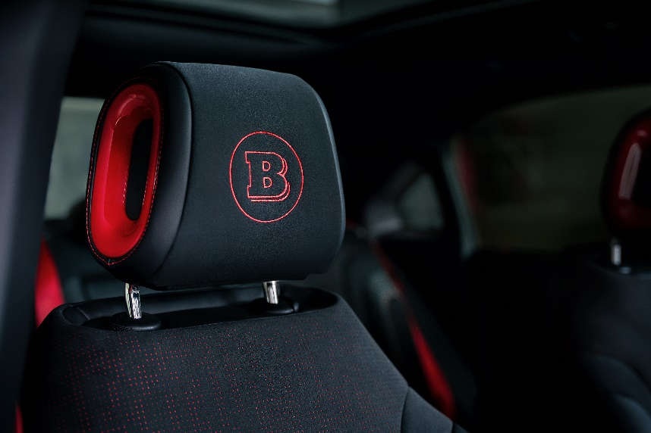
the all-new smart #1 BRABUS: headrests
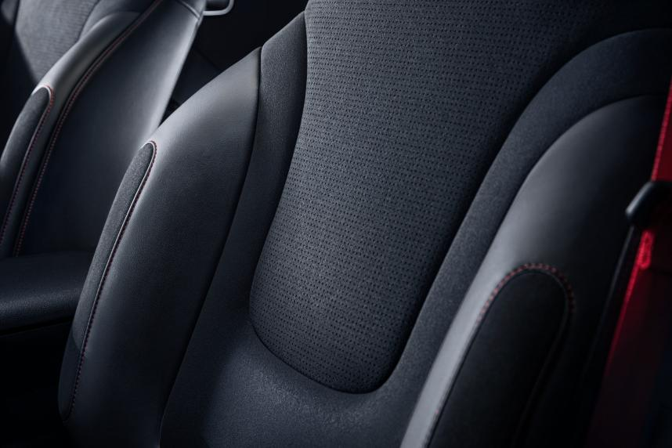
the all-new smart #1 BRABUS: microfiber suede seat
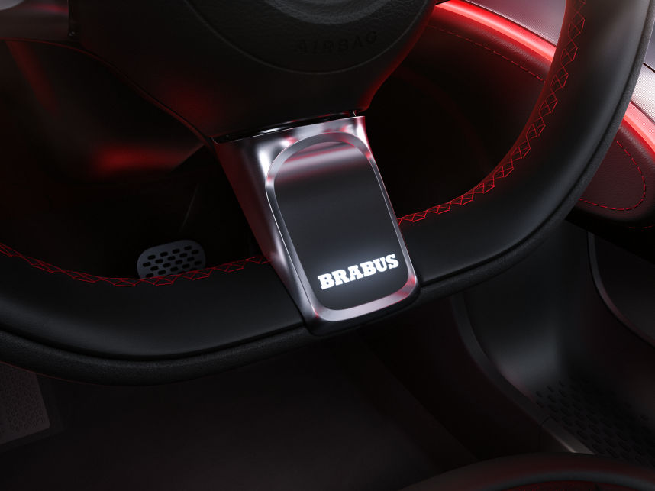
the all-new smart #1 BRABUS: steering wheel logo
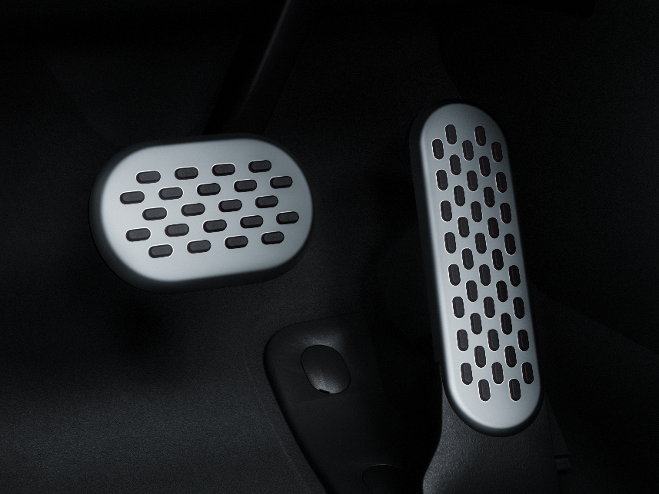
the all-new smart #1 BRABUS: metal pedals

Head of Design at smart, Kai Sieber said: ”The BRABUS trim line of the smart #1 will seamlessly tie into the history between the two brands. The design is clearly distinguished from other smart #1 trim lines by a body kit with performance-inspired expressive spoilers at the front and rear, and specific side sills. Dedicated rims, the classic BRABUS red accents on the exterior, and the specific interior line complete the car.”
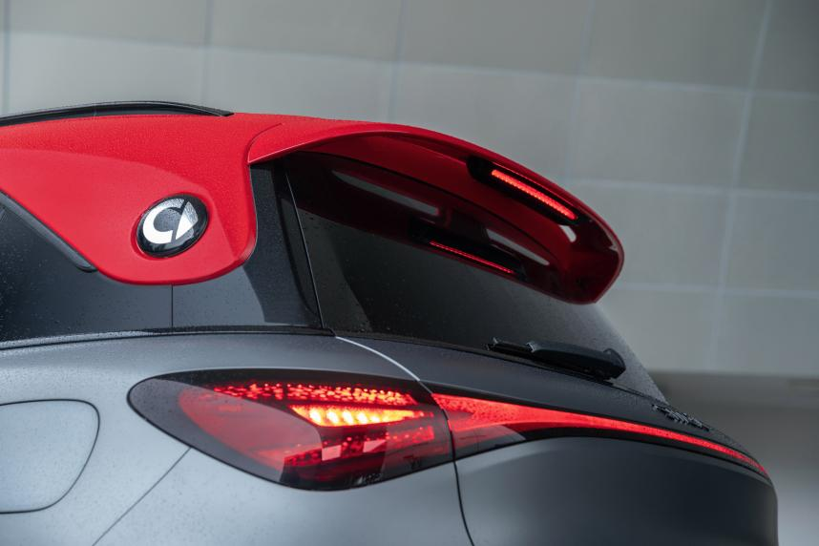
the all-new smart #1 BRABUS: spoilers

The smart #1 BRABUS not only ensures every customer has access to hair-raising exhilaration, unbridled power and the agility that‘ll get from A to B in the smartest way possible, they’ll also be accompanied by the ultimate urban companion who’ll help to make it the most intelligent, efficient and convenient ride possible. smart‘s future-tech powered, intelligent urban e-mobility solutions paired with BRABUS’ versatile performance styling will set a new benchmark in the segment. Opening the new chapter of collaboration, the two iconic brands are sure to bring more exciting stories to customers, and to design a smarter future together.

Disclaimer: According to divergent local laws/regulations and market situations, the specifications of the products distributed in different countries/regions may vary. The pictures above are for reference only, and please refer to the detailed specifications of products sold in local markets.

- End –


Scan the QR code above and subscribe smart mini program

About smart Automobile
Since the birth of the brand in the 90s, smart has always maintained the vision of exploring the best solutions for future urban mobility. In 2019, smart Automobile Co., Ltd. was officially established. With a forward-looking "China-Europe dual-home" global development strategy, smart is committed to developing into a world-leading, premium, all-electric automobile technology brand.

smart has recently completed a comprehensive renewal of its brand, products, and business model. New generation all-electric product development is led by the smart R&D team, with the Mercedes-Benz global design team responsible for vehicle design, and the product portfolio now expanded into more market segments. The all-new smart #1, which recently celebrated its world premiere, will be launched on the market in 2022 and sold in China, Europe, and other markets. To further enhance its global operations, smart has established marketing and sales centers across China and Europe.

