Press Release
20th April ’21
Embracing Change, smart Gears up to Open Next Chapter of the Brand
- smart is committed to explore the best solution for urban mobility and embraces electrification and high-tech.
- The all-new smart concept car will stage a global debut this September in Munich International Motor Show.
- The next generation of smart vehicle opens next chapter of smart with strong brand heritage, China state-of-the-art production and global distribution.
- smart “Gravity Plan” new retail partner conference will kick off in Shanghai on April 22.
(April 20, 2021, Shanghai) With the theme of “Embracing Change”, the 19th Shanghai International Automobile Industry Exhibition already opened. As a pioneer in urban mobility, smart always eyes on electrification and high-tech and completed electrification in the end of 2019 as the first brand to all-electricity. With its all-electric positioning, smart adheres to the brand spirit -design a smarter future and is gearing up to bring a connected electric mobility experience for the avant-garde trendsetters. The compact all-new smart concept car will stage its global debut during the IAA in Munich this September.
Mr. Tong Xiangbei, Global Chief Executive Officer of smart Automobile Co., Ltd., said: “A large number of new technology players give rise to a new round of revolution. smart boasts of an international team. With its input on research, development and production as well as operation innovation, smart is extremely confident to cope with these changes and safeguard the future development.”
Mr. Daniel Lescow, Vice President of global Sales, Marketing & After-Sales of smart Automobile Co., Ltd., said, “We strongly believe that the combination of our smart brand with technological and electric innovation in a SUV will be groundbreaking. The premium design of smart - for which the brand is known worldwide will continue to come from Mercedes-Benz and embodies all we believe in – progressive design, short overhangs, innovation, high-tech and, of course, battery-electric driving. smart will be presenting a concept of the first vehicle in the brand's next chapter during this year’s IAA in Munich .”
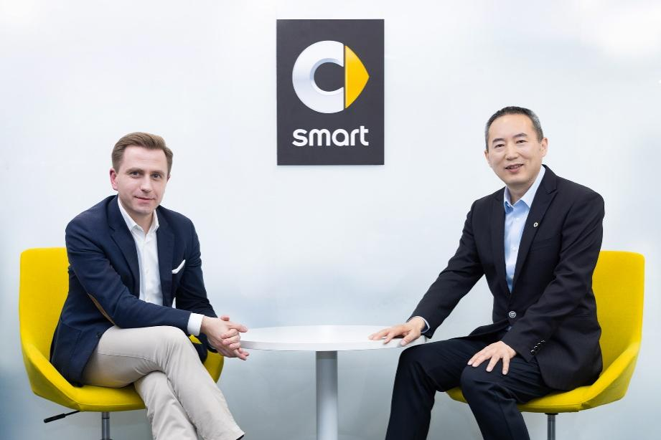
Group photo of Tong Xiangbei, Global CEO and Daniel Lescow, Vice President of global Sales, Marketing & After-Sales
In the end of 2019, the global joint venture of smart brand was formally established by Zhejiang Geely Holding and Mercedes-Benz AG. The two sides made joint efforts in the fields of R&D, manufacturing, and supply chain to achieve a win-win cooperation.
smart embodies a professional international team, makes full use of its resource advantages and strives to become a world leading premium all-electric technology brand. smart Automobile Co., Ltd. has completed the setup of global operations, R&D, and production. The sales & marketing centers in China and Europe have also been put into place, respectively responsible for smart business operations in Chinese and European market.
A Premium High-tech All-Electric smart Vehicle
smart has always been a pioneer in urban mobility and remains committed to being innovative in the field, that means more high tech, more connectivity and more of a premium appeal.
The first vehicle of new generation smart will be a premium high-tech all-electric compact SUV, which was designed by Mercedes-Benz AG and engineered with the support of Geely Group Holding. The new car is developed based on SEA architecture, a perfect embodiment of technology and high safety capabilities, will exceed customers’ expectation. The first all-electric compact SUV will be launched in 2022, and the new model will be the beginning of next chapter of smart, with strong brand heritage, China state-of-the art production and global distribution.
A smarter Business Model: Customer Centric, Data Driven
With the strong support of connected and digital technology, a new smart business model is going to be launched in the future.
smart “Gravity Plan” new retail partner conference will kick off in Shanghai on April 22. During the event, smart will discuss future development with potential investor partners from successful groups in the national auto distribution industry and announce the new business mode. Through the sophisticated interaction between online and offline and a true omnichannel approach, smart will continue to explore the future mobility technology.
As new energy vehicle market competition moves towards deeper and more refined segment, smart is ready to uphold a strategic foresight to approach change of global auto market with a new chapter of development.

