Press Release
December 21, 2023

Advancing the “Carbon Neutrality” Process, Driving Digital Transformation in the Industry Forward
smart Releases Latest Sustainability Report

- On December 21, 2023, smart released its latest Sustainability Report, showcasing the brand's annual achievements and action plans in advancing sustainability across five key areas: Integrity & Transparency, Product & Privacy, Climate & Low Carbon, Circularity & Resources, and Employees & Society.
- Amid the industry trends of carbon neutrality and digital transformation, smart has made continuous strides in low-carbon management and responsible data, integrating sustainable development into its global operations, and promoting balanced development between the environment, society, and the company.
- smart continues to fulfil its commitment to providing the market with carbon-neutral all-electric vehicle models by 2045, collaborating with the entire industry chain to reduce carbon emissions.

(December 21, 2023, Hangzhou) smart, the new-premium intelligent all-electric auto brand, today officially released its latest Sustainability Report. The report focuses on smart's achievements and action plans related to five key areas of sustainable development, the “Five Pillars” of Integrity & Transparency, Product & Privacy, Climate & Low Carbon, Circularity & Resources, and Employees & Society. Over the past year, smart has continued to make progress in low-carbon management and data responsibility, embedding sustainable development into its global operations, communicating sustainability values to a wider audience, and fostering balanced development between the environment, society, and the company.
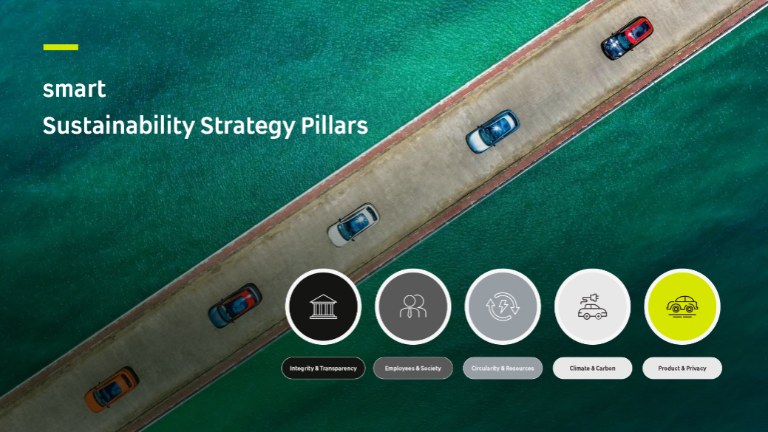
smart Releases Its Latest Sustainability Report
Mr. Tong Xiangbei, CEO of smart Automobile, said, “After the comprehensive renewal of the smart brand, product, and business model, we have focused on advancing our sustainability strategy and action plan to ensure long-term business operations and value creation. We are also collaboratively driving forward low-carbon and digital transformation across the entire value chain.”
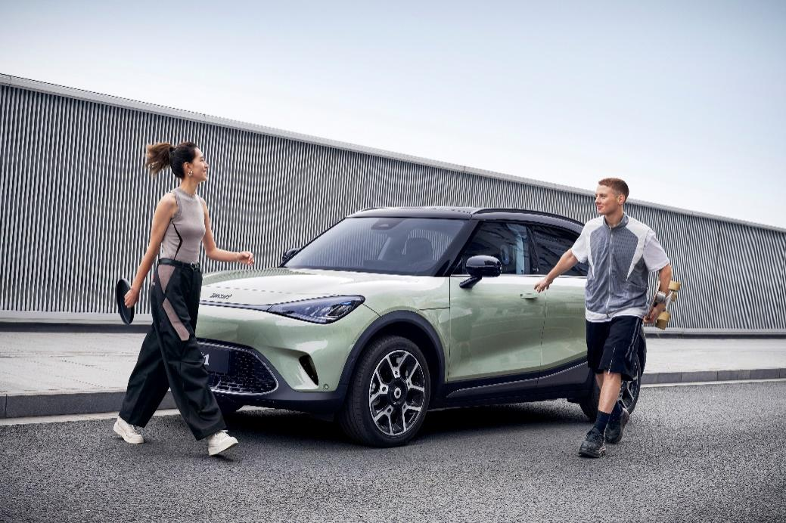
The smart #1 Boasts an Average Recyclability rate of 95.82%
Accelerating the “Carbon Neutrality” Process, Safeguarding Digital Transformation
As the industry's first brand to fully complete the transition from ICE to all-electric vehicles, smart considers decarbonization its mission, integrating “life-cycle carbon reduction” into every aspect of its business operations. Leveraging its leading carbon management capabilities, smart actively collaborates on low-carbon technologies with industry partners, promoting environmentally friendly development of new models and accelerating the low-carbon transformation of the entire value chain. The smart #1 has received authoritative certificates for both its battery and vehicle carbon footprint, based on the ISO 14067 standard.
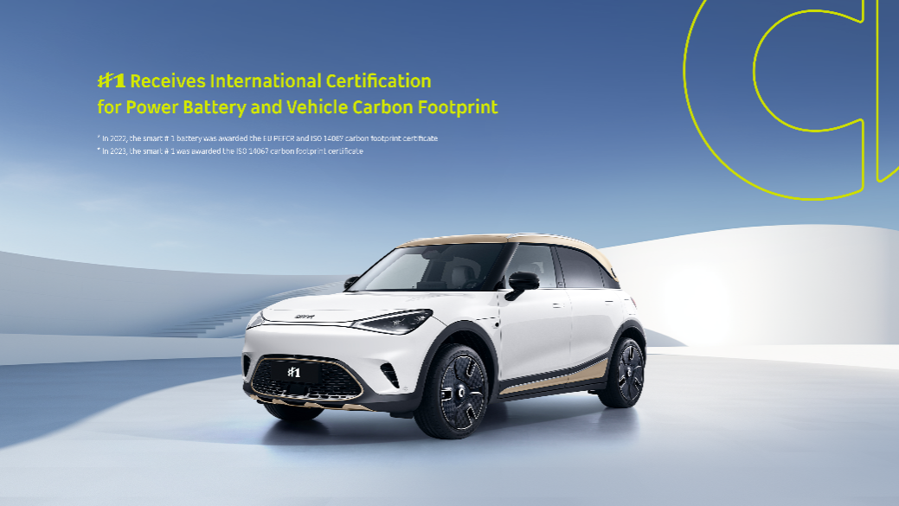
smart #1 Receives International Certification for Power Battery and Vehicle Carbon Footprint
In the era of digital transformation, smart proactively embraces its role as a responsible custodian of corporate data. The brand has established an efficient and comprehensive information and network security management system, deepening data management from information security and privacy protection to overarching responsible data governance. During the reporting period, smart obtained related dual certifications, ISO/IEC 27001 “Information Security Management System” and ISO/IEC 27701 “Privacy Management System”.
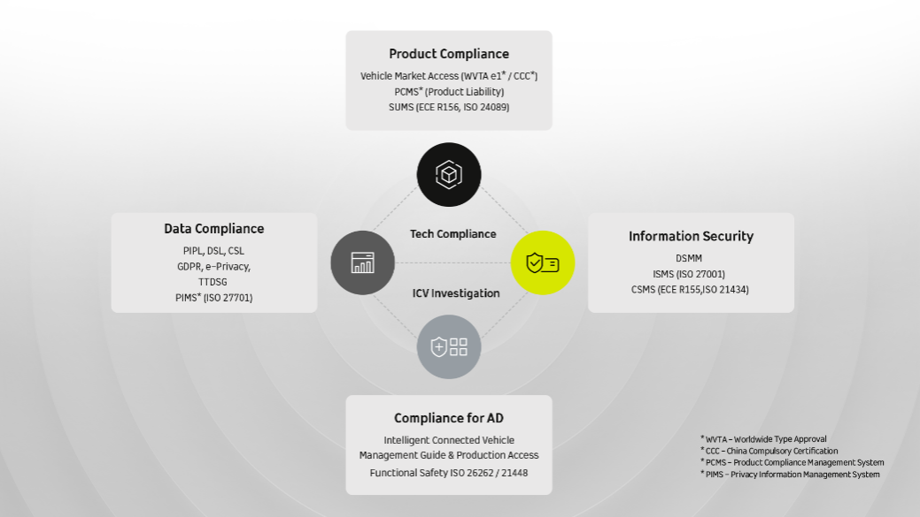
smart’s Technical Compliance System
Communicating Sustainability Values, Promoting High-Quality Brand Development
smart's sustainable development practices extend beyond the environmental and product domains, focusing also on the impact of the brand on individuals and society and striving to convey sustainable values to a broader audience. smart is dedicated to creating diverse, collaborative, open forms of interaction, encouraging employees, customers, and communities to participate in sustainable development action.
When approaching opportunities or navigating the changes in global market expansion, smart’s sustainability principles are an integrated element of corporate operations and brand development. The company is continuously enriching its next-generation all-electric product portfolio, promoting innovative research and development and the development of a circular economy. Moreover, smart actively protects its technological advancements, safeguards driving safety and user privacy, and continues to expand its sustainable influence on the environment and society.

smart will continue to explore the best solutions for future urban mobility, aiming to provide the market with carbon-neutral, all-electric vehicle models by 2045, driving the global energy revolution and zero-carbon transformation while collaborating with customers and partners to design a smarter, more sustainable future together.

-End-

For the latest information, please visit:
smart Global Media Centre: https://media.smart.com/
smart Automobile Website: https://www.smart.cn/

Media Inquiries
Jingyi Xiang: jingyi.xiang@smart.com

About smart Automobile
Since the birth of the brand in the 90s, smart has always maintained the vision of exploring the best solutions for future urban mobility. smart Automobile was officially established in 2019 with a forward-looking "China-Europe, dual home" global development strategy, and is committed to becoming a world-leading, new-premium, intelligent and all-electric auto brand.
smart has completed a comprehensive renewal of its brand, product, and business model and has entered a new era of full-speed operations, accelerating the establishment of a global product development, sales, and service management system. Engineering, research, and development for the new generation all-electric vehicle portfolio is led by the smart R&D team, with the Mercedes-Benz Global design team overseeing vehicle design. smart has now launched two all-electric SUV models, the smart #1 and smart #3, with deliveries underway across multiple markets in China and Europe and continued expansion into high-potential markets in Southeast Asia and the Middle East. From 2022 to 2025, smart will bring an all-new model to customers each year, further enriching the new generation all-electric product portfolio.

