Press Release
Jan. 19 , 2024
Global Deliveries Near 70,000 Units, Business Expands to 22 Countries and Regions
smart will “Sprint to the Next Level” in 2024

- Following its comprehensive brand renewal, smart has successfully achieved its core objectives for the new era of global operations in 2023. The global brand, global R&D, global products, global layout, and smart’s ‘China-Europe dual-home’ global development strategy continues to be enhanced.
- smart continues to expand its global market, now covering China, Europe, the Middle East, Southeast Asia, and South Asia, with a business presence in 22 countries and regions.
- Since the launch of its first product, smart has delivered nearly 70,000 units globally. In 2023, smart led the premium brand in compact SUV segment in the Chinese market.
- The new generation smart all-electric product portfolio has won global media and customers acclaim, earning the C-NCAP and Euro NCAP 2023 “Five-Star Safety” Rating, Red Dot and iF Design Awards, the C-AHI 2023 “Five-star Healthy Car” award and “Golden Steering Wheel” awarded by “AUTO BILD”.
- The product family is rapidly expanding, with technology R&D strengths increasingly evident. From 2022 to 2025, smart plans to launch an all-new model each year, entering whole new market segments. Recent achievements are helping smart become a leader in software-defined vehicle technology, from ADAS to intelligent cockpits.
- Operating with a “customer-centric, data-driven” philosophy, smart adopts a D2C agent-based business model for distribution flexibility in the global market. smart now has over 190 points of sales and service in China, covering 57 cities, and is actively exploring the feasibility of building brand owned charging infrastructure in China, with the first 800V superfast charging station available now in Shanghai.
- Committed to sustainable development, smart has achieved significant results in the realm of environment, society, and corporate governance (ESG). With such strong momentum, smart has earned the attention of global capital markets. Following the successful Series-A funding, the valuation (Pre-investment) of the company exceeds 5 billion USD.
- In 2024, smart will advance further in terms of its brand, products, technology, services, and business operations, continuously improving operational efficiency and establishing a new paradigm for development – “Sprint to the Next Level”.

(Hangzhou, Jan. 19, 2024) Following the brand’s comprehensive renewal, smart has completed its core objectives for a new phase of global operations in 2023, further enhancing its global presence and strengthening its brand, R&D, products, and strategic positioning. Since the launch of its first product, total global deliveries are approaching 70,000 units. In the China market, smart led the premium brand in compact SUV segment. The new generation smart all-electric product portfolio has won global media and customers acclaim, earning accolades including the 2023 C-NCAP & Euro NCAP “Five-Star Safety” Rating, Red Dot and iF Design Awards, C-AHI “Five-Star Healthy Car” award and “Golden Steering Wheel” awarded by “AUTO BILD”. Adhering to the “China-Europe dual-Home” global development strategy, smart continues to expand its global footprint, covering China, Europe, the Middle East, Southeast Asia, and South Asia, now reaching 22 countries and regions. smart’s strong momentum has attracted favourable attention from global capital markets. Following the successful Series-A funding, the valuation (Pre-investment) of the company exceeds 5 billion USD.

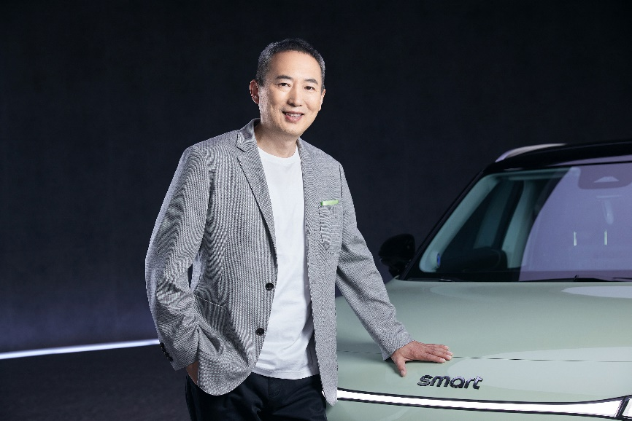
Mr. Tong Xiangbei, Global CEO of smart Automobile
Mr. Tong Xiangbei, Global CEO of smart Automobile said, “2023 marked the 25th anniversary of the smart brand, as well as a milestone year of global operations. With the joint efforts of our global team, smart has reached new levels in global operations, R&D innovation and product experience. Now in 2024, smart will advance further in terms of its brand, products, technology, services, and business operations, continuously improving operational efficiency and establishing a new paradigm for development – ‘Sprint to the Next Level’.”
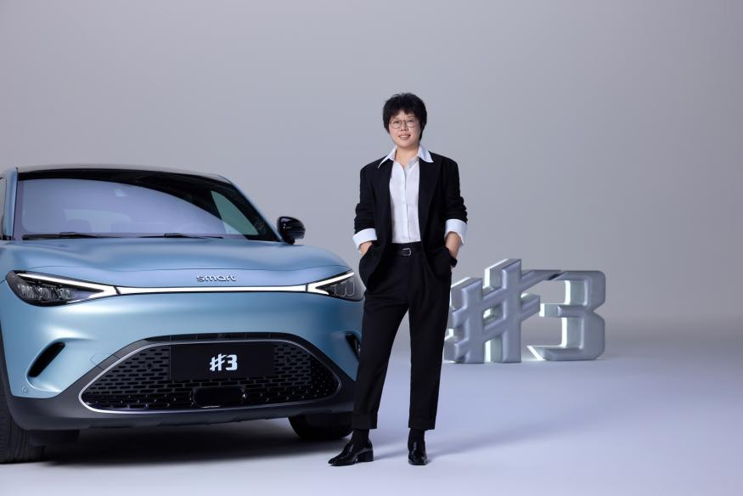
Ms. Mandy Zhang, Global CMO of smart Automobile
Ms. Mandy Zhang, Global CMO of smart Automobile said, “More customers’ trust, broader market coverage, and an expanding product family. In 2023, we proved the strong vitality of the brand's development at ‘smart speed’. Moving forward, smart will focus on the customer experience even more, providing the market and our global fans with yet more intelligent smart products and services.”

Never Think smart Small: Global Brand, Global R&D, Global Products, Global Layout
In 2023, smart continued to expand its global footprint, achieving excellent results for global operations. The smart #1 launched rapidly, landing in 10 European markets in just 10 months. The model received acclaim and keen attention from the both industry and customers in Germany, France, Spain, Switzerland, Italy, Netherlands, Austria, UK, Norway, and Iceland. In Southeast Asia, smart deepened its strategic cooperation with PROTON, strengthened its strategic position in Southeast Asia, and explored building production capacity overseas. In Hong Kong, the smart #1 has received high praise, with customer test drives in full swing. In the Middle East and South Asia, smart has identified partners in multiple locations, further advancing product market launches.
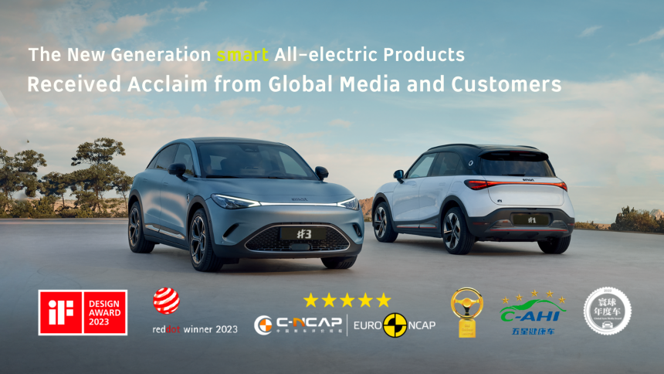
The New Generation smart All-Electric Product Portfolio has Received Acclaim from Global Media and Customers
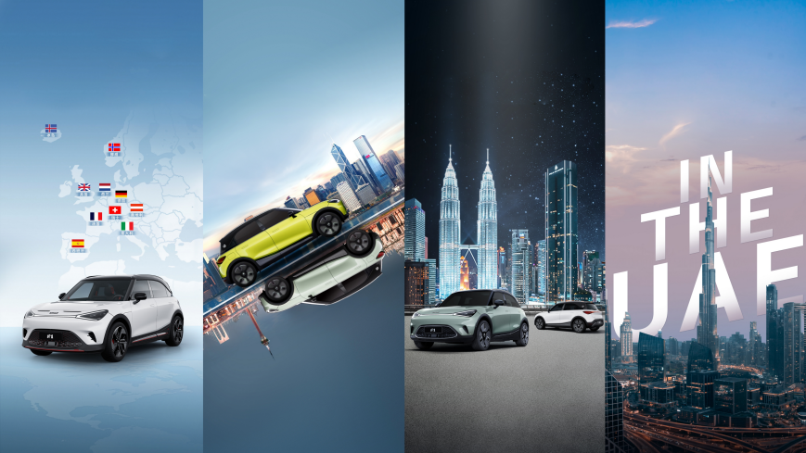
smart Continues to Expand into the Global Market
While rapidly expanding its business, smart adheres to a policy of sustainable development and has achieved new progress in the realm of environment, society, and corporate governance (ESG). smart was the first to establish a scientific whole-vehicle lifecycle carbon footprint accounting system, with the smart #1 receiving authoritative certificates for both battery and vehicle carbon footprint.
In this way, smart enters more global markets in a lower carbon and more environmentally friendly way, helping to drive the local automotive industry's low-carbon transformation.
People-oriented Technology Powers Product Evolution: The New Generation smart All-Electric Product Portfolio is Growing Rapidly
In 2023, the all-new smart #3 successfully launched, first hitting the markets in China. This was closely followed by the model’s European debut at IAA in Munich, and an extensive roadshow tour through Amsterdam, Brussels, Paris, Rome, Barcelona, and Lisbon. Even more noteworthy was the smart #3 media test drive in Mallorca. At the same time, smart announced plans to introduce an all-new model each year from 2022 to 2025, entering new market segments. Recent achievements are helping smart become a leader in software-defined vehicle technology, from ADAS to intelligent cockpits.
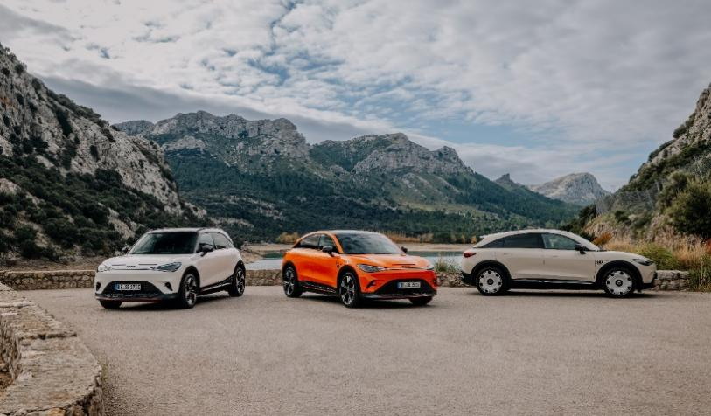
In 2023, the All-new smart #3 Successfully Launched
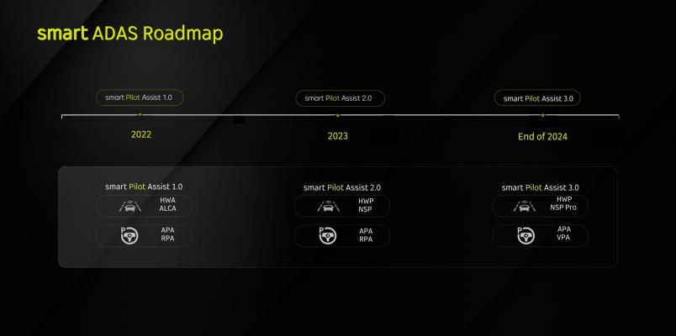
smart ADAS Roadmap, Evolving from smart Pilot Assist 1.0 to 3.0
In less than a year, smart has rolled out five OTA (Over-The-Air) iterative updates in China, rapidly evolving at an industry-leading pace and continuously enhancing product competitiveness and customer satisfaction. Leveraging its strong global R&D capabilities, smart unveiled its ADAS strategy for the first time. The smart Pilot Assist 2.0 was launched on schedule in October of 2023, propelling smart's intelligent driving capabilities to a leading position in the industry. The more advanced smart Pilot Assist 3.0 is scheduled to be launched before the end of 2024. In the field of intelligent cockpit, smart has officially announced that it will become the world's first new energy auto brand to feature the AMD V2000 chip, creating the next generation of immersive intelligent cockpit experiences. smart is actively exploring the establishment of self-operated charging networks, with its first 800V superfast charging station available now in Shanghai.
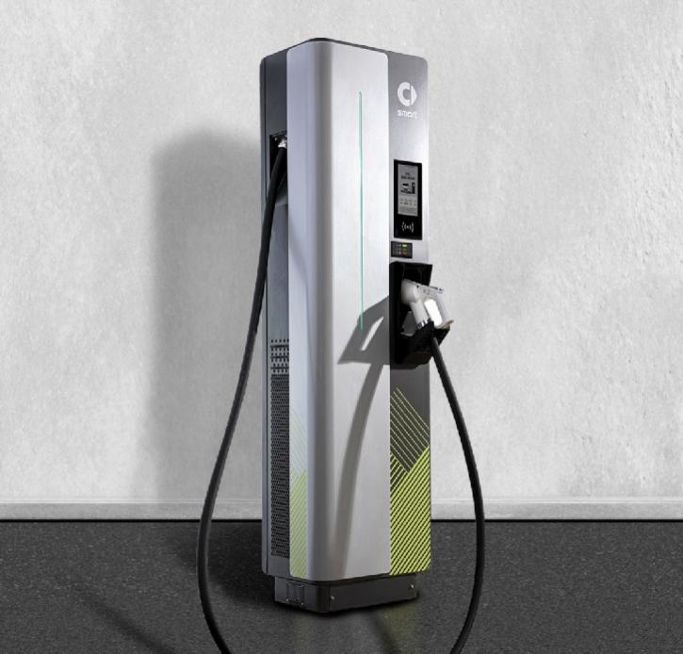
smart is Actively Exploring the Establishment of Self-operated Charging Networks
25th Anniversary Global Celebration: smart times Returns with Lifestyle Inspiration
2023 marked the 25th anniversary of smart’s development. Returning with the original passion and inspiration, smart times re-emerged in both China and Europe, celebrating offline with tens of thousands of enthusiasts worldwide. smart also officially welcomed its first brand ambassador for the all-electric era in China, Henry Lau.
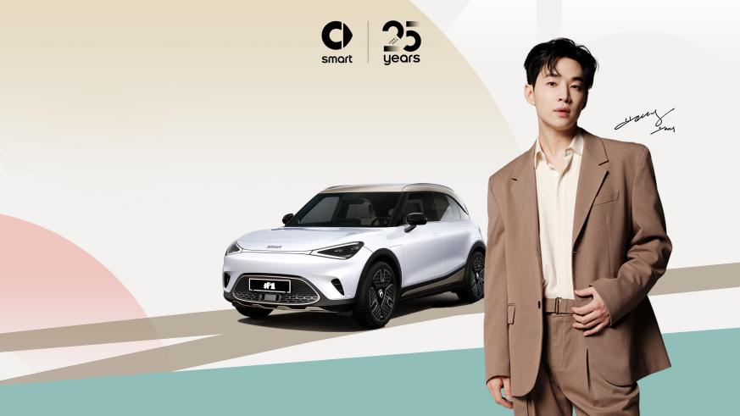
China Market Brand Ambassador - Henry Lau
In China, smart is collaborating with top IPs in cross-industry sectors such as fitness and dining, to craft a smart lifestyle ecosystem. The new customer service brand, smartcare, has officially launched, and is committed to creating an all-encompassing service experience that is proficiency and efficiency. Meanwhile, the avant-garde lifestyle brand, smartidea, is exploring attractive cross-border collaborations, combining quirky ideas to make potentially anything “smart”.

Strong Momentum Builds Confidence from Capital Markets
Navigating the first five years following the brand’s transition to all-electric auto, smart has not only rejuvenated its business model, brand, and products, but also established a complete “R&D, production, management, and sales” system for the global market, laying a solid foundation for further advancement. Meanwhile, the brand's strong momentum has attracted attention and favour from global capital markets. Currently, smart's series-A funding is led by Tianqi Lithium with an investment of 150 million USD, and the company achieved a valuation (Pre-investment) exceeding 5 billion USD.
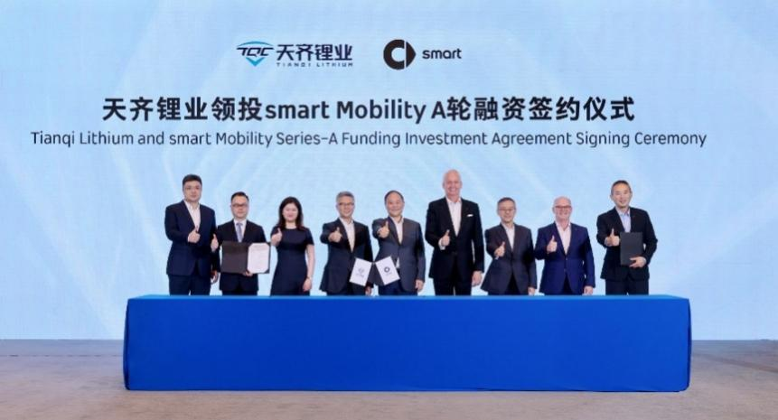
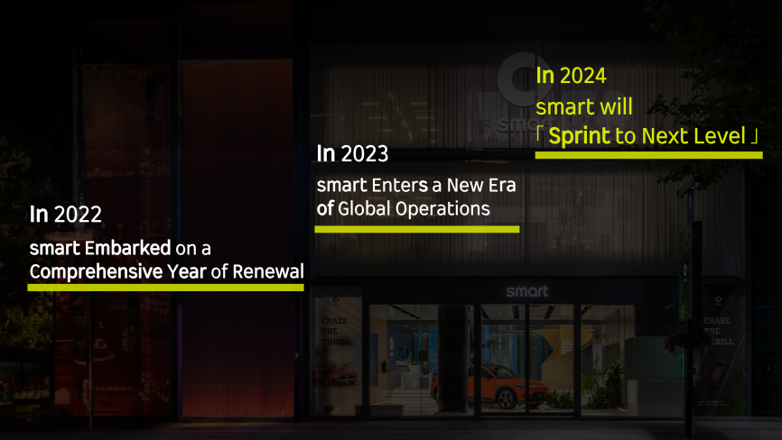
smart’s Strong Momentum Builds Confidence from Capital Markets
smart has always been committed to “exploring the best solutions for future urban mobility” and has never ceased to make progress here. Relying on the brand equity built since the start of the all-electric era, smart is set to adopt a new global development paradigm, "Sprint to the Next Level" in 2024, continuously pursuing the enhancement of its brand, product, service, and business operations, and to design a smarter future together.

-End-

