All-New smart #3 Receives First UNECE R155 Cybersecurity and R156 Software Upgrade VTA E1 Certification in China

(June 30, Shanghai) After rigorous review and evaluation, the all-new smart #3 was recently awarded the first domestic UNECE R155 cybersecurity and R156 software upgrade VTA E1 certification, issued by the German Ministry of Transport (KBA). This certification fully demonstrates that smart's vehicle network security and software upgrade technology complies with the latest international market regulations, meets new vehicle entry conditions for the European Union, and provides technical compliance assurances for the brand to expand its “China-Europe dual-home” global operations.
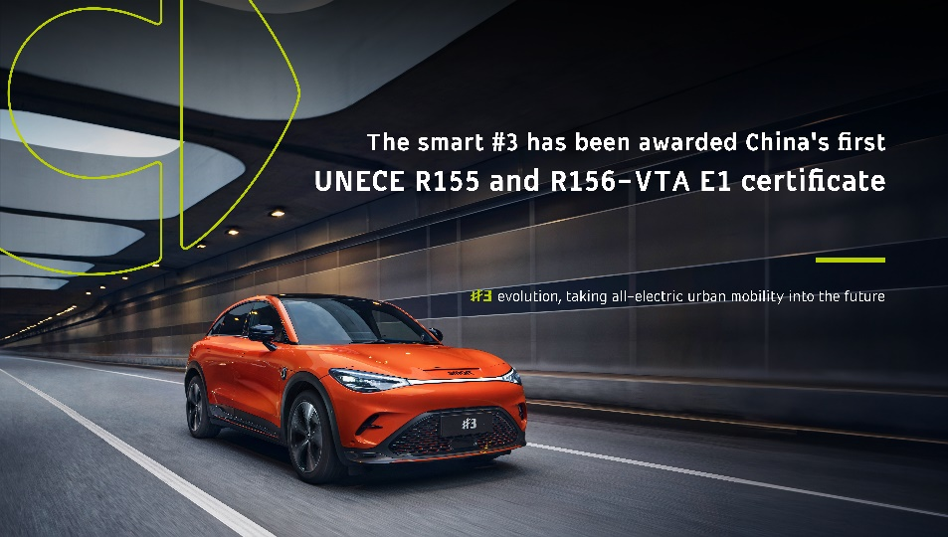
Mr. Yang Jun, Vice President of Research and Development of smart Automobile said, “The smart #3’s award of the first domestic EU R155 and R156-VTA E1 certification fully illustrates that our vehicle's technical strength, from product development to operation, complies with the latest EU market regulations on cybersecurity and software upgrades, enabling product upgrades throughout the vehicle lifecycle. In the new era of ‘software-defined vehicles’, smart continues to build strength in technology to provide global customers with legal, compliant, data-secure, and continuously evolving products and services.”
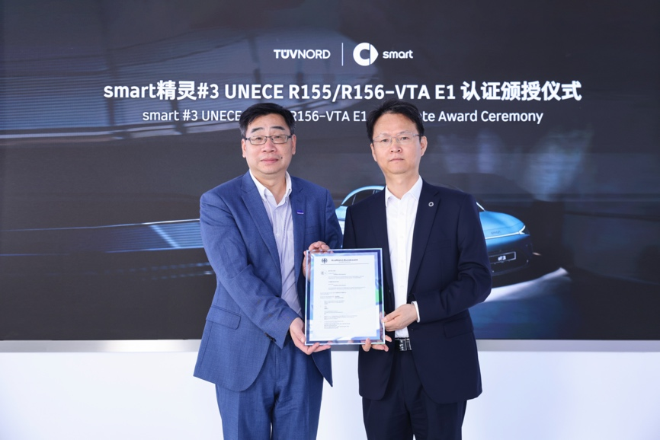
The smart #3 has received the first UNECE R155 cybersecurity and R156 software upgrade VTA E1 certification in China
(Right: Mr. Yang Jun, Vice President of Research and Development of smart Automobile; Left: Mr. Ren Jun, President of TÜV NORD Asia-Pacific)
Mr. Ren Jun, President of TÜV NORD Asia-Pacific, congratulated smart on being the first in China to be awarded the UNECE R155 and R156-VTA E1 certification: “The certification represents that smart's technical strength in cybersecurity and software upgrades is officially recognized by mainstream European certification authorities, and complies with the latest international regulatory requirements, which is seldom seen anywhere in the world currently. Meanwhile, now in the era of intelligent networking, this certification is the leading standard in the field of vehicle network security and software upgrades, contributing to the joint advancement of industry technology and regulation.”
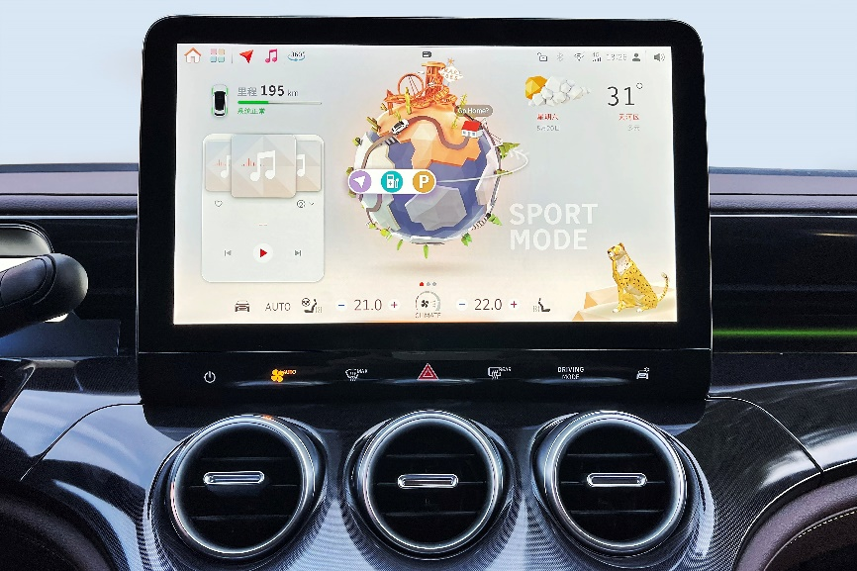
The “smart inspiration planet” intelligent UI system
Remaining true to its “customer-centric, data driven” business philosophy, smart has always been dedicated to bringing its customers the best solutions for future urban mobility. As the second all-new smart vehicle model to be released since the comprehensive brand renewal, the smart #3 is equipped with the industry's first “smart inspiration planet” intelligent UI system, which optimises the user's driving experience more safely and conveniently via OTA updates.
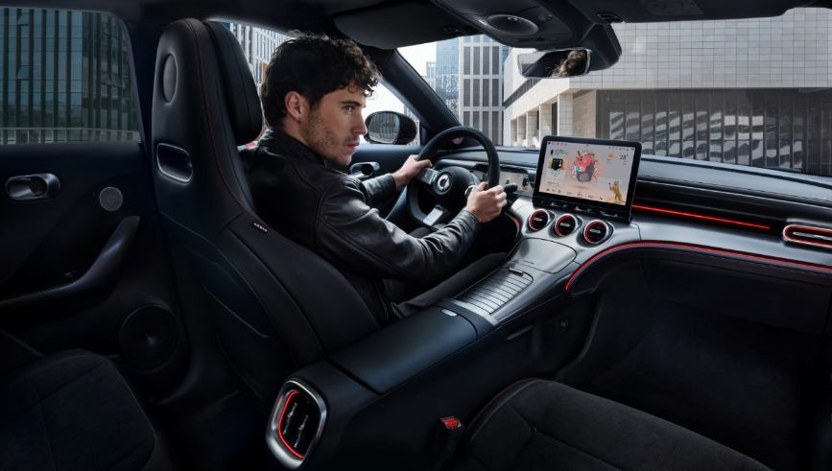
smart continues to provide customers with an international standard of premium all-electric travel
With the continuation of smart’s “China-Europe dual-home” global development strategy, the brand also enters a new era of global operation in 2023. smart’s D2C agent based business network is rapidly taking shape in the core markets of China and Europe, with nearly 300 sales and service outlets already established in the European market. With the innovation and evolution of the product's entire lifecycle as a foundation, smart will continue in providing customers with international standard new-premium all-electric travel experiences, to design a smarter future together.
-End-

For the latest information, please visit
smart Global Media Centre: https://media.smart.com/
smart Automobile Website: https://www.smart.cn/

Media Inquiries
Jingyi Xiang: jingyi.xiang@smart.com

About smart Automobile
Since the birth of the brand in the 90s, smart has always maintained the vision of exploring the best solutions for future urban mobility. In 2019, smart Automobile Co., Ltd. was officially established. With a forward-looking "China-Europe dual-home" global development strategy, smart is committed to developing into a world-leading, new-premium, intelligent and all-electric auto brand.
smart has completed a comprehensive renewal of its brand, product and business model. The new generation all-electric product development is led by the smart R&D team, with the Mercedes-Benz global design team responsible for vehicle design, and the product portfolio now expanded into more market segments. As the renewed brand's first compact all-electric SUV, the smart #1 made its world premiere in April 2022, with initial deliveries in China followed by Europe. The second model, the thrilling new-premium smart #3 SUV coupé, made its world premiere in April 2023. Every year from 2022 to 2024, smart will bring an all-new model to customers, further enriching the new generation all-electric product portfolio.

