Press Release
January 10, 2024

Mr. Yi Han Appointed as the Deputy CMO of smart Automobile and the CEO of smart China

(January 10, 2024, Hangzhou) Following comprehensive brand renewal and global operation at full-speed, smart embarks on a new chapter of "Sprint to the Next Level" in 2024. Upholding its "China-Europe Dual-Home" global development strategy, the brand is expanding into new overseas markets while also further strengthening its business operations in China. Effective on today, Mr. Yi Han will assume the role of the Deputy CMO of smart Automobile and the CEO of smart China, fully responsible for the comprehensive business of smart brand, including marketing, sales, and service in the Chinese mainland. In this role, he will report directly to Ms. Mandy Zhang, Global CMO of smart Automobile.

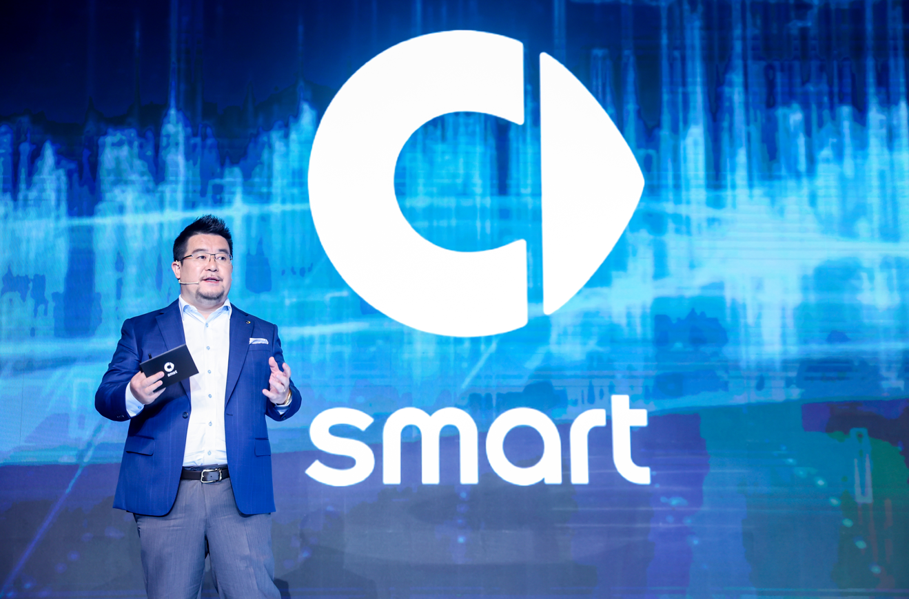
Mr. Yi Han, the Deputy CMO of smart Automobile and the CEO of smart China

Mr. Yi Han brings over 20 years of professional and managerial experience to smart. He has held key positions at various well-known automotive brands, possessing extensive experience in brand strategy, sales management, marketing, PR & communications, business development and after-sales service, and has demonstrated remarkable foresight and managerial skills. What's even more valuable is that, Mr. Yi Han, as a core member of the startup team during the initial setup of smart Automobile, played a crucial role in the planning and decision-making for the company's strategy, organizational structure, and business model, making significant contributions to the renewal of the smart brand.
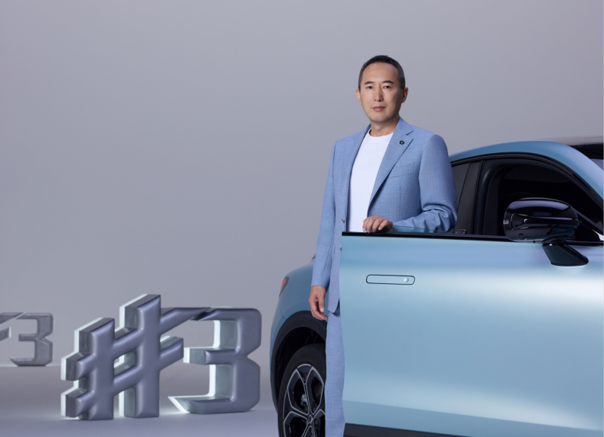
Mr. Tong Xiangbei, Global CEO of smart Automobile

Mr. Tong Xiangbei, Global CEO of smart Automobile said, “Following the development of initial five years, the completely renewed smart brand is ready to ‘Sprint to the Next Level’. Mr. Yi Han’s addition will further strengthen the core management capabilities of smart's China marketing and sales team, aiding smart's continued vigorous growth into this new chapter.”

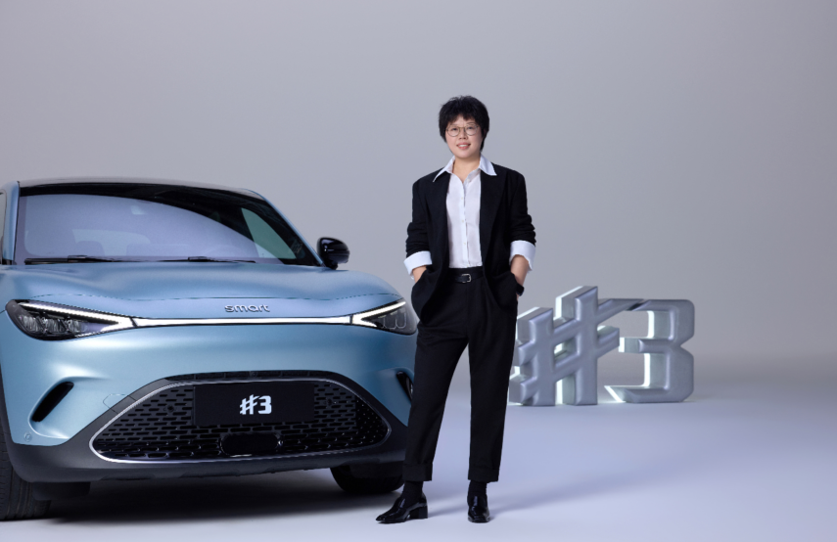
Ms. Mandy Zhang, Global CMO of smart Automobile

Ms. Mandy Zhang, Global CMO of smart Automobile, said: “For smart, Mr. Yi Han is not a newcomer but an old friend. With his rich industry experience, exceptional management abilities, and most importantly, his deep understanding and love for the smart brand, he will lead the China marketing and sales team to further improve the quality and efficiency of smart’s development. We welcome Mr. Yi Han back home.”

In 2023, smart accomplished its core objectives for a new era of global operations, further establishing its global brand, R&D, products, and footprint, delivering nearly 70,000 new vehicles. smart's operations currently extend to 22 countries and regions globally. The new generation of smart all-electric vehicle products has been warmly received by the global media and customers. In 2024, smart will step on the new stage, achieving upward leaps in brand, product, R&D, service, corporate development, continuously enhancing operational efficiency and enacting a new development paradigm, "Sprint to the Next Level".

-End-

