Press Release
July 25, 2022

The All-New smart #1 Receives EU WVTA e1 Certification
Accelerating smart Brand’s "China- Europe Dual-Home" Global Development

(July 25, 2022, Hangzhou) The first member of smart's new-generation all-electric product family lineup, the all-new smart #1, has received unlimited series EU Whole Vehicle Type Approval e1 (Germany) (hereinafter referred to as "WVTA e1 certification"), issued by the German Ministry of Transport (KBA). The smart #1 is smart’s first product to be awarded the WVTA e1 certification, indicating the product’s safety, environmental standards and energy efficiency fully meet the requirements of EU Vehicle Type Approval Framework Technical Regulation (EU) 2018/858, accelerating smart brand’s "China-Europe Dual-Home" global development.

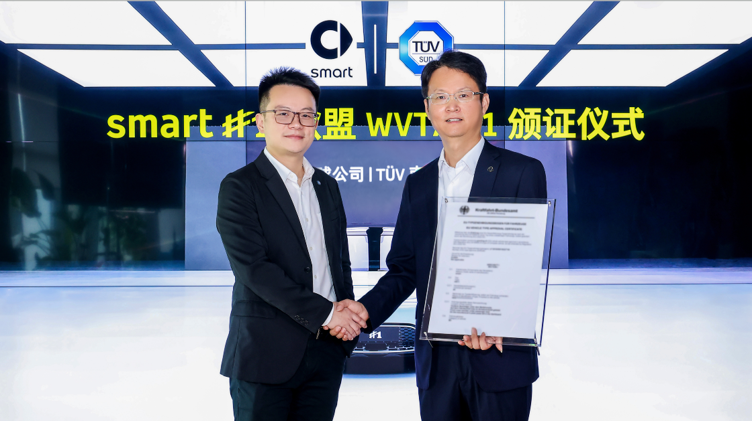
The all-new smart #1 has received EU WVTA e1 certification via the German Ministry of Transport
(From right to left: Mr. Yang Jun, Vice President of R&D at smart; Mr. Zhao Chongmin, Senior Manager of Mobility, TÜV SÜD Greater China)

Mr. Yang Jun, Vice President of Research and Development of smart Automobile Co., Ltd. said: "The all-new smart #1 has received WVTA e1 certification, as expected by our customers. It fills us with confidence to see the car’s active and passive safety features, intelligent assisted driving functions and advanced vehicle technology at work. As the first brand in the industry to fully complete the transition from fuel vehicles to all-electric vehicles, smart puts no limits on its future development. We are committed to continuously improving the technological strength of the smart brand through R&D and innovation, so as to bring a steady stream of surprises to customers and smart fans around the world."

Rigorous Testing Demonstrates the Global Quality of smart
The EU WVTA is a set of compulsory certification system which covers vehicle safety, environmental protection, and energy efficiency. The all-new smart #1 achieved e1 (Germany) WVTA certification, which employs some of the strictest standards and most reliable technology, meaning the vehicle can be sold to all EU member states and non-EU member states which officially recognize the EU WVTA certification system.

The all-new smart #1 is equipped with many advanced safety technologies, such as the automatic steering control system (ACSF) intelligent assisted driving function, as well as automatic control and adjustment of the high and low beams of the headlights (AFS) and high beam automatic adaptive adjustment (ADB) function, which works according to the vehicle speed and road conditions. The WVTA certification test is based on the product’s functional characteristics, operating principles and safety design, especially in the case of complex or unconventional technical configurations. For example, the ADB system testing simulated 44 unilluminated roads to ensure the customer's driving experience meets safety design standards in any scenario.

Mr. Zhao Chongmin, Senior Manager of Mobility at TÜV SÜD Greater China said: "We review manufacturing and quality systems in accordance with EU technical regulations and the technical requirements of the KBA, conducting full inspections, tests and analysis to confirm our findings. The all-new smart #1 has obtained EU WVTA e1 certification as issued by the KBA, along with around 50 relevant system and component certificates covering safety, environmental protection, energy saving and others, meaning the product is now approved for the EU market.”

smart Brand Accelerates Global Development
Adhering to its forward-looking “China-Europe Dual-Home” global development strategy, smart brand’s D2C agent network is rapidly taking shape in the two core markets of China and Europe. In China, following the unveiling of the world's first smart flagship center in Chengdu, more than 150 independent points of sales and service are set to open in 2022; in Europe, smart is working closely with long-term strategic partners to establish 300 sales and service outlets in 14 European markets (including the UK and Switzerland).

With the launch of the all-new smart #1 in China and the acquisition of the WVTA e1 certification, smart is racing ahead to meet friends all over the world, going beyond the international market standard to bring customers a new generation of smart all-electric vehicles that lead the industry. The renewed premium brand, high-quality products and fantastic service experience are sure to win the favor of customers, connecting more people and ideas to design a smarter future together.

-END-

Media Inquiries
jingyi.xiang@smart.com

For the latest information, please visit:
smart Global Media Centre: https://media.smart.com/
smart Automobile Website: https://www.smart.cn/


smart mini program

About smart Automobile

Since the birth of the brand in the 90s, smart has always maintained the vision of exploring the best solutions for future urban mobility. In 2019, smart Automobile Co., Ltd. was officially established. With a forward-looking “China-Europe dual-home” global development strategy, smart is committed to developing into a world-leading, premium, all-electric automobile and technology brand.

smart has recently completed a comprehensive renewal of its brand, products, and business model. New generation all-electric product development is led by the smart R&D team, with the Mercedes-Benz global design team responsible for vehicle design, and the product portfolio now expanded into more market segments. The renewed brand’s first all-new all-electric SUV, the smart #1, which premiered worldwide in April, is now on sale in China, with official deliveries from September. To further enhance its global operations, smart has established marketing and sales centres across China and Europe.

