Press Release
September 27, 2022

smart is Awarded China’s First EU PEFCR & ISO 14067 Carbon Footprint Certificate

(September 27, 2022) The all-new smart #1 battery has undergone a rigorous audit and certification process, and today became the first in China to be awarded the Carbon Footprint Certificate based on the EU Product Environmental Footprint Category Rules (PEFCR) & ISO 14067. The certificate was issued by TÜV Rheinland Greater China (TÜV Rheinland), an international independent third-party testing, inspection, and certification organisation. smart’s steadfast commitment to energy conservation and carbon reduction has laid a solid foundation for the brand’s expansion into the European new energy vehicle (NEV) market.
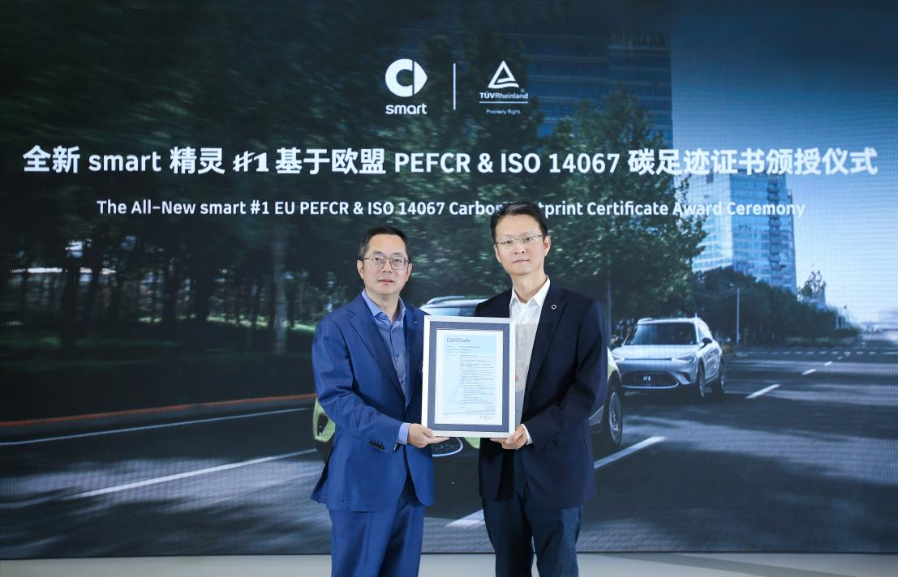
smart is awarded China’s first EU PEFCR & ISO 14067 Carbon Footprint Certificate
(From right to left: Mr. Yang Jun, Vice President of Research and Development of smart Automobile Co., Ltd.; Mr. Fang Weimin, Vice President of TÜV Rheinland Greater China Systems)

Mr. Yang Jun, Vice President of Research and Development of smart Automobile Co., Ltd. said: ”The all-new smart #1 battery has been awarded China’s First Carbon Footprint Certificate based on the EU Product Environmental Footprint Category Rules (PEFCR) & ISO 14067, so is well prepared for the higher carbon emissions requirements of the European market. The certification acts as a benchmark, leading the decarbonisation process for the industry and elevating standards across NEVs, batteries, and the related supply chains.”

Sustainable development and “carbon neutral” corporate responsibility
Now entering the era of carbon neutrality, decarbonisation is an important part of smart brand’s sustainable development. smart has established a complete battery recycling traceability management system to minimise impact on the environment. To be awarded the certificate, the carbon footprint of the all-new smart #1 battery was calculated throughout its life cycle according to the EU PEFCR method, involving field research and analysis of production processes at related battery manufacturing facilities. Energy consumption used in production together with raw material data is then processed and further analysed using professional life cycle carbon footprint software (Chengdu Yike efootprint) for modeling and calculation. The final result successfully passed TÜV Rheinland’s audit and certification standards.

Mr. Fang Weimin, Vice President of TÜV Rheinland Greater China Systems said: “The carbon footprint of an electric vehicle’s battery often determines how beneficial the vehicle is to the low-carbon economy, and also whether that vehicle meets the EU carbon footprint requirements to enter the market. smart has taken the lead in passing this EU industry certification, indicating it has a forward-looking carbon neutral strategic approach, promoting the brand and becoming more competitive by lowering emissions.”


smart is committed to exploring low-carbon urban mobility solutions

Establishing industry benchmarks, the “China-Europe dual-home” layout is advancing rapidly
smart’s “China-Europe dual-home” global layout means the brand is actively deployed in the world’s two major mainstream NEV markets of China and Europe. In China, the first batch of all-new smart #1 began official deliveries on September 23 to 33 brand-specific showrooms and service stations across the country. Meanwhile, smart has completed the building of 133 multi-level independent points of sales and service, with the number set to exceed 150 by the end of 2022. In Europe, smart is working closely with long-term strategic partners, leading in the establishment of 300 points of sales and service across 14 European markets (including the UK and Switzerland).

Looking ahead, smart will continue to develop sustainably, launching the new generation smart all-electric product family for the global market with energy saving and carbon reduction at the forefront of considerations, as well as explore the best solutions for low-carbon urban mobility hand in hand with customers and the industry - to design a smarter future together!

-End-

For the latest information, please visit
smart Global Media Centre: https://media.smart.com/
smart Automobile Website: https://www.smart.cn/

Media Inquiries
Jingyi Xiang: jingyi.xiang@smart.com


smart mini program

About smart Automobile
Since the birth of the brand in the 90s, smart has always maintained the vision of exploring the best solutions for future urban mobility. In 2019, smart Automobile Co., Ltd. was officially established. With a forward-looking "China-Europe dual-home" global development strategy, smart is committed to developing into a world-leading, premium, all-electric automobile and technology brand.
smart has recently completed a comprehensive renewal of its brand, products, and business model. New generation all-electric product development is led by the smart R&D team, with the Mercedes-Benz global design team responsible for vehicle design, and the product portfolio now expanded into more market segments. The renewed brand’s first all-new all-electric SUV, the smart #1, which premiered worldwide in April, is now on sale in China, with official deliveries from September. To further enhance its global operations, smart has established marketing and sales centres across China and Europe.

