Press Release
October 21, 2022

smart Receives More Than RMB 8 Billion in Credit, Boosting Production Efficiency, R&D Innovation and Sustainable Development

(October 21, 2022, Hangzhou) Along with smart’s comprehensive renewal of its brand, products and business model, the premium all-electric automobile and technology brand has begun a new chapter of high-speed development. The all-new smart #1 was delivered in China on schedule in September, garnering widespread recognition from customers and the market. Meanwhile, the rapidly growing smart brand has also won the favor of leading banking partners, receiving more than RMB 8 Billion in credit.
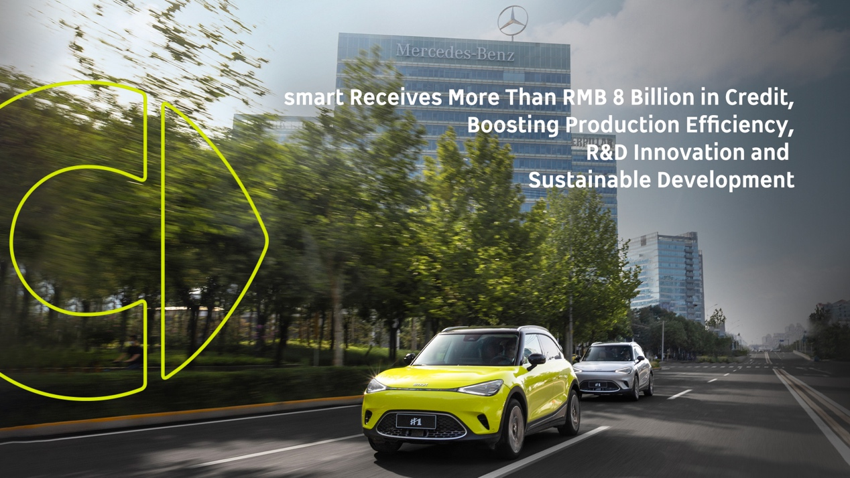
smart Automobile Co., Ltd. recently reached a strategic partnership with a syndicate of seven banks, including Shanghai Pudong Development Bank, China Construction Bank, Bohai Bank, Bank of Communications, Agricultural Bank of China, China Minsheng Bank, and China Guangfa Bank. Carefully planned, the credit fund will be used to further boost production efficiency, accelerate future product research and development, advance business network expansion, and help the smart brand to bring better product and service quality, faster delivery speed and more value to the market.
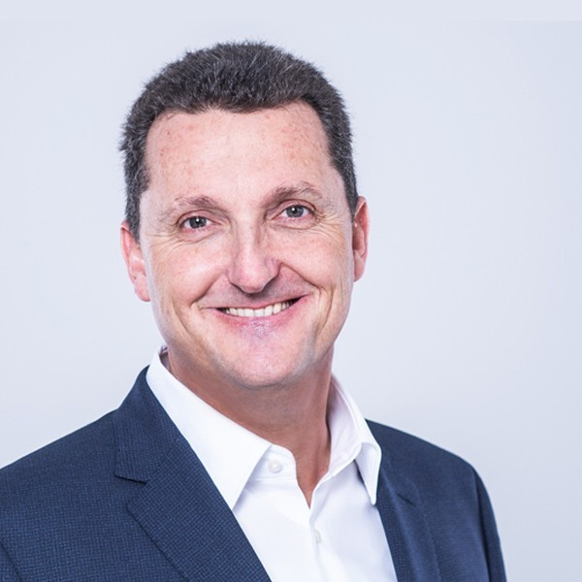
Mr. Ulf Nestler, Vice President of Finance of smart Automobile Co., Ltd., said: "I am very pleased to have the trust and support of our banking partners in China. This syndicated credit extension will not only enhance the operational resilience and sustainable profitable growth of smart, but also help the smart brand to effectively implement its forward-looking ‘China-Europe dual-home’ strategy and achieve long-term sustainable development on a global scale."

Consolidating the core strength of the brand – “customer-centric”
The comprehensively renewed smart is committed to remaining “customer-centric”, consolidating its brand strengths, products, services, and R&D, to shape itself into a world-leading premium all-electric automobile and technology brand.
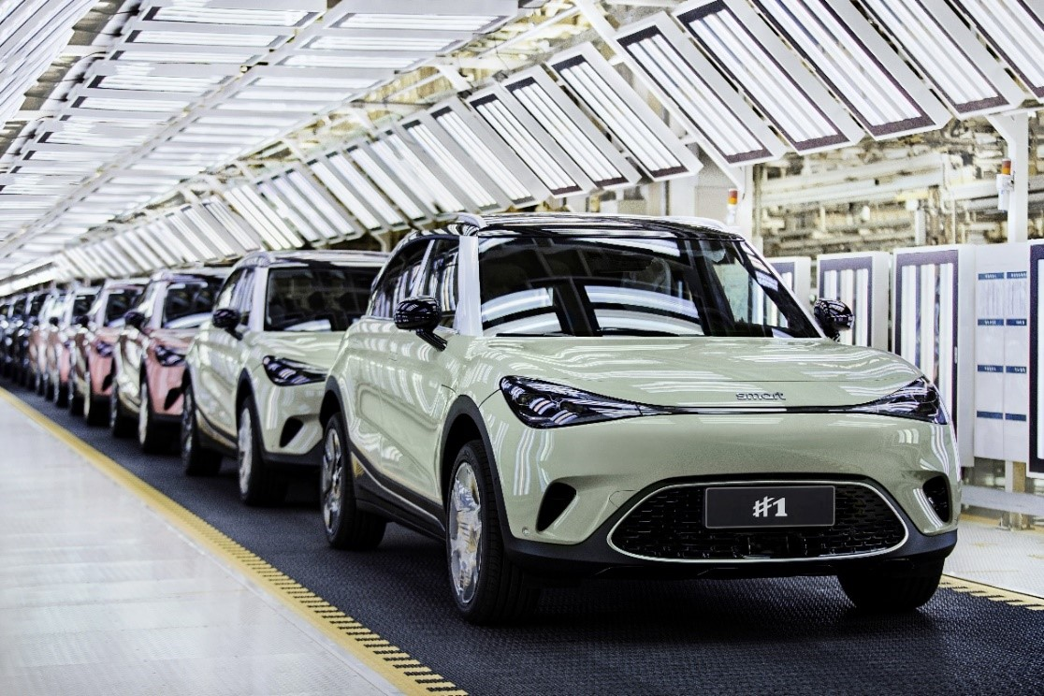
The smart brand always listens sincerely to customers and reinforces positive feedback with practical actions. The comprehensive credit fund will help smart to further improve production efficiency, shorten the delivery cycle and allow customers to join hands with the all-new smart #1 faster than ever. At the same time, smart will ramp-up investment in R&D, fulfill the promise to deliver "an all-new model every year from 2022 to 2024", and strengthen the core capabilities of future products in intelligent assisted driving.

Accelerating development of the global business network for sustainability
Adhering to a forward-looking “China-Europe dual-home” development strategy, smart's global sales and service network is rapidly taking shape. While cultivating the core markets of China and Europe, smart will develop the Southeast Asian market, centered on Malaysia and Thailand together with PROTON, as well as actively explore other high-potential new energy vehicle market opportunities around the world.
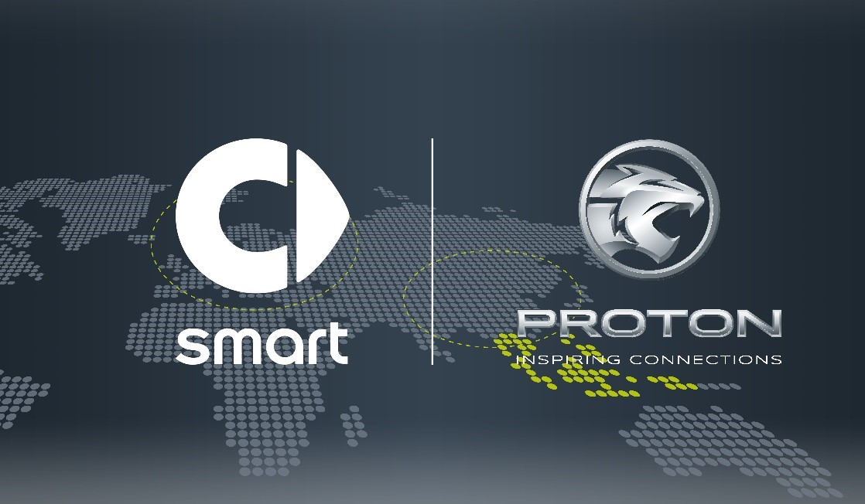
smart and PROTON signed General Distributer Agreement for Malaysia and Thailand
Based on the “customer-centric, data-driven” D2C agent-based business model, smart has built high-quality online and offline touchpoints. The credit fund will also be used to improve the efficiency of the smart business network and speed up market coverage to provide customers with a more convenient all-round brand, product, and service experience. Deliveries of the all-new smart #1 will begin in the European market in early 2023 and in Malaysia in the fourth quarter of 2023.
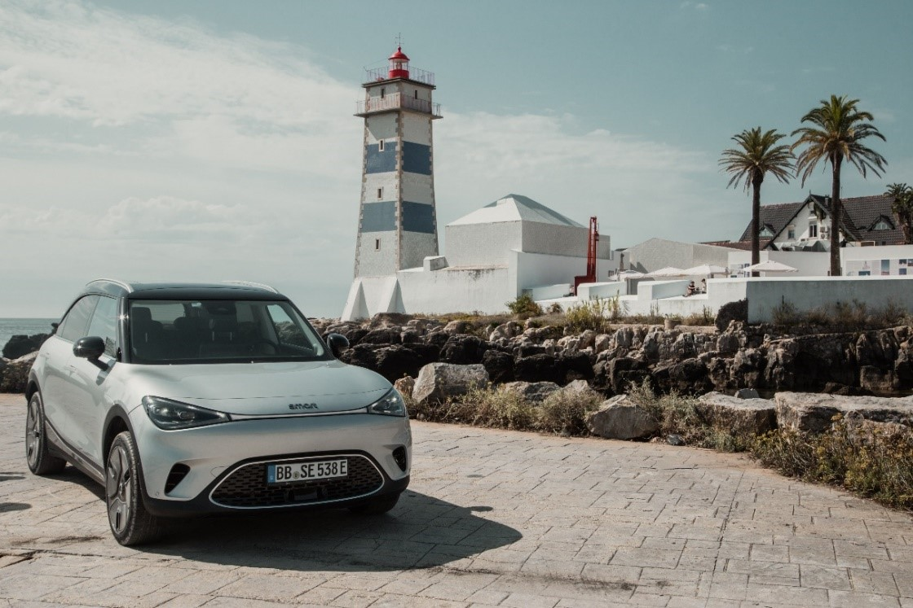
All-new smart #1 will be delivered in the European market in early 2023 (pictured in Lisbon, Portugal)
In the future, smart plans to collaborate with other high-quality partners from various industries to jointly explore tomorrow’s urban mobility solutions, while using technology to keep the fun and inspiration always alive - to design a smarter future together.

-End-

For the latest information, please visit
smart Global Media Centre: https://media.smart.com/
smart Automobile Website: https://www.smart.cn/

Media Inquiries
Sebastian Liu: sebastian.liu@smart.com


smart mini program

About smart Automobile
Since the birth of the brand in the 90s, smart has always maintained the vision of exploring the best solutions for future urban mobility. In 2019, smart Automobile Co., Ltd. was officially established. With a forward-looking "China-Europe dual-home" global development strategy, smart is committed to developing into a world-leading, premium, all-electric automobile and technology brand.
smart has recently completed a comprehensive renewal of its brand, products, and business model. New generation all-electric product development is led by the smart R&D team, with the Mercedes-Benz global design team responsible for vehicle design, and the product portfolio now expanded into more market segments. The renewed brand’s first all-new all-electric SUV, the smart #1, which premiered worldwide in April, is now on sale in China, with official deliveries from September. To further enhance its global operations, smart has established marketing and sales centres across China and Europe.

