Press Release
December 28, 2023

smart Joins Hands with ECARX to Explore Innovative Technology Ecosystems for “Software-Defined Cars”

- On December 28, smart and ECARX announced the establishment of a joint venture intelligent driving software company, smart Software Technology. Both parties will collaborate to shorten the incubation time for smart's new generation intelligent cockpit.
- smart will rely on the new joint venture to help bring more cutting-edge intelligent urban mobility solutions to users worldwide, further meeting consumer needs for personalization, and creating an industry benchmark for new-premium intelligent mobility experiences.

(Shanghai/Hangzhou, December 28, 2023) Today, smart, the new-premium intelligent all-electric auto brand, together with ECARX, a global mobility technology provider, announced the establishment of a new joint venture, smart Software Technology. The company is set to explore innovative technology ecosystems, focusing on the development of automotive-grade intelligent software, and on building the future of “software-defined cars” through innovative technology ecosystems. The two parties will jointly invest in technological research and development, facilitating talent aggregation and resource sharing while shortening the incubation period for smart's new generation intelligent cockpit. In future, smart will rely on smart Software Technology to help bring intelligent urban mobility solutions to customers worldwide, further meeting consumer needs for personalisation, and creating an industry benchmark for the new-premium mobility experience.
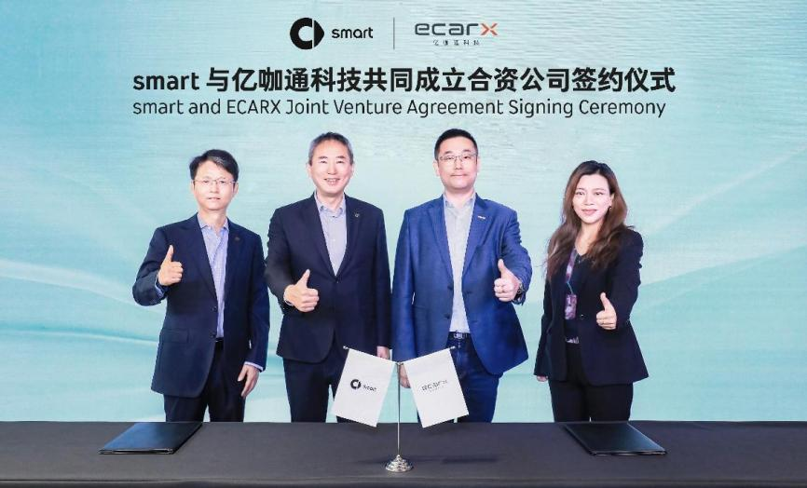
smart Collaborates with ECARX to Establish New Joint Venture
Xiangbei Tong, Global CEO of smart Automobile, said, “The era of software-defined cars has arrived, and smart considers ‘future tech’ as a core brand value. By joining hands with ECARX to establish a joint venture, we will build an outstanding team of talent, integrate shared resources, invest in innovative research and development, and jointly empower smart to continue leading in the field of intelligent technology and in bringing high quality, new-premium intelligent mobility experiences to customers.”
Shen Ziyu, Co-Founder, Chairman & CEO of ECARX Technology, said: "ECARX and smart have a strong track record of cooperation, having jointly developed the highly acclaimed smart OS. Through this joint venture, we will continue iterating to create a refreshing and industry-leading intelligent experience by expanding our talent exchanges, R&D efforts, and supply chain network. Together, ECARX and smart will work to bring our intelligent technology ecosystem to vehicle owners around the world."
Inspired by Technology, Sparking a New Paradigm in Collaborative Innovation
As the first Chinese intelligent automobile startup listed on the U.S. stock market, ECARX is firmly committed to global development, building an industry technology ecosystem incorporating “intelligent cockpit + intelligent driving + intelligent manufacturing” across the whole value chain. smart, empowered by technology for future urban mobility, is dedicated to creating “technology with warmth” for customers, continuously enhancing the driving and riding experience with real-world scenarios.
smart maintains a close collaborative relationship with ECARX. Together, they developed the widely acclaimed smart OS with a unique HMI (Human-Machine Interface) design, laying a solid foundation for further cooperation between the two parties in the field of intelligent cockpits.
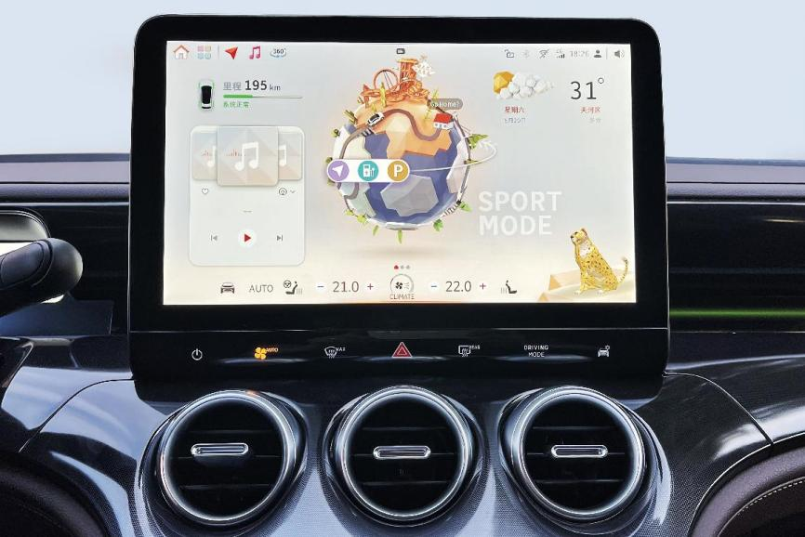
smart and ECARX jointly created "Inspiration Planet" smart OS
Expanding Collaborative Advantages, Accelerating Technological Advancements
By pooling talent in vehicle development and intelligent technology, smart and ECARX will better leverage their outstanding brand resources and the product quality strength of smart's all-electric models. The new joint venture will focus on full-stack, self-developed capabilities for intelligent driving technology, furthering both parties' sustainable global development goals.
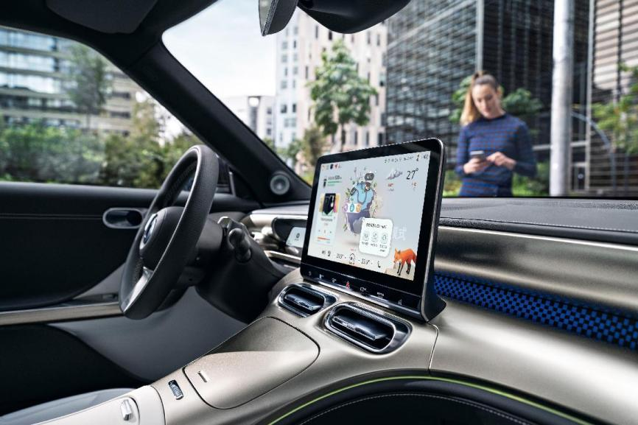
Allowing users to enjoy the benefits of innovative technology, both parties plan to bring the high-performance ECARX Makalu computing platform, powered by embedded AMD Ryzen V2000 processors and Radeon RX 6000 series GPUs, to smart models, jointly expanding a new generation of immersive cockpit digital experiences.
Upholding its “future tech” brand value, smart has established a global research and development system and will collaborate with more leading industry partners to build an innovative technology ecosystem, endowing urban mobility and lifestyle with extraordinary intelligent experiences, to design a smarter future together.
-End-

