Press Release
September 6 2023

Navigation smart Pilot (NSP) Set to Launch in Q4
smart to Release New Special Edition Model Equipped with Mobileye SuperVision™ System

- On August 25th, smart officially unveiled its ADAS evolution strategy roadmap. The smart Pilot Assist 2.0 version, which includes the Navigation smart Pilot (NSP) feature, is planned to launch officially in the fourth quarter of 2023.
- The special edition model, equipped with 12 cameras (12V), will simultaneously make its world premiere. This model marks the first application of the Mobileye SuperVision™ system by smart, encompassing 11 cameras and one driver attention monitoring camera, setting a new benchmark for intelligent driving technology and safety in its class.
- Deepening its commitment to intelligent mobility, following the launch of the smart Pilot Assist 2.0 version, the smart Pilot Assist 3.0 version is expected to officially launch by the end of 2024.

(September 6, 2023, Hangzhou/Jerusalem) Following its initial announcement of the ADAS evolution strategy roadmap, smart has announced that the smart Pilot Assist 2.0 version will officially launch in the fourth quarter of 2023. This version will feature the Navigation smart Pilot (NSP), which will enable gradual implementation of point-to-point automatic navigation on highways and urban trunk roads. It supports OTA remote online upgrades, bringing more advanced intelligent driving assistance functions that combine intelligence and safety to drivers.
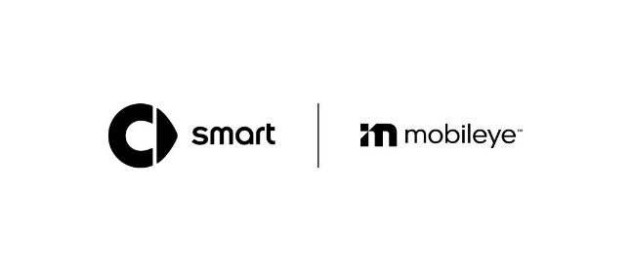
smart is collaborating with Mobileye, deepening its commitment to intelligent driving assistance technology
Meanwhile, a special edition of smart, equipped with 12 cameras, is set to make its world premiere. This model marks the first application of the Mobileye SuperVision™ system by smart, which includes 11 cameras and one driver attention monitoring camera, setting a new benchmark for vehicles in its class in terms of intelligent driving technology and safety. Moving forward, smart will continue to deepen its commitment to ADAS technology, collaborating with partners to integrate their respective technological strengths, aiming to provide users with a leading-edge intelligent mobility experience.

Empowered by Mobileye Supervision™, smart provides NSP feature
Recognized as one of the most advanced driver assistance systems globally, the Mobileye SuperVision™ system operates on two Mobileye EyeQ5™ chips, an advanced custom 7-nanometer ADAS chipset, building on Mobileye’s two decades of experience in applied AI and machine learning to handle AI tasks with high energy efficiency, a key consideration for electric vehicles. The smart Pilot Assist 2.0 version based on it has the NSP feature, which will enable gradual implementation of point-to-point automatic navigation on highways and urban trunk roads. This includes capabilities such as automatic overtaking and lane-changing based on road traffic conditions, automatic entry or exit from ramps, and traffic congestion assistance, among other leading autonomous driving functions. Additionally, it supports OTA upgrades.

Mr. Yang Jun, Vice President of Global Research and Development of smart Automobile

Mr. Yang Jun, Vice President of Global Research and Development at smart Automobile, said: "Since the birth of the brand, smart has always been led by the vision of exploring the best solutions for future urban mobility. We believe that the smarter ADAS technology, will further enhance the competitiveness of the new generation of smart all-electric product family. Leveraging the R&D capability and the collaboration with industry leading partners, such as Mobileye, smart will continue to elevate the brand’s technology label, providing more intelligent, safer urban mobility experience to the users.”

Johann Jungwirth, senior vice president of autonomous driving at Mobileye

“We’re excited to launch this new era of collaboration with the smart brand, offering new capabilities built from the foundation of our SuperVision technology,” said Johann Jungwirth, senior vice president of autonomous driving at Mobileye. “SuperVision complements smart’s commitment to offering the future of urban mobility globally.”

Driven by ambition and aspiration: Accelerating towards a smarter future
At the recently concluded 2023 Chengdu Motor Show, smart unveiled its ADAS evolution strategy roadmap for the first time by the end of 2023, the smart Pilot Assist 2.0 version will be launched, featuring the NSP function. By the end of 2024, the smart Pilot Assist 3.0 version will be introduced, which will enable the NSP PRO function. With the launch of a new version each year, smart's ambition to lead in the ADAS technology segment speaks for itself.

"Technology" is one of the smart brand’s three core attributes, and the brand has always been dedicated to "exploring the best solutions for future urban mobility". In pursuit of ushering in the future of intelligent mobility sooner, smart established smart Robotics Technology Co., Ltd. in 2022. The company aims to develop full-stack, high-level intelligent driving software, and is committed to continuous research and innovation to enhance the technological prowess of the smart brand.

-End-

