Press Release
November 7, 2022

smart Publishes First Sustainability Report Following the Brand’s Comprehensive Renewal

(November 7, 2022, Hangzhou) As the first brand in the industry to fully complete the transition from fuel vehicles to all-electric vehicles, smart has comprehensively renewed its brand, product, and business model, yet retains its original vision of “exploring the best solutions for future urban mobility”. In the carbon-neutral era, smart has actively embraced its role as a responsible corporate citizen, promoting sustainable, environmentally and socially conscious development. Today, smart published its first sustainability report following the brand’s renewal, covering the company’s performance and achievements in sustainability throughout 2021 and focusing on a new strategy and action plan to implement best practice in sustainable development.

Mr. Tong Xiangbei, Global CEO of smart Automobile said: “Sustainability sits at the core of smart’s brand values and business strategy. We have established a systematic sustainability strategy and roadmap to enhance brand influence, and its implementation will help both the environment and society. With decarbonisation its mission, smart is committed to providing carbon neutral electric vehicles to the market by 2045.”
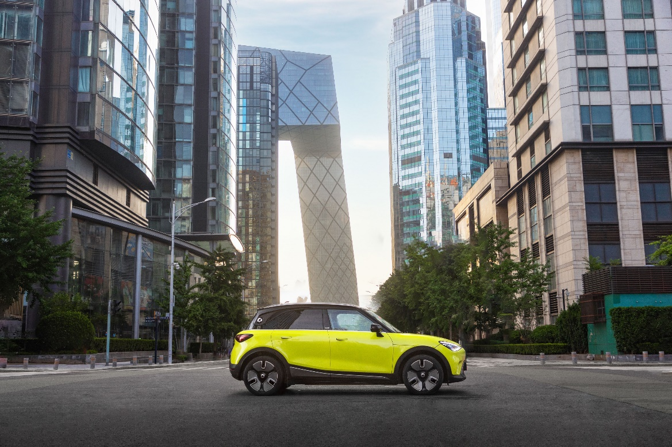
smart is committed to providing carbon neutral electric vehicles to the market by 2045

While accelerating its global operations, smart always considers the company’s impact on the environment, society, and governance (ESG), establishing and implementing the new sustainability strategy in 2021. The strategy covers five pillars to ensure sustainability is integrated into all of smart’s business operations.

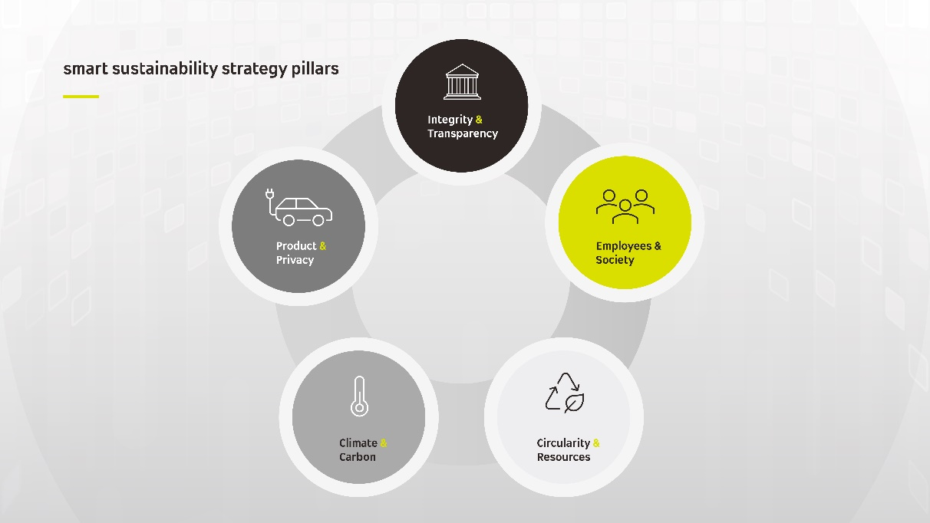
smart has formulated a sustainability strategy focused on 5 key areas

“Levelling Up” Integrity and the Compliance Management System
With a forward looking ”China-Europe dual-home” global development strategy, smart believes in conducting global business with integrity and compliance, ensuring business practise meets the requirements of local laws and regulations while making continuous improvements to the open and transparent corporate management system. In 2021, smart operates business in accordance with ISO 37301 Compliance Management Systems standards while also putting into practice an Antitrust Compliance Policy to ensure fair competition. smart is committed to R&D innovation and is constantly making technical breakthroughs; the company works hard to protect its intellectual property rights and was granted 116 patents in 2021.

Improving Driving Safety and Privacy Protection
With the intelligent, digital development of the automotive industry, smart has built a “customer-centric, data-driven” D2C agent-based business model, integrating online and offline touch points to enhance user brand experience. While being a great proponent of digital transformation, smart knows the importance of user privacy and data security, integrating secure information management into the entire R&D and operations process. smart follows GDPR, ISO/IEC 27001 “Information Security Management System”, and ISO/IEC 27701 “Privacy Information Management System” standards in combination with relevant Chinese laws and regulations related to information and data, and has established and implemented an information security management system.

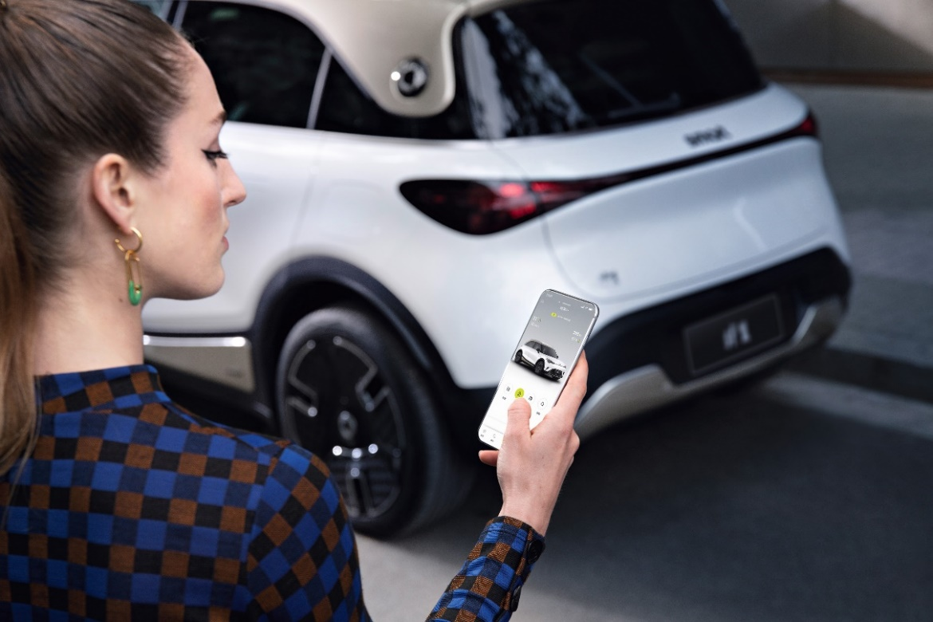
smart integrates secure information management into the entire R&D and operations process

Exploring Low-Carbon Solutions
Actively responding to global climate change, smart not only regards decarbonisation as a responsibility, but as a driving force to truly embody “exploring the best solutions for future urban mobility”. smart is committed to creating a sustainable means of travel for the future. smart developed and established a life cycle assessment (“LCA”) system to comprehensively understand the carbon emissions of a product’s entire life cycle, from R&D to production and recycling. In addition, 95% of smart’s current suppliers are from local companies. Through logistics planning and cross-border collaboration, related carbon emissions are significantly reduced, maximising the environmental and social benefits of supply chain localisation.


smart is committed to creating a sustainable means of travel for the future

Advocating for the Circular Economy and Responsible Sourcing
smart is committed to the circular economy and responsible sourcing. In 2021, while ensuring quality and performance, smart incorporated recycled and sustainable materials into a wide range of automotive parts, with each new smart #1 containing 130kg of recycled steel and 40kg of recycled aluminium. In addition, smart has made great progress in the field of battery traceability and recyclability, and has established a near complete system to track battery data to minimise the negative impacts of battery disposal on the environment. Meanwhile, silicon carbide (“SiC”) technology has been adopted for the vehicle’s electric drive system, reducing power consumption by 0.6 kWh per 100 km of driving, thus lowering the vehicle’s carbon footprint from driving.

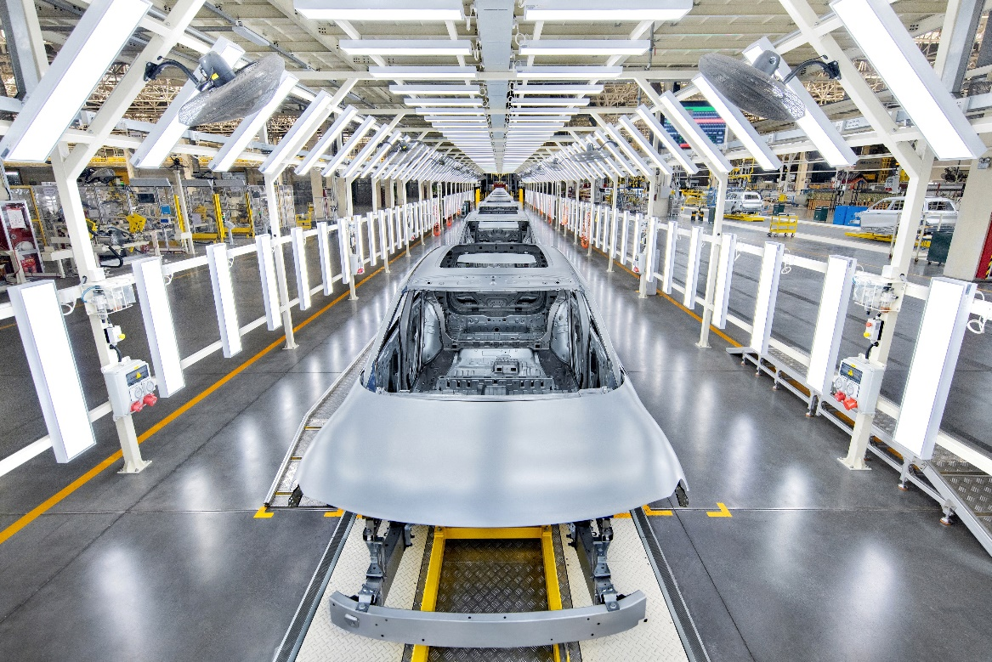
smart advocates for the circular economy and incorporates sustainable materials into automotive parts

Empowering Individuals to Benefit Society
With an international background, the smart team is made up of members from more than 30 different countries and regions, with a variety of cultures, educational and professional backgrounds. smart is a proactive advocate for a diverse and inclusive corporate culture, and cares about employee wellbeing. smart collaborates with partners who share a commitment to sustainability, working side by side to improve technical strengths and increase brand influence. During the reporting period, 100% of smart's existing suppliers committed to smart’s Supplier Code of Conduct, growing sustainably together with smart and giving back to society with better products and services.

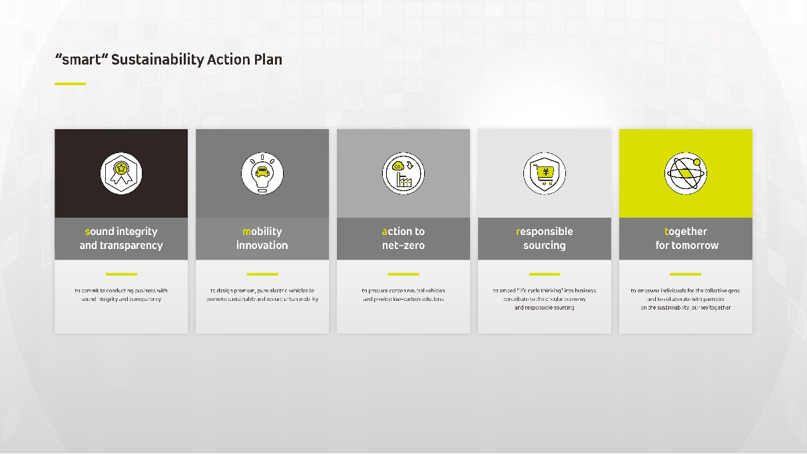
“smart” Sustainability Action Plan

smart has officially launched the “smart” sustainability action plan based on the five pillars of the sustainability strategy. The plan includes a series of innovative short, medium, and long-term initiatives currently under implementation and designed to provide social and environmental benefits. Looking ahead, smart will share its latest progress and explorations along the company’s sustainable development journey, collaborating with partners, customers, and the broader community to design a smarter and more sustainable future together.

-End-

For the latest information, please visit
smart Global Media Centre: https://media.smart.com/
smart Automobile Website: https://www.smart.cn/

Media Inquiries
Jingyi Xiang: jingyi.xiang@smart.com


smart mini program

About smart Automobile
Since the birth of the brand in the 90s, smart has always maintained the vision of exploring the best solutions for future urban mobility. In 2019, smart Automobile Co., Ltd. was officially established. With a forward-looking "China-Europe dual-home" global development strategy, smart is committed to developing into a world-leading, premium, all-electric automobile and technology brand.
smart has recently completed a comprehensive renewal of its brand, products, and business model. New generation all-electric product development is led by the smart R&D team, with the Mercedes-Benz global design team responsible for vehicle design, and the product portfolio now expanded into more market segments. The renewed brand’s first all-new all-electric SUV, the smart #1, which premiered worldwide in April, is now on sale in China, with official deliveries from September. To further enhance its global operations, smart has established marketing and sales centres across China and Europe.

