Press Release
27 September 2023

smart and AW Rostamani Group Sign Memorandum of Understanding to Expand into the UAE Market

- smart signs Memorandum of Understanding (MoU) with leading UAE automotive distributor AW Rostamani Group, marking forward momentum in the brand’s global development strategy.
- smart plans to launch its product portfolio of all-electric vehicles in the UAE.
(27 September 2023, Hangzhou/Dubai) smart, the new-premium intelligent all-electric auto brand, has taken another significant step in its global development strategy, signing a MoU with AW Rostamani Group (AWR), a leading automotive distributor in the United Arab Emirates. This partnership underscores smart’s commitment to continuous business development in the Middle East, with the company set to introduce its all-electric vehicle lineup in the UAE.
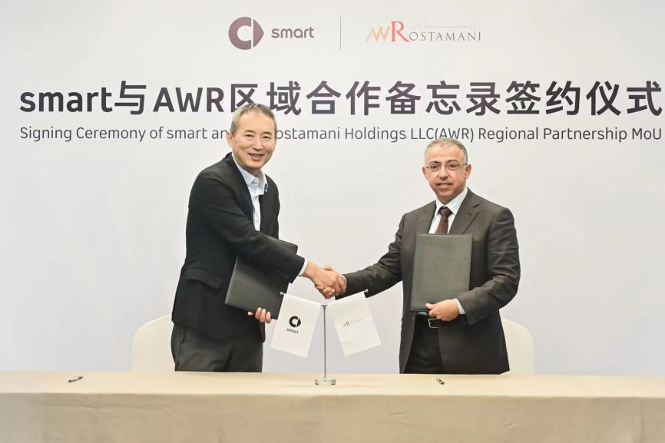
Mr. Xiangbei Tong, Global CEO of smart Automobile , and, Mr. Khalid Al Rostamani, Chairman of AWR Group
Mr. Xiangbei Tong, Global CEO of smart Automobile, said: “In smart’s new era of global operations, partnerships with industry leaders accelerate our global development strategy and help us establish wider coverage for the brand worldwide. We are excited to collaborate with AW Rostamani Group to grow our business coverage in the UAE and look forward to presenting customers with a premium, intelligent, all-electric urban mobility experience with unique brand characteristics.”
Boasting a strong local market presence and a varied business portfolio, AWR holds substantial expertise in the UAE market, which will be pivotal in instituting smart’s foothold in the region.
Mr Michel Ayat, AW Rostamani Automotive CEO, said: “As we observe the automotive industry evolving at an unprecedented pace, it is clear that intelligent electric mobility is the future. Aligning with smart, a brand emblematic of innovation and forward-thinking, harmonises seamlessly with AWR’s enduring legacy of pioneering automotive excellence in the UAE. This collaboration is not just about expanding our portfolios but also a testament to AWR’s capability as the right partner to usher in a new era of sustainable, intelligent urban transportation.”
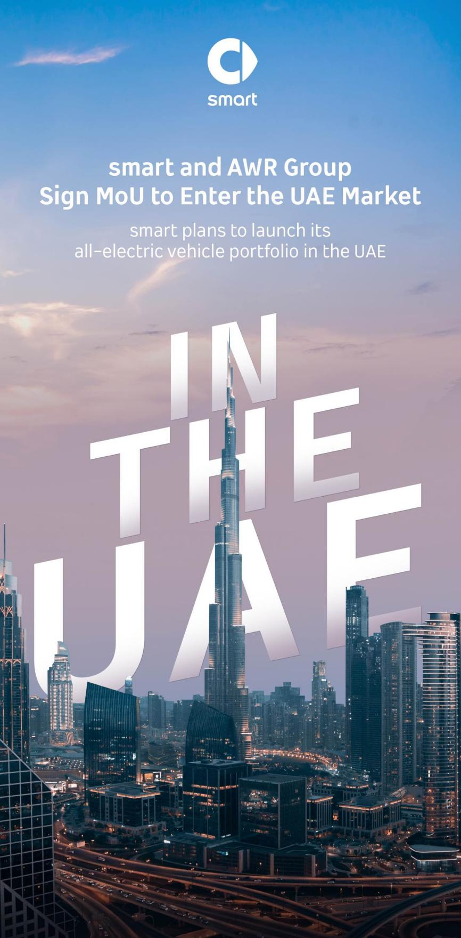
smart plans to launch its all-electric vehicle portfolio in the UAE
New partnerships signify smart’s commitment to expanding its global presence; as the brand continues its journey, such collaborations will be instrumental in exploring the best solutions for future urban mobility. Remaining true to its ‘China-Europe dual-home’ global development strategy, smart is currently amid a ‘Westward and Southern Expansion,’ accelerating its exploration in high-potential markets globally.
-END-

