Press Release
January 4,2024
smart #1 to Launch in Singapore by the First Half of 2024
smart Signs General Distributor Agreement with Cycle & Carriage
- smart announced that Cycle & Carriage will be its general distributor for the Singapore market, the smart #1 is scheduled for launch and delivery in Singapore by the first half of 2024.
- Cycle & Carriage is a leading automotive group in Southeast Asia, holding a market-leading position in Singapore, and is the exclusive dealer for Mercedes-Benz in Singapore.

(Singapore/Hangzhou, January 4,2024) smart, the new-premium intelligent all-electric automobile brand today announced that Cycle & Carriage will be its general distributor for the Singapore market. By the first half of 2024, the smart #1 is scheduled for launch and delivery in Singapore.

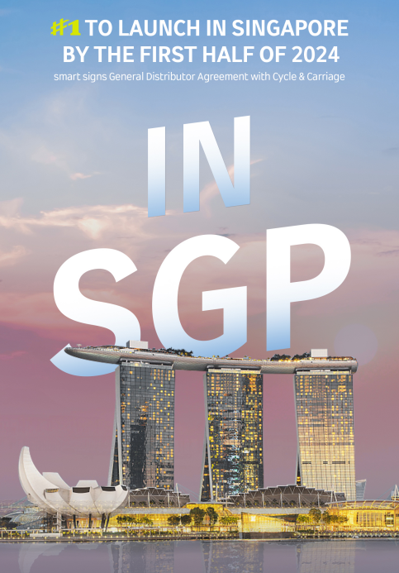
smart announced that Cycle & Carriage
will be its general distributor for the Singapore market

As a leading automotive distributor group in the Southeast Asian market, as well as the exclusive dealer of Mercedes-Benz in Singapore, Cycle & Carriage is one of the most diversified automotive groups in the country, having been around for over a century. The group has an advantage operating in Singapore, maintaining well-established sales and aftersales channels together with a highly experienced operations team. By choosing Cycle & Carriage, smart aims to quickly integrate into the local market and establish a brand advantage in Singapore.
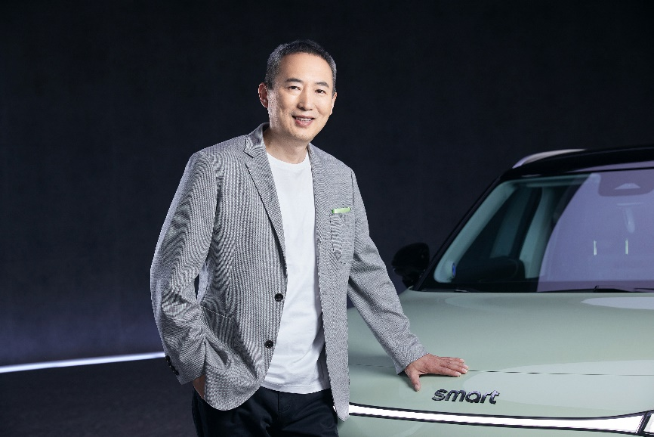
Mr. Tong Xiangbei, Global CEO of smart Automobile
Mr. Tong Xiangbei, Global CEO of smart Automobile said, “We are delighted to announce our plan to expand smart's business network in Singapore and the partnership with Cycle & Carriage. With extensive business network and abundant industry experience in the local market, Cycle & Carriage is an ideal partner to drive the region into the all-electric era together with smart.”
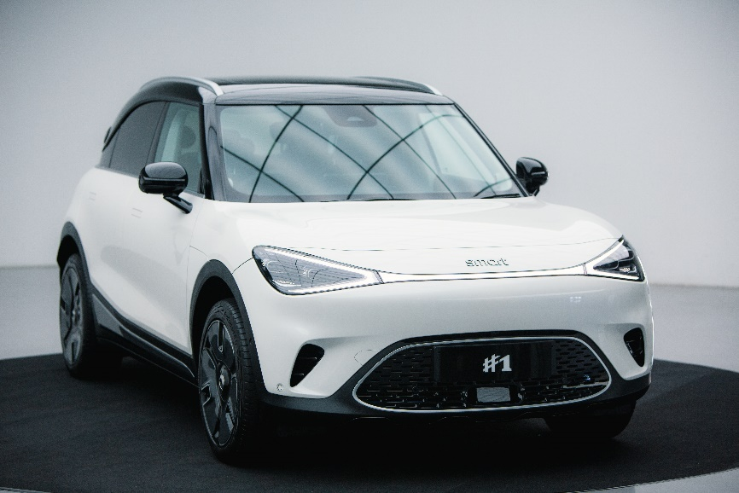
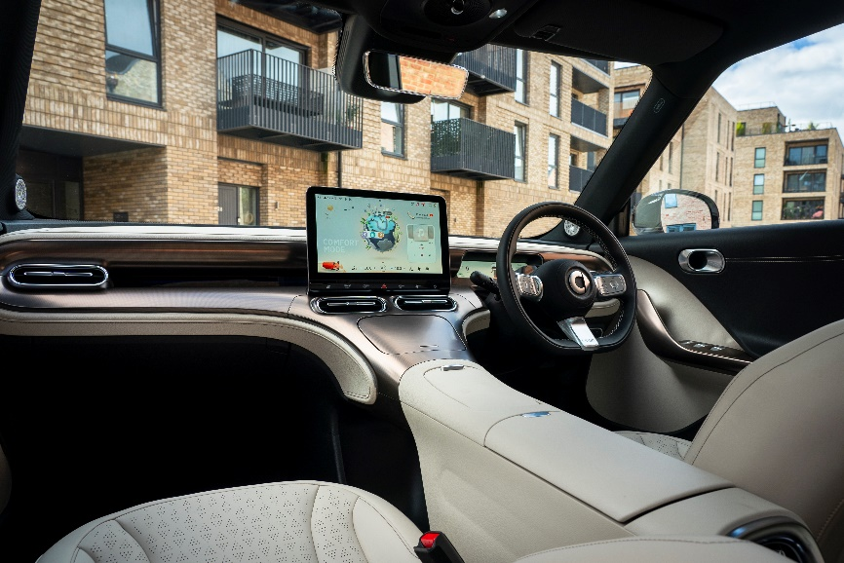
smart #1
In recent years, the Singapore government has introduced a series of incentive plans, including tax reductions and subsidies to increase support and adoption of new energy vehicles. Cycle & Carriage’s expertise in this electric mobility ecosystem includes electric vehicle sales and aftersales, e-logistics, and other green mobility solution explorations. This backdrop provides strong support for smart's business expansion in Singapore.
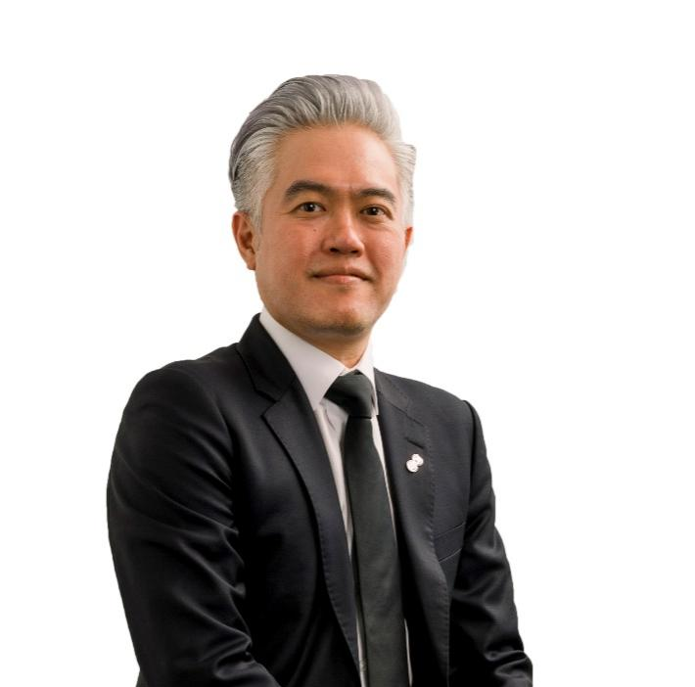
Wilfrid Foo, Managing Director of Cycle & Carriage Singapore
“We are excited about the product offerings that smart brings, which fit in perfectly to meet the growing demand of EVs in Singapore. New product development is led by the smart R&D team, supported by the Mercedes-Benz global design team who are responsible for vehicle design. With smart’s strong expertise and experience in product design, development, and operations, we are confident that smart will do well in Singapore, and we welcome smart into the C&C family,” said Wilfrid Foo, Managing Director of Cycle & Carriage Singapore.
Adhering to its forward-looking "China-Europe Dual-Home" global development strategy, smart holds firm to its original vision of "exploring the best solutions for future urban mobility". With global operations supporting sustainable local growth, smart is now accelerating into Singapore's dynamic market with Cycle & Carriage, driving innovation and sustainability to design a smarter future together.
-End-

