Press Release
22 August 2023

smart appoints Zung Fu as region’s general distributor
Expanding business network in Hong Kong and Macau

- smart has announced its plan to expand its business network in Hong Kong and Macau via a new partnership with Zung Fu.
- As one of the leading automotive groups in Hong Kong and Macau, Zung Fu has been the region’s exclusive dealer for Mercedes-Benz since 1954 and first partnered with smart in 2002.
- The all-new smart #1 is expected to be officially launched in Hong Kong in Q4 this year.
(22 August 2023, Hangzhou/Hong Kong/Macau) Today, smart, the new premium intelligent all-electric auto brand, announced its plan to expand its business network in Hong Kong and Macau via a new partnership with Zung Fu, one of the region’s leading automotive groups. smart appoints Zung Fu as the general distributor for its new-generation all-electric product portfolio in the region, with the smart #1 model expected to be officially launched in Hong Kong and Macau in Q4 2023.

smart has announced its plan to expand its business network in Hong Kong and Macau via a new partnership with Zung Fu.
Ms. Mandy Zhang, Vice President of Global Sales, Marketing and After-Sales of smart, said, "We are delighted to announce our plan to expand smart’s business network in Hong Kong and Macau through a renewed partnership with Zung Fu. With abundant industry experience and an extensive Mercedes-Benz sales and after-sales network, Zung Fu is uniquely positioned as the ideal partner to drive the region into the all-electric era together with us. We look forward to joining hands again.”
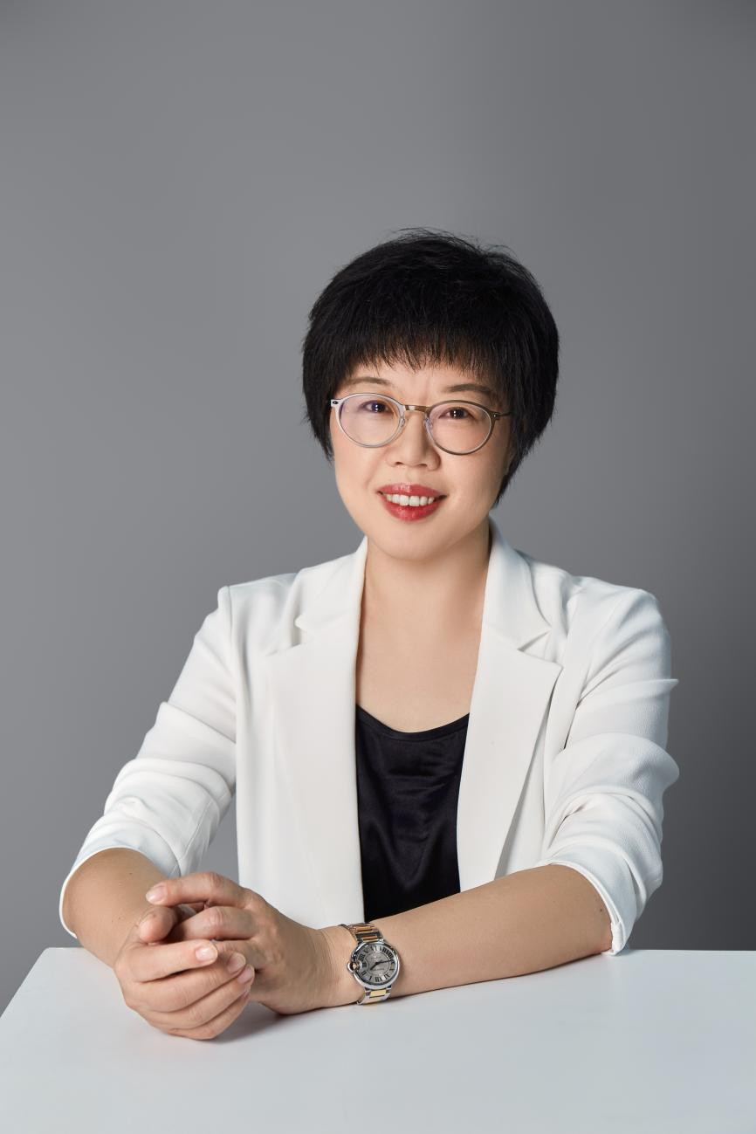
Ms Mandy Zhang, Vice President of Global Sales, Marketing and After-Sales of smart
A renewed partnership with Zung Fu brings a wealth of advantages to smart's Hong Kong and Macau expansion. There will be smart showrooms and service centres in Zung Fu’s areas of presence across the region. With 360 comprehensive marketing and sales strategies along with the Zung Fu team’s leading expertise, will offer an unparalleled network and market familiarity.
Mr. Simon Arnold, Managing Director, Zung Fu (Hong Kong & Macau) said, " Zung Fu shares a long, favourable history with smart that dates back to 2002, throughout the petrol vehicle era. Today, we are all very excited to reconnect with smart and embark on this new partnership together. With our extensive sales and service footprint in the region and our highly experienced people from both the frontline and supporting functions, we are confident about co-creating a brand-new customer experience with smart, serving each customer at every touch point with excellence and smart uniqueness. We look forward to developing an exciting and successful all-electric smart future in Hong Kong and Macau."
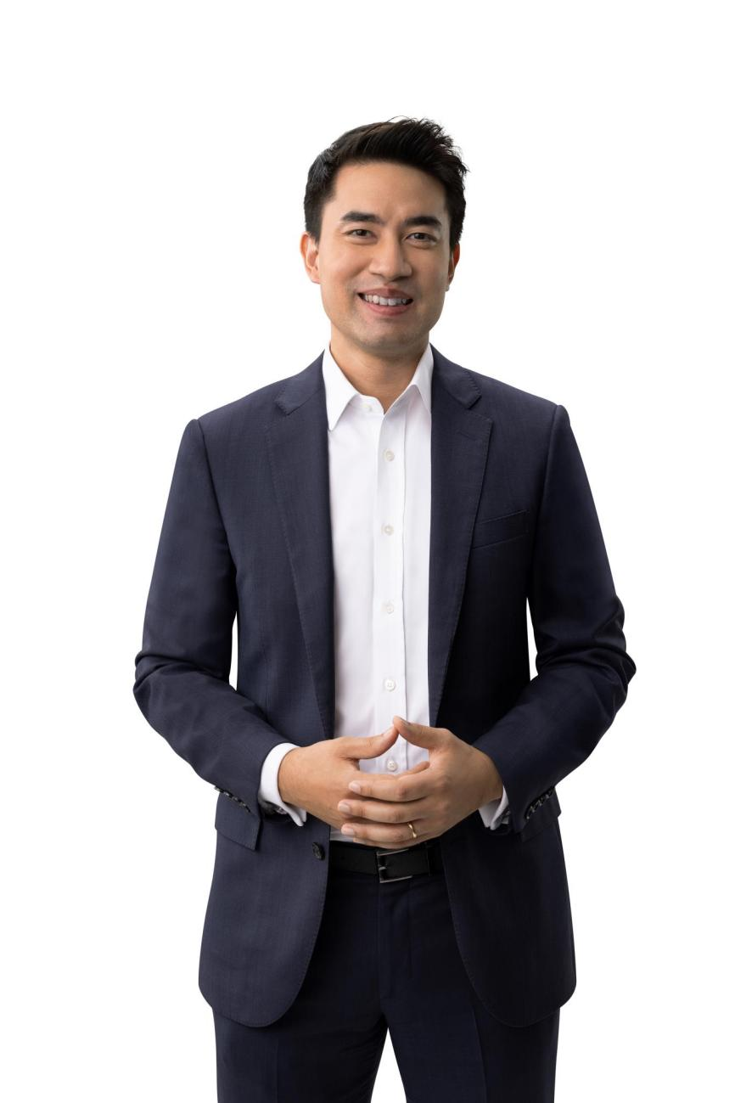
Mr. Simon Arnold, Managing Director, Zung Fu (Hong Kong & Macau)
Our partnerships with leading industry players exemplify a shared vision of the future and the brand’s dedication to its "China-Europe dual-home" global development strategy. Now on an exciting new path with operations at full speed, smart has completed construction of 164 independent brand sales and service outlets in China with plans to expand to more than 200 by the end of the year, on top of nearly 300 sales and service outlets across 13 European markets. Meanwhile, smart #1 is expected to be ready for delivery in Malaysia in the fourth quarter of 2023.
-End-

