THE RITUAL OF ADVENT
24 first-class suprises
Advent is a cherished tradition that turns waiting into wonder - an invitation to slow the run-up to Christmas into a journey with intention. This year, that sense of anticipation is brought to life through two collectible designs, each with its own world to step into: A luxurious house that feels nostalgic and captures the glow of home, warmth behind windows, and calm moments waiting inside. The second keepsake is a playful train that feels like motion, discovery and little surprises around every corner.

Playful, premium, and impossible to ignore, both calendars are designed to spark joy and stop the scroll - turning the countdown into a story you can hold, display, and return to every day. Not just a calendar, but a December routine: one door, one pause, one small moment of joy at a time.
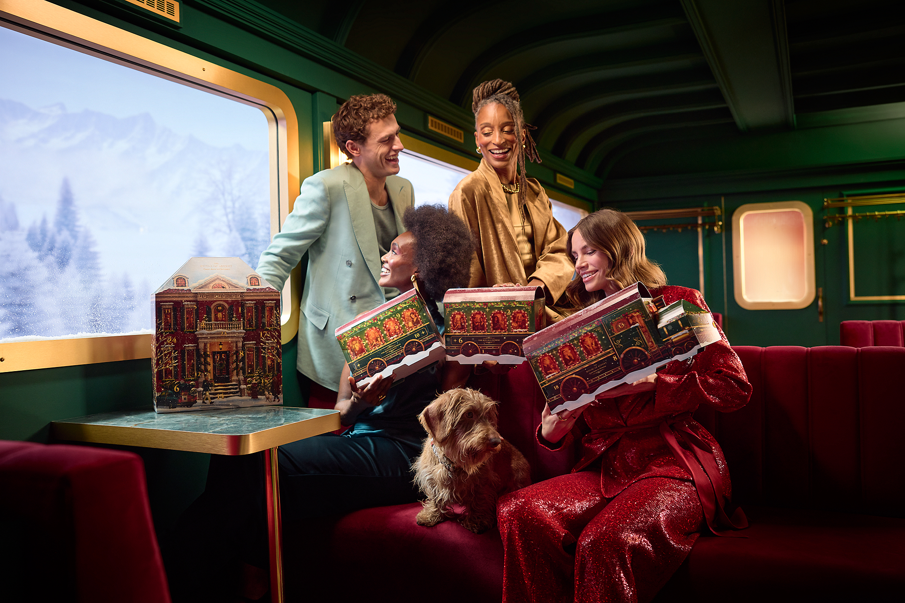

CLASSIC ADVENT CALENDER 2026

What is it?
Knock, knock - 24 doors to joy. From cosy spices to clean florals, this pop-up townhouse hides daily treats for body, bath, and home including the Limited Edition. Build your daily routine, door by door. Open a door each day, a nostalgic nod to the chocolate Advent calendars of our youth, and build your routine. Cleanse, nourish, scent, unwind; keep it on show while you enjoy this year’s Advent countdown.

How to use it?
ooh jThis Advent calendar is super easy to set up. Scan the QR on the side of the box for our guide on how to assemble it.

USP’s
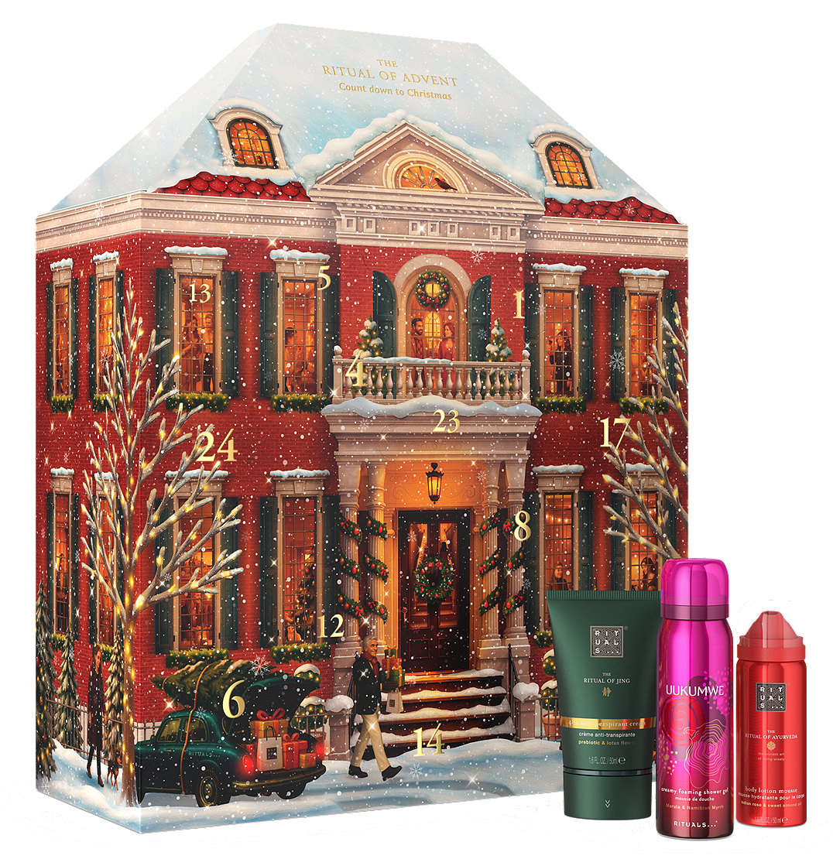
- Pop-up house display, do daily assembly
- Body, bath, and home
- 2 full-size products and loads of travel minis


PREMIUM ADVENT CALENDER 2026

What is it?
All aboard the countdown express. Build your daily routine, one day at a time. This keepsake train is packed with bath, body, and home favourites - travel minis, the Limited Edition, all scented from cosy spice to soft floral and fresh citrus. Set it out once, then open one door each day to refresh your routine: cleanse, nourish, scent, unwind. Designed to stay on display all Advent.

How to use it?
This Advent calendar is super easy to set up. Scan the QR on the side of the box for our guide on how to assemble it.

USP’s
- Keepsake train display
- Body bath home and limited editions.

- 7 full-size products



