The Earth Prize 2026: Indian teen trio named Global Winners for magnetic tamarind powder that removes microplastics from water
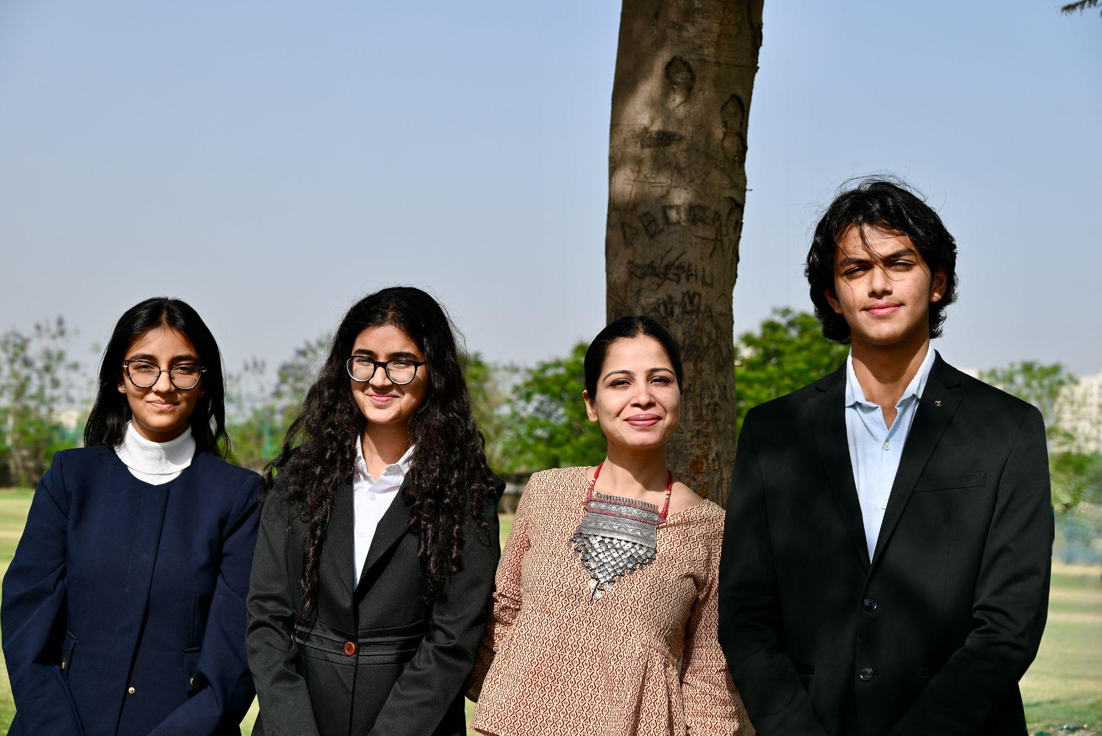
Team Plas-Stick (Avyana Mehta, Ariana Agarwal, Vivaan Chhawchharia) and their teacher (Minal Jain)
- The Earth Prize is the world’s largest environmental competition and ‘ideas incubator’ for 13-19 year-olds, empowering young people with mentorship and shared $100K funding
- Global Winners team Plas-Stick from India created a magnetic tamarind powder that removes microplastics from water
- Around 23,000 people voted to decide the Global Winner from seven Regional Winners across the globe
- Plas-Stick is the first ever Global Winner of The Earth Prize from India
GENEVA, Switzerland, 29 May - Today, The Earth Prize 2026 named its Global Winners: 16-year-olds Vivaan Chhawchharia, Ariana Agarwal and Avyana Mehta from India. Their solution, Plas-Stick, is a biodegradable magnetic tamarind powder that removes microplastics from water. Notably, Plas-Stick is the first-ever Global Winner of The Earth Prize from India.
Last week, around 23,000 people cast their votes to select the Global Winner from seven inspiring Regional Winners representing every continent: North America, Africa, Asia, Central and South America, Oceania and Southeast Asia, Europe, and the Middle East. Representing the Regional Winner for Asia, Plas-Stick had already received $12.5K to scale their solution.
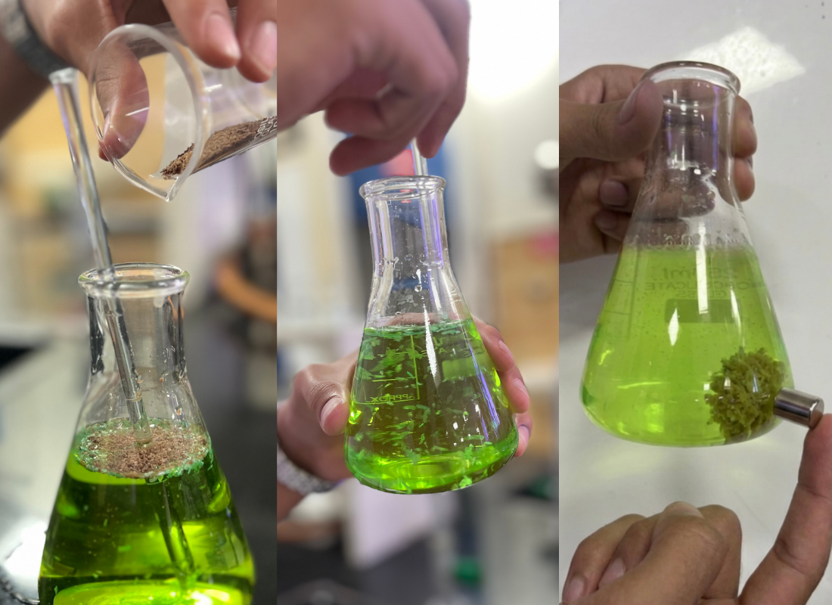
3-phase demonstration - Adding the powder to coloured water, mixing, and attracting clumped microplastics using a handheld magnet
The announcement was made today during The Earth Prize 2026 Award Ceremony. Plas-Stick will also now receive a sustainably crafted ‘100-year’ flag to be flown at their school, handsewn from recycled sailboat sails, and passed on from the previous winners. Reflecting on their win, Vivaan, Ariana and Avyana said:
“Being named the Global Winners of The Earth Prize is incredibly special for all of us, especially as the first team from India to receive this recognition. What started as an idea between students has now been recognised among thousands of projects from around the world, which feels both surreal and deeply motivating. We hope this not only helps us scale Plas-Stick further, but also encourages more young people to believe that their ideas can create meaningful environmental change.”
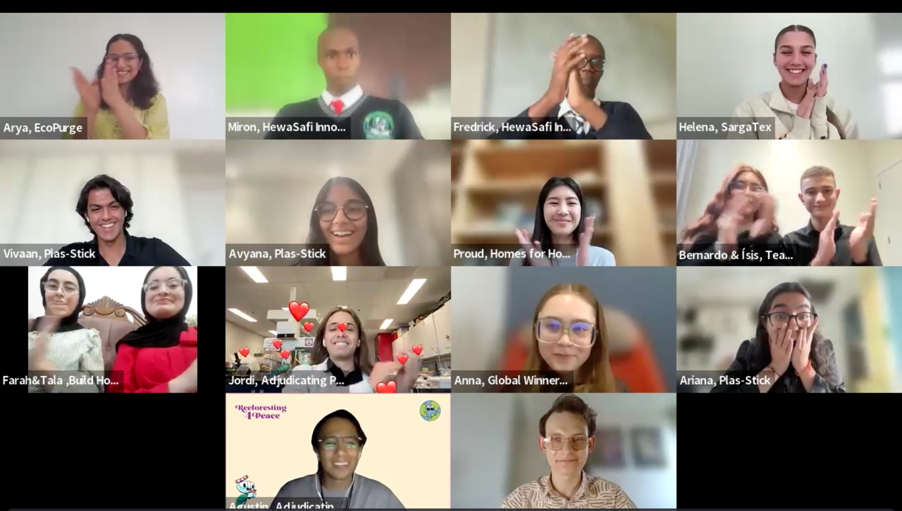
During the Earth Prize Awards Ceremony on Friday 29 May, the students found out who was the Global Winner for 2026
The idea for Plas-Stick emerged after the team visited a rural community where drinking water was commonly stored in shared plastic containers, without advanced filtration systems.
During this visit, seeing a child drink from one of these containers highlighted exposure to microplastics through everyday drinking water, particularly in underserved rural communities in India. Globally, over 2.2 billion people lack safely managed drinking water infrastructure, increasing reliance on stored water that may contain microplastics.
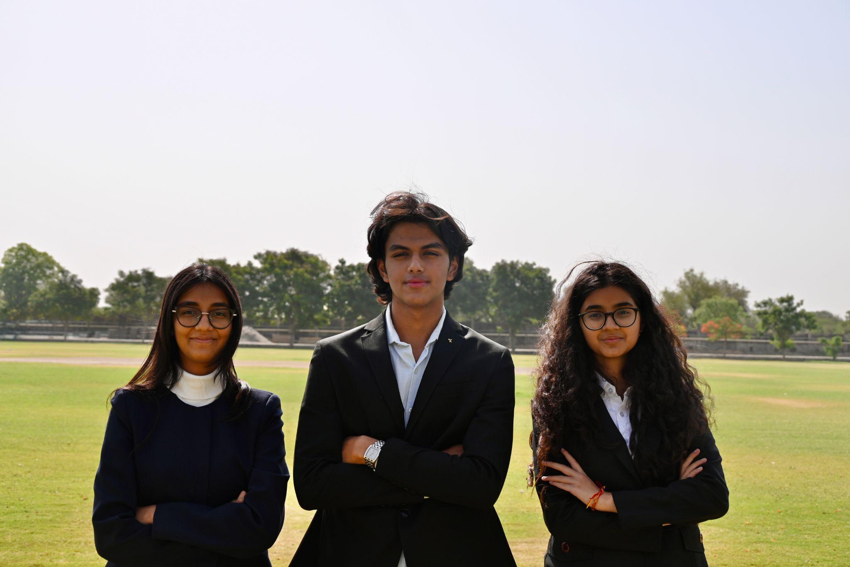
Team Plas-Stick - Avyana Mehta, Vivaan Chhawchharia and Ariana Agarwal
Determined to create a solution, the team developed a biodegradable powder made from discarded tamarind seeds. When added to water, the powder attracts and binds microplastic particles into visible clumps that can then be removed using a handheld magnet. Designed to work without electricity or complex machinery, the solution is low-cost and scalable.
Already deployed through workshops and demonstrations, Plas-Stick has reached and educated more than 8,000 students and teachers so far. The team has also collaborated with professionals from IIT Guwahati to further strengthen testing and development of the technology.
Following their Global Winner recognition, the team now plans to scale the solution through decentralised production hubs and expand to rural communities across India, making safer drinking water more accessible across rural Indian communities and beyond.
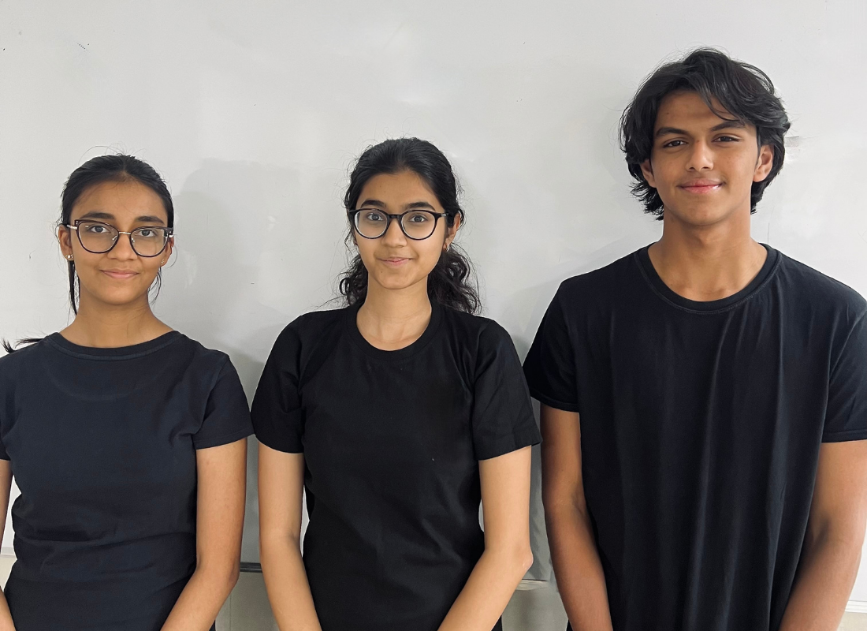
Like many students taking part in The Earth Prize, the team turned a problem they witnessed firsthand into a practical environmental solution. Now in its fifth year, The Earth Prize has reached over 21,000 students across 169 countries and territories. Previous winners have been featured in leading international media including Forbes, BBC, the Financial Times, CBS, Business Insider, Euronews, and UN Today, with several teams advancing their ideas through patents, partnerships and commercial pilots.
The Earth Prize is run by The Earth Foundation, a non-profit based in Geneva, Switzerland, founded during the School Strike for Climate in 2019. At a time when climate anxiety affects a majority of young people - with 59% reporting they are very or extremely worried about the environment - the Prize provides a pathway from concern to action, equipping students with the tools to develop tangible, real-world solutions.
Peter McGarry, Founder of The Earth Foundation, said of Plas-Stick’s win:
“Team Plas-Stick represents exactly the kind of innovation The Earth Prize was created to elevate: solutions that are scientifically grounded, environmentally responsible and accessible to the communities that need them most. By transforming agricultural waste into a practical tool for removing microplastics from drinking water, these young innovators are addressing a growing global challenge with remarkable creativity and purpose.”
For young people aged 13-19 years who have been inspired by this year’s Earth Prize cohort, there has never been a better time to innovate for our planet. Registrations are already open for 2027 at https://www.theearthprize.org.
About The Earth Prize
The Earth Foundation is a Geneva-based non-profit that empowers, educates and inspires young people to tackle environmental challenges. Founded in response to the 2019 student-led climate rallies, it launched its flagship initiative, The Earth Prize, the world’s largest environmental competition and ‘ideas incubator’ for young people. The competition aims to inspire and empower the next generation of environmental innovators, supporting participants with the tools they need to develop eco solutions for real-world impact, including one-on-one mentoring, learning resources and $100,000 shared funding for the winners. Since 2019, The Earth Prize has reached over 21,000 students across 169 countries and territories, and awarded over $500,000.
Impact PDF: https://tinyurl.com/tep2026

