The $100K Earth Prize 2026: 17-year-old from Thailand named Oceania & Southeast Asia Winner for hornbill nesting solution

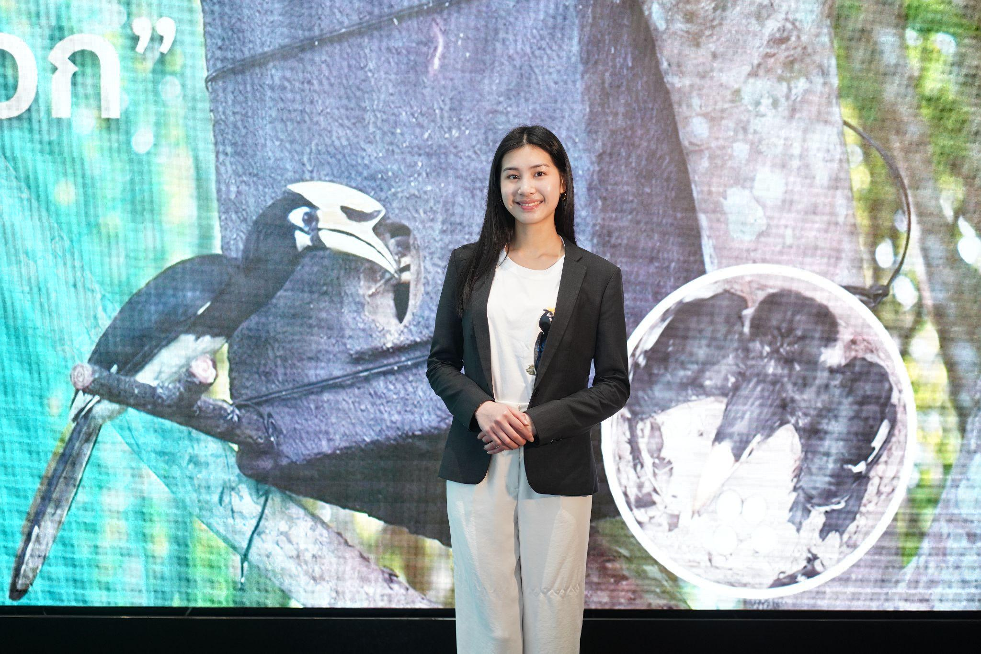

- The Earth Prize is the world’s largest environmental competition and ‘ideas incubator’ for 13-19-year-olds, empowering young people with mentorship and $100K funding
- Yanin (Proud) Tangkaravakoon is protecting hornbills, vital seed dispersers in forests, through artificial nests made from upcycled plastic bottles and community conservation
- Seven Winners will be announced each day this week, representing the regions of North America, Africa, Asia, Central and South America, Oceania and Southeast Asia, Europe and the Middle East
- Each team receives $12.5K to develop and implement their idea for real life impact
- A public vote opens soon to crown the Global Winner on 29 May

GENEVA, Switzerland, 15 May - In an effort to address the decline of hornbill populations and the impact on forest ecosystems worldwide, 17-year-old Yanin (Proud) Tangkaravakoon from Thailand has been named as the Oceania and Southeast Asia Winner of The Earth Prize 2026. Her solution, Homes for Hornbills, creates artificial nests made from upcycled materials like plastic bottles while working with communities to reduce poaching and deforestation.

Proud first saw hornbills on a fourth-grade school field trip to Khao Yai National Park, where she was fascinated by their behaviour. However, she soon learned that 51 of the 62 hornbill species globally were decreasing in population due to deforestation, habitat loss, and poaching. Motivated to act, she worked closely with the Thailand Hornbill Research Foundation (THRF) to design and refine a three-part solution: durable artificial nests tailored to hornbill behaviour, a school-based conservation programme, and, eventually, alternative income opportunities for local communities to reduce poaching and deforestation.

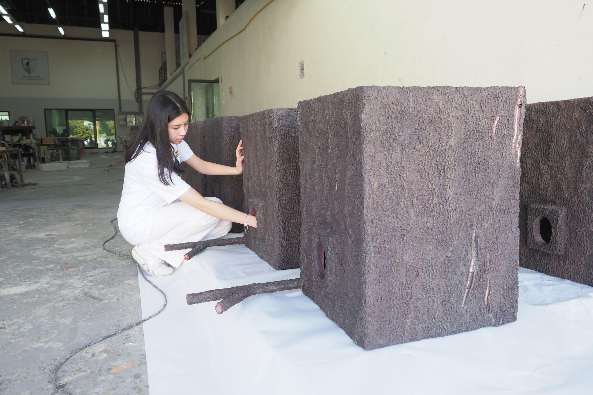

So far, 20 nests have been installed in southern Thailand, with 14 hornbill chicks successfully fledging in 2025 and 14 nests now occupied in 2026. The project has engaged 60 local students, and partnered with TOA Venture Holding (TOAVH) to support the use of upcycled plastic materials in nest production. Proud has also created an award-winning top 10 documentary Homes for Hornbills now streaming on Thai PBS’s VIPA platform, presented her research findings to the Faculty of Forestry, Kasetsart University and been featured in local news.

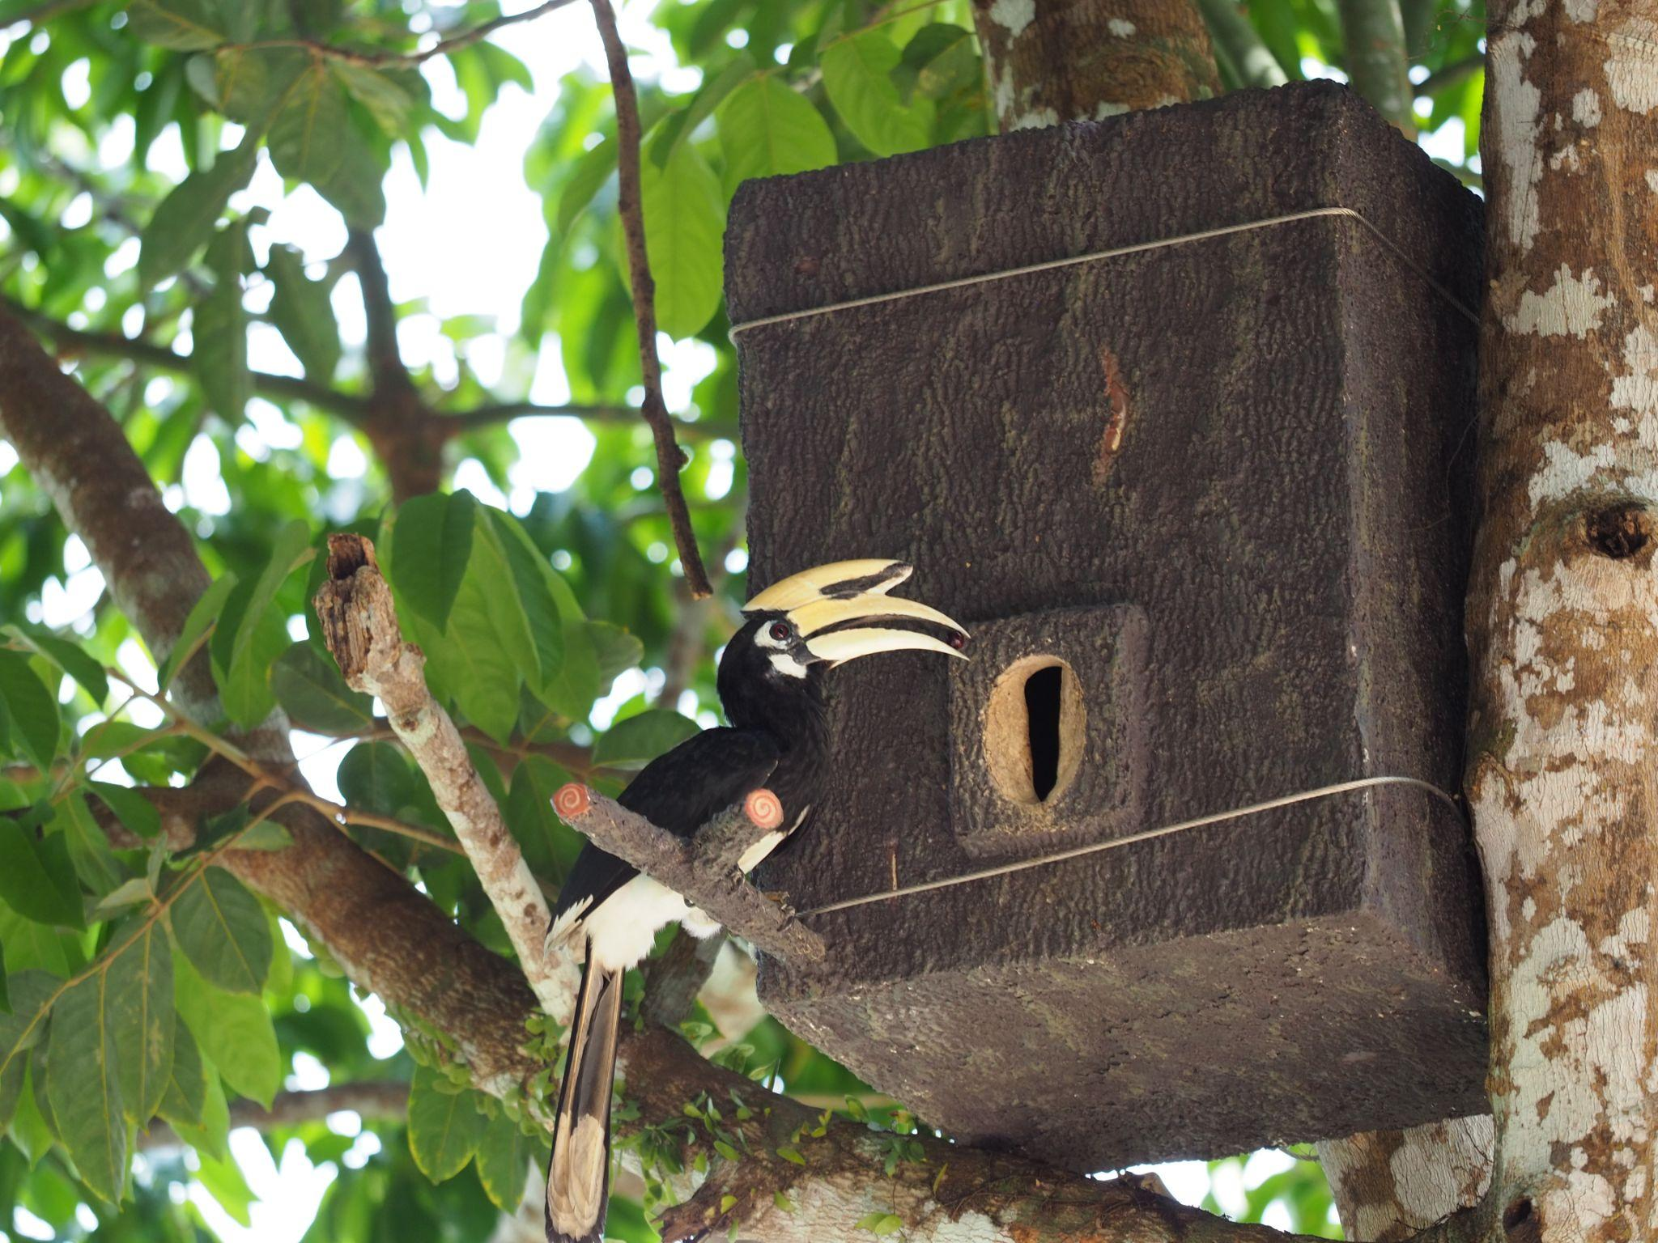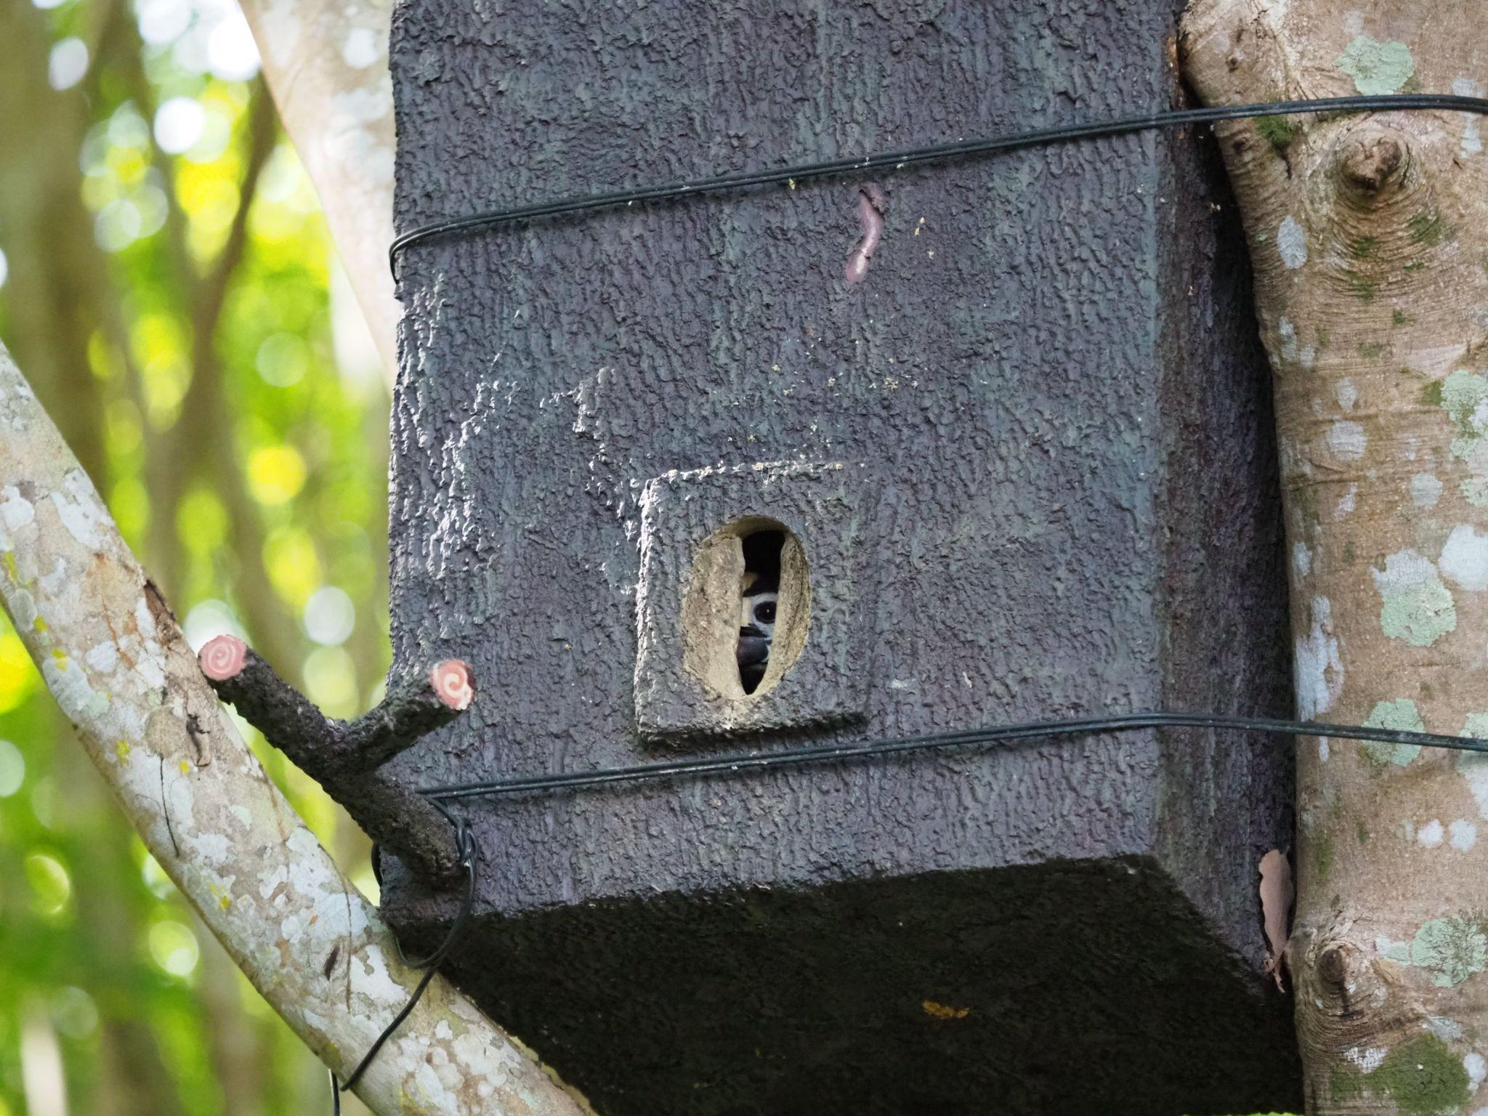

With the support and now $12.5K of prize funding from The Earth Prize, Proud aims to expand across key habitats and work with communities to scale the model, including introducing alternative income opportunities such as nest construction and monitoring to help reduce poaching.

Proud explained: “Seeing how important hornbills are to forests made me realize how urgent it is to protect them. Winning the Earth Prize gives me the chance to scale this work by expanding nest deployment and partnering with local communities to create long-term solutions for both wildlife and the forests they sustain.”

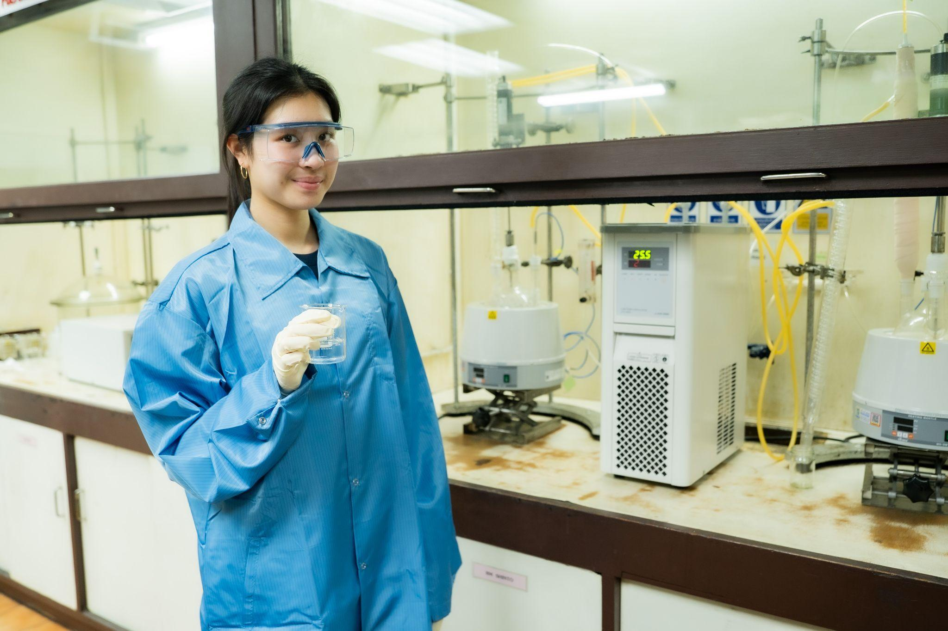

Now in its fifth year, The Earth Prize has reached over 21,000 students across 169 countries and territories. Previous winners have been featured in leading international media including Forbes, Business Insider (US and Africa), The Irish Times, and UN Today, with several teams advancing their ideas through patents and corporate partnerships.

The Earth Prize is run by The Earth Foundation, a non-profit based in Geneva, Switzerland, founded during the School Strike for Climate in 2019. At a time when climate anxiety affects a majority of young people - 59% reporting they are very or extremely worried about the environment - the Prize provides a pathway from concern to action, equipping students with the tools to develop tangible, real-world solutions.

Peter McGarry, Founder of The Earth Foundation, commented on this year’s competition: “The Earth Prize winners 2026 represent seven outstanding teams across seven global regions, each tackling environmental challenges with distinct and impactful solutions. Once again, these young innovators demonstrate that age is no barrier to meaningful change. Their work reflects a powerful combination of creativity, determination and a deep understanding of the communities they serve.”

Public voting for the Global Winner opens on Monday 18 May, the day after the final Regional Winner is announced. Cast your vote on The Earth Prize website: www.theearthprize.org/vote.

About The Earth Prize
The Earth Foundation is a Geneva-based non-profit that empowers, educates and inspires young people to tackle environmental challenges. Founded in response to the 2019 student-led climate rallies, it launched its flagship initiative, The Earth Prize, the world’s largest environmental competition and ‘ideas incubator’ for young people. The competition aims to inspire and empower the next generation of environmental innovators, supporting participants with the tools they need to develop eco solutions for real-world impact, including one-on-one mentoring, learning resources and $100,000 shared funding for the winners. Since 2019, The Earth Prize has reached over 21,000 students across 169 countries and territories, and awarded over $500,000.
Impact PDF: https://tinyurl.com/tep2026

