The $100K Earth Prize 2026: 17-year-old Brazilians named Central and South America Winners for biodegradable aloe and chamomile bandages
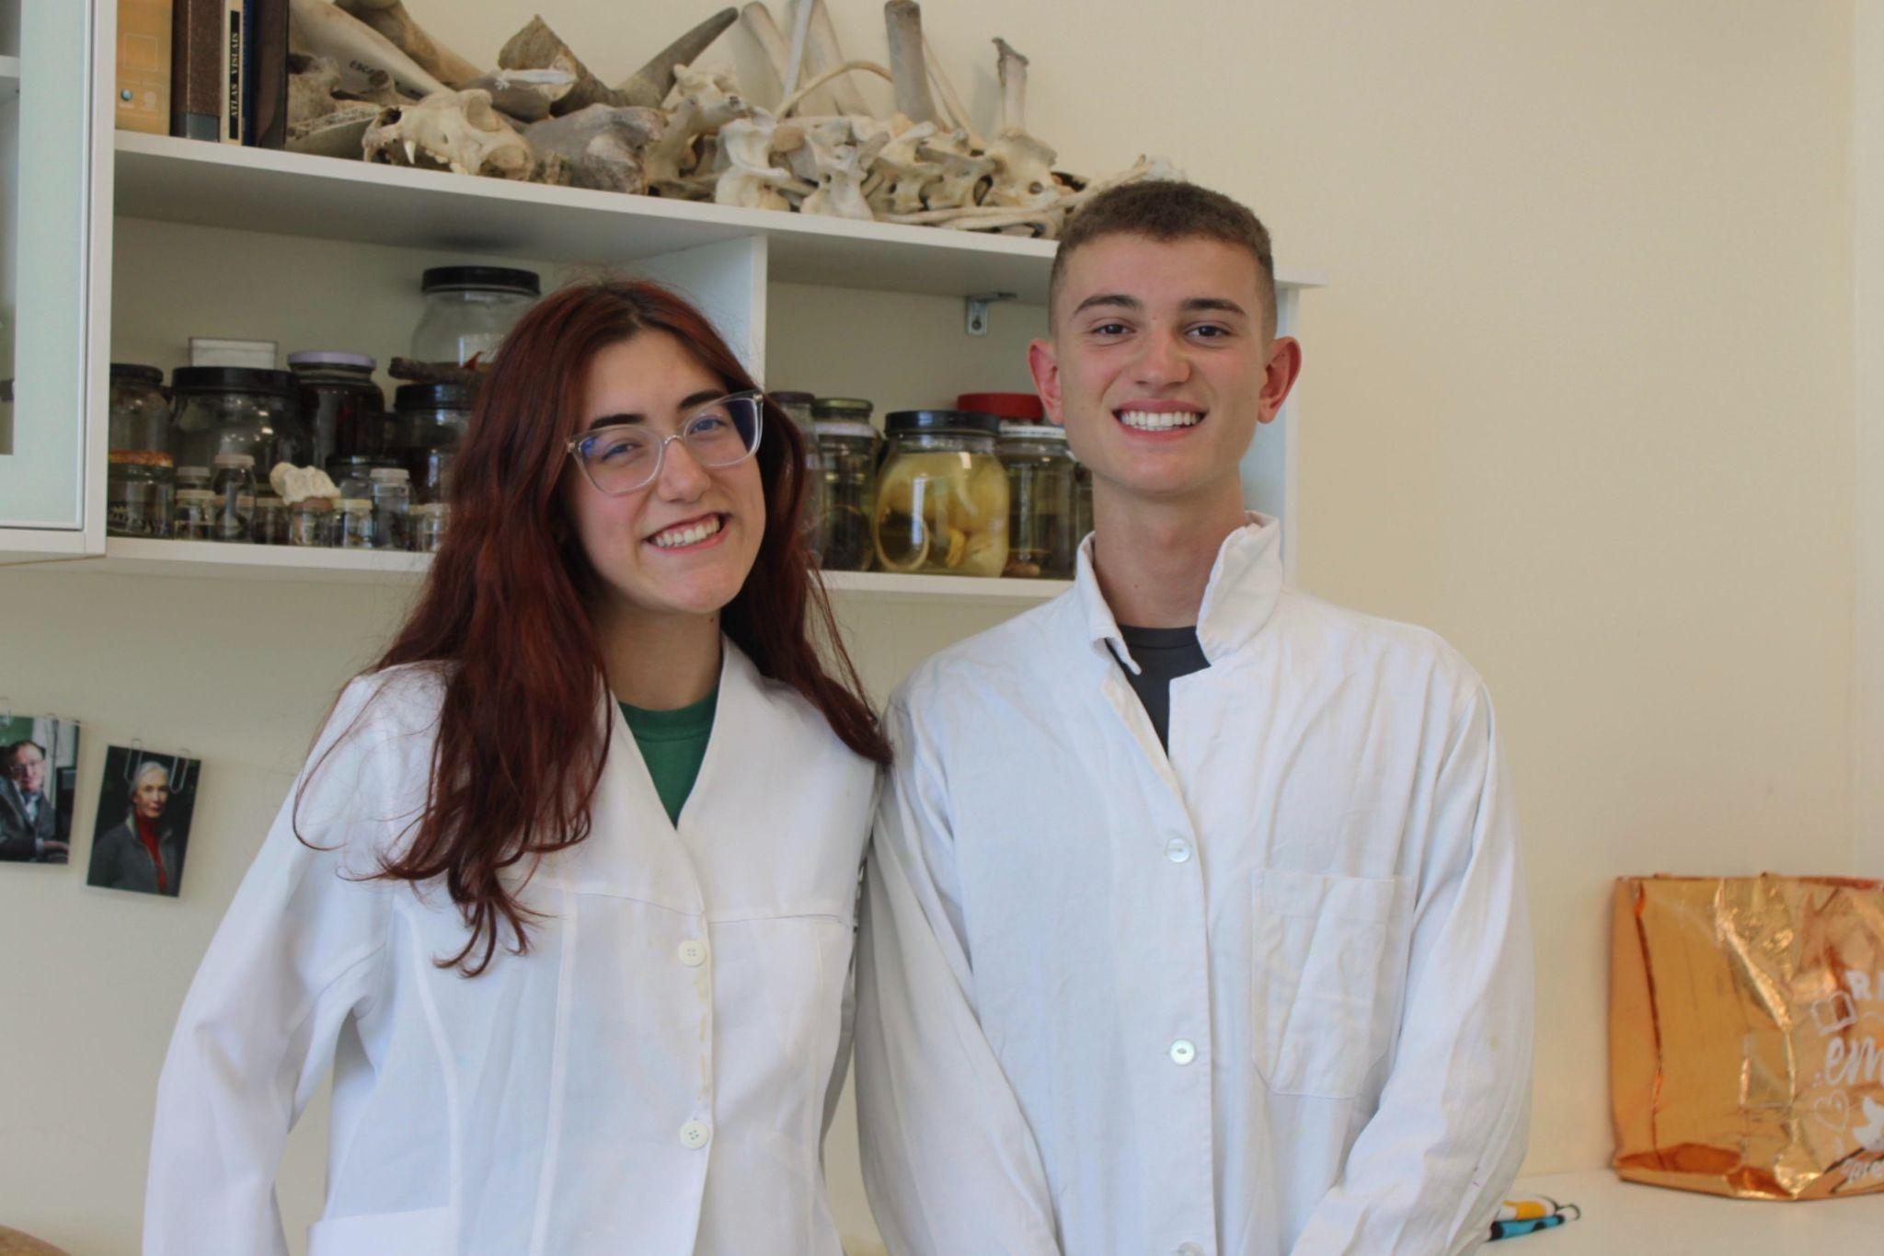

- The Earth Prize is the world’s largest environmental competition and ‘ideas incubator’ for 13-19-year-olds, empowering young people with mentorship and $100K funding
- 17-year-olds Bernardo Renner and Ísis Valentin created a biodegradable aloe vera and chamomile dressing that replaces plastic bandages and supports natural healing
- Seven Winners will be announced each day this week, representing the regions of North America, Africa, Asia, Central and South America, Oceania and Southeast Asia, Europe and the Middle East
- Each team receives $12.5K to develop and implement their idea for real life impact
- A public vote will crown the Global Winner on 29 May

GENEVA, Switzerland, 17 May - In an effort to tackle plastic waste in healthcare, 17-year-olds Bernardo Renner and Ísis Valentin from Brazil have been named the Central & South America Winners of The Earth Prize 2026. Their solution, HADA, is a biodegradable dressing made from aloe vera and chamomile to support healing and replace conventional plastic bandages.

The idea for Hada began on the volleyball court. As active players, Bernardo and Ísis were used to frequent cuts and injuries, often treated at school with basic first aid that simply covered wounds without supporting recovery. This personal frustration led them to explore better solutions, which soon expanded into a wider global challenge: an estimated 2.2 billion plastic bandages were discarded in 2023 alone, contributing to microplastic pollution and offering limited medical benefit.

In response, they developed a plant-based bio-dressing using aloe vera and camomile, combining their well-established antibacterial, anti-inflammatory, and regenerative properties into a single material. Unlike conventional plastic bandages, which merely cover wounds and contribute to microplastic pollution, HADA actively promotes tissue repair while remaining fully biodegradable, breaking down in soil within 48 hours. Designed using accessible, locally sourced ingredients, the solution is scalable and environmentally sustainable.

Already developed into working prototypes, Hada has demonstrated strong adhesion, flexibility, and antimicrobial performance in early testing. The team has produced four research papers and is now seeking a robust laboratorial structure and advancing regulatory pathways, working alongside several experts: Instituto Caldeira, the largest innovation hub in south Brazil, Prado Tech in Gravataí, and Carlos Johannpeter, a renowned Brazilian entrepreneur who is a main Hada's collaborator. With support from The Earth Prize, they aim to further validate and enhance the technology, scale production, and bring the bio-dressing into real-world settings such as schools, sports centres, and healthcare environments.

Ísis and Bernardo explained: “We started by trying to solve a problem we experienced ourselves, but quickly realised it was much bigger than that. Something as small as a bandage is used by millions of people every day, yet it creates waste and doesn’t always support healing. Winning The Earth Prize gives us the chance to bring Hada into real world use and solve an exponential problem: the human plastic dependency”.

Now in its fifth year, The Earth Prize has reached over 21,000 students across 169 countries and territories. Previous winners have been featured in leading international media including Forbes, Business Insider (US and Africa), The Irish Times, and UN Today, with several teams advancing their ideas through patents and corporate partnerships.

The Earth Prize is run by The Earth Foundation, a non-profit based in Geneva, Switzerland, founded during the School Strike for Climate in 2019. At a time when climate anxiety affects a majority of young people - 59% reporting they are very or extremely worried about the environment - the Prize provides a pathway from concern to action, equipping students with the tools to develop tangible, real-world solutions.

Peter McGarry, Founder of The Earth Foundation, commented on this year’s competition: “The Earth Prize winners 2026 represent seven outstanding teams across seven global regions, each tackling environmental challenges with distinct and impactful solutions. Once again, these young innovators demonstrate that age is no barrier to meaningful change. Their work reflects a powerful combination of creativity, determination and a deep understanding of the communities they serve.”

Public voting for the Global Winner opens on Monday 18 May, the day after the final Regional Winner is announced. Cast your vote on The Earth Prize website: www.theearthprize.org/vote.

About The Earth Prize
The Earth Foundation is a Geneva-based non-profit that empowers, educates and inspires young people to tackle environmental challenges. Founded in response to the 2019 student-led climate rallies, it launched its flagship initiative, The Earth Prize, the world’s largest environmental competition and ‘ideas incubator’ for young people. The competition aims to inspire and empower the next generation of environmental innovators, supporting participants with the tools they need to develop eco solutions for real-world impact, including one-on-one mentoring, learning resources and $100,000 shared funding for the winners. Since 2019, The Earth Prize has reached over 21,000 students across 169 countries and territories, and awarded over $500,000.
Impact PDF: https://tinyurl.com/tep2026

