The $100K Earth Prize 2026: Gazan sisters named Middle East Winners for their recycled rubble bricks

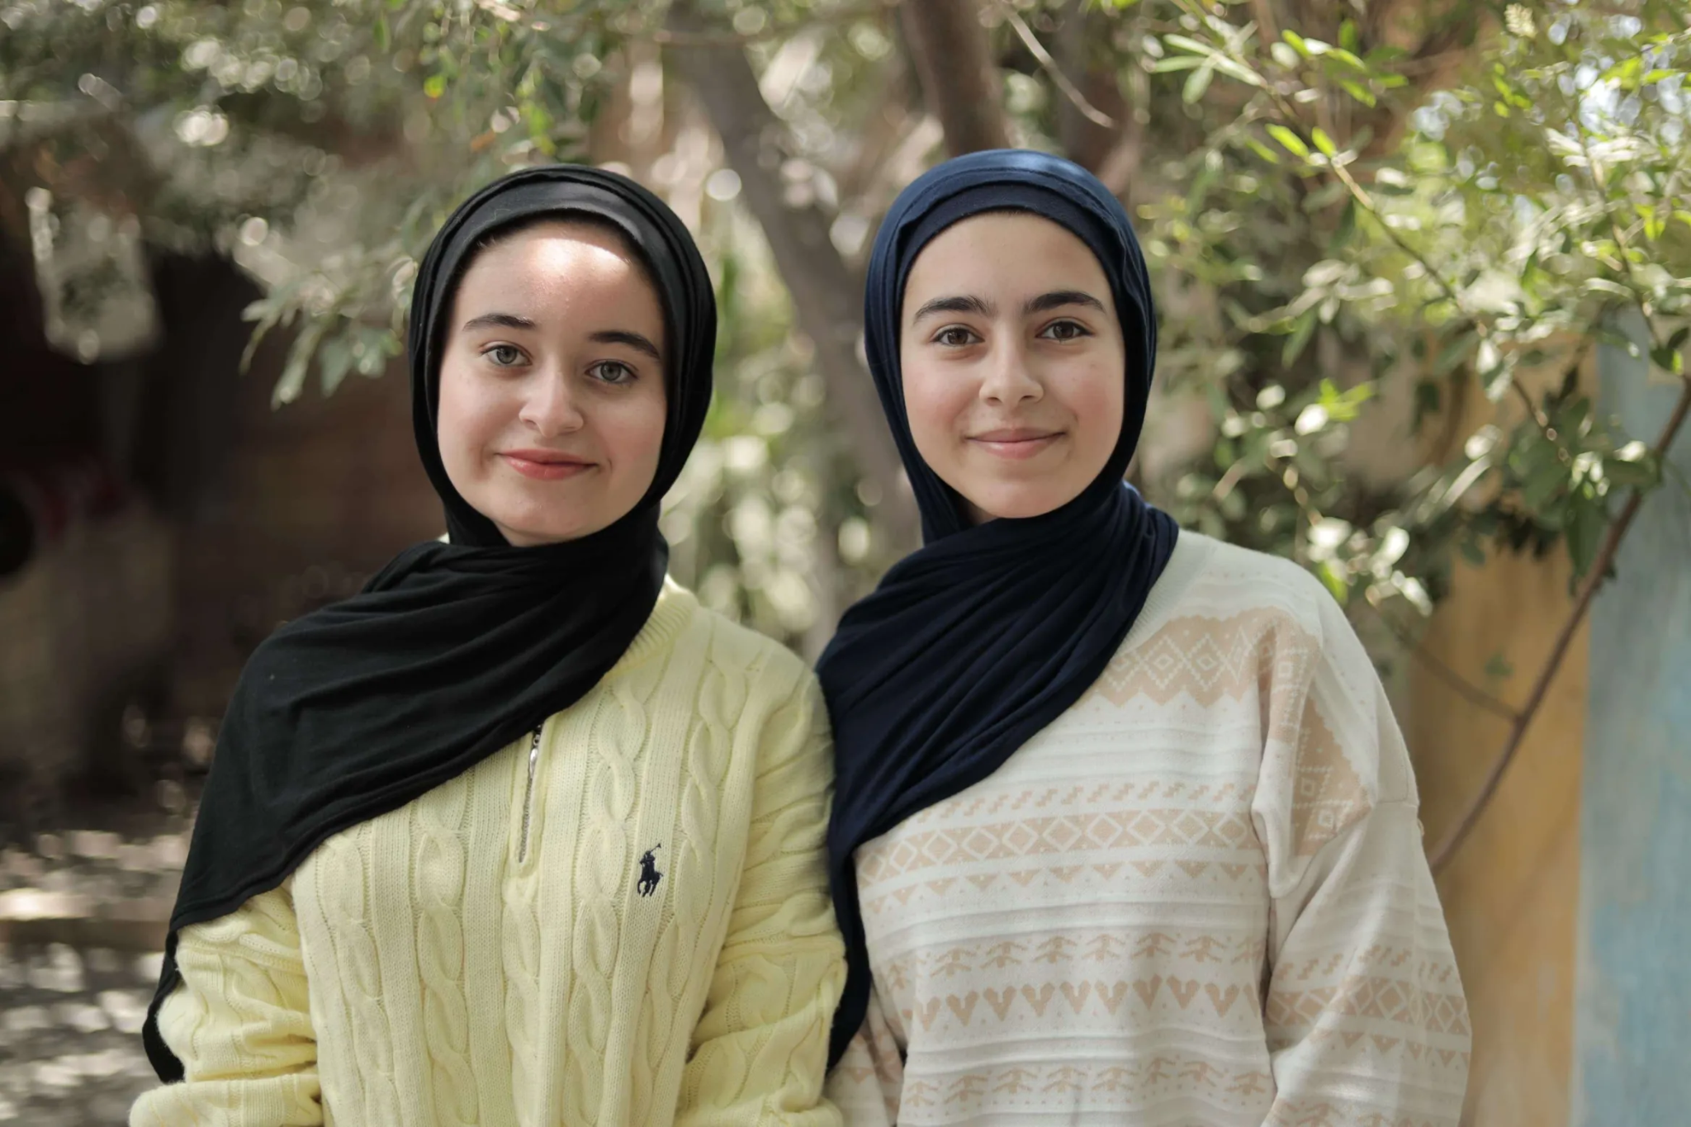

- The Earth Prize is the world’s largest environmental competition and ‘ideas incubator’ for 13-19-year-olds, empowering young people with mentorship and $100K funding
- Team ‘Build Hope - Palestine’ is turning rubble into reusable blocks, bringing young people together to rebuild their communities
- Seven winning teams will be announced each day this week, representing the regions of North America, Africa, Asia, Central and South America, Oceania and Southeast Asia, Europe and the Middle East
- Each team receives $12.5K to develop and implement their idea
- A public vote opens soon to crown the Global Winner on 29 May

GENEVA, Switzerland, 13 May - Sisters Tala Mousa (17) and Farah Mousa (15) have been named the Middle East Winners in The Earth Prize 2026, the world’s largest environmental competition and incubator for young people aged 13-19 years. Their project ‘Build Hope - Palestine’ is recycling rubble into reusable bricks and bringing young people together to help rebuild their communities.

Living in Gaza amid ongoing conflict, and after their house was bombed, sisters Tala Mousa and Farah Mousa began looking for a way to support their community. They set out to develop a practical solution that could work within the constraints around them. Their project, ‘Build Hope - Palestine’, transforms rubble from damaged buildings into reusable, non-load-bearing blocks for applications such as garden beds, pavements, and partitions. Using simple, locally available materials, the process involves crushing and sieving debris, then mixing it with binders such as clay, ash, or glass powder before moulding and drying it into blocks.

VIDEO LINK: https://drive.google.com/file/d/1VGijf5wdQglfTnTpKdaUQjCNwLO8kmvU/view?usp=sharing

Designed to be scalable, the project focuses on recycling debris while supporting communities. Through hands-on workshops, the sisters aim to bring together 100 young people to produce at least 200 blocks, while giving them the skills to share the process with others, expanding its impact to more than 1,000 people, with potential to reach many more.
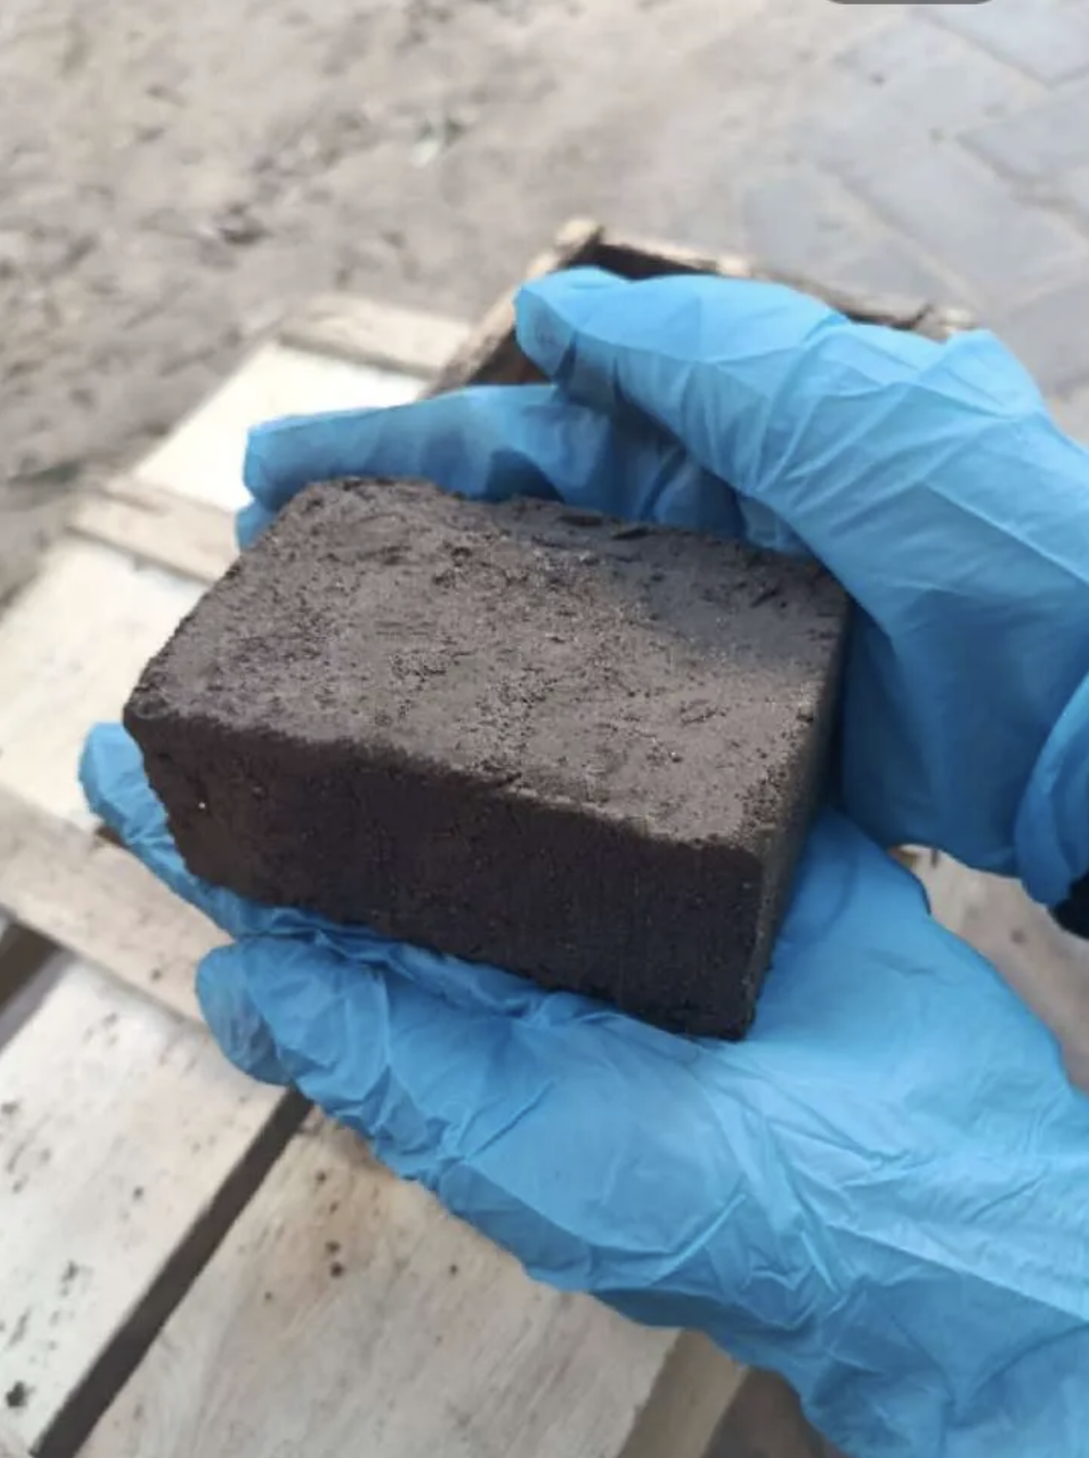

Tala and Farah impressed The Earth Prize’s expert jury with the project, being the first ever Winning team from Gaza. Tala explained: “The view from our tent window is what keeps us always motivated. The large amount of rubble and the lack of accessible rebuilding solutions inspire us to work on this project. The solution is decentralised, low-cost and relies on locally available materials. It’s designed to be replicated by communities without heavy machinery or specialised infrastructure, and turn what was once destruction into a starting point for hope.”

On their win, Tala also explained: “It was an amazing feeling to be named Winners of the Middle East region. This recognition feels like proof that hope can rise from rubble."

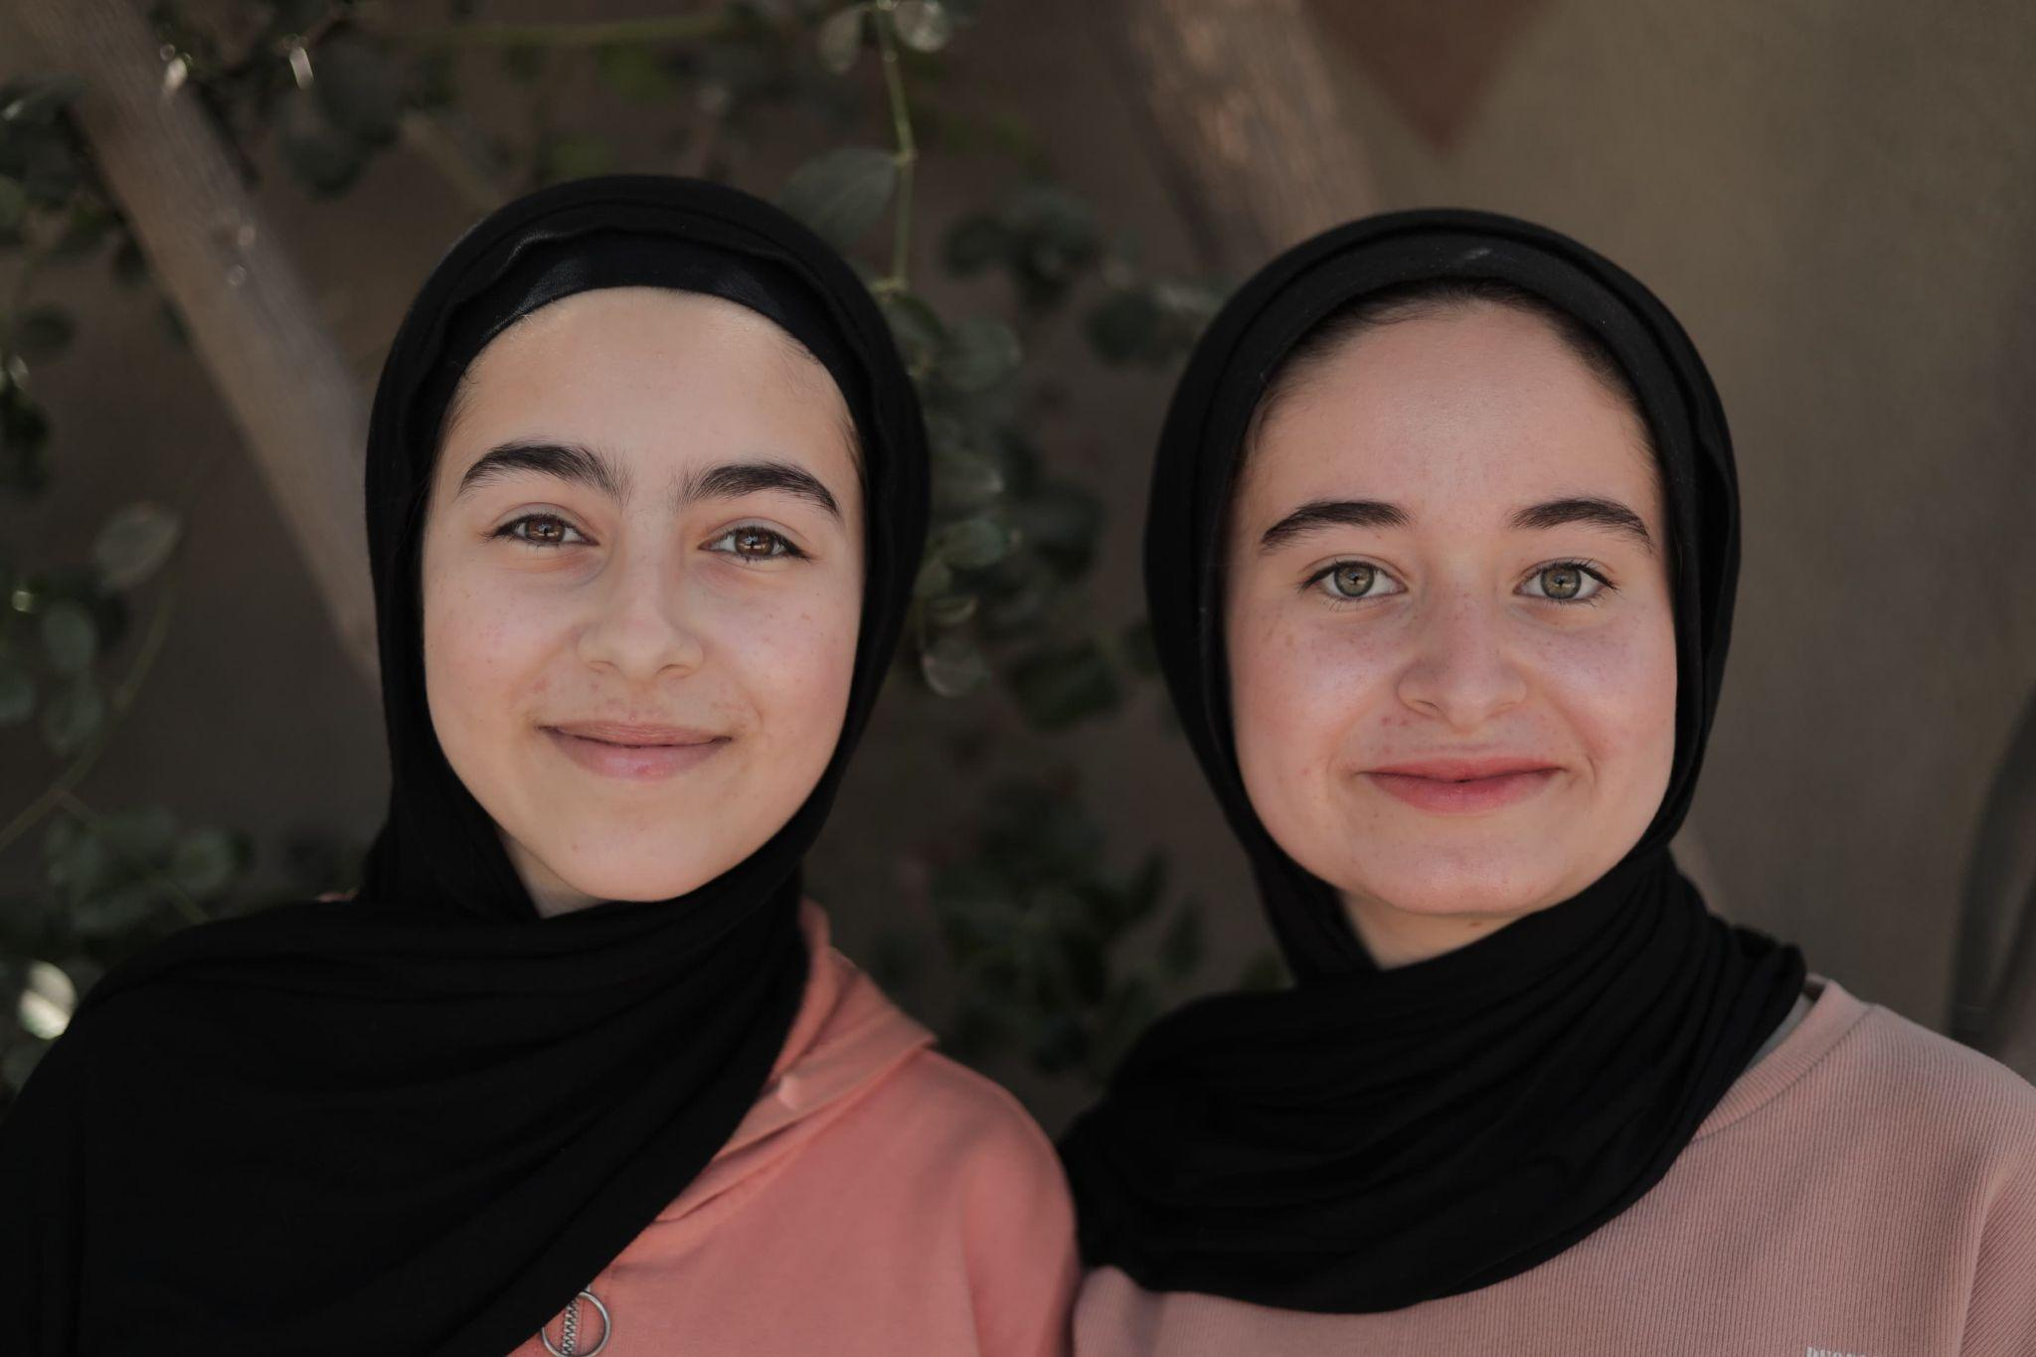

Now in its fifth year, The Earth Prize has reached over 21,000 students across 169 countries and territories. Previous winners have been featured in leading international media including Forbes, Business Insider (US and Africa), The Irish Times, and UN Today, with several teams advancing their ideas through patents and corporate partnerships.

This year’s teams represent seven global regions: Africa, Asia, Europe, North America, Central and South America, the Middle East, and Oceania and Southeast Asia. Their solutions span a wide range of innovations, from an ocean-cleaning robot, to fog-powered drinking water, and an AI-driven drought predictor.

The Earth Prize is run by The Earth Foundation, a non-profit based in Geneva, Switzerland, founded during the School Strike for Climate in 2019. At a time when climate anxiety affects a majority of young people - 59% reporting they are very or extremely worried about the environment - the Prize provides a pathway from concern to action, equipping students with the tools to develop tangible, real-world solutions.

Peter McGarry, Founder of The Earth Foundation, commented on this year’s competition: “The Earth Prize winners 2026 represent seven outstanding teams across seven global regions, each tackling environmental challenges with distinct and impactful solutions. Once again, these young innovators demonstrate that age is no barrier to meaningful change. Their work reflects a powerful combination of creativity, determination and a deep understanding of the communities they serve.”

Public voting for the Global Winner opens on Monday 18 April, the day after the final Regional Winner is announced. Cast your vote on The Earth Prize website: www.theearthprize.org/vote.

About The Earth Prize
The Earth Foundation is a Geneva-based non-profit that empowers, educates and inspires young people to tackle environmental challenges. Founded in response to the 2019 student-led climate rallies, it launched its flagship initiative, The Earth Prize, the world’s largest environmental competition and ‘ideas incubator’ for young people. The competition aims to inspire and empower the next generation of environmental innovators, supporting participants with the tools they need to develop eco solutions for real-world impact, including one-on-one mentoring, learning resources and $100,000 shared funding for the winners. Since 2019, The Earth Prize has reached over 21,000 students across 169 countries and territories, and awarded over $500,000.
Impact PDF: https://tinyurl.com/tep2026

