The $100K Earth Prize 2026: 18-year-old Arya Satheesh named European Winner for biodegradable plastic that breaks down microplastics
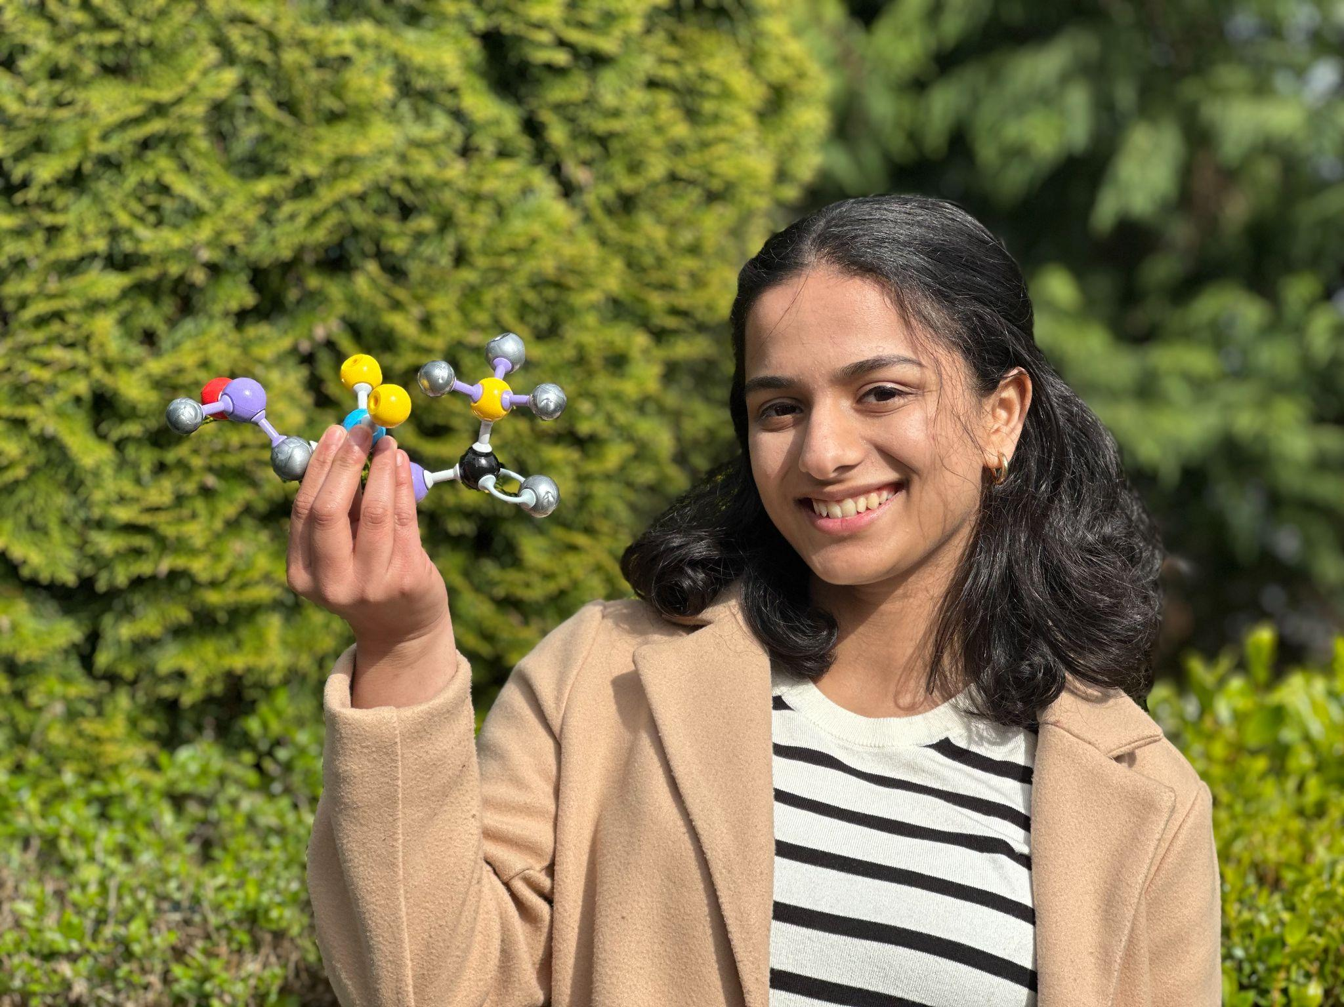

- The Earth Prize is the world’s largest environmental competition and ‘ideas incubator’ for 13-19-year-olds, empowering young people with mentorship and $100K funding
- 18-year-old European Winner Arya Satheesh has created Eco Purge, a biodegradable plastic that also removes existing microplastics in the environment
- Seven Winners will be announced each day this week, representing the regions of North America, Africa, Asia, Central and South America, Oceania and Southeast Asia, Europe and the Middle East
- Each team receives $12.5K to develop and implement their idea for real life impact
- A public vote will crown the Global Winner on 29 May

GENEVA, Switzerland, 11 May - In an effort to tackle the growing crisis of microplastic pollution, 18-year-old Arya Satheesh in Ireland has been named as the European Winner of The Earth Prize 2026. Arya’s solution, Eco Purge, is a biodegradable plastic that breaks down safely, while releasing catalysts that help actually remove existing microplastics from the environment.

While most solutions focus on reducing plastic use, Eco Purge goes a step further by helping clean up the tiny plastic particles that are already polluting oceans, soil, and even our food and water.

Arya was inspired by an earlier project monitoring water quality, which revealed a key problem: microplastics could be detected, but not removed. Wanting to solve this, Arya explored how plastics break down and developed a plant-based plastic that can carry special enzymes. By embedding these enzymes inside the material, they remain stable and are released gradually as the plastic degrades, allowing them to continue breaking down microplastics in different environments like water, soil, and compost.

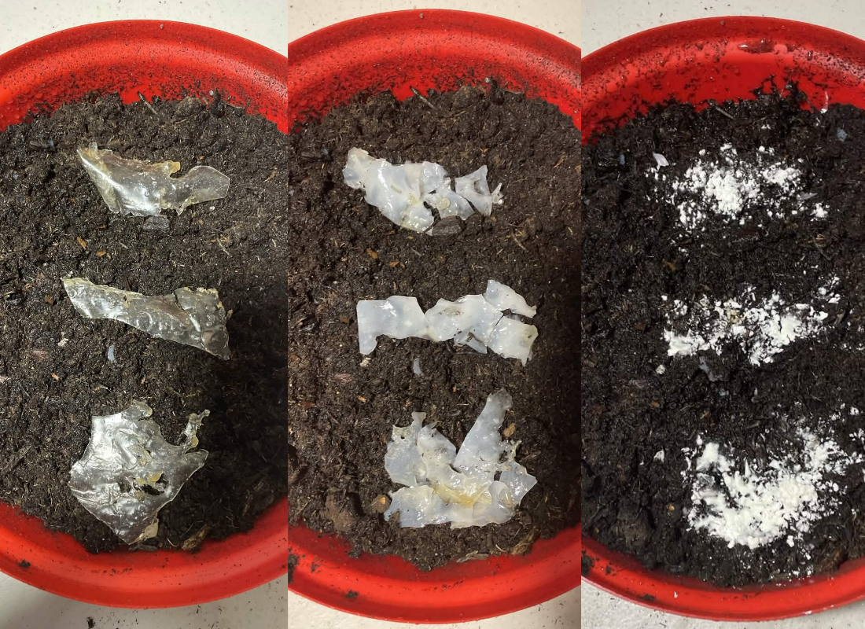
3 phases of biodegradation in soil, which releases the enzyme into the environment and further breaks down microplastics

Now developed into a working prototype, Eco Purge has already collaborated with researchers at Irish universities UCD Dublin and ATU Letterkenny, as well as BiOrbic Bioeconomy Research Centre.
With the support and now $12.5K of prize funding from The Earth Prize, Arya plans to scale the solution for real-world use in products like packaging and compost bags, making it easier to tackle microplastic pollution on a larger scale.

Arya explained: “Plastic pollution doesn’t just disappear, it breaks into tiny pieces that stay in our environment. I wanted to create something that could help tackle that problem directly. Eco Purge is designed to both replace plastic and help remove existing microplastics, and this is just the beginning , and I hope it can become a scalable solution that makes a real difference”.
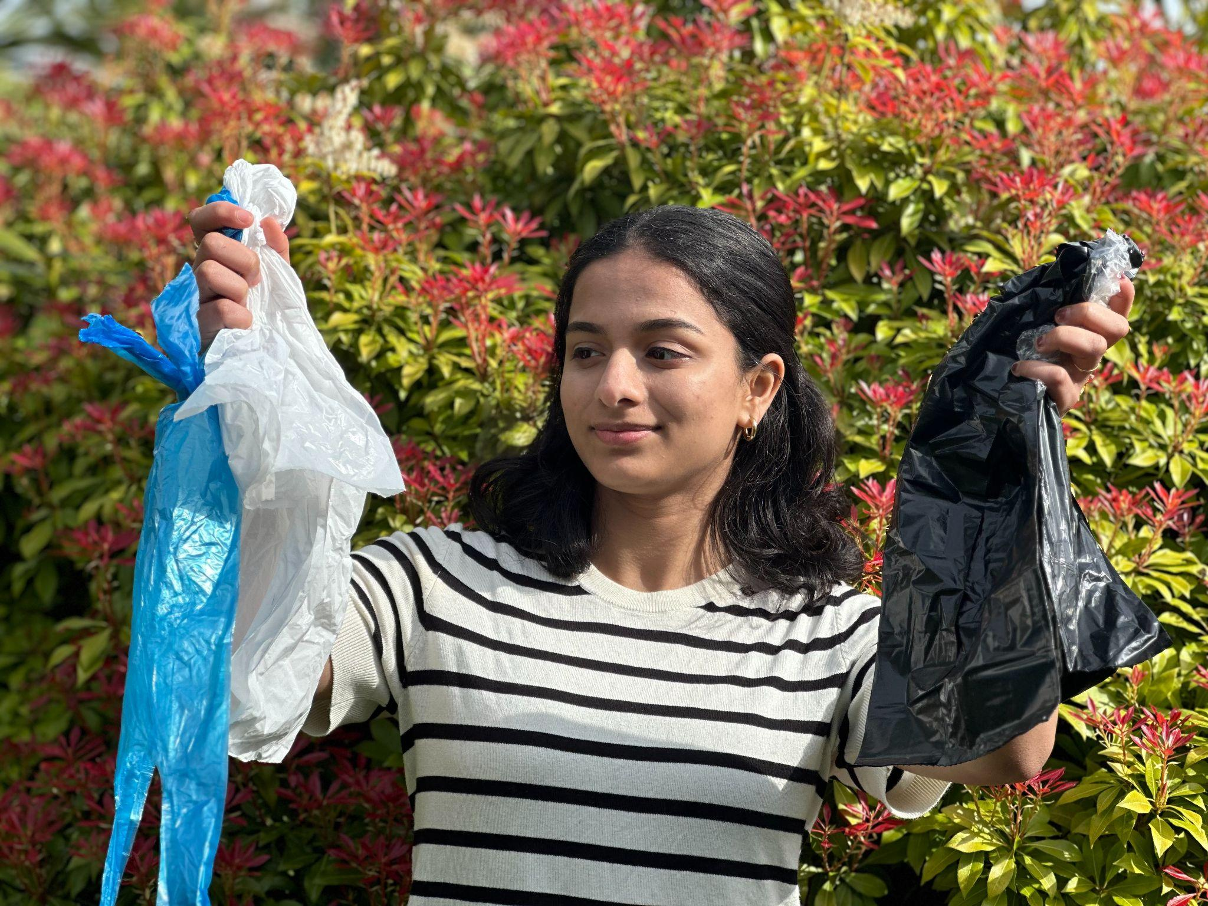

Now in its fifth year, The Earth Prize has reached over 21,000 students across 169 countries and territories. Previous winners have been featured in leading international media including Forbes, Business Insider (US and Africa), The Irish Times, and UN Today, with several teams advancing their ideas through patents and corporate partnerships.

The Earth Prize is run by The Earth Foundation, a non-profit based in Geneva, Switzerland, founded during the School Strike for Climate in 2019. At a time when climate anxiety affects a majority of young people - 59% reporting they are very or extremely worried about the environment - the Prize provides a pathway from concern to action, equipping students with the tools to develop tangible, real-world solutions.

Peter McGarry, Founder of The Earth Foundation, commented on this year’s competition: “The Earth Prize winners 2026 represent seven outstanding teams across seven global regions, each tackling environmental challenges with distinct and impactful solutions. Once again, these young innovators demonstrate that age is no barrier to meaningful change. Their work reflects a powerful combination of creativity, determination and a deep understanding of the communities they serve.”

Public voting for the Global Winner opens on Monday 18 April, the day after the final Regional Winner is announced. Cast your vote on The Earth Prize website: www.theearthprize.org/vote.

About The Earth Prize
The Earth Foundation is a Geneva-based non-profit that empowers, educates and inspires young people to tackle environmental challenges. Founded in response to the 2019 student-led climate rallies, it launched its flagship initiative, The Earth Prize, the world’s largest environmental competition and ‘ideas incubator’ for young people. The competition aims to inspire and empower the next generation of environmental innovators, supporting participants with the tools they need to develop eco solutions for real-world impact, including one-on-one mentoring, learning resources and $100,000 shared funding for the winners. Since 2019, The Earth Prize has reached over 21,000 students across 169 countries and territories, and awarded over $500,000.
Impact PDF: https://tinyurl.com/tep2026

