The Earth Prize 2025: Teenagers from the Philippines named as Oceania and Southeast Asia Winners in $100K global competition for food waste web app
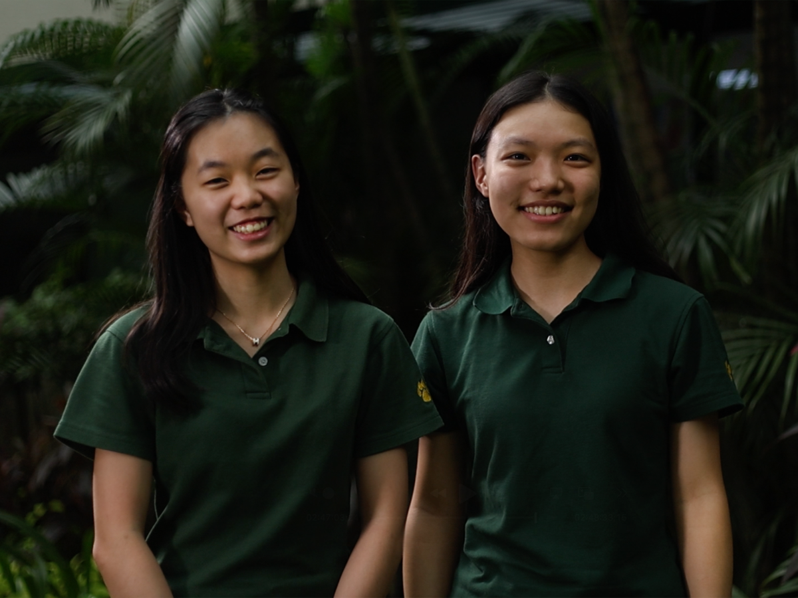
More images available here

- The Earth Prize is the world’s largest environmental competition and ‘ideas incubator’ for 13-19-year-olds, empowering young people with mentorship and $100K funding
- Seven winning teams will be announced each day this week, representing the regions of North America, Africa, Asia, Central and South America, Oceania and Southeast Asia, Europe and the Middle East
- The Winners representing Oceania and SouthEast Asia created a food waste web app that addresses supply chain efficiencies, saving both farmers and consumers money
- Each team receives $12.5K to develop and implement their idea
- A public vote opens soon to crown the Global Winner on Earth Day (April 22)

In a bid to tackle food waste, two teenagers from the Philippines have been named the Oceania and SouthEast Asia Winners of The Earth Prize 2025. Hailey Yap and Yume Yorita’s solution is an innovative web app, called ‘Kultibado’, that connects farmers to consumers.

16-year-old Yume and 17-year-old Hailey were driven by a pressing issue in their community - 30% of agricultural produce in the Philippines is wasted due to supply chain inefficiencies. Delays, excessive handling, and poor logistics cause food to spoil before reaching consumers, contributing to waste. This not only leads to economic losses but also generates methane emissions and limits access to nutritious meals.

To combat this, they’ve created Kultibado, an innovative web app that reduces food waste by connecting farmers, consumers and cooperatives directly. The platform cuts out the middleman and shortens the supply chain, ultimately allowing farmers to sell surplus and ‘ugly’ but perfectly edible produce, as well as optimise transport. The result? Farmers earn more, and consumers pay around 70% less. Their multi-cooperative partnerships, robust support networks, quality assurance and user-friendly tools set them apart, positioning them for scalable expansion across the Philippines.

The team impressed The Earth Prize’s expert jury with their final pitch, having excelled in the programme’s incubation and mentorship phases, and will now receive $12.5K to scale up their idea further. Hailey Yap and Yume Yorita commented: “We are thrilled to be named the Oceania and SouthEast Asia Winners of The Earth Prize 2025. This recognition will help us take our food waste web app to the next level. With the $12.5k funding, we will continue development of the web app and launch with our first partner (a chef-led restaurant group by Patrick Go). Our goal is to connect 150,000 farmers to our web app in the next five years. More than just a web-app, Kultibado aims to foster a paradigm shift where ugly and surplus produce are valued, and where everyone has access to nutritious food.”

The Earth Prize aims to empower the next generation with all the tools they need to develop their eco solutions for real life impact, including one-to-one mentoring, learning resources and funding of $100K for the winning teams to scale their solutions. Since 2021, The Earth Prize has reached over 15,000 young people across 160 countries and territories, and awarded $500K to the top teams.

Previous applicants have garnered global media attention in outlets such as Forbes, Business Insider, EuroNews, Positive.News and UN Today, and continue to scale their solutions after the competition has ended. For instance, team Delavo (Winners of The Earth Prize 2023), who invented a cutting-edge filter that recycles up to 90% of toxic laundry waste water, partnered with a national manufacturer and applied for a patent to make their solution a reality.

The Earth Prize was started by The Earth Foundation, a Swiss non-profit organization based in Geneva, as a way to empower and educate young people to tackle environmental challenges. As young people live through and observe extreme weather events such as the LA wildfires, many are mobilized to act - choosing to create solutions for our planet.

A recent study showed that 59% of youth and young adults are very or extremely worried about climate change, and more than 45% said their feelings about climate change negatively affected their daily life and functioning.

Peter McGarry, Founder of The Earth Foundation, commented on this year’s competition: “The 2025 winners of The Earth Prize are a true testament to the boundless creativity and passion of today's youth. Their bold solutions tackle the most urgent environmental challenges with the power to transform our world. I invite everyone to engage with these remarkable ideas, support their implementation, and be inspired to take action in their own communities. Together, we can turn these promising innovations into global environmental solutions.”

Public voting for the Global Winner opens Sunday, April 13, just after the final Regional Winner is announced. Cast your vote on The Earth Prize website until Tuesday, April 22 (Earth Day): https://www.theearthprize.org/vote

About The Earth Foundation
The Earth Foundation is a non-profit organization based in Geneva, Switzerland, dedicated to inspiring, educating, mentoring and empowering students and young entrepreneurs to address environmental changes with innovative ideas. The Earth Foundation was established as a result of the 2019 rallies organized by students to raise environmental awareness. This passion to fight for climate change inspired the creation of their flagship initiative, The Earth Prize—the world’s largest environmental competition and 'ideas incubator' for young people. The competition aims to inspire and empower the next generation of environmental innovators, supporting participants with all the tools they need to develop their eco solutions for real life impact, including one on one mentoring, learning resources and $100,000 funding for the winners. To learn more about The Earth Foundation visit: https://www.earth-foundation.org/. To learn more about The Earth Prize visit: https://www.earth-foundation.org/earthprize/.
- Previous coverage: Forbes, Business Insider, EuroNews, Positive.News, UN Today, Yahoo! Tech, The Cool Down
- Press contact: Charlotte Tucker, charlotte@earth-foundation.org

