The Earth Prize 2024 Winners: Meet the inspiring teenage climate activists predicting floods, saving energy, creating eco-diapers & protecting crops

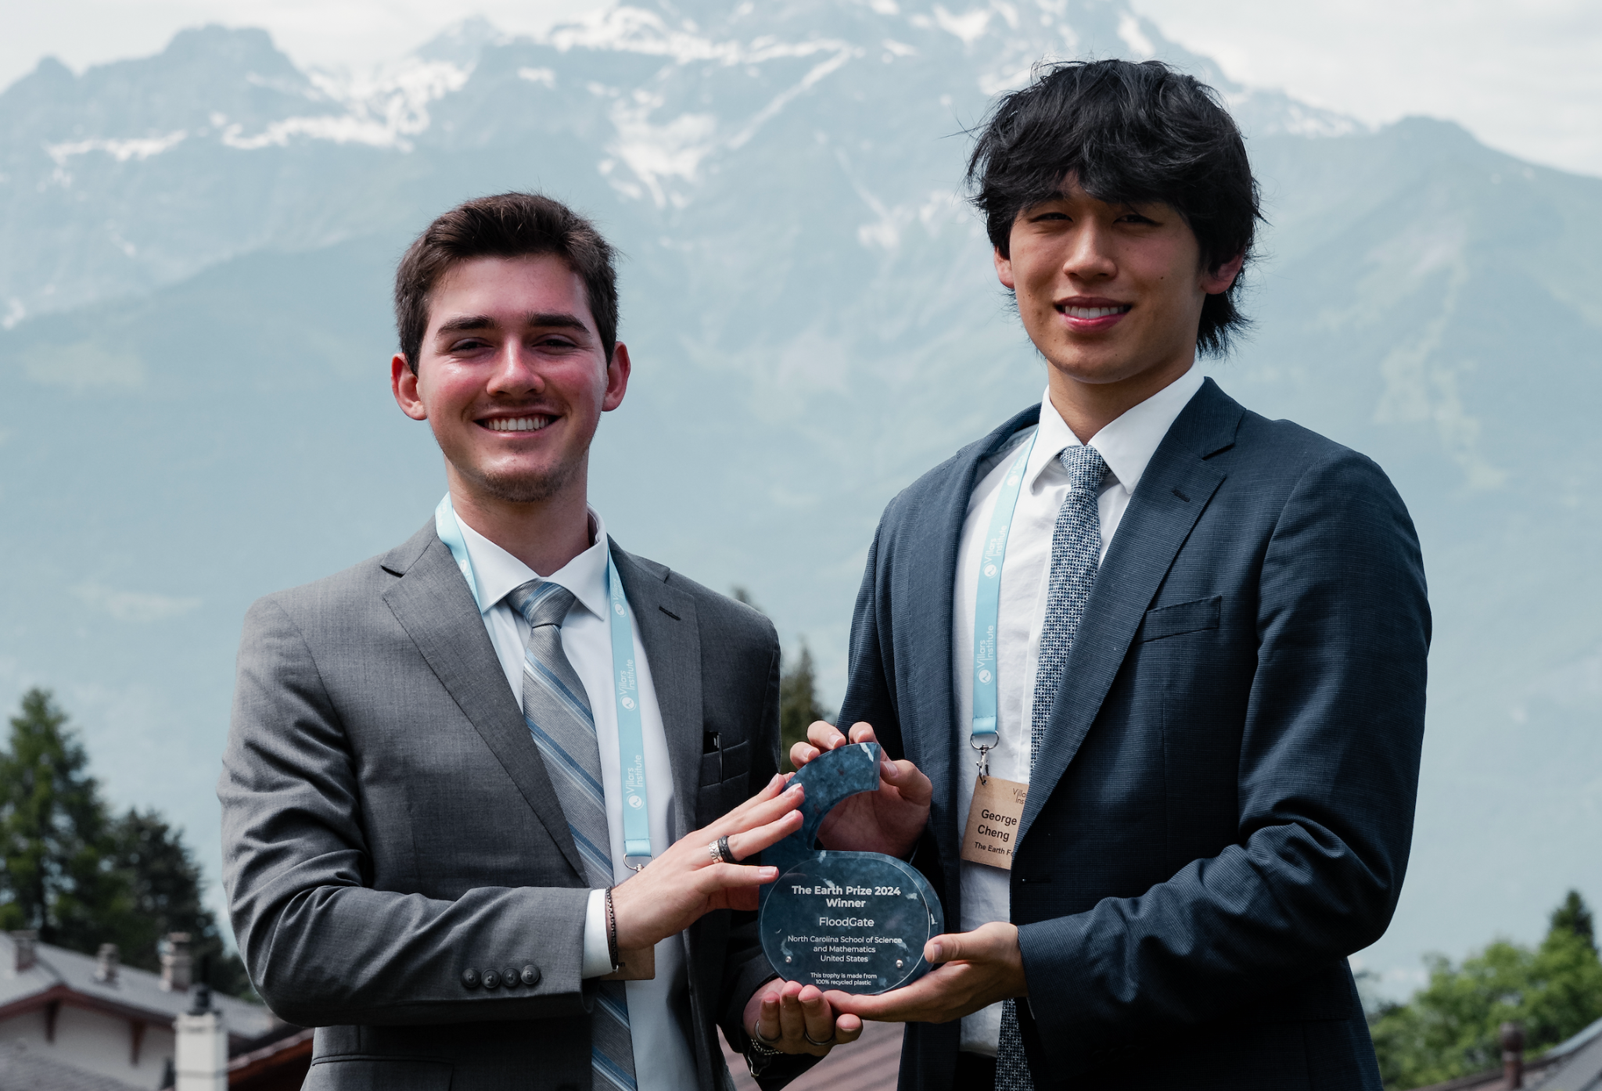

The Winning team FloodGate (US, aged 17-18 years) have invented a revolutionary flood prediction and warning technology that can save hundreds of thousands of lives globally

- The Earth Prize is the world’s largest environmental competition for teenagers, having awarded $500,000 to the top teams and their schools for their planet-saving ideas
- Since 2021, it’s reached over 10,000 students, across 154 countries and territories
- This year’s Winning team FloodGate (US) has created a revolutionary flood prediction and warning technology to protect communities worldwide
- The three pioneering Runner-up teams are CocoMellow (Vietnam) who created banana-based diapers to fight single-use product waste; Ceres (Türkiye) who are protecting crops from climate events; and Pebble (UK) who are pooling computer power to reduce energy use
- One Educator of the Year and three Mentors of the Year were also awarded

On Earth Day, 22nd April, the Winning team was announced for The Earth Prize, a global competition spotlighting the teenagers aged 13-19 who are innovating to save our planet. This inspiring competition, now in its 3rd year, has attracted over 10,000 young people from over 2,000 schools, across 154 countries and territories. The applicants’ inventions have covered topics from plastic waste to climate change, and have been featured in media such as The Irish Times, Positive.News, Independent.ie and UN Today.

This year’s Winning team is FloodGate, a team of four students (North Carolina School of Science and Mathematics, US), who took the top spot for their groundbreaking flood prediction and warning technology. Motivated by the increasingly commonplace flooding in their state, they came together to create a solution which could be scaled up for global use. Their technology, which will soon become an easily accessible app, allows governmental organisations, agencies and individuals to plan for flooding events, reducing damage and potentially saving hundreds of thousands of lives worldwide.

The Runners-up this year included Team Ceres (Bahçeşehir Koleji Diyarbakir, Türkiye), who are using innovative plasma technology to protect crops worldwide from environmental damage, Team CocoMellow (i-IVY, Vietnam), who are fighting single-use product waste with their revolutionary design for eco-diapers made from coconut coir and banana fibers; and Team Pebble (Eton College, UK), who are tackling energy consumption with a pioneering software that pools computer power.

The Earth Prize was started by The Earth Foundation, a Swiss non-profit organization based in Geneva, as a way to empower and educate young people to tackle environmental challenges. A recent study showed that 59% of youth and young adults are very or extremely worried about climate change, and more than 45% said their feelings about climate change negatively affected their daily life and functioning. The Earth Prize offers young people a path towards positive proactivity, supporting their remarkably bright ideas, and nurturing tomorrow’s (or even today’s) change-makers.

Every year, The Earth Prize also gives out three additional awards: one Educator of the Year award, and three Mentor of the Year awards. This year, the top Educator spot was awarded to Aashna Saraf (founder and CEO of CreatED innovation hub in Mumbai, India), for her extraordinary efforts during the competition. The mentors were chosen after a tough nominations process, in which the students voted for 50 mentors representing 34 countries, finally selecting Elham Ashrafizadeh (University of Toronto, Canada), Francisca Majala Mwaila (Kenyatta University, Kenya), and Yoong Sze Yeong (Nanyang Technological University, Singapore).

Bryce Coon, EarthDay.org’s Director of Education, who gave out the Educator of the Year award, explained why initiatives like The Earth Prize are key for young people today: "I was a classroom teacher for 11 years - during this time, I could see that my students were eager to learn more about the climate crisis, and they were showing signs of climate anxiety. Climate education allows us to motivate students and address their concerns."

Peter McGarry, Founder of The Earth Foundation, commented on this year’s competition: “Amid the growing environmental concerns and widespread anxiety, it's truly inspiring to see young people from around the world tackling these issues head-on. The Earth Prize provides a stage for these innovative minds to demonstrate their creativity and the power of collaborative effort. Their solutions never cease to amaze me, and I hope they inspire you as well!”

Angela McCarthy, CEO of The Earth Foundation, added: "The Earth Prize is much more than a competition. It galvanizes the world’s youth to act in a positive way on behalf of the environment. Every year, and within the span of 5 months, the innovative minds of young people worldwide produce remarkable solutions to specific environmental sustainability problems. Given the critical challenges facing our planet, their contributions couldn't be more pertinent. Through initiatives like The Earth Prize competition, we prioritize listening to the voices of youth, fostering a world where their ideas can shape the future."

17-year-old Sumedh Kotrannavah, from the Winning team FloodGate, explained how their generation serves as an inspiration: "One way to describe The Earth Prize is unparalleled. The opportunities that you’re going to get from competing in this competition are just going to drive your passion and your project to the next level. The things that people our age are creating across the globe is just wonderful - seeing other people pursue these types of ideas are also changing the way we think about our project, pushing us to make edits and make our project even better. I think our generation is starting to really spark change and innovate new solutions, and I’m really excited to see in the next twenty years or so what we are going to do.”

Find out more about The Earth Prize 2024 Winning team and three Runners-up teams on the website, and re-watch the video recording of the Live Stream reveal on YouTube. And if you’re aged 13-19 years old and are inspired to pre-register for The Earth Prize 2025, you can do so here.

