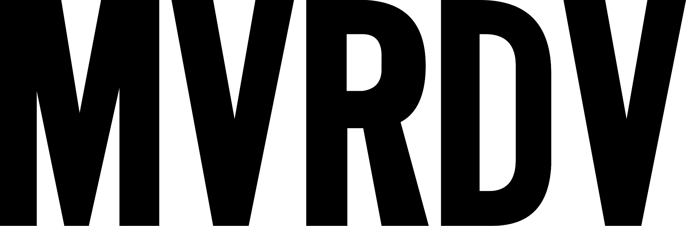
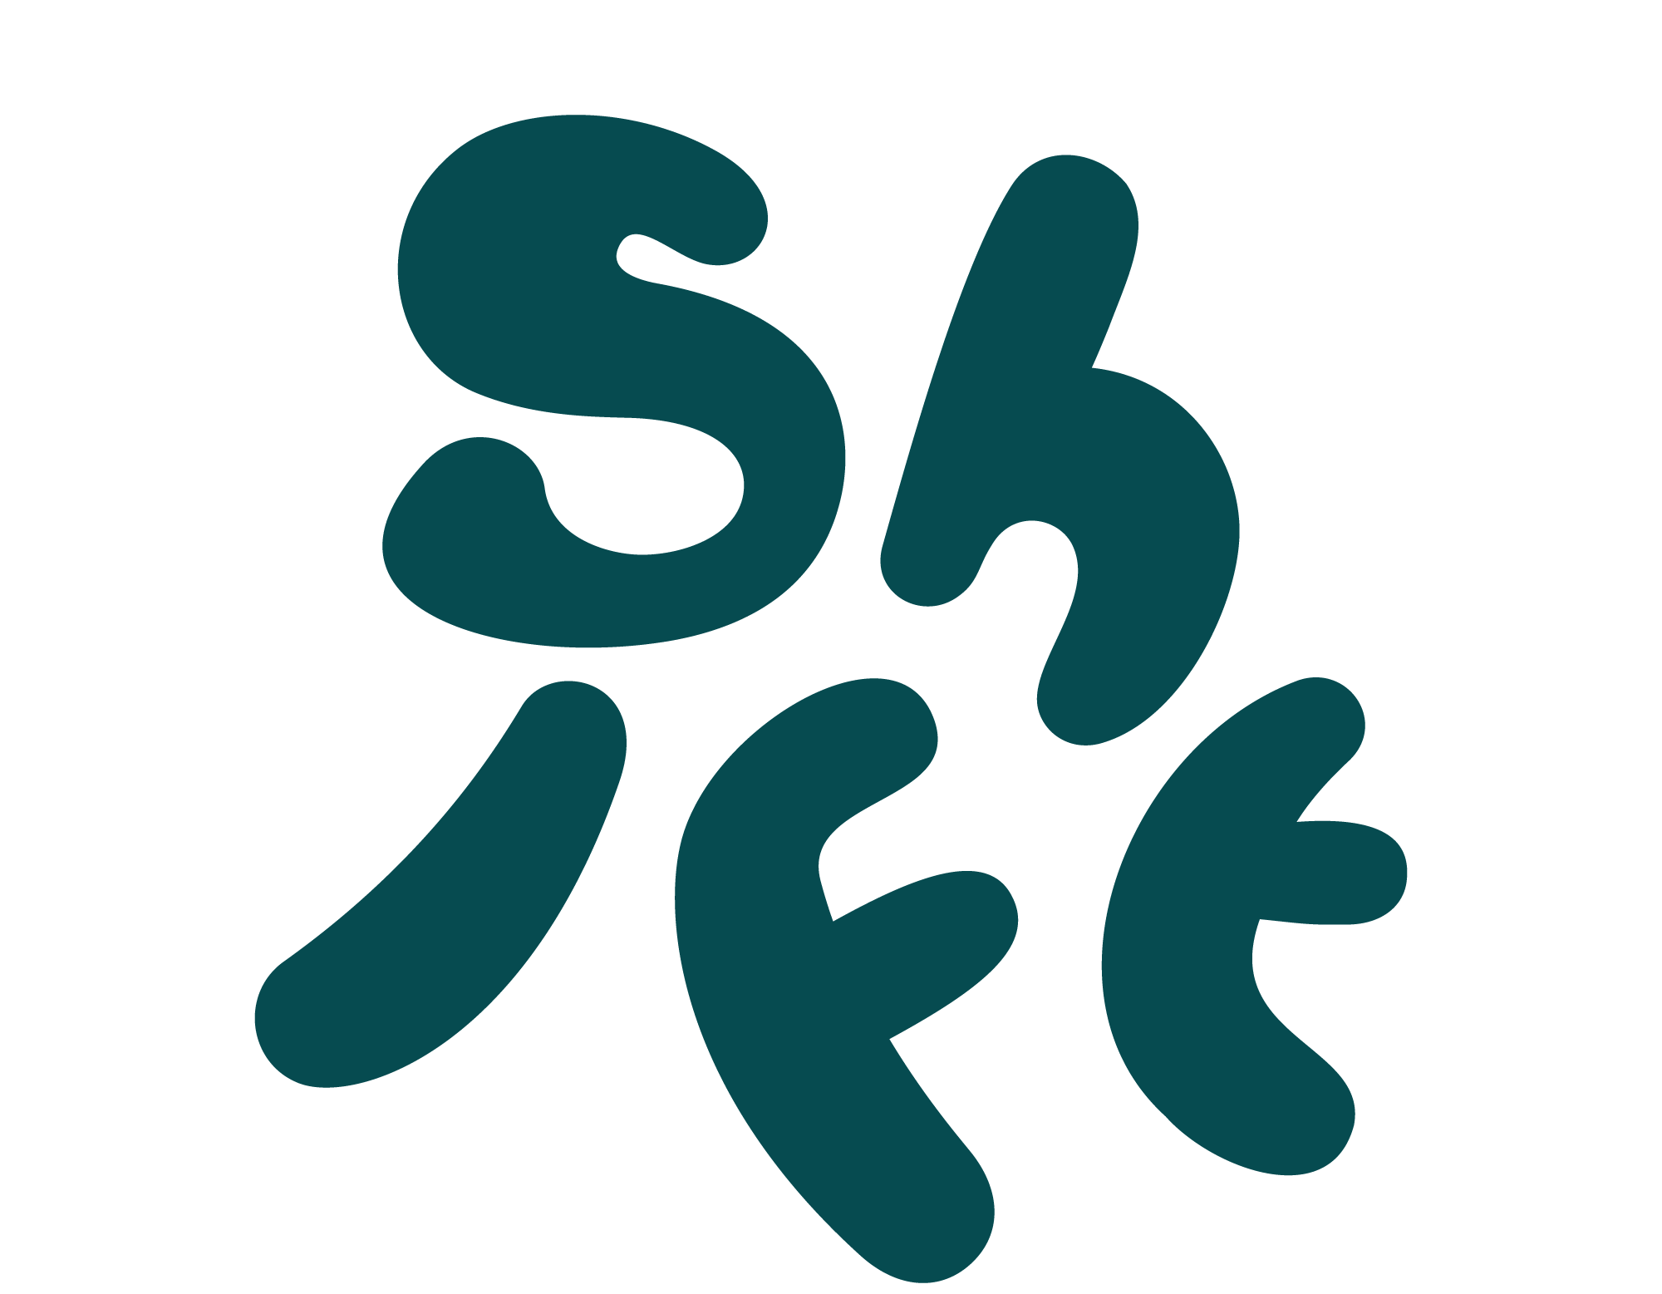

UNDER EMBARGO TILL 21st July 7AM CET
Rotterdam, July 21st 2026
MVRDV wins international architecture competition for ‘Shift Embassy’ in Rotterdam
MVRDV has won the international design competition of social enterprise Shift for the ‘Shift Embassy’ – a major cultural destination in Rotterdam that aims to inspire visitors to help realising large-scale ecological and societal change.
Motivated by the competition brief’s goal to create a landmark devoted to a future where humans and nature live in symbiosis, MVRDV’s proposal – dubbed ‘Rotterdam ROCKS!’ – sets out to act as a landscape along the Maas. It is a rocky green landmark – largely accessible to the public – where visitors move up and down along terraces, water, greenery, exhibitions, viewpoints, and gathering spots.
Programme
The Shift Embassy aims to inspire visitors with a 5.000 m2 immersive experience called ‘the Elysium’. Rather than explaining the future, The Elysium invites visitors to experience it through immersive art, inspiring stories and practical pathways for action. It will also feature a hotel with 200 rooms, spaces for education, business events and gatherings for local communities, a food court, a restaurant and an observation deck. The project’s overarching goal is to create a major cultural destination in Rotterdam that accelerates the behavioural, systemic and social changes required to build a more resilient and sustainable future.
Rotterdam ROCKS! will be built as part of Rotterdam’s Waterkant, a soon-to-be-realised new district on the South bank of the river Maas that will provide 3,750 new homes, schools, maker spaces, an urban sports campus, a new train station, offices, restaurants and cultural spaces.
Chantal Zeegers, Alderman for Building and Society
“Rotterdam is fully committed to policies aimed at becoming a greener and climate-resilient city. It is wonderful to see that Shift shares this same ambition—an ambition reflected not only in the striking and iconic architecture but also in a program that inspires Rotterdammers and visitors alike to take action for a sustainable future”.
Jury: “bold and unconventional”
The jury described the winning concept as follows: “MVRDV’s proposal is a remarkably bold, powerful statement that we expect will capture visitors' imagination and encourage them to come back again and again. Rotterdam Rocks departs from how sustainability is traditionally communicated, bringing together joy, discovery, and surprise into a new architectural language. We anticipate this building and its program will invite people to rethink their everyday behavior and encourage new ways of living sustainably together"
The jury consisted of Aric Chen (Director, Zaha Hadid Foundation), Astrid Leyssens, (Founder, We Are Impact Collective), Ben van Berkel (Founder, UNS), Carice van Houten, (Activist, Actor), Clemens Brenninkmeijer, (Chair Family Community COFRA), Dr. Lewis Akenji, (Executive Director, Hot or Cool Institute), Géke Roelink, (Director, NEMO Science Museum), Lodewijk Hoekstra, (Ambassador and Presenter, NL Greenlabel), Matthias Schuler, (Founder, TRANSSOLAR), Mireia Luzárraga, (Co-Founder, TAKK) and Nicole Maarsen, (Independent Real Estate Professional).
Shift embassy: “A place of hope, storytelling and practical solutions”
The building is an initiative of social enterprise Shift, which – in the words of founder Don Ritzen – aims to create the social momentum required to “shift from complacency and powerlessness to hope, imagination and collective action for our shared future.”
The Shift Embassy is conceived as a purpose-driven destination combining immersive art, architecture, community building, storytelling, and real-world examples of sustainable living and business practices. Built around global achievements and success stories in nature, energy, travel, and circularity, Shift’s aim is to inspire a mindshift at home and at work. Shift’s goal is to move from individual, to collective and ultimately systemic change.
Don Ritzen: “Climate change is one of the defining challenges of our time and deserves a response and destination that matches its scale. The bold and distinctive design of Rotterdam Rocks invites visitors to explore some of the most important questions of our time. Where do we come from? Where are we going? What role can we play ourselves in shaping the future of our planet? Through wonder, curiosity and imagination, the building and its immersive experience encourages visitors to envision a different future and their role in it.
Don Ritzen: “Our goal is to empower every visitor to take ownership in building a brighter future. We want to show that everyone is able to live a better and more sustainable life by making small and incremental changes in their daily habits.”
MVRDV: “Spaces for humans and nature”
MVRDV founding partner Winy Maas: “Our first step in approaching this design was to expand the brief – we need to reduce carbon dioxide emissions and to create inclusive spaces for people, trees, plants, for water, air, and for animal habitats, balancing the need for new built space with new landscapes to compensate our ecological impact. Our design integrates these human and natural spaces, playing with porosity to keep the project compact while maximising its ecological value.”
The seven stacked rocks that make up the building are arranged around two key routes through the building’s “caves”: one for the exhibition experience and another for the project’s hospitality functions. A third exterior route twists up the sides of the rocks, leading to a publicly accessible viewing terrace, while the top of the building features a rooftop terrace for visitors to The Elysium. These terraces extend the riverside tidal park vertically, enveloping visitors in the nature that finds its home on the building’s surfaces while offering spectacular views of Rotterdam. To enable this proliferation of nature on its surface, the skin of the building is covered with pockmarks and niches that provide space for soil, water, plants, and animals.
As part of the design’s own sustainability ambitions, the construction of the Shift Embassy will become a form of public experiment, an open documentation of which low-carbon construction strategies succeed and which do not, and which approaches succeed in minimising the ecological impact of construction. The project will serve as a scale-up lab to test and showcase the latest innovations in low-carbon construction, helping to advance sustainable building practices across the industry.
Grand finale of a unique selection process
The Shift International Architecture Competition launched in January 2025 as a two-stage competition inviting multidisciplinary teams of architects, engineers, artists, scientists, ecologists, and other experts to develop holistic design proposals. After receiving eighty proposals for stage one, five finalists - Ecosistema Urbano, Heatherwick Studio, Mecanoo, MVRDV and Office for Political Innovation - continued to the final stage and presented their design early March 2026.
After completing a verification process for the jury’s top two ranked teams, Shift selected MVRDV with collaborators Arup, Arcadis, DGMR, Studio Bertels and Joris Laarman Labs as the winning Team and entered a short pre-design phase in June to further test and improve the design. The refined design is now being unveiled for the first time, ahead of a local participation process in autumn 2026.
The visions and presentations of the architects and their design teams - Ecosistema Urbano (ES), Heatherwick Studio (UK), Office for Political Innovation (ES), Mecanoo (NL) and MVRDV (NL) - are now available on the Shift’s website www.shift.world.

About MVRDV

Architecture practice MVRDV was set up in 1993 in Rotterdam, the Netherlands by Winy Maas, Jacob van Rijs, and Nathalie de Vries. Finding early success with projects such as the headquarters for the Dutch Public Broadcaster VPRO and WoZoCo housing for the elderly in Amsterdam, MVRDV developed into an internationally renowned firm. Now, the three founding partners lead a dynamic and optimistic team of over 270 alongside partners Frans de Witte, Fokke Moerel, Wenchian Shi, and Bertrand Schippan. With four satellite offices in Shanghai, Paris, Berlin, and New York, MVRDV engages globally in providing solutions to contemporary architectural and urban issues.

MVRDV operates via a research-based and highly collaborative design method, engaging experts from all fields, clients, and stakeholders in their rigorous technical and creative investigation. This results in exemplary and outspoken buildings, urban plans, studies, and objects that enable our cities and landscapes to develop towards a better future.

About Shift

Shift is a steward-owned societal enterprise founded to enable large-scale societal and ecological change. Shift is 95% owned by a foundation, and will enable everyone to become a co-owner and an active participant in Shift's mission.
Through art, architecture, digital tools, community programs and immersive experiences, Shift helps people to a new type of personal wellbeing. By fostering community and connection, Shift makes the transition to a greener, more circular future more tangible, shareable and actionable.
About the Shift Embassy
The Shift Embassy - in full: Shift Embassy for a Better World - is conceived as a purpose-driven destination combining immersive art, architecture, community building, storytelling, and real-world examples of sustainable living and business practices. Built around global achievements and success stories in nature, energy, travel, and circularity, the aim is to inspire a mindshift at home and work. Shift’s goal is to move from individual, to collective and ultimately to systemic change.
About the five finalist designs
Ecosistema Urbano (ES) — A Living Landmark. a regenerative ecosystem and evolving social organism that nurtures biodiversity and collective life.
Heatherwick Studio (UK) — ‘Urban Reef’: a building for Rotterdam, shaped by layers of activity that echo a reef‑inspired ecosystem, gathering people, sparking climate awareness and inspiring lighter ways of living.
Mecanoo (NL) — House of Shift Rotterdam: an icon centered on upcycling, carbon storage, energy neutrality, and joyful exploration.
MVRDV (NL) — Rotterdam ROCKS! is a collection of porous, living rocks that imagines Rotterdam’s new landmark through ecology and experience.
Office for Political Innovation (ES) — Planetary Landmark for the Climate Age: a working section through a changing world, where climate is sensed and reshaped collectively.

About Waterkant
Waterkant is a major urban development in Rotterdam planned to include 3,750 new homes, schools, cultural venues, offices and a new train station. Built around a new tidal park, the district is designed as a resilient, nature-positive model aligned with the city’s long-term climate adaptation strategy.
About DVDL
The Shift competition advisor is DVDL, a cultural planning and visitor experience strategy agency that transforms spaces and organizations by pairing innovative program mixes with design and cultural interventions. The firm inspires people to see the world differently through dynamic visitor experiences shaped by culture.

More information and interview requests
MVRDV: Please reach out to pr@mvrdv.com
Shift: please reach out to media@shift.world or jiri@shift.world

