nhow Hotels & Resorts Unveils ‘GAME:NXT by nhow’ Across Europe
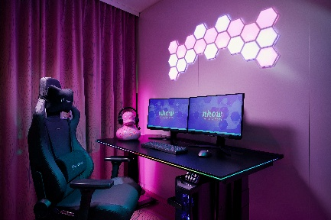
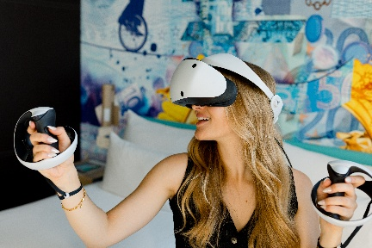
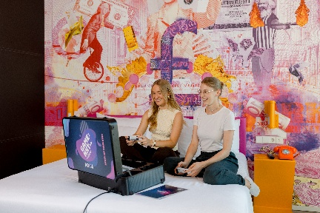

High-res imagery HERE.

In partnership with SK Gaming, the design-driven hotel brand brings gaming and digital culture into the hotel experience

London, September 2026 – nhow Hotels & Resorts is taking its gaming offering to the next level with the launch of ‘GAME:NXT by nhow’, a new gaming and esports ecosystem designed to bring interactive digital experiences into the hotel stay.

Building on the success of its gaming offering at nhow Berlin, the concept combines hospitality with gaming and digital culture, giving guests new ways to connect, play and create during their stay.

Designed to meet the needs of different types of gamers, ‘GAME:NXT by nhow’ comprises three core elements: Gaming Rooms, professional-level Gaming Studios and portable Gaming Suitcases. To ensure a professional-grade experience, the entire project has been certified by SK Gaming, the gaming and esports partner of Minor Hotels.

"Embracing gaming and digital culture is pivotal to the future of the nhow brand. By launching ‘GAME:NXT by nhow’, we are tapping into a vibrant new target demographic and thereby expanding our market reach. This forward-thinking concept aligns perfectly with the creative DNA of the nhow brand, ensuring our properties remain at the forefront of lifestyle innovation," said Alexander Dürr, SVP Operations Central Europe at Minor Hotels.

Managing Director and Co-founder SK Gaming, Alexander Müller, adds: "We are delighted to build upon our long-standing partnership with nhow Hotels & Resorts as they continue to elevate and expand their gaming footprint into new markets. By leveraging our decades of industry-leading esports and gaming expertise, 'GAME:NXT by nhow' is set to deliver an unparalleled guest experience."

Gaming Arrives at nhow Frankfurt

Following the successful pilot of five Gaming Rooms and a Gaming Studio at nhow Berlin, gaming and esports have now officially arrived at nhow Frankfurt as part of the wider rollout. Guests can book one of the six Gaming Rooms located on the fourth floor of the hotel. Each room is designed with immersive neon lighting and features a high-performance PC setup with ultra-fast connectivity, an ergonomic gaming chair and desk, and two large, high-resolution screens.

The setup also includes a mechanical keyboard and precision mouse, while a PlayStation 5 is integrated into the room. Specialised streaming equipment and VR headsets are also available on request. Whether guests want to compete with friends, stream live content or simply unwind after a busy day, the Gaming Rooms offer a dedicated space to fully immerse themselves in the world of gaming.

For added flexibility, two portable POGA Gaming Suitcases can transform any room into a private arcade. Each Gaming Suitcase comes equipped with a PlayStation 5 console, two controllers and a high-quality integrated screen.

‘GAME:NXT by nhow’ Expands Across Europe

The Gaming Suitcases are now available to guests across nhow Hotels & Resorts in Germany, the BeNeLux, Italy and France, allowing guests to bring a mobile gaming setup directly to their room. The offering is available at properties including nhow Berlin and nhow Frankfurt, as well as nhow Amsterdam, nhow Rotterdam, nhow Brussels, nhow Milan, nhow Rome and nhow Marseille.

This is just the beginning of an ambitious roadmap for ‘GAME:NXT by nhow’. In 2027, Minor Hotels plans to further expand the concept’s physical infrastructure, with Gaming Rooms planned for nhow Amsterdam, nhow Rotterdam and nhow Brussels.

A Gaming Studio is also in the planning stages for nhow Brussels. Following the model established at nhow Berlin, the space will provide a hub for content creators, local esports teams and boot camps, further establishing nhow hotels as spaces where gaming and digital culture can come together.

From portable Gaming Suitcases to dedicated Gaming Rooms and future cultural hubs, ‘GAME:NXT by nhow’ is redefining how gaming can become part of the hotel experience – giving guests a new way to play, connect and level up their stay.

Find out more about the world of ‘GAME:NXT by nhow’ on YouTube.

-Ends-

nhow Hotels & Resorts
nhow is part of Minor Hotels disruptive hotel brand, known for its iconic establishments. Inspired by the cities in which they are located and designed by the leading creative minds of our times (Foster+Partners, OMA, founded by Rem Koolhaas, Karim Rashid, Sergei Tchoban, Teresa Sapey and Matteo Thun, among others), nhow is simultaneously a hotel and a creative hub. Each nhow establishment becomes a landmark in its city, a melting pot for creativity. At a nhow hotel everything is unexpected, through-provoking and surprising. Every room, restaurant and lobby are an invitation to meditate, a call to take action in our lives, as embodied by the slogan #changenhow. Each guest will live their own personal experiences with one thing in common: the wow factor! Located in key urban districts undergoing a transformation, the nhow hotels quickly emerge as landmarks for self-discovery and experimentation through 'artivism'. Why wait? The time is now, nhow. For more information, visit www.nhow-hotels.com/en

Minor Hotels
Minor Hotels is a global leader in the hospitality industry with more than 640 hotels, resorts and branded residences in operation and committed development across 67 countries. The group crafts innovative and insightful experiences through its hotel brands including Anantara, Elewana Collection, The Wolseley Hotels, Tivoli, Minor Reserve Collection, NH Collection, nhow, Avani, Colbert Collection, NH, Oaks, and iStay, as well as a diverse portfolio of restaurants and bars, travel experiences, and spa and wellness brands. With over four decades of expertise, Minor Hotels builds stronger brands, fosters lasting partnerships, and drives business success by always focusing on what matters most to our guests, team members and partners.

Minor Hotels is a proud member of the Global Hotel Alliance (GHA) and recognises its guests through one unified loyalty programme, Minor DISCOVERY, part of GHA DISCOVERY.

Discover our world at minorhotels.com and connect with Minor Hotels on Facebook, Instagram, LinkedIn, and YouTube.

SK Gaming
For all those who are passionate about gaming, SK Gaming offers an inspirational approach and one clear vision: Anyone, and really anyone, can achieve anything in life. Starting out as “Schroet Kommando” in 1997, the company has pioneered the esports industry with numerous innovations and created iconic legends like the famed Swedish Counter-Strike team, Quake superstar rapha, the FIFA twins, its long-standing Warcraft III division, the Brazilian Global Offensive heroes or the Clash Royale GOAT Morten. More than 75 major championship titles across many disciplines are part of the company’s success story.

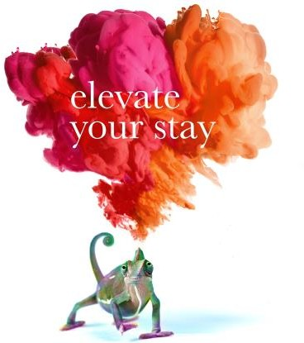

Twitter | LinkedIn | YouTube | Instagram





minorhotels.com

