PRESS RELEASE
Urban Adventures, Effortless Discovery
Avani Ibn Battuta Dubai Curates Contemporary City Experiences for Modern Travellers
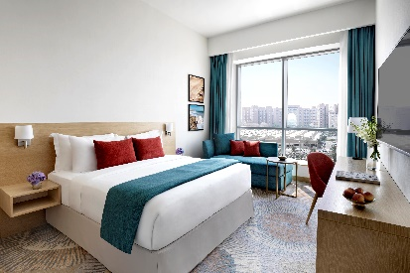
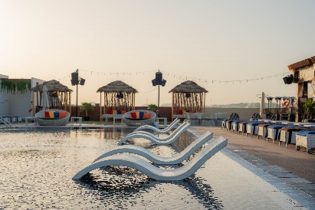
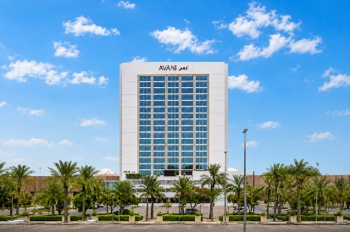

Located along Sheikh Zayed Road, near Ibn Battuta Mall and Ibn Battuta Metro Station, Avani Ibn Battuta Dubai offers a convenient base for modern travellers looking to discover Dubai at their own pace. Combining contemporary accommodation with vibrant social spaces and easy access to the city's shopping, entertainment and leisure destinations, the four-star lifestyle hotel provides an ideal starting point for couples, families, business travellers and urban explorers seeking to experience the many sides of Dubai.

The hotel's location makes city exploration effortless, with Ibn Battuta Mall just moments away and the metro providing convenient access to Dubai's diverse neighbourhoods and attractions. Guests can explore the distinctive architecture and themed courts of Ibn Battuta Mall, head towards Dubai Marina for waterfront experiences, or discover Expo City Dubai and other major destinations across the city. With Dubai Marina approximately 10 minutes away and Expo City Dubai around 15 minutes by car, guests can easily combine relaxation at the hotel with experiences beyond its doors.

For guests looking to make the most of their time in Dubai, Avani Ibn Battuta Dubai offers a balance of leisure and social experiences within the hotel. Guests can unwind at the outdoor swimming pool, maintain their fitness routine at the 24-hour AvaniFit fitness centre or enjoy time at Azurro by Niyama Spa. The hotel's dining and social venues, including Pele Social Hub, Pele Pool Bar and The Pantry, provide relaxed spaces to gather, recharge and enjoy the day.

Family and leisure experiences are equally accessible, with the hotel's location providing a convenient starting point for discovering Dubai's shopping, entertainment and attractions. Guests can spend the day exploring the city before returning to the hotel for a relaxed evening, creating an easy balance between adventure and downtime.

-Ends-

About Avani Ibn Battuta Dubai
Located on Sheikh Zayed Road and directly connected to Ibn Battuta Mall and Ibn Battuta Dubai Metro Station, Avani Ibn Battuta Dubai offers a convenient and contemporary base for both business and leisure travellers in Dubai. The hotel features 358 rooms and suites, an all-day dining restaurant and pool bar, meeting and event spaces, a swimming pool and a 24-hour fitness centre.

Designed for travellers who value comfort, convenience and connectivity, the hotel provides easy access to Dubai’s key business, shopping and leisure destinations. Guests can reach Dubai Marina in approximately 10 minutes, Expo City Dubai in 15 minutes and Dubai Parks and Resorts in 15 minutes, while Dubai International Airport and Dubai World Central Airport are approximately 25 minutes away by car.
The hotel is home to Pele Social Hub, offering a relaxed social setting with Neapolitan pizza and international favourites, alongside a pool bar and modern guest spaces. With its direct access to the metro, proximity to Ibn Battuta Mall and convenient location along Sheikh Zayed Road, Avani Ibn Battuta Dubai is well positioned for guests travelling for business, leisure, shopping and entertainment.
Website: avanihotels.com/ibn-battuta-dubai | Social Media: Facebook, Instagram, TikTok and LinkedIn.

About Avani Hotels & Resorts
Avani Hotels & Resorts is a contemporary hospitality brand for modern travellers, offering a balance of style, comfort and genuine hospitality across vibrant destinations around the world. Avani hotels are designed around the way people travel today, combining vibrant social spaces, stylish and functional accommodation, locally inspired food and an upbeat service culture.

With hotels and resorts across Asia, Europe, the Middle East, Africa and Australia, Avani continues to expand its portfolio while creating experiences that encourage guests to connect with the destination and enjoy travel on their own terms.
Avani Hotels & Resorts is a brand of Minor Hotels and participates in the Minor DISCOVERY loyalty programme.

Visit avanihotels.com for more information, and connect with Avani Hotels & Resorts on Facebook, Instagram, TikTok, LinkedIn and YouTube.

About Minor Hotels
Minor Hotels is a global leader in the hospitality industry with more than 640 hotels, resorts and branded residences across 66 countries. The group crafts innovative and insightful experiences through its hotel brands including Anantara, Elewana Collection, The Wolseley Hotels, Tivoli, Minor Reserve Collection, NH Collection, nhow, Avani, Colbert Collection, NH, Oaks and iStay, as well as a diverse portfolio of restaurants and bars, travel experiences and spa and wellness brands. With over four decades of expertise, Minor Hotels builds stronger brands, fosters lasting partnerships and drives business success by always focusing on what matters most to our guests, team members and partners.

Minor Hotels is a proud member of the Global Hotel Alliance (GHA) and recognises its guests through one unified loyalty programme, Minor DISCOVERY, part of GHA DISCOVERY.

Discover our world at minorhotels.com and connect with Minor Hotels on Facebook, Instagram, LinkedIn, TikTok and YouTube.

For media enquiries, please contact:
Priya Johny
Director of Sales
Avani Ibn Battuta Dubai Hotel
E: pjohny@avanihotels.com

