Press Release
Elevate the Way You Meet
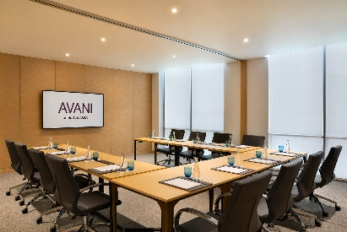
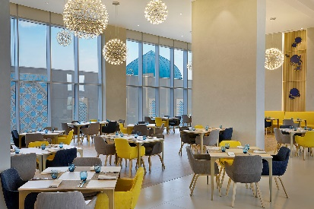
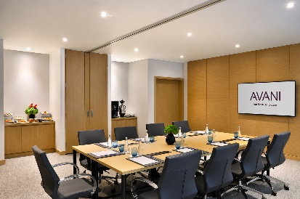

Avani Ibn Battuta Dubai Brings Business and Leisure Together with Flexible Meetings & Events

Located along Sheikh Zayed Road and directly connected to Ibn Battuta Mall and Ibn Battuta Metro Station, Avani Ibn Battuta Dubai offers a convenient and contemporary setting for meetings, corporate gatherings and events in Dubai. Designed for modern business travelers, the hotel combines sleek meeting spaces, state-of-the-art facilities and attentive service to create productive experiences with a relaxed Avani touch.

The hotel's dedicated meeting room is designed to accommodate small teams, corporate meetings and company gatherings, providing a professional yet comfortable environment for focused discussions, presentations and workshops. Equipped with modern facilities and supported by a dedicated team, Avani makes it easy for organizers to plan and deliver successful events.

Beyond the meeting room, corporate groups can enjoy flexible catering options designed to keep delegates energized throughout the day. From working lunches and coffee breaks to more relaxed group dining, the hotel's culinary team can tailor arrangements to suit the needs of each event.

For teams looking to add a social element to their programme, Avani Ibn Battuta Dubai provides opportunities to combine business with leisure. Groups can unwind at the hotel's leisure facilities or explore the surrounding destination, with Ibn Battuta Mall and the Dubai Metro conveniently located directly beside the hotel.

The hotel's strategic location also makes it easily accessible for local and international delegates, with convenient connections to Dubai's major business districts, attractions and transport links. Whether hosting a small team meeting, corporate gathering, training session or group event, Avani Ibn Battuta Dubai offers a seamless setting where business can meet pleasure.

-Ends-

About Avani Ibn Battuta Dubai
Located on Sheikh Zayed Road and directly connected to Ibn Battuta Mall and Ibn Battuta Dubai Metro Station, Avani Ibn Battuta Dubai offers a convenient and contemporary base for both business and leisure travellers in Dubai. The hotel features 358 rooms and suites, an all-day dining restaurant and pool bar, meeting and event spaces, a swimming pool and a 24-hour fitness centre.

Designed for travellers who value comfort, convenience and connectivity, the hotel provides easy access to Dubai’s key business, shopping and leisure destinations. Guests can reach Dubai Marina in approximately 10 minutes, Expo City Dubai in 15 minutes and Dubai Parks and Resorts in 15 minutes, while Dubai International Airport and Dubai World Central Airport are approximately 25 minutes away by car.
The hotel is home to Pele Social Hub, offering a relaxed social setting with Neapolitan pizza and international favourites, alongside a pool bar and modern guest spaces. With its direct access to the metro, proximity to Ibn Battuta Mall and convenient location along Sheikh Zayed Road, Avani Ibn Battuta Dubai is well positioned for guests travelling for business, leisure, shopping and entertainment.
Website: avanihotels.com/ibn-battuta-dubai | Social Media: Facebook, Instagram, TikTok and LinkedIn.

About Avani Hotels & Resorts
Avani Hotels & Resorts is a contemporary hospitality brand for modern travellers, offering a balance of style, comfort and genuine hospitality across vibrant destinations around the world. Avani hotels are designed around the way people travel today, combining vibrant social spaces, stylish and functional accommodation, locally inspired food and an upbeat service culture.

With hotels and resorts across Asia, Europe, the Middle East, Africa and Australia, Avani continues to expand its portfolio while creating experiences that encourage guests to connect with the destination and enjoy travel on their own terms.
Avani Hotels & Resorts is a brand of Minor Hotels and participates in the Minor DISCOVERY loyalty programme.

Visit avanihotels.com for more information, and connect with Avani Hotels & Resorts on Facebook, Instagram, TikTok, LinkedIn and YouTube.

About Minor Hotels
Minor Hotels is a global leader in the hospitality industry with more than 640 hotels, resorts and branded residences across 66 countries. The group crafts innovative and insightful experiences through its hotel brands including Anantara, Elewana Collection, The Wolseley Hotels, Tivoli, Minor Reserve Collection, NH Collection, nhow, Avani, Colbert Collection, NH, Oaks and iStay, as well as a diverse portfolio of restaurants and bars, travel experiences and spa and wellness brands. With over four decades of expertise, Minor Hotels builds stronger brands, fosters lasting partnerships and drives business success by always focusing on what matters most to our guests, team members and partners.

Minor Hotels is a proud member of the Global Hotel Alliance (GHA) and recognises its guests through one unified loyalty programme, Minor DISCOVERY, part of GHA DISCOVERY.

Discover our world at minorhotels.com and connect with Minor Hotels on Facebook, Instagram, LinkedIn, TikTok and YouTube.

For media enquiries, please contact:
Priya Johny
Director of Sales
Avani Ibn Battuta Dubai Hotel
E: pjohny@avanihotels.com

