At the Forefront of Conscious Hospitality and Sustainable Living in Dubai
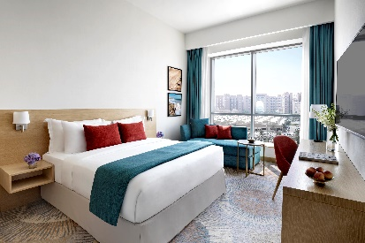
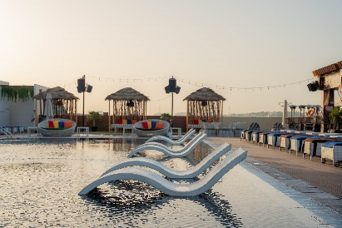
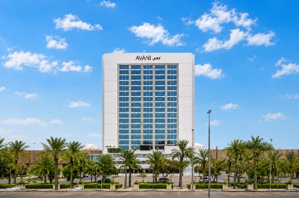

AVANI IBN BATTUTA DUBAI - SUSTAINABILITY OVERVIEW

At Avani Ibn Battuta Dubai, sustainability is an important part of the hotel’s ongoing commitment to more responsible hospitality. Located along Sheikh Zayed Road and directly connected to Ibn Battuta Mall and Ibn Battuta Metro Station, the hotel continues to introduce practical initiatives focused on reducing waste, conserving resources, lowering its environmental footprint and creating positive impact within the local community.

Aligned with Minor Hotels’ sustainability strategy and its commitment to responsible hospitality, Avani Ibn Battuta Dubai continues to strengthen its environmental and social practices across daily operations. The hotel has recently progressed from Green Growth 2050 Gold to Platinum certification, following a sustainability audit recognising its continued efforts in areas including energy and water efficiency, waste reduction, plastic reduction and community engagement. This achievement reflects the hotel's ongoing journey towards more sustainable hotel operations.

Reducing single-use plastic is one of the hotel's key sustainability priorities. Avani Ibn Battuta Dubai has replaced single-use plastic water bottles in guest rooms with reusable glass water bottles. Through this initiative, the hotel has eliminated approximately 300,000 single-use plastic bottles from waste, representing a significant step towards reducing plastic consumption and encouraging reusable alternatives within its operations.

Water conservation remains another important area of focus. The hotel continues to explore and implement practical measures designed to reduce water consumption and promote responsible water management across its operations. Through greater awareness and ongoing improvements to operational practices, the hotel aims to use this vital resource more responsibly while encouraging sustainable habits among both guests and team members.
Avani Ibn Battuta Dubai is also committed to reducing its overall reliance on single-use plastics. By introducing reusable alternatives and reviewing everyday operational practices, the hotel continues to identify opportunities to minimise unnecessary waste and support more sustainable ways of working. These initiatives form part of a wider approach to responsible resource management across the property.

Environmental responsibility extends beyond the hotel's own operations through its participation in community-led initiatives. Avani Ibn Battuta Dubai participated in the Emirates Environmental Group (EEG) “Adopt a Tree” campaign, under the “For Our Emirates We Plant” programme, supporting the planting of five indigenous trees. Once matured, the trees are expected to collectively sequester approximately 0.03 metric tonnes of CO₂ per year, contributing to climate mitigation and environmental sustainability in the UAE.

Community engagement is another important element of the hotel's sustainability approach. Through environmental campaigns, community donation drives and support for local causes and organisations, Avani Ibn Battuta Dubai seeks to create positive social and environmental impact within the UAE. These initiatives encourage colleagues and the wider community to participate in meaningful activities that support the environment and those around them.

Sustainability awareness is also encouraged among hotel colleagues through ongoing engagement with responsible practices. From reducing plastic consumption and managing resources responsibly to participating in environmental and community initiatives, the hotel continues to build sustainability into everyday operations and team culture.

Guests are encouraged to become part of this journey through simple, conscious choices during their stay. The introduction of reusable glass water bottles provides an easy way for guests to reduce single-use plastic consumption, while the hotel's wider sustainability initiatives create opportunities to experience a more responsible approach to modern hospitality.

At Avani Ibn Battuta Dubai, sustainability is an ongoing journey rather than a single initiative. Through practical changes to everyday operations, responsible resource management, environmental partnerships and community engagement, the hotel continues to build on its sustainability efforts. Its progression to Green Growth 2050 Platinum certification represents an important milestone, while its continued focus on reducing plastic, conserving water, supporting environmental initiatives and engaging with the local community demonstrates Avani Ibn Battuta Dubai's commitment to creating a more sustainable future for hospitality in the UAE.

-Ends-

About Avani Ibn Battuta Dubai
Located on Sheikh Zayed Road and directly connected to Ibn Battuta Mall and Ibn Battuta Dubai Metro Station, Avani Ibn Battuta Dubai offers a convenient and contemporary base for both business and leisure travellers in Dubai. The hotel features 358 rooms and suites, an all-day dining restaurant and pool bar, meeting and event spaces, a swimming pool and a 24-hour fitness centre.

Designed for travellers who value comfort, convenience and connectivity, the hotel provides easy access to Dubai’s key business, shopping and leisure destinations. Guests can reach Dubai Marina in approximately 10 minutes, Expo City Dubai in 15 minutes and Dubai Parks and Resorts in 15 minutes, while Dubai International Airport and Dubai World Central Airport are approximately 25 minutes away by car.
The hotel is home to Pele Social Hub, offering a relaxed social setting with Neapolitan pizza and international favourites, alongside a pool bar and modern guest spaces. With its direct access to the metro, proximity to Ibn Battuta Mall and convenient location along Sheikh Zayed Road, Avani Ibn Battuta Dubai is well positioned for guests travelling for business, leisure, shopping and entertainment.
Website: avanihotels.com/ibn-battuta-dubai | Social Media: Facebook, Instagram, TikTok and LinkedIn.

About Avani Hotels & Resorts
Avani Hotels & Resorts is a contemporary hospitality brand for modern travellers, offering a balance of style, comfort and genuine hospitality across vibrant destinations around the world. Avani hotels are designed around the way people travel today, combining vibrant social spaces, stylish and functional accommodation, locally inspired food and an upbeat service culture.

With hotels and resorts across Asia, Europe, the Middle East, Africa and Australia, Avani continues to expand its portfolio while creating experiences that encourage guests to connect with the destination and enjoy travel on their own terms.
Avani Hotels & Resorts is a brand of Minor Hotels and participates in the Minor DISCOVERY loyalty programme.

Visit avanihotels.com for more information, and connect with Avani Hotels & Resorts on Facebook, Instagram, TikTok, LinkedIn and YouTube.

About Minor Hotels
Minor Hotels is a global leader in the hospitality industry with more than 640 hotels, resorts and branded residences across 66 countries. The group crafts innovative and insightful experiences through its hotel brands including Anantara, Elewana Collection, The Wolseley Hotels, Tivoli, Minor Reserve Collection, NH Collection, nhow, Avani, Colbert Collection, NH, Oaks and iStay, as well as a diverse portfolio of restaurants and bars, travel experiences and spa and wellness brands. With over four decades of expertise, Minor Hotels builds stronger brands, fosters lasting partnerships and drives business success by always focusing on what matters most to our guests, team members and partners.

Minor Hotels is a proud member of the Global Hotel Alliance (GHA) and recognises its guests through one unified loyalty programme, Minor DISCOVERY, part of GHA DISCOVERY.

Discover our world at minorhotels.com and connect with Minor Hotels on Facebook, Instagram, LinkedIn, TikTok and YouTube.

For media enquiries, please contact:
Priya Johny
Director of Sales
Avani Ibn Battuta Dubai Hotel
E: pjohny@avanihotels.com

