Leadership Bios
Avani Ibn Battuta Dubai
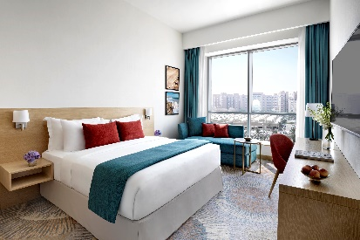
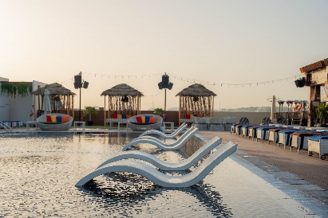
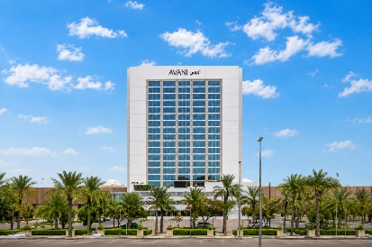

Zaid Mashini – General Manager
Zaid Mashini is General Manager of Avani Ibn Battuta Dubai Hotel, a contemporary four-star lifestyle hotel located along Sheikh Zayed Road, near Ibn Battuta Mall and Ibn Battuta Metro Station. With extensive experience in international hospitality, Mashini oversees the hotel's overall operations and strategic direction, with a focus on delivering engaging guest experiences, operational excellence and commercial performance. His leadership supports Avani Ibn Battuta Dubai's positioning as a well-connected lifestyle destination for both business and leisure travellers. For media and interview requests regarding Avani Ibn Battuta Dubai Hotel, please contact him directly at zmashini@avanihotels.com.

Subodha Perera – Rooms Division Manager
Subodha Perera is Rooms Division Manager of Avani Ibn Battuta Dubai Hotel, overseeing the hotel's accommodation and guest-facing rooms operations. With a focus on service standards, operational efficiency and guest satisfaction, Perera plays an important role in ensuring a consistent and welcoming experience across the hotel's 358 rooms and suites. For rooms operations and guest experience inquiries regarding Avani Ibn Battuta Dubai Hotel, please contact superera@avanihotels.com.

Lorelei Regragui – Cluster Director of eCommerce & Distribution
Lorelei Regragui is Cluster Director of eCommerce & Distribution for Minor Hotels, supporting the hotel's digital presence, distribution strategy and online commercial performance. Her role focuses on strengthening the hotel's visibility across digital channels and optimising distribution opportunities to support revenue growth and reach key international and regional audiences. For eCommerce, digital distribution and related commercial inquiries regarding Avani Ibn Battuta Dubai Hotel, please contact lregragui@minorhotels.com.

Shahzad Zia – Cluster Director of Revenue
Shahzad Zia is Cluster Director of Revenue for Minor Hotels, overseeing revenue strategy and commercial performance across the relevant hotel portfolio. His role focuses on optimising revenue opportunities through strategic pricing, demand analysis, forecasting and market performance. For revenue-related and commercial strategy inquiries regarding Avani Ibn Battuta Dubai Hotel, please contact szia@minorhotels.com.

Priya Johny – Director of Sales
Priya Johny is Director of Sales of Avani Ibn Battuta Dubai Hotel, leading the hotel's sales strategy and commercial partnerships across key market segments. Her role focuses on developing business opportunities, strengthening corporate and trade relationships, and positioning the hotel as a convenient and well-connected destination for business and leisure travel. For sales partnerships, commercial opportunities and market-related inquiries regarding Avani Ibn Battuta Dubai Hotel, please contact pjohny@avanihotels.com.

Avinash Prabhu – Food & Beverage Manager
Avinash Prabhu is Food & Beverage Manager of Avani Ibn Battuta Dubai Hotel, overseeing the hotel's dining and beverage operations. His role focuses on delivering engaging food and beverage experiences across the property's social and dining venues while maintaining consistent service and operational standards. For food and beverage media inquiries, partnerships and interview requests regarding Avani Ibn Battuta Dubai Hotel, please contact aprabhu@avanihotels.com.

Santiago Dunuan – Chef de Cuisine
Santiago Dunuan is Chef de Cuisine at Avani Ibn Battuta Dubai Hotel, contributing to the hotel's contemporary culinary offering across its dining venues. His role focuses on delivering quality cuisine and creating approachable dining experiences that reflect Avani's relaxed and social approach to hospitality. For culinary media inquiries and interview requests regarding Avani Ibn Battuta Dubai Hotel, please contact sdunuan@avanihotels.com.

-Ends-

About Avani Ibn Battuta Dubai
Located on Sheikh Zayed Road and directly connected to Ibn Battuta Mall and Ibn Battuta Dubai Metro Station, Avani Ibn Battuta Dubai offers a convenient and contemporary base for both business and leisure travellers in Dubai. The hotel features 358 rooms and suites, an all-day dining restaurant and pool bar, meeting and event spaces, a swimming pool and a 24-hour fitness centre.

Designed for travellers who value comfort, convenience and connectivity, the hotel provides easy access to Dubai’s key business, shopping and leisure destinations. Guests can reach Dubai Marina in approximately 10 minutes, Expo City Dubai in 15 minutes and Dubai Parks and Resorts in 15 minutes, while Dubai International Airport and Dubai World Central Airport are approximately 25 minutes away by car.
The hotel is home to Pele Social Hub, offering a relaxed social setting with Neapolitan pizza and international favourites, alongside a pool bar and modern guest spaces. With its direct access to the metro, proximity to Ibn Battuta Mall and convenient location along Sheikh Zayed Road, Avani Ibn Battuta Dubai is well positioned for guests travelling for business, leisure, shopping and entertainment.
Website: avanihotels.com/ibn-battuta-dubai | Social Media: Facebook, Instagram, TikTok and LinkedIn.

About Avani Hotels & Resorts
Avani Hotels & Resorts is a contemporary hospitality brand for modern travellers, offering a balance of style, comfort and genuine hospitality across vibrant destinations around the world. Avani hotels are designed around the way people travel today, combining vibrant social spaces, stylish and functional accommodation, locally inspired food and an upbeat service culture.

With hotels and resorts across Asia, Europe, the Middle East, Africa and Australia, Avani continues to expand its portfolio while creating experiences that encourage guests to connect with the destination and enjoy travel on their own terms.
Avani Hotels & Resorts is a brand of Minor Hotels and participates in the Minor DISCOVERY loyalty programme.

Visit avanihotels.com for more information, and connect with Avani Hotels & Resorts on Facebook, Instagram, TikTok, LinkedIn and YouTube.

About Minor Hotels
Minor Hotels is a global leader in the hospitality industry with more than 640 hotels, resorts and branded residences across 66 countries. The group crafts innovative and insightful experiences through its hotel brands including Anantara, Elewana Collection, The Wolseley Hotels, Tivoli, Minor Reserve Collection, NH Collection, nhow, Avani, Colbert Collection, NH, Oaks and iStay, as well as a diverse portfolio of restaurants and bars, travel experiences and spa and wellness brands. With over four decades of expertise, Minor Hotels builds stronger brands, fosters lasting partnerships and drives business success by always focusing on what matters most to our guests, team members and partners.

Minor Hotels is a proud member of the Global Hotel Alliance (GHA) and recognises its guests through one unified loyalty programme, Minor DISCOVERY, part of GHA DISCOVERY.

Discover our world at minorhotels.com and connect with Minor Hotels on Facebook, Instagram, LinkedIn, TikTok and YouTube.

For media enquiries, please contact:
Priya Johny
Director of Sales
Avani Ibn Battuta Dubai Hotel
E: pjohny@avanihotels.com

