Press Release
Introducing Avani Ibn Battuta Dubai Hotel
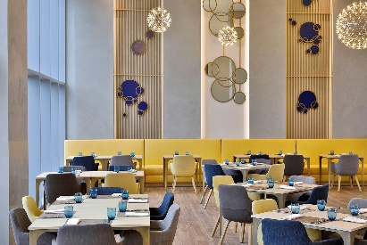
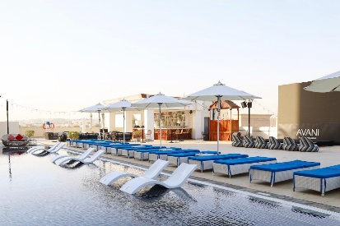
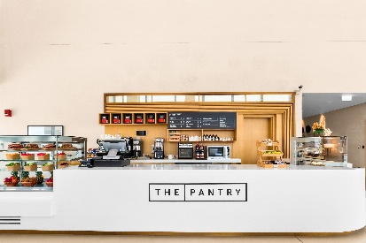

Contemporary Lifestyle and Effortless Connectivity in the Heart of Dubai

Located along Sheikh Zayed Road and directly connected to Ibn Battuta Mall and Ibn Battuta Metro Station, Avani Ibn Battuta Dubai offers a contemporary lifestyle experience for modern travellers seeking comfort, convenience and easy access to the energy of Dubai. Combining stylish design with vibrant social spaces and an upbeat hospitality experience, the four-star lifestyle hotel provides a well-connected base for both business and leisure travellers, with shopping, dining, entertainment and major destinations across the city within easy reach.

The hotel features 358 contemporary rooms and suites, designed to provide a comfortable and functional stay for today's connected traveller. Accommodation ranges from Superior Rooms and Superior Pool View Rooms to Executive Rooms and One Bedroom Suites, with room sizes ranging from 30 to 60 square metres. The hotel's location beside Ibn Battuta Mall and the Dubai Metro makes it particularly convenient for guests looking to explore the city, while providing straightforward access to Dubai Marina, Expo City Dubai, Dubai Parks and Resorts and the city's key business districts.

Dining and social experiences are centred around a relaxed, contemporary approach to hospitality. Pele Social Hub offers a lively setting for international favourites and casual social dining, while Pele Pool Bar provides a laid-back poolside environment for refreshments throughout the day. The Pantry offers a convenient lobby stop for coffee, fresh juices, salads, sandwiches and snacks, complemented by in-room dining for guests seeking added convenience.

Leisure and wellness facilities include an outdoor swimming pool, dedicated children's pool, 24-hour AvaniFit fitness centre and Azzurro Spa. For business travellers and corporate groups, the hotel offers a 48-square-metre meeting room accommodating up to 22 guests in a theatre setup, supported by modern meeting facilities, catering and flexible seating arrangements. With the convenience of the metro on its doorstep, direct access to Ibn Battuta Mall and a vibrant selection of social and leisure experiences, Avani Ibn Battuta Dubai brings together contemporary living, connectivity and the distinctive Avani spirit in one of Dubai's most accessible destinations.

-Ends-

About Avani Ibn Battuta Dubai
Located on Sheikh Zayed Road and directly connected to Ibn Battuta Mall and Ibn Battuta Dubai Metro Station, Avani Ibn Battuta Dubai offers a convenient and contemporary base for both business and leisure travellers in Dubai. The hotel features 358 rooms and suites, an all-day dining restaurant and pool bar, meeting and event spaces, a swimming pool and a 24-hour fitness centre.

Designed for travellers who value comfort, convenience and connectivity, the hotel provides easy access to Dubai’s key business, shopping and leisure destinations. Guests can reach Dubai Marina in approximately 10 minutes, Expo City Dubai in 15 minutes and Dubai Parks and Resorts in 15 minutes, while Dubai International Airport and Dubai World Central Airport are approximately 25 minutes away by car.
The hotel is home to Pele Social Hub, offering a relaxed social setting with Neapolitan pizza and international favourites, alongside a pool bar and modern guest spaces. With its direct access to the metro, proximity to Ibn Battuta Mall and convenient location along Sheikh Zayed Road, Avani Ibn Battuta Dubai is well positioned for guests travelling for business, leisure, shopping and entertainment.
Website: avanihotels.com/ibn-battuta-dubai | Social Media: Facebook, Instagram, TikTok and LinkedIn.

About Avani Hotels & Resorts
Avani Hotels & Resorts is a contemporary hospitality brand for modern travellers, offering a balance of style, comfort and genuine hospitality across vibrant destinations around the world. Avani hotels are designed around the way people travel today, combining vibrant social spaces, stylish and functional accommodation, locally inspired food and an upbeat service culture.

With hotels and resorts across Asia, Europe, the Middle East, Africa and Australia, Avani continues to expand its portfolio while creating experiences that encourage guests to connect with the destination and enjoy travel on their own terms.
Avani Hotels & Resorts is a brand of Minor Hotels and participates in the Minor DISCOVERY loyalty programme.

Visit avanihotels.com for more information, and connect with Avani Hotels & Resorts on Facebook, Instagram, TikTok, LinkedIn and YouTube.

About Minor Hotels
Minor Hotels is a global leader in the hospitality industry with more than 640 hotels, resorts and branded residences across 66 countries. The group crafts innovative and insightful experiences through its hotel brands including Anantara, Elewana Collection, The Wolseley Hotels, Tivoli, Minor Reserve Collection, NH Collection, nhow, Avani, Colbert Collection, NH, Oaks and iStay, as well as a diverse portfolio of restaurants and bars, travel experiences and spa and wellness brands. With over four decades of expertise, Minor Hotels builds stronger brands, fosters lasting partnerships and drives business success by always focusing on what matters most to our guests, team members and partners.

Minor Hotels is a proud member of the Global Hotel Alliance (GHA) and recognises its guests through one unified loyalty programme, Minor DISCOVERY, part of GHA DISCOVERY.

Discover our world at minorhotels.com and connect with Minor Hotels on Facebook, Instagram, LinkedIn, TikTok and YouTube.

For media enquiries, please contact:
Priya Johny
Director of Sales
Avani Ibn Battuta Dubai Hotel
E: pjohny@avanihotels.com

