Press Release
RELAX & RESET

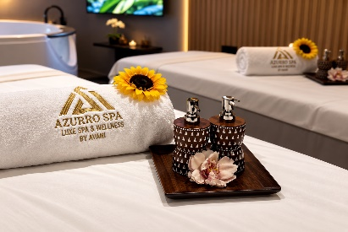
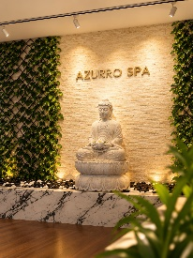

Azurro by Niyama Spa at Avani Ibn Battuta Dubai Offers a Contemporary Urban Escape

Located along Sheikh Zayed Road and directly connected to Ibn Battuta Mall and Ibn Battuta Metro Station, Avani Ibn Battuta Dubai offers a convenient urban retreat where guests can pause, recharge and make time for themselves. At the heart of the hotel's wellness offering, Azurro by Niyama Spa provides a dedicated sanctuary for relaxation, combining restorative treatments with a tranquil setting away from the pace of the city.

Designed for modern travellers seeking a moment of calm between busy days, business commitments and city adventures, Azurro by Niyama Spa offers a selection of treatments focused on relaxation and rejuvenation. The spa provides guests with an opportunity to slow down, switch off and enjoy personalised experiences designed to leave the body feeling refreshed and the mind recharged.

The spa experience complements Avani Ibn Battuta Dubai's contemporary approach to wellness, giving guests an accessible way to incorporate relaxation into their stay. Whether enjoying a treatment after a day of meetings, taking time to unwind following a day of exploring Dubai or simply setting aside time for self-care, Azurro by Niyama Spa provides a peaceful pause within the energy of the city.

Wellness at Avani Ibn Battuta Dubai extends beyond the spa, with guests also able to enjoy the 24-hour AvaniFit fitness centre and outdoor swimming pool. Together, these facilities offer a flexible approach to wellbeing, allowing guests to choose how they want to move, relax and recharge during their stay. With the convenience of Ibn Battuta Mall and the metro directly connected to the hotel, Azurro by Niyama Spa brings a considered wellness experience to one of Dubai's most connected destinations.

-Ends-

About Avani Ibn Battuta Dubai
Located on Sheikh Zayed Road and directly connected to Ibn Battuta Mall and Ibn Battuta Dubai Metro Station, Avani Ibn Battuta Dubai offers a convenient and contemporary base for both business and leisure travellers in Dubai. The hotel features 358 rooms and suites, an all-day dining restaurant and pool bar, meeting and event spaces, a swimming pool and a 24-hour fitness centre.

Designed for travellers who value comfort, convenience and connectivity, the hotel provides easy access to Dubai’s key business, shopping and leisure destinations. Guests can reach Dubai Marina in approximately 10 minutes, Expo City Dubai in 15 minutes and Dubai Parks and Resorts in 15 minutes, while Dubai International Airport and Dubai World Central Airport are approximately 25 minutes away by car.
The hotel is home to Pele Social Hub, offering a relaxed social setting with Neapolitan pizza and international favourites, alongside a pool bar and modern guest spaces. With its direct access to the metro, proximity to Ibn Battuta Mall and convenient location along Sheikh Zayed Road, Avani Ibn Battuta Dubai is well positioned for guests travelling for business, leisure, shopping and entertainment.
Website: avanihotels.com/ibn-battuta-dubai | Social Media: Facebook, Instagram, TikTok and LinkedIn.

About Avani Hotels & Resorts
Avani Hotels & Resorts is a contemporary hospitality brand for modern travellers, offering a balance of style, comfort and genuine hospitality across vibrant destinations around the world. Avani hotels are designed around the way people travel today, combining vibrant social spaces, stylish and functional accommodation, locally inspired food and an upbeat service culture.

With hotels and resorts across Asia, Europe, the Middle East, Africa and Australia, Avani continues to expand its portfolio while creating experiences that encourage guests to connect with the destination and enjoy travel on their own terms.
Avani Hotels & Resorts is a brand of Minor Hotels and participates in the Minor DISCOVERY loyalty programme.

Visit avanihotels.com for more information, and connect with Avani Hotels & Resorts on Facebook, Instagram, TikTok, LinkedIn and YouTube.

About Minor Hotels
Minor Hotels is a global leader in the hospitality industry with more than 640 hotels, resorts and branded residences across 66 countries. The group crafts innovative and insightful experiences through its hotel brands including Anantara, Elewana Collection, The Wolseley Hotels, Tivoli, Minor Reserve Collection, NH Collection, nhow, Avani, Colbert Collection, NH, Oaks and iStay, as well as a diverse portfolio of restaurants and bars, travel experiences and spa and wellness brands. With over four decades of expertise, Minor Hotels builds stronger brands, fosters lasting partnerships and drives business success by always focusing on what matters most to our guests, team members and partners.

Minor Hotels is a proud member of the Global Hotel Alliance (GHA) and recognises its guests through one unified loyalty programme, Minor DISCOVERY, part of GHA DISCOVERY.

Discover our world at minorhotels.com and connect with Minor Hotels on Facebook, Instagram, LinkedIn, TikTok and YouTube.

For media enquiries, please contact:
Priya Johny
Director of Sales
Avani Ibn Battuta Dubai Hotel
E: pjohny@avanihotels.com

