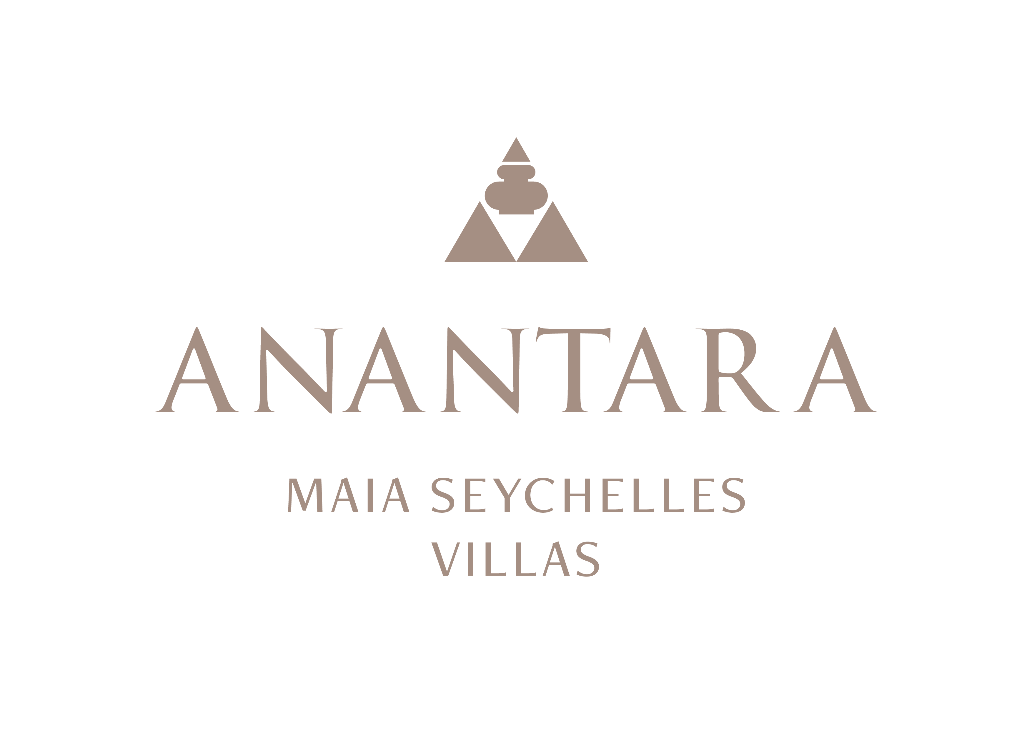
PRESS RELEASE
Seychelles by Sea, Land and Sky: Anantara Maia Curates Private Island Experiences
Marine discovery, garden encounters, Creole culture and private journeys reveal the archipelago beyond the villa.
Mahé, Seychelles - Anantara Maia Seychelles Villas invites guests to discover the Seychelles through experiences that begin on its private peninsula and extend across the archipelago. Each journey can be tailored by the resort team and Villa Hosts according to interests, pace, weather and season.
On the water, guests can kayak or stand-up paddleboard from Anse Louis, snorkel the house reef with WiseOceans specialists, learn about reef restoration or arrange private boat and yacht charters. Diving and freediving can be coordinated with specialist partners, while sunset cruises offer a slower view of Mahé's west coast.
Island-hopping journeys bring the wider Seychelles into reach. A private excursion may combine a scenic flight with Praslin and Curieuse, home to giant tortoises and coastal trails, or continue by boat to snorkelling sites such as St Pierre and Anse Lazio. Helicopter flights can also reveal the scale and colour of the islands from above.
Back on Mahé, guided hikes, private island tours and visits to local markets connect guests with landscape and culture. Spice Spoons pairs ingredient discovery with a hands-on Creole cooking session, while the resort's botanical garden tours introduce the living collection cared for by Chief Gardener Allan Marguerite and his team.
The peninsula itself offers a varied daily rhythm. Yoga, qigong and fitness sessions can begin the morning, followed by snorkelling or time on the water. Sunset rituals, sound bowls and live entertainment mark the evening, while private Designer Dining and Massage Under the Stars create experiences that require no departure from the resort.
Families can combine marine learning, creative activities and gentle island exploration, with experiences adapted to different ages. Couples may prefer a private beach dinner, a wine tasting in “20” or a secluded cruise. Active travellers can add surfing, hiking, diving or a padel session to the itinerary.
Rather than offering a fixed programme, Anantara Maia uses its network of resort teams, conservation specialists and island partners to build a personal sequence of experiences around each guest.
“The Seychelles rewards curiosity. We want guests to experience the islands from several perspectives, then return to the privacy of their villa with a stronger connection to the place and its people,” said Naji Esta, Cluster General Manager.

-Ends-
About Anantara Maia Seychelles Villas
Anantara Maia Seychelles Villas is an ultra-luxury private-pool villa resort on a secluded 30-acre peninsula overlooking Anse Louis on Mahé's west coast. Its 30 villas pair ocean or garden views with private infinity pools, outdoor living and a dedicated Villa Host. Designed by Bill Bensley and Lek Bunnag, the resort is known for deep privacy, dine-anywhere experiences, Tec-Tec's beachfront cuisine and restorative wellness in three open-sided Anantara Spa pavilions. Around 35 minutes from Seychelles International Airport, it is suited to honeymooners, couples, families and intimate celebrations seeking tailored island experiences. Visit https://www.anantara.com/en/maia-seychelles or follow @anantaramaiaseychelles.
About Anantara Hotels & Resorts
A luxury hospitality brand for modern travellers, Anantara Hotels & Resorts connects guests to genuine places, people and stories in some of the world's most extraordinary destinations. Each Anantara embraces the surroundings and culture of its destination, creating unforgettable memories for every guest since 2001. From city to sea and desert to jungle, Anantara delivers heartfelt, Thai-inspired hospitality at its over 50 hotels and resorts across Asia, Europe, Africa, the Middle East and the Indian Ocean.
Anantara Hotels & Resorts is a Minor Hotels brand and recognises its guests through one unified loyalty programme, Minor DISCOVERY, part of GHA DISCOVERY.

Visit anantara.com for more information, and connect with Anantara on Facebook, Instagram, TikTok, X and YouTube.

About Minor Hotels
Minor Hotels is a global leader in the hospitality industry with more than 640 hotels, resorts and branded residences across 66 countries. The group crafts innovative and insightful experiences through its hotel brands including Anantara, Elewana Collection, The Wolseley Hotels, Tivoli, Minor Reserve Collection, NH Collection, nhow, Avani, Colbert Collection, NH, Oaks and iStay, as well as a diverse portfolio of restaurants and bars, travel experiences and spa and wellness brands. With over four decades of expertise, Minor Hotels builds stronger brands, fosters lasting partnerships and drives business success by always focusing on what matters most to our guests, team members and partners.
Minor Hotels is a proud member of the Global Hotel Alliance (GHA) and recognises its guests through one unified loyalty programme, Minor DISCOVERY, part of GHA DISCOVERY.

Discover our world at minorhotels.com and connect with Minor Hotels on Facebook, Instagram, LinkedIn, TikTok and YouTube.
Media Contact
Kevin Seeburrun
Cluster PR & MarCom Manager
Anantara Maia Seychelles Villas | Avani+ Barbarons Seychelles Resort
E: kseeburrun@minorhotels.com
M: +248 282 0987

