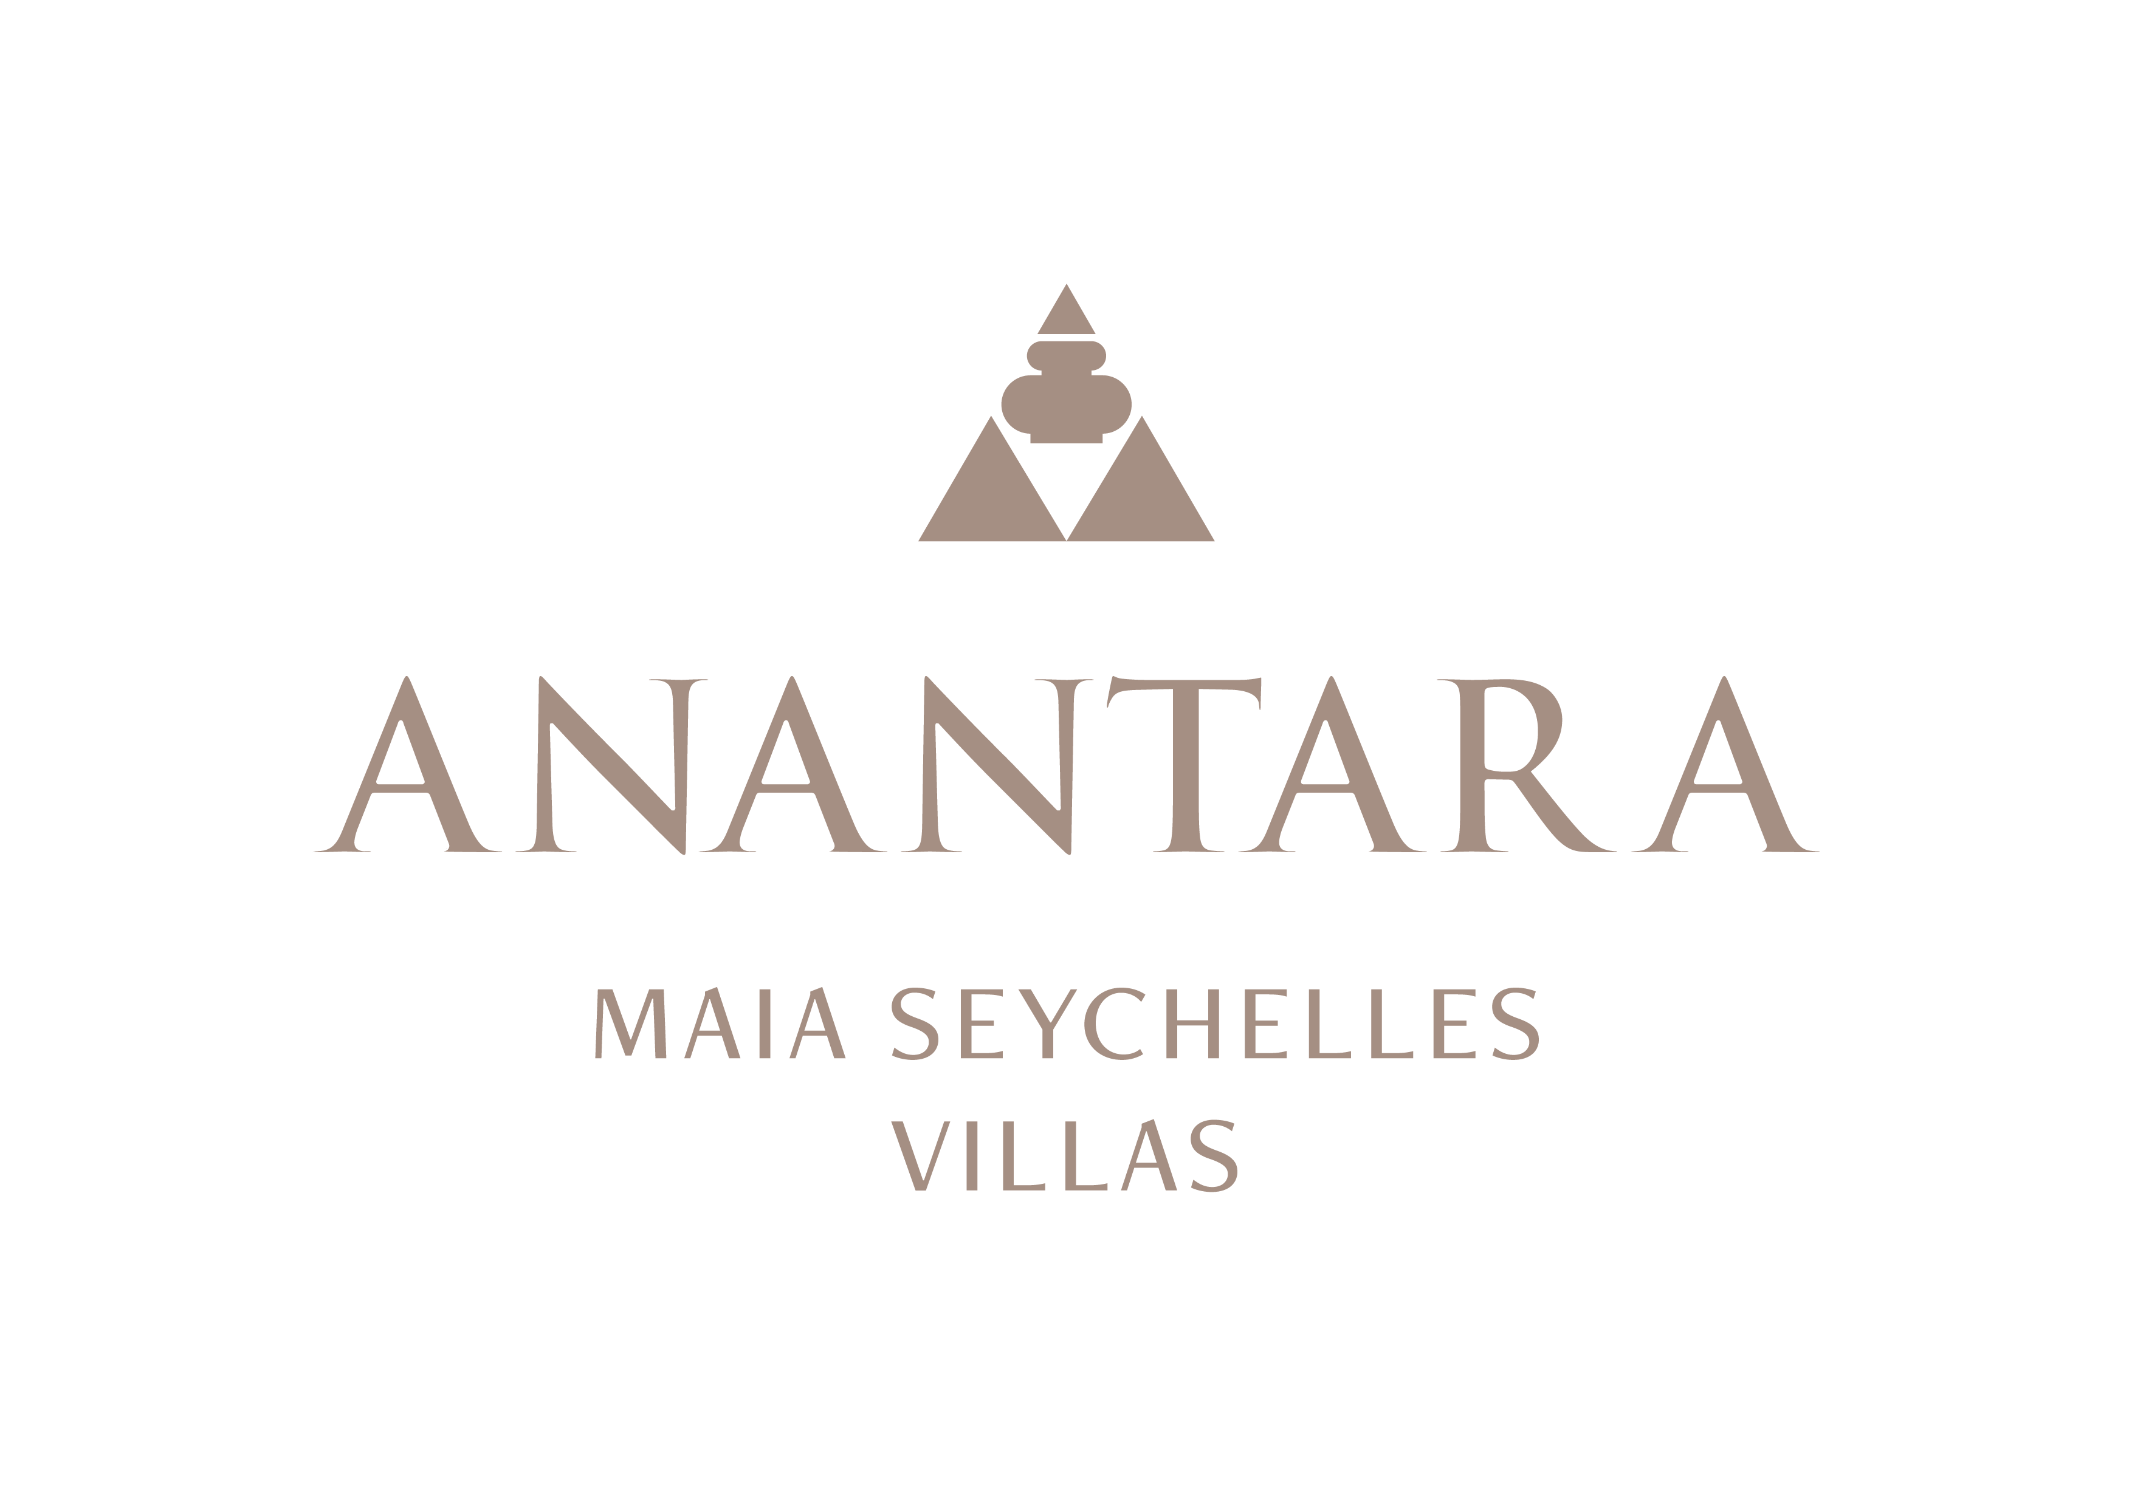
PRESS RELEASE
Open-Air Wellness: Anantara Maia Seychelles Villas Creates Restorative Journeys in Nature
Three open-sided spa pavilions, personalised programmes and marine-inspired rituals place nature at the centre of wellbeing.
Mahé, Seychelles - Wellness at Anantara Maia Seychelles Villas begins with the setting. Three open-sided Anantara Spa pavilions are tucked among granite boulders and tropical vegetation, creating private spaces where sea air, birdsong and the rhythms of the peninsula become part of each treatment.
Every journey can begin with a personal consultation, allowing the spa team to tailor treatments, movement and daily rituals around individual intentions. Guests may choose a single restorative experience or follow a structured three- to five-night pathway focused on unwinding, rebalancing or revitalising.
The spa menu draws on traditions from Thailand, India, Tibet and Indonesia, alongside treatments inspired by the Seychelles. Signatures include the Maia Signature Treatment, Coconut Indulgence, Seychelles Sand Poultice Ritual and Maia Signature Vichy Rain Ritual by Thalion. Marine-based Thalion experiences and Omorovicza skincare complement Ayurvedic therapies, Thai massage, hot stone rituals and sound-led practices.
Wellness also moves beyond the treatment pavilion. Yoga, qigong, fitness sessions, aqua sound yoga, sound bowls and mindful time in the gardens can be incorporated into a stay. Private in-villa baths and Massage Under the Stars create quiet evening rituals, while children can enjoy age-appropriate spa experiences through the VIK selection.
The resort's three- to five-night wellness programmes bring together four elements: consultation, cuisine, therapies and movement. De-Stress, Switch Off & Unwind supports guests seeking calm; Detox & Reboot centres on lighter routines and mindful nourishment; and Rejuvenate & Revitalise combines movement and restorative care. Plant-forward menus and personalised dining choices support each pathway without separating wellness from the pleasures of a holiday.
The result is an adaptable approach to wellbeing. Guests can follow a defined programme, select individual treatments or simply allow the landscape, privacy and unhurried pace of villa life to create space for rest.
“Wellness at Anantara Maia is not a separate part of the stay. It is present in the open-air spa, the food, the movement experiences and the quiet of the villa, allowing each guest to create a rhythm that feels genuinely restorative,” said Naji Esta, Cluster General Manager.

-Ends-
About Anantara Maia Seychelles Villas
Anantara Maia Seychelles Villas is an ultra-luxury private-pool villa resort on a secluded 30-acre peninsula overlooking Anse Louis on Mahé's west coast. Its 30 villas pair ocean or garden views with private infinity pools, outdoor living and a dedicated Villa Host. Designed by Bill Bensley and Lek Bunnag, the resort is known for deep privacy, dine-anywhere experiences, Tec-Tec's beachfront cuisine and restorative wellness in three open-sided Anantara Spa pavilions. Around 35 minutes from Seychelles International Airport, it is suited to honeymooners, couples, families and intimate celebrations seeking tailored island experiences. Visit https://www.anantara.com/en/maia-seychelles or follow @anantaramaiaseychelles.
About Anantara Hotels & Resorts
A luxury hospitality brand for modern travellers, Anantara Hotels & Resorts connects guests to genuine places, people and stories in some of the world's most extraordinary destinations. Each Anantara embraces the surroundings and culture of its destination, creating unforgettable memories for every guest since 2001. From city to sea and desert to jungle, Anantara delivers heartfelt, Thai-inspired hospitality at its over 50 hotels and resorts across Asia, Europe, Africa, the Middle East and the Indian Ocean.
Anantara Hotels & Resorts is a Minor Hotels brand and recognises its guests through one unified loyalty programme, Minor DISCOVERY, part of GHA DISCOVERY.

Visit anantara.com for more information, and connect with Anantara on Facebook, Instagram, TikTok, X and YouTube.

About Minor Hotels
Minor Hotels is a global leader in the hospitality industry with more than 640 hotels, resorts and branded residences across 66 countries. The group crafts innovative and insightful experiences through its hotel brands including Anantara, Elewana Collection, The Wolseley Hotels, Tivoli, Minor Reserve Collection, NH Collection, nhow, Avani, Colbert Collection, NH, Oaks and iStay, as well as a diverse portfolio of restaurants and bars, travel experiences and spa and wellness brands. With over four decades of expertise, Minor Hotels builds stronger brands, fosters lasting partnerships and drives business success by always focusing on what matters most to our guests, team members and partners.
Minor Hotels is a proud member of the Global Hotel Alliance (GHA) and recognises its guests through one unified loyalty programme, Minor DISCOVERY, part of GHA DISCOVERY.

Discover our world at minorhotels.com and connect with Minor Hotels on Facebook, Instagram, LinkedIn, TikTok and YouTube.
Media Contact
Kevin Seeburrun
Cluster PR & MarCom Manager
Anantara Maia Seychelles Villas | Avani+ Barbarons Seychelles Resort
E: kseeburrun@minorhotels.com
M: +248 282 0987

