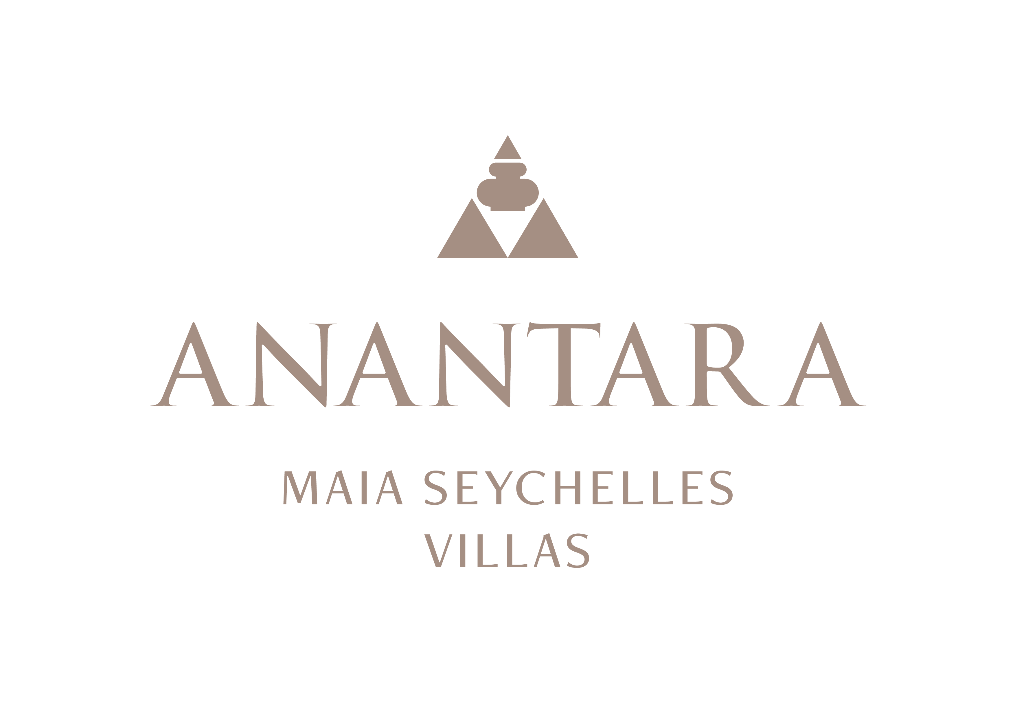
PRESS RELEASE
Anantara Maia Seychelles Villas Defines Private-Peninsula Luxury on Mahé
Thirty private-pool villas, intuitive Villa Host service and a secluded setting create a highly personal expression of Seychelles hospitality.
Mahé, Seychelles - Set on a secluded 30-acre peninsula overlooking Anse Louis, Anantara Maia Seychelles Villas offers a rare combination of space, privacy and personal service on Mahé's west coast. The resort's 30 private-pool villas are arranged across lush hillsides and close to the beach, creating a sanctuary where each stay can move at its own pace.
The villa collection comprises Ocean View, Premier Ocean View, Premier Beach and Peninsula Ocean View categories. Each villa is designed for indoor-outdoor living, with a private infinity pool, open-air lounge and generous spaces that frame views of the Indian Ocean or tropical gardens. Premier Beach Villas add direct access to the sands of Anse Louis, while Peninsula Ocean View Villas occupy some of the resort's most private positions.
At the heart of the experience is the dedicated Villa Host, who acts as a personal service connector throughout the stay. From arranging an unhurried breakfast by the pool to coordinating spa rituals, island adventures or a private dinner in a secluded setting, the Villa Host brings together the resort's people and experiences around each guest's preferences.
Dining is intentionally flexible. Guests can enjoy Creole, Mediterranean and Asian flavours at beachfront Tec-Tec, relaxed refreshments at the Sunset Pool Bar, intimate evenings in the temperature-controlled wine cellar known as “20”, or menus served in the privacy of their villa. Designer Dining extends the table to settings such as the beach, gardens, hillside and helipad, shaped around the occasion and the surroundings.
Wellbeing unfolds in three open-sided Anantara Spa pavilions set among granite boulders and dense vegetation. Yoga, sound-led practices and tailored wellness programmes complement treatments inspired by traditions from across Asia and the Indian Ocean. Beyond the resort, private boat journeys, snorkelling, guided garden discovery, Creole cooking and curated excursions invite guests to experience the Seychelles from sea, land and sky.
Located around 35 minutes from Seychelles International Airport, Anantara Maia Seychelles Villas is designed for couples, honeymooners, families and intimate celebrations seeking privacy without formality, and service that feels attentive without interrupting the tranquillity of the peninsula.
“Anantara Maia is defined by the freedom to experience the Seychelles in a deeply personal way. Our villas, our team and the peninsula itself give us the space to shape every stay around the individual guest,” said Naji Esta, Cluster General Manager.

-Ends-
About Anantara Maia Seychelles Villas
Anantara Maia Seychelles Villas is an ultra-luxury private-pool villa resort on a secluded 30-acre peninsula overlooking Anse Louis on Mahé's west coast. Its 30 villas pair ocean or garden views with private infinity pools, outdoor living and a dedicated Villa Host. Designed by Bill Bensley and Lek Bunnag, the resort is known for deep privacy, dine-anywhere experiences, Tec-Tec's beachfront cuisine and restorative wellness in three open-sided Anantara Spa pavilions. Around 35 minutes from Seychelles International Airport, it is suited to honeymooners, couples, families and intimate celebrations seeking tailored island experiences. Visit https://www.anantara.com/en/maia-seychelles or follow @anantaramaiaseychelles.
About Anantara Hotels & Resorts
A luxury hospitality brand for modern travellers, Anantara Hotels & Resorts connects guests to genuine places, people and stories in some of the world's most extraordinary destinations. Each Anantara embraces the surroundings and culture of its destination, creating unforgettable memories for every guest since 2001. From city to sea and desert to jungle, Anantara delivers heartfelt, Thai-inspired hospitality at its over 50 hotels and resorts across Asia, Europe, Africa, the Middle East and the Indian Ocean.
Anantara Hotels & Resorts is a Minor Hotels brand and recognises its guests through one unified loyalty programme, Minor DISCOVERY, part of GHA DISCOVERY.

Visit anantara.com for more information, and connect with Anantara on Facebook, Instagram, TikTok, X and YouTube.

About Minor Hotels
Minor Hotels is a global leader in the hospitality industry with more than 640 hotels, resorts and branded residences across 66 countries. The group crafts innovative and insightful experiences through its hotel brands including Anantara, Elewana Collection, The Wolseley Hotels, Tivoli, Minor Reserve Collection, NH Collection, nhow, Avani, Colbert Collection, NH, Oaks and iStay, as well as a diverse portfolio of restaurants and bars, travel experiences and spa and wellness brands. With over four decades of expertise, Minor Hotels builds stronger brands, fosters lasting partnerships and drives business success by always focusing on what matters most to our guests, team members and partners.
Minor Hotels is a proud member of the Global Hotel Alliance (GHA) and recognises its guests through one unified loyalty programme, Minor DISCOVERY, part of GHA DISCOVERY.

Discover our world at minorhotels.com and connect with Minor Hotels on Facebook, Instagram, LinkedIn, TikTok and YouTube.
Media Contact
Kevin Seeburrun
Cluster PR & MarCom Manager
Anantara Maia Seychelles Villas | Avani+ Barbarons Seychelles Resort
E: kseeburrun@minorhotels.com
M: +248 282 0987

