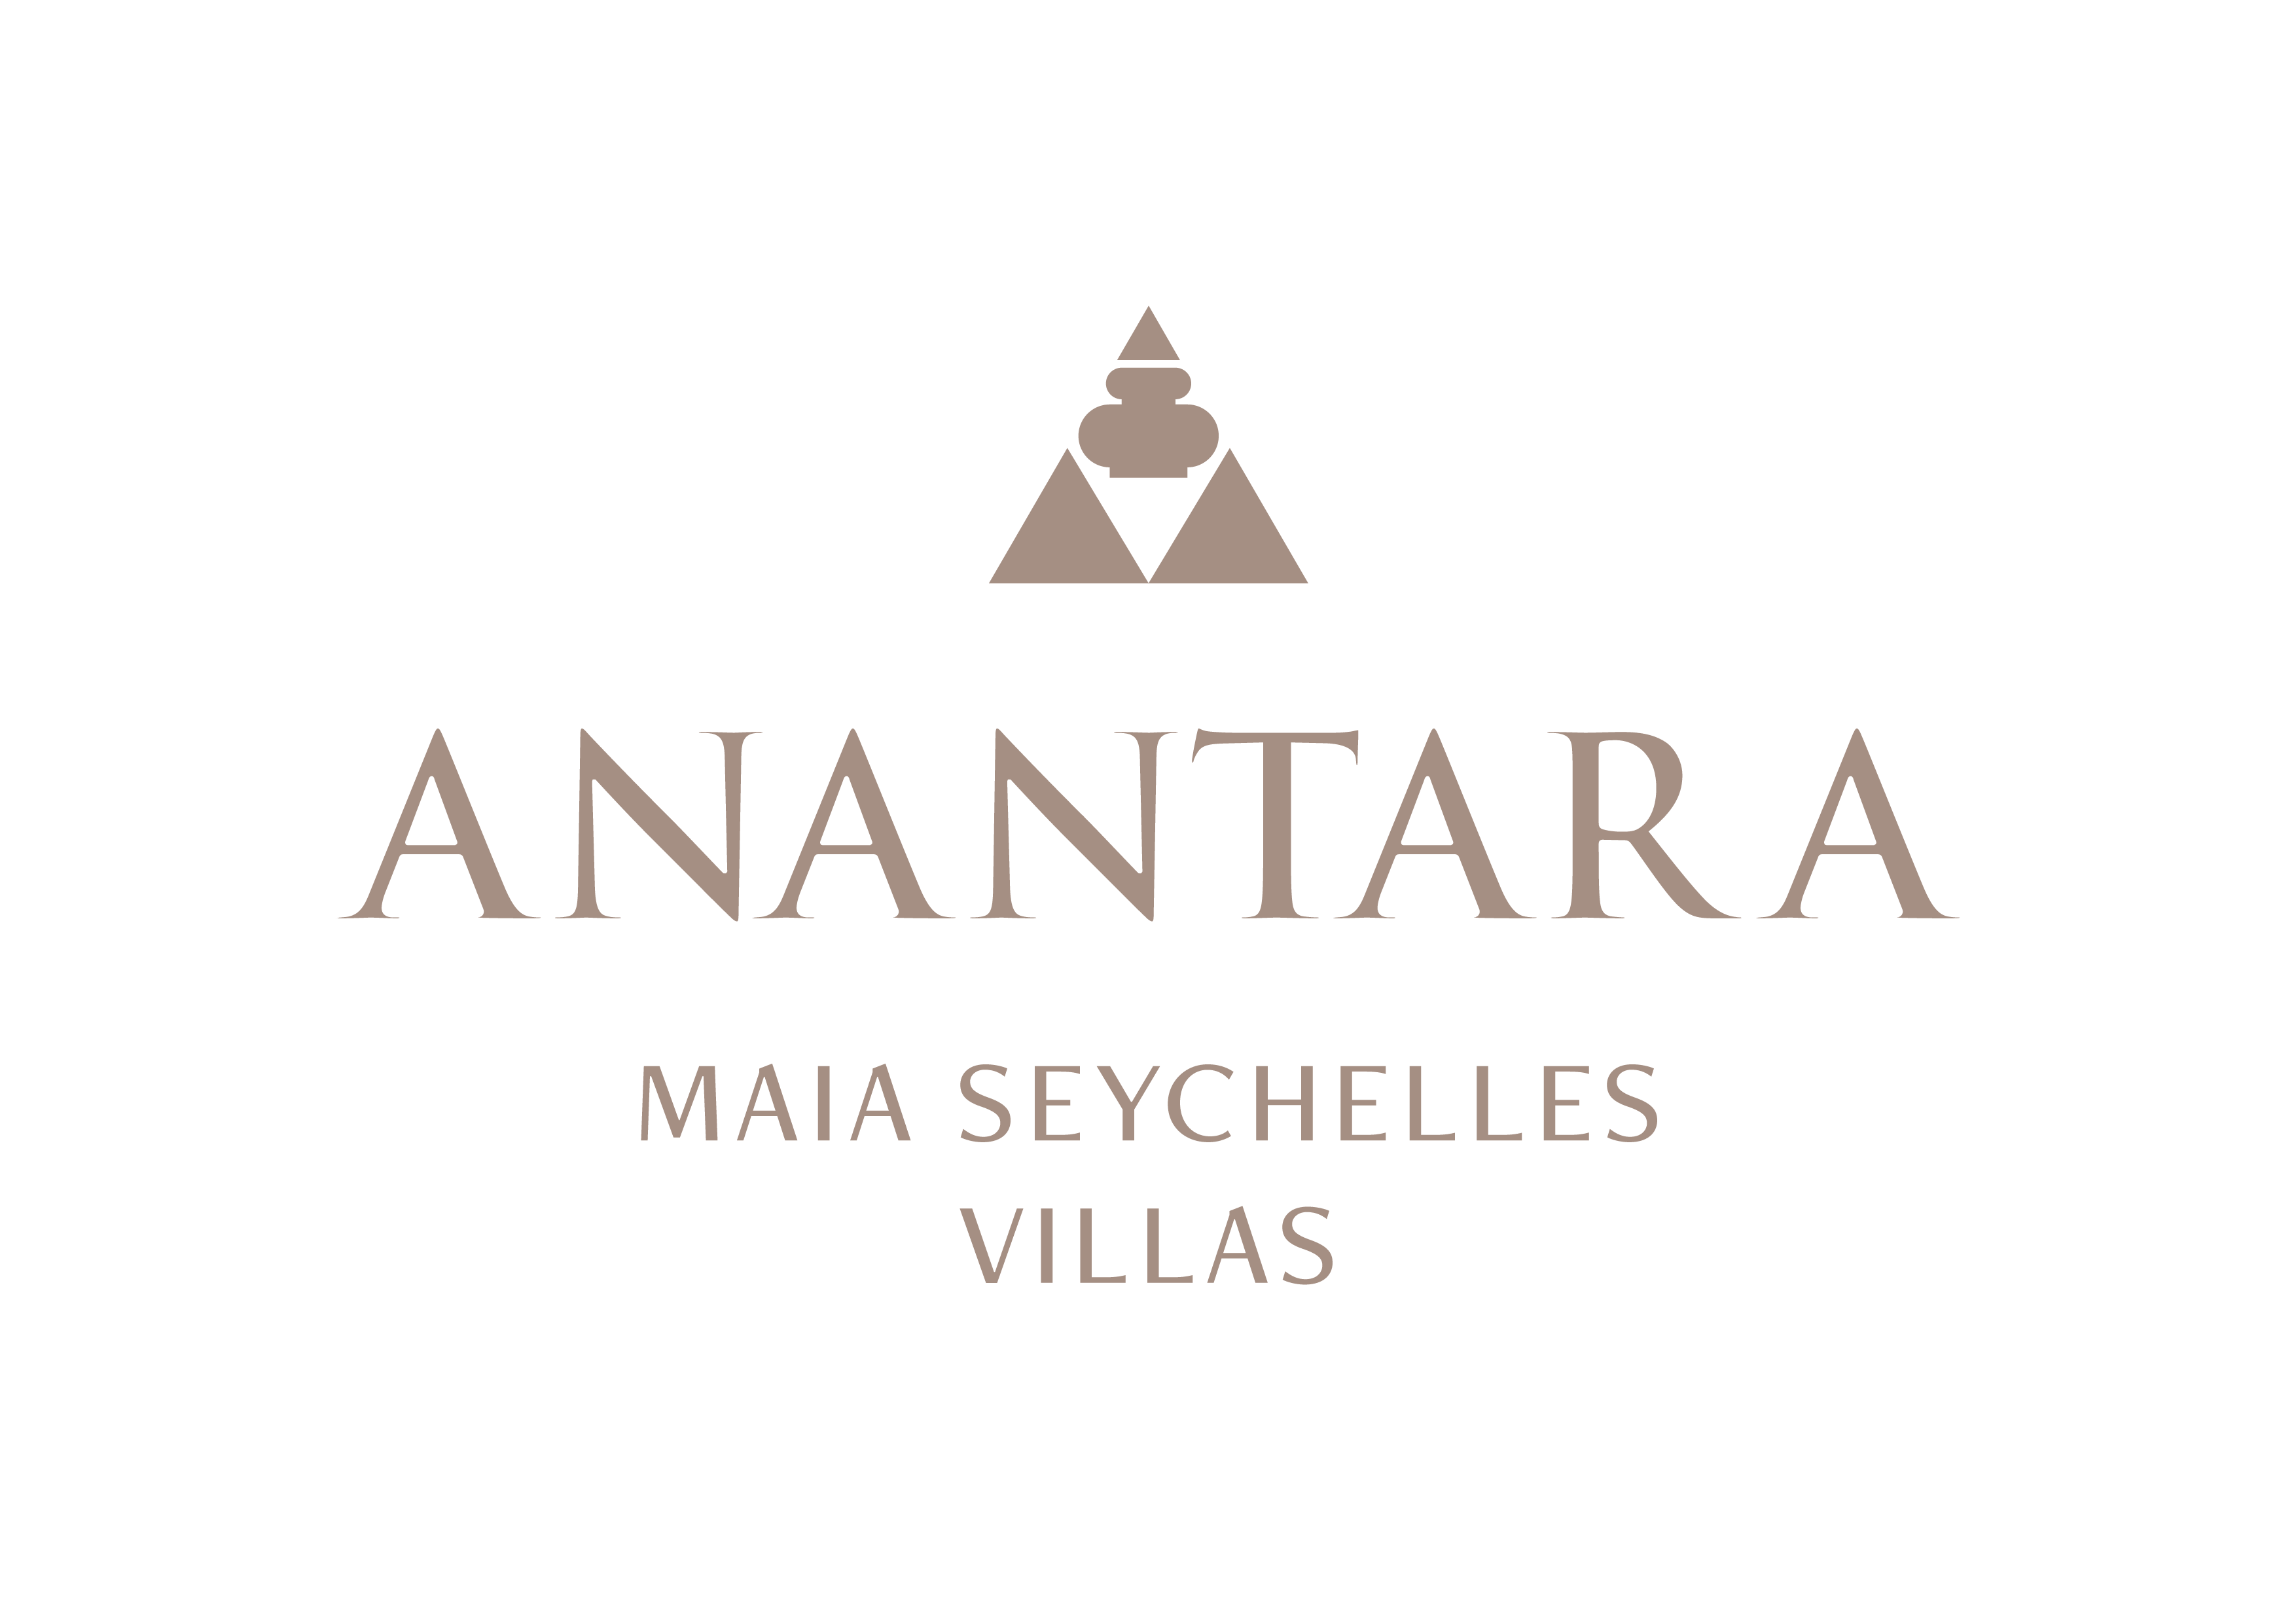
PRESS RELEASE
Private Celebrations: Anantara Maia Seychelles Villas Creates Intimate Weddings on Anse Louis
Beach and garden ceremonies, private dining and tailored island moments turn the peninsula into a destination for two.
Mahé, Seychelles - Anantara Maia Seychelles Villas offers couples a deeply private setting for weddings, vow renewals, honeymoons and anniversaries on Mahé's west coast. With just 30 private-pool villas across a secluded peninsula, celebrations can feel personal, unhurried and closely connected to the landscape.
The Maia Bliss Wedding and Vow Renewal experience can be staged on the sands of Anse Louis or in the resort's tropical gardens. A dedicated coordinator guides the occasion from planning to ceremony, bringing together tropical flowers, a bridal bouquet and buttonhole, a celebration cake, Champagne, canapés and a romantic villa turndown.
Each celebration can be expanded around the couple's story. Photography, videography and drone coverage can be arranged, alongside live musicians, traditional dancers, hair and make-up, spa preparations, a sunset cruise, a private chef or a scenic helicopter flight. All additional services are tailored and subject to availability.
Designer Dining transforms the peninsula into a private reception setting. Couples may choose a table on the beach, among the gardens, on a secluded hillside or overlooking the ocean, with menus developed for the occasion. For smaller moments, a floating aperitivo, private wine experience in “20” or dinner beside the villa pool can continue the celebration.
The villas provide a natural setting for the days around the ceremony. Private infinity pools, open-air living and dedicated Villa Host service allow couples to move easily between preparation, celebration and quiet time together. Spa rituals and personalised in-villa baths can be arranged before or after the occasion.
The resort team can also advise on civil documentation, translations and timing requirements for legal ceremonies in the Seychelles. Couples are encouraged to begin this process well in advance, as original documents and minimum-stay conditions may apply.
Whether the occasion is a legal wedding, symbolic ceremony or private renewal of vows, the emphasis remains on intimacy, flexibility and a sense of place.
“The beauty of a celebration at Anantara Maia is its privacy. We can shape the ceremony, dining and island experiences around the couple, while allowing the peninsula and Anse Louis to provide the most memorable setting,” said Naji Esta, Cluster General Manager.

-Ends-
About Anantara Maia Seychelles Villas
Anantara Maia Seychelles Villas is an ultra-luxury private-pool villa resort on a secluded 30-acre peninsula overlooking Anse Louis on Mahé's west coast. Its 30 villas pair ocean or garden views with private infinity pools, outdoor living and a dedicated Villa Host. Designed by Bill Bensley and Lek Bunnag, the resort is known for deep privacy, dine-anywhere experiences, Tec-Tec's beachfront cuisine and restorative wellness in three open-sided Anantara Spa pavilions. Around 35 minutes from Seychelles International Airport, it is suited to honeymooners, couples, families and intimate celebrations seeking tailored island experiences. Visit https://www.anantara.com/en/maia-seychelles or follow @anantaramaiaseychelles.
About Anantara Hotels & Resorts
A luxury hospitality brand for modern travellers, Anantara Hotels & Resorts connects guests to genuine places, people and stories in some of the world's most extraordinary destinations. Each Anantara embraces the surroundings and culture of its destination, creating unforgettable memories for every guest since 2001. From city to sea and desert to jungle, Anantara delivers heartfelt, Thai-inspired hospitality at its over 50 hotels and resorts across Asia, Europe, Africa, the Middle East and the Indian Ocean.
Anantara Hotels & Resorts is a Minor Hotels brand and recognises its guests through one unified loyalty programme, Minor DISCOVERY, part of GHA DISCOVERY.

Visit anantara.com for more information, and connect with Anantara on Facebook, Instagram, TikTok, X and YouTube.

About Minor Hotels
Minor Hotels is a global leader in the hospitality industry with more than 640 hotels, resorts and branded residences across 66 countries. The group crafts innovative and insightful experiences through its hotel brands including Anantara, Elewana Collection, The Wolseley Hotels, Tivoli, Minor Reserve Collection, NH Collection, nhow, Avani, Colbert Collection, NH, Oaks and iStay, as well as a diverse portfolio of restaurants and bars, travel experiences and spa and wellness brands. With over four decades of expertise, Minor Hotels builds stronger brands, fosters lasting partnerships and drives business success by always focusing on what matters most to our guests, team members and partners.
Minor Hotels is a proud member of the Global Hotel Alliance (GHA) and recognises its guests through one unified loyalty programme, Minor DISCOVERY, part of GHA DISCOVERY.

Discover our world at minorhotels.com and connect with Minor Hotels on Facebook, Instagram, LinkedIn, TikTok and YouTube.
Media Contact
Kevin Seeburrun
Cluster PR & MarCom Manager
Anantara Maia Seychelles Villas | Avani+ Barbarons Seychelles Resort
E: kseeburrun@minorhotels.com
M: +248 282 0987

