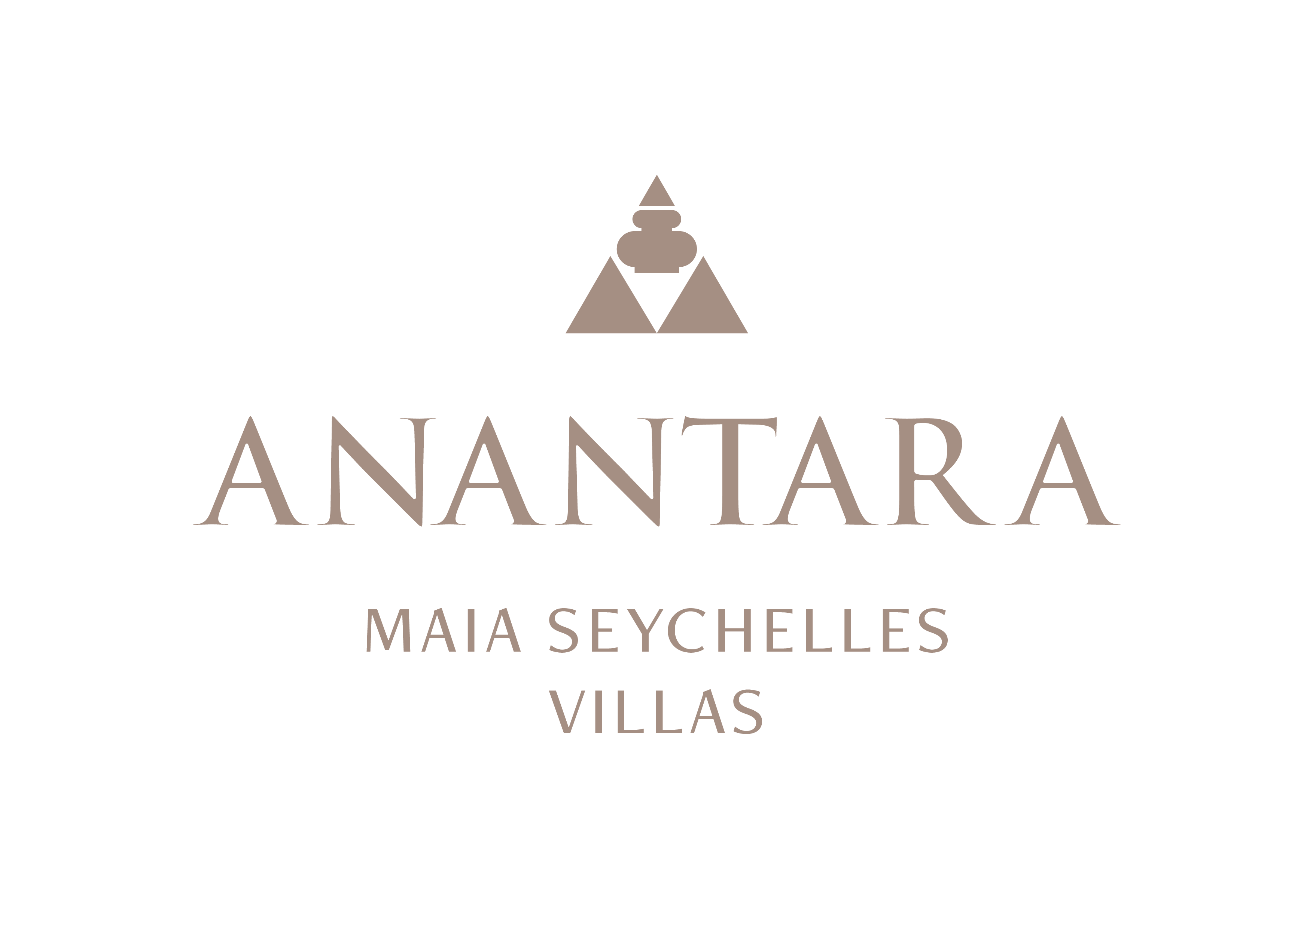
PRESS RELEASE
Designed by Nature: The Architecture and Living Landscape of Anantara Maia Seychelles Villas
Bill Bensley and Lek Bunnag's design places gardens, granite and the Indian Ocean at the centre of the guest experience.
Mahé, Seychelles - At Anantara Maia Seychelles Villas, architecture and landscape are inseparable. The resort occupies a secluded peninsula between Anse Louis and Anse Boileau, where villas, pathways and pavilions follow the natural contours of the land rather than compete with them.
Architect Lek Bunnag and designer Bill Bensley conceived the resort as a collection of open, tropical spaces shaped by the elements. Thatched pavilion roofs, warm timber, carved stone and brass details sit comfortably against weathered granite and dense vegetation. Water moves through the property in pools, ponds and ocean views, while breezes and natural light animate open-air living areas.
Each of the 30 villas is conceived as a private retreat. Indoor and outdoor spaces flow into one another through generous terraces, open-sided lounges and infinity pools. The palette is deliberately grounded in natural materials and tactile detail, allowing the colours of the gardens, sky and sea to remain the dominant visual language.
The landscape is a destination in its own right. Chief Gardener Allan Marguerite has cared for the grounds since 2008 and today leads a team of 12 gardeners. Together they tend a collection of around 300 plant species, including rare and endemic Seychelles flora. Sculptural palms, tropical flowers, shaded ponds and winding paths transform a walk between villa, beach and restaurant into a continuous garden experience.
Personalised garden tours introduce guests to the peninsula's botanical character and the careful work required to sustain it. Selected plants are also connected to the resort's culinary and wellbeing experiences, from herbs and produce grown for the kitchen to aromatic ingredients that evoke the Seychelles.
This relationship between design and nature is visible throughout the resort: at Tec-Tec, where a high thatched roof and warm materials frame the beachfront setting; in the open-sided spa pavilions nestled among granite boulders; and at Designer Dining locations where the architecture recedes and the peninsula becomes the setting.
“The design of Anantara Maia encourages guests to notice the peninsula: its light, textures, gardens and views. Every space is intended to feel private, but also deeply connected to the natural character of Mahé,” said Naji Esta, Cluster General Manager.

-Ends-
About Anantara Maia Seychelles Villas
Anantara Maia Seychelles Villas is an ultra-luxury private-pool villa resort on a secluded 30-acre peninsula overlooking Anse Louis on Mahé's west coast. Its 30 villas pair ocean or garden views with private infinity pools, outdoor living and a dedicated Villa Host. Designed by Bill Bensley and Lek Bunnag, the resort is known for deep privacy, dine-anywhere experiences, Tec-Tec's beachfront cuisine and restorative wellness in three open-sided Anantara Spa pavilions. Around 35 minutes from Seychelles International Airport, it is suited to honeymooners, couples, families and intimate celebrations seeking tailored island experiences. Visit https://www.anantara.com/en/maia-seychelles or follow @anantaramaiaseychelles.
About Anantara Hotels & Resorts
A luxury hospitality brand for modern travellers, Anantara Hotels & Resorts connects guests to genuine places, people and stories in some of the world's most extraordinary destinations. Each Anantara embraces the surroundings and culture of its destination, creating unforgettable memories for every guest since 2001. From city to sea and desert to jungle, Anantara delivers heartfelt, Thai-inspired hospitality at its over 50 hotels and resorts across Asia, Europe, Africa, the Middle East and the Indian Ocean.
Anantara Hotels & Resorts is a Minor Hotels brand and recognises its guests through one unified loyalty programme, Minor DISCOVERY, part of GHA DISCOVERY.

Visit anantara.com for more information, and connect with Anantara on Facebook, Instagram, TikTok, X and YouTube.

About Minor Hotels
Minor Hotels is a global leader in the hospitality industry with more than 640 hotels, resorts and branded residences across 66 countries. The group crafts innovative and insightful experiences through its hotel brands including Anantara, Elewana Collection, The Wolseley Hotels, Tivoli, Minor Reserve Collection, NH Collection, nhow, Avani, Colbert Collection, NH, Oaks and iStay, as well as a diverse portfolio of restaurants and bars, travel experiences and spa and wellness brands. With over four decades of expertise, Minor Hotels builds stronger brands, fosters lasting partnerships and drives business success by always focusing on what matters most to our guests, team members and partners.
Minor Hotels is a proud member of the Global Hotel Alliance (GHA) and recognises its guests through one unified loyalty programme, Minor DISCOVERY, part of GHA DISCOVERY.

Discover our world at minorhotels.com and connect with Minor Hotels on Facebook, Instagram, LinkedIn, TikTok and YouTube.
Media Contact
Kevin Seeburrun
Cluster PR & MarCom Manager
Anantara Maia Seychelles Villas | Avani+ Barbarons Seychelles Resort
E: kseeburrun@minorhotels.com
M: +248 282 0987

