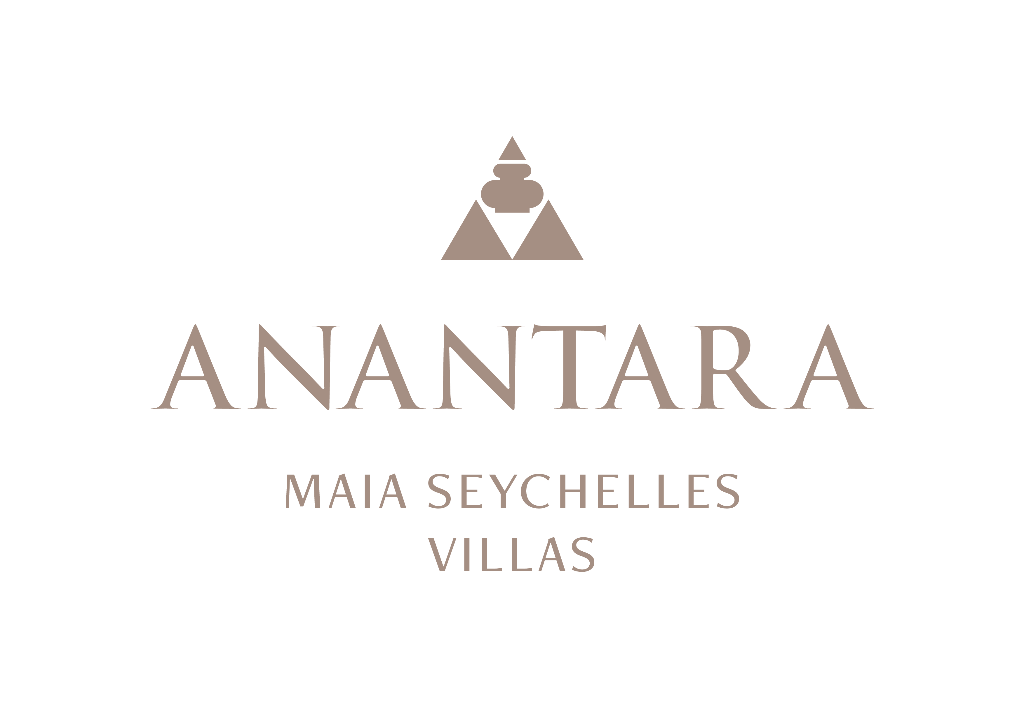
PRESS RELEASE
The Art of Personalised Luxury: Villa Hosts Shape Every Stay at Anantara Maia Seychelles Villas
A dedicated Villa Host brings together dining, wellbeing and island discovery around each guest's preferences.
Mahé, Seychelles - Anantara Maia Seychelles Villas places personal service at the centre of its 30-villa experience. Every stay is supported by a dedicated Villa Host, creating a single, intuitive point of connection for the many ways guests can experience the private peninsula and the wider Seychelles.
More than a conventional concierge, the Villa Host learns the rhythm and priorities of each stay. One morning may begin with breakfast floating across a private infinity pool; another with yoga, a walk through the gardens or an early departure by boat. A family may need children's activities coordinated around lunch, while a couple may prefer a spa ritual followed by dinner on a secluded stretch of Anse Louis.
This service philosophy is supported by a villa product designed for privacy and flexibility. Ocean View, Premier Ocean View, Premier Beach and Peninsula Ocean View Villas offer expansive indoor-outdoor living, private pools and views across the sea or gardens. The most spacious Premier Beach Villas provide direct access to the beach and additional room for families.
Dining can be arranged in the villa at any time of day, while Designer Dining takes special occasions into the landscape. The Villa Host can also connect guests with wine tastings in “20”, Creole cooking through Spice Spoons, spa journeys, marine experiences, helicopter flights, private charters and tailored island tours, subject to availability and weather conditions.
The approach is intentionally discreet. Preferences are anticipated, plans remain flexible and the guest decides how present the resort should be. For repeat visitors, the experience can become increasingly individual as familiar rituals, tastes and ways of travelling are remembered and refined.
At a time when luxury is increasingly measured in privacy, time and ease, the Villa Host model allows Anantara Maia to deliver a stay that feels carefully orchestrated without feeling scheduled.
“Our Villa Hosts are the thread that connects the entire stay. Their role is to listen closely, anticipate thoughtfully and give guests the freedom to enjoy the peninsula in their own way,” said Naji Esta, Cluster General Manager.

-Ends-
About Anantara Maia Seychelles Villas
Anantara Maia Seychelles Villas is an ultra-luxury private-pool villa resort on a secluded 30-acre peninsula overlooking Anse Louis on Mahé's west coast. Its 30 villas pair ocean or garden views with private infinity pools, outdoor living and a dedicated Villa Host. Designed by Bill Bensley and Lek Bunnag, the resort is known for deep privacy, dine-anywhere experiences, Tec-Tec's beachfront cuisine and restorative wellness in three open-sided Anantara Spa pavilions. Around 35 minutes from Seychelles International Airport, it is suited to honeymooners, couples, families and intimate celebrations seeking tailored island experiences. Visit https://www.anantara.com/en/maia-seychelles or follow @anantaramaiaseychelles.
About Anantara Hotels & Resorts
A luxury hospitality brand for modern travellers, Anantara Hotels & Resorts connects guests to genuine places, people and stories in some of the world's most extraordinary destinations. Each Anantara embraces the surroundings and culture of its destination, creating unforgettable memories for every guest since 2001. From city to sea and desert to jungle, Anantara delivers heartfelt, Thai-inspired hospitality at its over 50 hotels and resorts across Asia, Europe, Africa, the Middle East and the Indian Ocean.
Anantara Hotels & Resorts is a Minor Hotels brand and recognises its guests through one unified loyalty programme, Minor DISCOVERY, part of GHA DISCOVERY.

Visit anantara.com for more information, and connect with Anantara on Facebook, Instagram, TikTok, X and YouTube.

About Minor Hotels
Minor Hotels is a global leader in the hospitality industry with more than 640 hotels, resorts and branded residences across 66 countries. The group crafts innovative and insightful experiences through its hotel brands including Anantara, Elewana Collection, The Wolseley Hotels, Tivoli, Minor Reserve Collection, NH Collection, nhow, Avani, Colbert Collection, NH, Oaks and iStay, as well as a diverse portfolio of restaurants and bars, travel experiences and spa and wellness brands. With over four decades of expertise, Minor Hotels builds stronger brands, fosters lasting partnerships and drives business success by always focusing on what matters most to our guests, team members and partners.
Minor Hotels is a proud member of the Global Hotel Alliance (GHA) and recognises its guests through one unified loyalty programme, Minor DISCOVERY, part of GHA DISCOVERY.

Discover our world at minorhotels.com and connect with Minor Hotels on Facebook, Instagram, LinkedIn, TikTok and YouTube.
Media Contact
Kevin Seeburrun
Cluster PR & MarCom Manager
Anantara Maia Seychelles Villas | Avani+ Barbarons Seychelles Resort
E: kseeburrun@minorhotels.com
M: +248 282 0987

