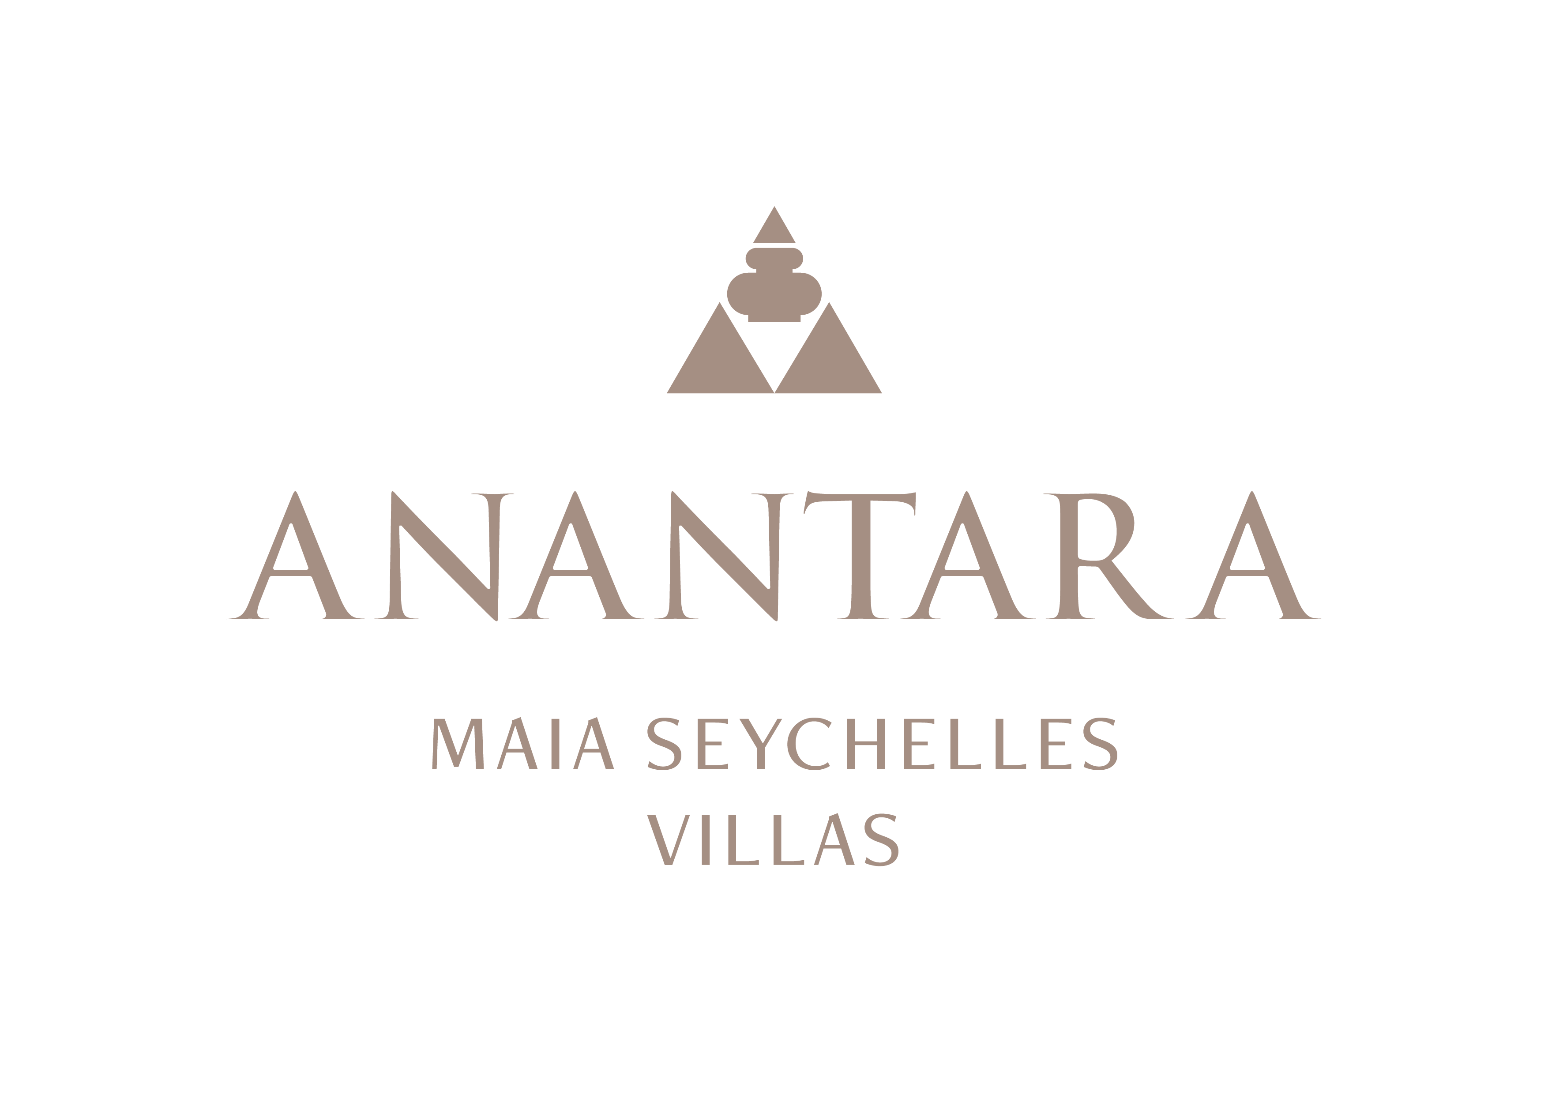
LEADERSHIP PROFILE
Naji Esta: Leading Personalised Island Hospitality at Anantara Maia Seychelles Villas
The Cluster General Manager oversees Anantara Maia Seychelles Villas and Avani+ Barbarons Seychelles Resort on Mahé's west coast.
Mahé, Seychelles - Naji Esta is Cluster General Manager for Anantara Maia Seychelles Villas and Avani+ Barbarons Seychelles Resort, overseeing two complementary hospitality experiences on Mahé's west coast.
His remit brings together luxury villa operations, resort performance, guest experience, people development and destination stewardship. At Anantara Maia, he leads a property defined by 30 private-pool villas, dedicated Villa Host service and a secluded 30-acre peninsula overlooking Anse Louis.
Esta's focus at Anantara Maia is on protecting the resort's sense of privacy while ensuring that its dining, wellness and island experiences remain highly personal. This requires close collaboration across operational teams, from Villa Hosts and chefs to spa practitioners, gardeners and marine partners.
Across the cluster, he works with commercial and operational teams to strengthen quality, sustainability and the international visibility of the Seychelles. The dual-property remit offers a distinctive perspective on managing different brands and guest propositions within one island destination.
At Anantara Maia, current priorities include developing experience-led storytelling, supporting local talent, advancing the resort's environmental initiatives and refining the individual details that turn a private-villa stay into a lasting memory.
Esta is available for commentary on private-pool villa hospitality, the role of personal service in modern luxury, responsible destination storytelling and the opportunities created by managing distinct resort brands in the Seychelles.
“The most meaningful luxury is personal. At Anantara Maia, our responsibility is to understand what matters to each guest, bring the right people and experiences together, and preserve the remarkable natural setting that makes the resort unique,” said Naji Esta, Cluster General Manager.

-Ends-
About Anantara Maia Seychelles Villas
Anantara Maia Seychelles Villas is an ultra-luxury private-pool villa resort on a secluded 30-acre peninsula overlooking Anse Louis on Mahé's west coast. Its 30 villas pair ocean or garden views with private infinity pools, outdoor living and a dedicated Villa Host. Designed by Bill Bensley and Lek Bunnag, the resort is known for deep privacy, dine-anywhere experiences, Tec-Tec's beachfront cuisine and restorative wellness in three open-sided Anantara Spa pavilions. Around 35 minutes from Seychelles International Airport, it is suited to honeymooners, couples, families and intimate celebrations seeking tailored island experiences. Visit https://www.anantara.com/en/maia-seychelles or follow @anantaramaiaseychelles.
About Anantara Hotels & Resorts
A luxury hospitality brand for modern travellers, Anantara Hotels & Resorts connects guests to genuine places, people and stories in some of the world's most extraordinary destinations. Each Anantara embraces the surroundings and culture of its destination, creating unforgettable memories for every guest since 2001. From city to sea and desert to jungle, Anantara delivers heartfelt, Thai-inspired hospitality at its over 50 hotels and resorts across Asia, Europe, Africa, the Middle East and the Indian Ocean.
Anantara Hotels & Resorts is a Minor Hotels brand and recognises its guests through one unified loyalty programme, Minor DISCOVERY, part of GHA DISCOVERY.

Visit anantara.com for more information, and connect with Anantara on Facebook, Instagram, TikTok, X and YouTube.

About Minor Hotels
Minor Hotels is a global leader in the hospitality industry with more than 640 hotels, resorts and branded residences across 66 countries. The group crafts innovative and insightful experiences through its hotel brands including Anantara, Elewana Collection, The Wolseley Hotels, Tivoli, Minor Reserve Collection, NH Collection, nhow, Avani, Colbert Collection, NH, Oaks and iStay, as well as a diverse portfolio of restaurants and bars, travel experiences and spa and wellness brands. With over four decades of expertise, Minor Hotels builds stronger brands, fosters lasting partnerships and drives business success by always focusing on what matters most to our guests, team members and partners.
Minor Hotels is a proud member of the Global Hotel Alliance (GHA) and recognises its guests through one unified loyalty programme, Minor DISCOVERY, part of GHA DISCOVERY.

Discover our world at minorhotels.com and connect with Minor Hotels on Facebook, Instagram, LinkedIn, TikTok and YouTube.
Media Contact
Kevin Seeburrun
Cluster PR & MarCom Manager
Anantara Maia Seychelles Villas | Avani+ Barbarons Seychelles Resort
E: kseeburrun@minorhotels.com
M: +248 282 0987

