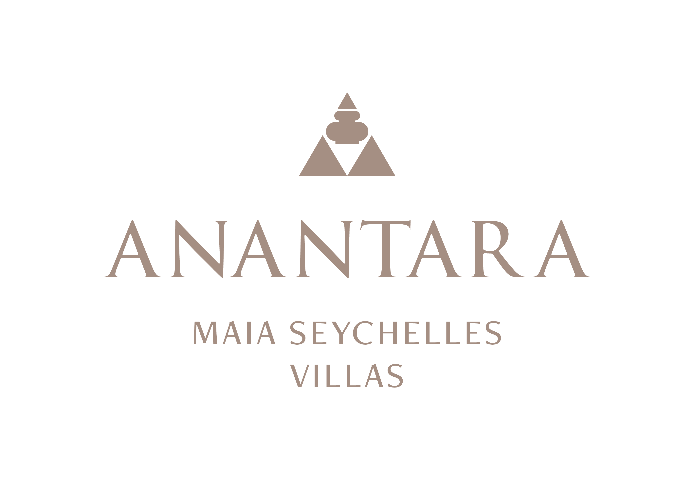
PRESS RELEASE
A Peninsula of Flavour: Anantara Maia Seychelles Villas Turns Gastronomy into a Personal Journey
Beachfront dining, private wine experiences and destination-led menus unfold wherever guests choose to dine.
Mahé, Seychelles - At Anantara Maia Seychelles Villas, gastronomy is not confined to a dining room or a timetable. Across the private peninsula, menus, settings and service are shaped around the guest, from barefoot lunches at Tec-Tec and sunset cocktails to wine-led dinners in an intimate cellar or a table created for two on Anse Louis.
Tec-Tec is the resort's beachfront culinary heart. Beneath a high thatched roof, the restaurant brings together Creole, Mediterranean, Asian and Indian influences, reflecting both the diversity of the Seychelles and the resort's international character. Breakfast moves at an unhurried pace, lunch follows the light of the bay and dinner introduces richer island flavours and produce.
Nearby, the Sunset Pool Bar offers a relaxed setting for cocktails, fresh juices and light dishes throughout the day. In-villa dining extends this flexibility around the clock, allowing guests to eat beside their private pool, in an open-air gazebo or indoors according to the weather and mood.
For a more intimate experience, “20” The Wine Cellar houses close to 300 references selected from established and emerging regions. Tastings and private dinners can be tailored by the resort team, creating a conversation between the cellar and menus influenced by the Indian Ocean. The Ultimate Wine Journey builds on this approach with guided discovery and carefully considered pairings.
Designer Dining takes gastronomy into the landscape. The team can create private occasions on the beach, in the gardens, on the hillside or at the helipad, with menus developed around the setting and celebration. A floating breakfast brings the experience to a villa pool, while Mookata offers an interactive Thai-style barbecue ritual in private surroundings.
Guests who want to look behind the plate can join Spice Spoons, Anantara's signature cooking experience. A visit to a local market or producer can be followed by garden discovery and a hands-on introduction to Creole recipes, connecting ingredients, people and place. Botanical gin moments, craft rum tastings and seasonal culinary activations add further ways to explore island flavours.
Together, these experiences form a flexible gastronomic journey that can be spontaneous or carefully planned, casual or celebratory, always grounded in personal taste and the character of the Seychelles.
“Our culinary philosophy begins with choice: what guests would like to taste, where they would like to dine and how they want the moment to feel. The peninsula gives us an extraordinary canvas for creating those experiences,” said Naji Esta, Cluster General Manager.

-Ends-
About Anantara Maia Seychelles Villas
Anantara Maia Seychelles Villas is an ultra-luxury private-pool villa resort on a secluded 30-acre peninsula overlooking Anse Louis on Mahé's west coast. Its 30 villas pair ocean or garden views with private infinity pools, outdoor living and a dedicated Villa Host. Designed by Bill Bensley and Lek Bunnag, the resort is known for deep privacy, dine-anywhere experiences, Tec-Tec's beachfront cuisine and restorative wellness in three open-sided Anantara Spa pavilions. Around 35 minutes from Seychelles International Airport, it is suited to honeymooners, couples, families and intimate celebrations seeking tailored island experiences. Visit https://www.anantara.com/en/maia-seychelles or follow @anantaramaiaseychelles.
About Anantara Hotels & Resorts
A luxury hospitality brand for modern travellers, Anantara Hotels & Resorts connects guests to genuine places, people and stories in some of the world's most extraordinary destinations. Each Anantara embraces the surroundings and culture of its destination, creating unforgettable memories for every guest since 2001. From city to sea and desert to jungle, Anantara delivers heartfelt, Thai-inspired hospitality at its over 50 hotels and resorts across Asia, Europe, Africa, the Middle East and the Indian Ocean.
Anantara Hotels & Resorts is a Minor Hotels brand and recognises its guests through one unified loyalty programme, Minor DISCOVERY, part of GHA DISCOVERY.

Visit anantara.com for more information, and connect with Anantara on Facebook, Instagram, TikTok, X and YouTube.

About Minor Hotels
Minor Hotels is a global leader in the hospitality industry with more than 640 hotels, resorts and branded residences across 66 countries. The group crafts innovative and insightful experiences through its hotel brands including Anantara, Elewana Collection, The Wolseley Hotels, Tivoli, Minor Reserve Collection, NH Collection, nhow, Avani, Colbert Collection, NH, Oaks and iStay, as well as a diverse portfolio of restaurants and bars, travel experiences and spa and wellness brands. With over four decades of expertise, Minor Hotels builds stronger brands, fosters lasting partnerships and drives business success by always focusing on what matters most to our guests, team members and partners.
Minor Hotels is a proud member of the Global Hotel Alliance (GHA) and recognises its guests through one unified loyalty programme, Minor DISCOVERY, part of GHA DISCOVERY.

Discover our world at minorhotels.com and connect with Minor Hotels on Facebook, Instagram, LinkedIn, TikTok and YouTube.
Media Contact
Kevin Seeburrun
Cluster PR & MarCom Manager
Anantara Maia Seychelles Villas | Avani+ Barbarons Seychelles Resort
E: kseeburrun@minorhotels.com
M: +248 282 0987

