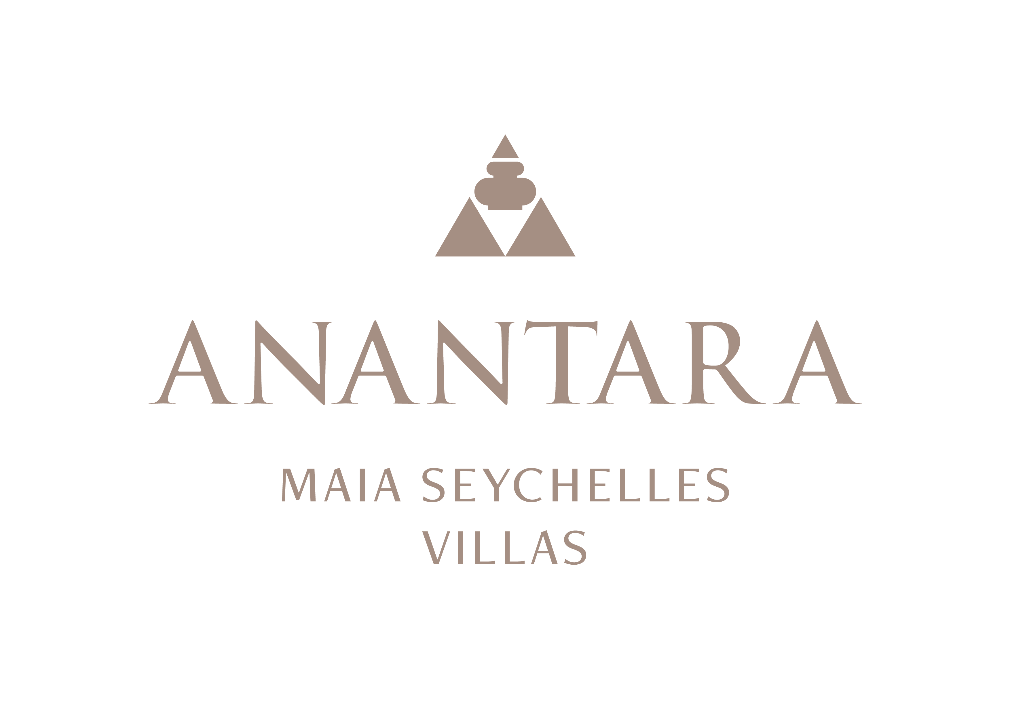
PRESS RELEASE
Padel in Paradise: Anantara Maia Seychelles Villas Opens a New Tropical Court
The private-peninsula resort adds coached padel sessions for beginners and experienced players.
Mahé, Seychelles - Anantara Maia Seychelles Villas has expanded its active wellbeing programme with a new padel court set within the resort's tropical peninsula on Mahé. Now open daily, the court gives guests a social and energetic way to complement villa life, spa rituals and time on the Indian Ocean.
The resort offers 90-minute sessions that combine court access with coaching, making the experience suitable for first-time players as well as guests looking to develop their game. Equipment and booking guidance are coordinated by the Anantara Spa team.
Padel's accessible format makes it a natural addition to the resort's programme of movement and recreation. Played in doubles on an enclosed court, it brings together the pace of racket sport with a relaxed, social character. Guests can arrange a morning match before the heat of the day or play in the late afternoon before sunset.
The new court joins yoga, qigong, fitness, kayaking, stand-up paddleboarding, snorkelling and guided outdoor activities as part of Anantara Maia's flexible approach to active stays. A session can be incorporated into a broader wellness itinerary or enjoyed as a spontaneous activity between time at the beach and the villa.
The court operates from 8.00 am to 8.00 pm, with the final booking at 6.30 pm. Players must be at least 12 years old; guests aged 12 to 17 require parental consent. Non-marking court shoes are required, and players are asked to keep sound considerate because of the court's proximity to villas.
Sessions are priced at SCR 4,200 for 90 minutes, including coach and court, with taxes and service charge included. Rates and operating times are subject to change, and advance reservations are recommended.
“Padel adds a playful, social dimension to wellbeing at Anantara Maia. Guests can learn with a coach, enjoy a match together and still remain immersed in the calm of the peninsula,” said Naji Esta, Cluster General Manager.

-Ends-
About Anantara Maia Seychelles Villas
Anantara Maia Seychelles Villas is an ultra-luxury private-pool villa resort on a secluded 30-acre peninsula overlooking Anse Louis on Mahé's west coast. Its 30 villas pair ocean or garden views with private infinity pools, outdoor living and a dedicated Villa Host. Designed by Bill Bensley and Lek Bunnag, the resort is known for deep privacy, dine-anywhere experiences, Tec-Tec's beachfront cuisine and restorative wellness in three open-sided Anantara Spa pavilions. Around 35 minutes from Seychelles International Airport, it is suited to honeymooners, couples, families and intimate celebrations seeking tailored island experiences. Visit https://www.anantara.com/en/maia-seychelles or follow @anantaramaiaseychelles.
About Anantara Hotels & Resorts
A luxury hospitality brand for modern travellers, Anantara Hotels & Resorts connects guests to genuine places, people and stories in some of the world's most extraordinary destinations. Each Anantara embraces the surroundings and culture of its destination, creating unforgettable memories for every guest since 2001. From city to sea and desert to jungle, Anantara delivers heartfelt, Thai-inspired hospitality at its over 50 hotels and resorts across Asia, Europe, Africa, the Middle East and the Indian Ocean.
Anantara Hotels & Resorts is a Minor Hotels brand and recognises its guests through one unified loyalty programme, Minor DISCOVERY, part of GHA DISCOVERY.

Visit anantara.com for more information, and connect with Anantara on Facebook, Instagram, TikTok, X and YouTube.

About Minor Hotels
Minor Hotels is a global leader in the hospitality industry with more than 640 hotels, resorts and branded residences across 66 countries. The group crafts innovative and insightful experiences through its hotel brands including Anantara, Elewana Collection, The Wolseley Hotels, Tivoli, Minor Reserve Collection, NH Collection, nhow, Avani, Colbert Collection, NH, Oaks and iStay, as well as a diverse portfolio of restaurants and bars, travel experiences and spa and wellness brands. With over four decades of expertise, Minor Hotels builds stronger brands, fosters lasting partnerships and drives business success by always focusing on what matters most to our guests, team members and partners.
Minor Hotels is a proud member of the Global Hotel Alliance (GHA) and recognises its guests through one unified loyalty programme, Minor DISCOVERY, part of GHA DISCOVERY.

Discover our world at minorhotels.com and connect with Minor Hotels on Facebook, Instagram, LinkedIn, TikTok and YouTube.
Media Contact
Kevin Seeburrun
Cluster PR & MarCom Manager
Anantara Maia Seychelles Villas | Avani+ Barbarons Seychelles Resort
E: kseeburrun@minorhotels.com
M: +248 282 0987

