PRESS RELEASE

Anantara Bophut Koh Samui Celebrates 25 Years of Anantara with
a Journey into the Island’s Spiritual Heart

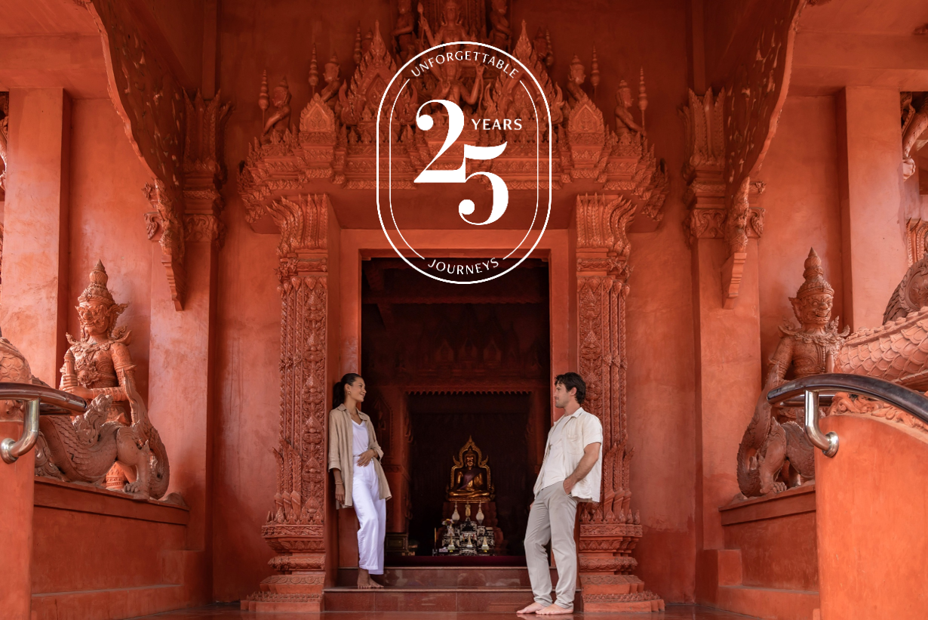

Imagery available here

Koh Samui, 24 August 2026 – To celebrate 25 years of Anantara, Anantara Bophut Koh Samui Resort invites guests to discover a quieter, more meaningful side of the island with the Island Blessings Experience, a cultural journey through Koh Samui’s Buddhist heritage.

The experience begins at the resort with the gentle art of lotus flower folding, creating a floral offering inspired by one of Buddhism’s most enduring symbols. Growing from muddy waters yet emerging pure and beautiful, the lotus represents purity, mindfulness and spiritual awakening. Carefully shaping each petal offers a moment to slow down, focus and prepare an offering with intention.

Guests then journey to Wat Sawang Arom, also known as Wat Chaweng, an active temple deeply connected to the local community. Here, they receive a traditional monk blessing and make merit, experiencing Buddhist traditions within a living place of worship.

The journey continues to Wat Sila Ngu, known as the Red Temple, where distinctive terracotta-red architecture, intricate carvings and Buddhist imagery reveal another facet of Koh Samui’s cultural heritage. Set against the island’s tropical landscape and the Gulf of Thailand, the temple reflects the enduring connection between spirituality, nature and island life.

The experience concludes at Wat Samret, one of Koh Samui’s oldest temples, where guests offer their carefully folded lotus flowers in a quiet and meaningful ritual. Surrounded by mature trees and historic Buddhist imagery, the temple offers a peaceful glimpse into the island’s enduring spiritual traditions.

More than a temple visit or cultural activity, the Island Blessings Experience is an invitation to connect with Koh Samui through mindfulness, generosity and a deeper appreciation of local traditions.

“The Island Blessings Experience allows our guests to discover a side of Koh Samui that exists beyond its beaches,” says Thomas Boehringer, Cluster General Manager of Anantara Bophut Koh Samui Resort. “It is a journey of quiet moments and meaningful encounters that connects travellers with the island’s spiritual heritage and the traditions that remain part of local life today.”

A Meaningful Stay in Koh Samui

Created as part of Anantara’s 25th anniversary celebrations, the experience reflects the brand’s enduring connection to the destinations it calls home, inviting travellers not simply to visit Koh Samui, but to pause, participate and discover the spirit of the island.

The Island Blessings package includes: a minimum two-night stay, daily breakfast and the Island Blessings Experience, including lotus flower folding, a monk blessing at Wat Sawang Arom and visits to Wat Sila Ngu and Wat Samret.

Travellers can book the Island Blessings package on the resort’s website – anantara.com/en/bophut-koh-samui – or by contacting the reservations team at +66 77 428 300 or bophutsamui@anantara.com.

-Ends-

About Anantara Bophut Koh Samui Resort

Anantara Bophut Koh Samui Resort is set on pristine Bophut Beach amid lush tropical gardens on the site of a former coconut plantation. Designed by renowned landscape architect Bill Bensley, the resort’s verdant grounds feature tranquil lotus ponds and a secluded spa garden, complemented by 106 rooms and suites inspired by southern Thai architecture and decorated in warm, earthy tones.

The resort offers a choice of dining experiences, including South American cuisine at Guilty, modern Thai cuisine at Thin Tai and relaxed beachfront dining at TĀN Beach Lounge. Guests can also enjoy Anantara’s signature Designer Dining experience, featuring a private chef and butler-attended meal.

Island days can be spent beside the infinity pool, on the beach or exploring the resort’s family-friendly facilities, including the Tree House Kids’ Club and Active Zone for teenagers. At the award-winning Anantara Spa, a tranquil walled garden provides a peaceful setting for a range of wellness treatments and rituals.

Combining the natural beauty of Koh Samui with thoughtful Thai-inspired design, dining and experiences, Anantara Bophut offers guests an opportunity to discover the island at a relaxed and authentic pace.

Visit anantara.com/en/bophut-koh-samui for more information, and connect with Anantara Bophut on Instagram, Facebook and TikTok.

About Anantara Hotels & Resorts

A luxury hospitality brand for modern travellers, Anantara Hotels & Resorts connects guests to genuine places, people and stories in some of the world’s most extraordinary destinations. Each Anantara embraces the surroundings and culture of its destination, creating unforgettable memories for every guest since 2001. From city to sea and desert to jungle, Anantara delivers heartfelt, Thai-inspired hospitality at its over 50 hotels and resorts across Asia, Europe, Africa, the Middle East and the Indian Ocean.

Anantara Hotels & Resorts is a Minor Hotels brand and recognises its guests through one unified loyalty programme, Minor DISCOVERY, part of GHA DISCOVERY.

Visit anantara.com for more information, and connect with Anantara on Facebook, Instagram, TikTok, X and YouTube.

About Minor Hotels

Minor Hotels is a global leader in the hospitality industry with more than 640 hotels, resorts and branded residences across 67 countries. The group crafts innovative and insightful experiences through its hotel brands including Anantara, Elewana Collection, The Wolseley Hotels, Tivoli, Minor Reserve Collection, NH Collection, nhow, Avani, Colbert Collection, NH, Oaks and iStay, as well as a diverse portfolio of restaurants and bars, travel experiences and spa and wellness brands. With over four decades of expertise, Minor Hotels builds stronger brands, fosters lasting partnerships and drives business success by always focusing on what matters most to our guests, team members and partners.

Minor Hotels is a proud member of the Global Hotel Alliance (GHA) and recognises its guests through one unified loyalty programme, Minor DISCOVERY, part of GHA DISCOVERY.

Discover our world at minorhotels.com and connect with Minor Hotels on Facebook, Instagram, LinkedIn, TikTok and YouTube.

For media enquiries, please contact:

Name: Sunny Chawla
Position: Area Director of Public Relations & Communications
Email: sunny_ch@minor.com

Name: Aryawan Arbani (Ary)
Position: Assistant Director of Marketing & Communications
Email: aarbani@anantara.com

